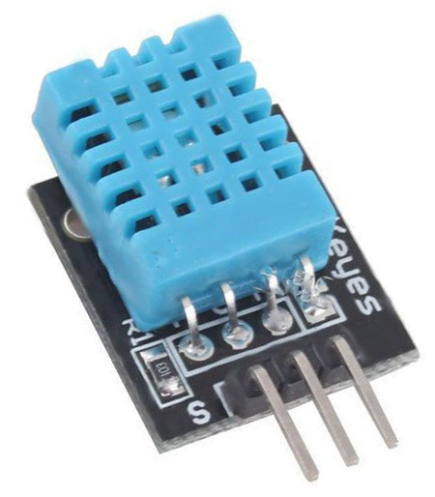

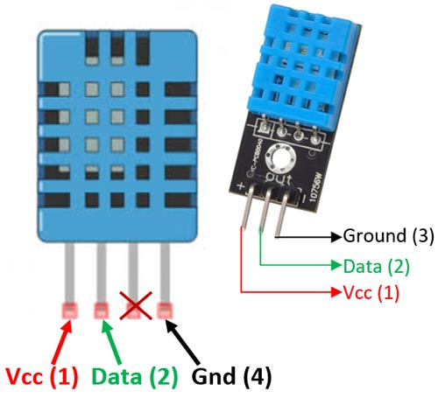

Pin Identification and Configuration:

|  |  |  |
| --- | --- | --- |
| **No:** | **Pin Name** | **Description** |
| **For DHT11 Sensor** | | |
| 1 | Vcc | Power supply 3.5V to 5.5V |
| 2 | Data | Outputs both Temperature and Humidity through serial Data |
| 3 | NC | No Connection and hence not used |
| 4 | Ground | Connected to the ground of the circuit |
| **For DHT11 Sensor module** | | |
| 1 | Vcc | Power supply 3.5V to 5.5V |
| 2 | Data | Outputs both Temperature and Humidity through serial Data |
| 3 | Ground | Connected to the ground of the circuit |

You can buy [DHT11 sensor module](https://quartzcomponents.com/products/dht11-temperature-humidity-sensor-module) from here.

DHT11 Specifications:

* Operating Voltage: 3.5V to 5.5V
* Operating current: 0.3mA (measuring) 60uA (standby)
* Output: Serial data
* Temperature Range: 0°C to 50°C
* Humidity Range: 20% to 90%
* Resolution: Temperature and Humidity both are 16-bit
* Accuracy: ±1°C and ±1%

Difference between DHT11 Sensor and module:

The **DHT11 sensor** can either be purchased as a sensor or as a module. Either way, the performance of the sensor is same. The sensor will come as a 4-pin package out of which only three pins will be used whereas the module will come with three pins as shown above.

The only difference between the sensor and module is that the module will have a filtering capacitor and pull-up resistor inbuilt, and for the sensor, you have to use them externally if required.

Where to use DHT11:

The **DHT11**is a commonly used **Temperature and humidity sensor.** The sensor comes with a dedicated NTC to measure temperature and an 8-bit microcontroller to output the values of temperature and humidity as serial data. The sensor is also factory calibrated and hence easy to interface with other microcontrollers.

The sensor can measure temperature from 0°C to 50°C and humidity from 20% to 90% with an accuracy of ±1°C and ±1%. So if you are looking to measure in this range then this sensor might be the right choice for you.

How to use DHT11 Sensor:

The DHT11 Sensor is factory calibrated and outputs serial data and hence it is highly easy to set it up. The connection diagram for this sensor is shown below.

As you can see the data pin is connected to an I/O pin of the MCU and a 5K pull-up resistor is used. This data pin outputs the value of both temperature and humidity as serial data. If you are trying to interface DHT11 with Arduino then there are ready-made libraries for it which will give you a quick start.

If you are trying to interface it with some other MCU then the datasheet given below will come in handy. The output given out by the data pin will be in the order of 8bit humidity integer data + 8bit the Humidity decimal data +8 bit temperature integer data + 8bit fractional temperature data +8 bit parity bit. To request the DHT11 module to send these data the I/O pin has to be momentarily made low and then held high as shown in the timing diagram below

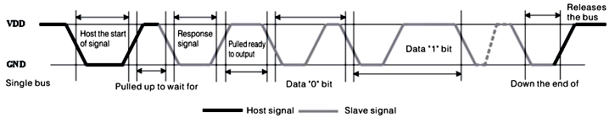

The duration of each host signal is explained in the DHT11 datasheet, with neat steps and illustrative timing diagrams

**Applications:**

* Measure temperature and humidity
* Local Weather station
* Automatic climate control
* Environment monitoring

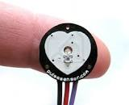



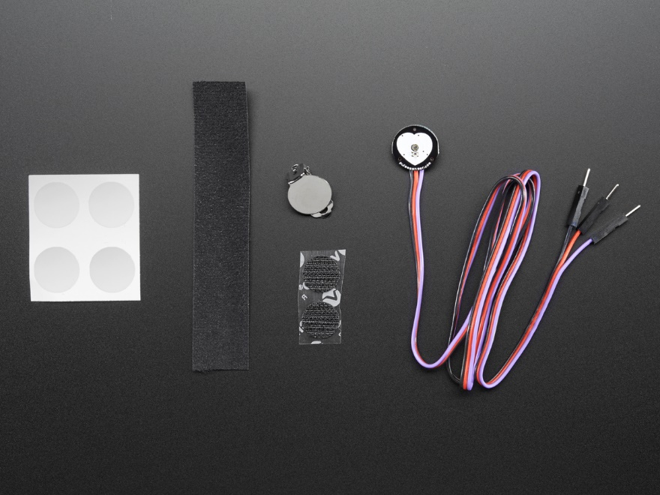

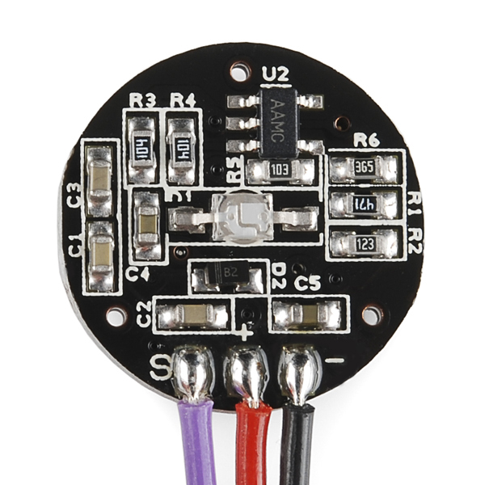

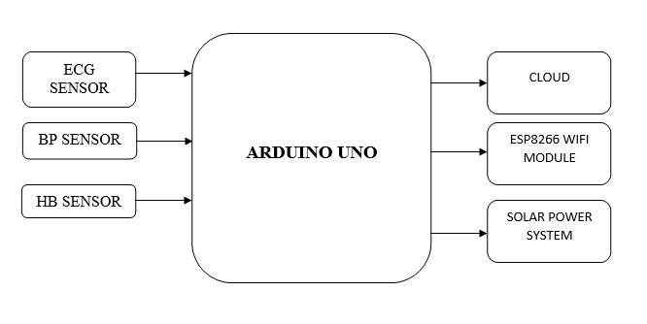

**What is Heart Rate Pulse Sensor Amped?**Heart rate pulse sensor amped is a such type of sensor which is mainly used for sensing heartbeat rate. Normally it is very difficult task to measure the exact heartbeat rate, but this have become so much easy with the help of this pulse sensor amped. If we talk about heartbeat, then heart beat is a periodic signal that is produced by any software or hardware system for giving intimation to normal of working of any system. For measuring this periodic intimation signal, so many sensors have been using currently in market but here we shell only talk about pulse sensor amped. This is basically plug and play heartbeat sensor and have been using by  makers, athletes , game developers and students in their hardware projects. It is easily available in market or online shop.

The working principle of this heartbeat rate  sensor is very simple. If we talk about heartbeat rate, then heartbeat rate is the ratio of time between two consecutive heartbeats. Similarly, when the human blood is circulated in human body then this blood is squeezed in capillary tissues. As a result, the volume of  capillary tissues is increased but this volume is decreased after each heartbeat. This change in volume of capillary tissues, effects on the LED light of heart rate pulse sensor, which transmits light after each heartbeat.

This change in light is very small but this can be measured by connecting any controller with this pulse sensor. Means, the LED light which have every pulse sensor helps for measuring pulse rate . The working of this sensor could be checked by placing human finger in front of this pulse sensor. When  finger is placed in front of this pulse sensor then the reflection of LED light is changed based on the volume of blood change inside capillary vessels. Means during heartbeat the volume of blood in capillary vessels will be high and then will be low after each heartbeat. So, by changing this volume the LED light is changed. This change in  of LED light measures the heartbeat rate of finger.

Every heart rate sensor consists of three pins first  one is ground  pin which is used for supplying ground to this sensor  and it is connected to source ground pin .Second one is VCC pin which is used for power on this heart rate sensor and it is connected to source VCC pin. This sensor is powered on at almost 3.3V to 5V dc voltages. Similarly, the last one is A0 pin which is an analogue pin and it is used for receiving analogue signal.

According to figure 2 this sensor also consists of a central LED. This LED helps the sensor for detecting heartbeat rate. Beside this, there is another circuitry below LED and this circuitry is called noise elimination circuitry. This circuitry is used for eliminating the noise which effects on the reading of the heart rate pulse sensor.