4.3 TOOLS AND PLATFORMS

4.3.1 System

A system is an arrangement in which all its unit assemble work together according to a set of rules. It can also be defined as a way of working, organizing or doing one or many tasks according to a fixed plan. For example, a watch is a time displaying system. Its components follow a set of rules to show time. If one of its parts fails, the watch will stop working. So, we can say, in a system, all its subcomponents depend on each other.

4.3.2 Embedded System

As its name suggests, Embedded means something that is attached to another thing. An embedded system can be thought of as a computer hardware system having software embedded in it. An embedded system can be an independent system or it can be a part of a large system. An embedded system is a microcontroller or microprocessor-based system which is designed to perform a specific task. For example, a fire alarm is an embedded system; it will sense only smoke.

An embedded system has three components −

* It has hardware.
* It has application software.
* It has Real Time Operating system (RTOS) that supervises the application software and provide mechanism to let the processor run a process as per scheduling by following a plan to control the latencies. RTOS defines the way the system works. It sets the rules during the execution of application program. A small-scale embedded system may not have RTOS.

So, we can define an embedded system as a Microcontroller based, software driven, reliable, real-time control system.

Characteristics of an Embedded System

* **Single-functioned** − An embedded system usually performs a specialized operation and does the same repeatedly. For example: A pager always functions as a pager.
* **Tightly constrained** − All computing systems have constraints on design metrics, but those on an embedded system can be especially tight. Design metrics is a measure of an implementation's features such as its cost, size, power, and performance. It must be of a size to fit on a single chip, must perform fast enough to process data in real time and consume minimum power to extend battery life.
* **Reactive and Real time** − Many embedded systems must continually react to changes in the system's environment and must compute certain results in real time without any delay. Consider an example of a car cruise controller; it continually monitors and reacts to speed and brake sensors. It must compute acceleration or de-accelerations repeatedly within a limited time; a delayed computation can result in failure to control of the car.
* **Microprocessors based** − It must be microprocessor or microcontroller based.
* **Memory** − It must have a memory, as its software usually embeds in ROM. It does not need any secondary memories in the computer.
* **Connected** − It must have connected peripherals to connect input and output devices.
* **HW-SW systems** − Software is used for more features and flexibility. Hardware is used for performance and security.

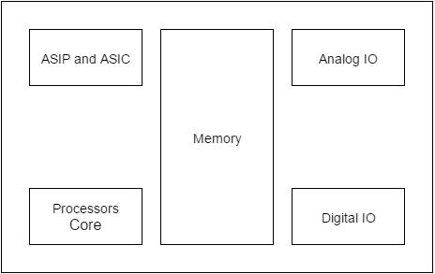

Advantages

* Easily Customizable
* Low power consumption
* Low cost
* Enhanced performance

Disadvantages

* High development effort
* Larger time to market

Basic Structure of an Embedded System

The following illustration shows the basic structure of an embedded system −

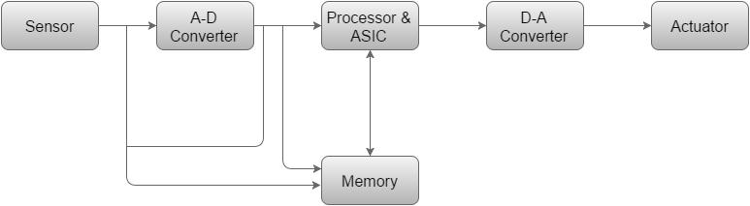

* **Sensor** − It measures the physical quantity and converts it to an electrical signal which can be read by an observer or by any electronic instrument like an A2D converter. A sensor stores the measured quantity to the memory.
* **A-D Converter** − An analog-to-digital converter converts the analog signal sent by the sensor into a digital signal.
* **Processor & ASICs** − Processors process the data to measure the output and store it to the memory.
* **D-A Converter** − A digital-to-analog converter converts the digital data fed by the processor to analog data
* **Actuator** − An actuator compares the output given by the D-A Converter to the actual (expected) output stored in it and stores the approved output.