PRACTICAL

TASK :CONFIGURING WINDOWS DEFENDER FIREWALL

STEP 1:
- Opening the Run Dialog Box

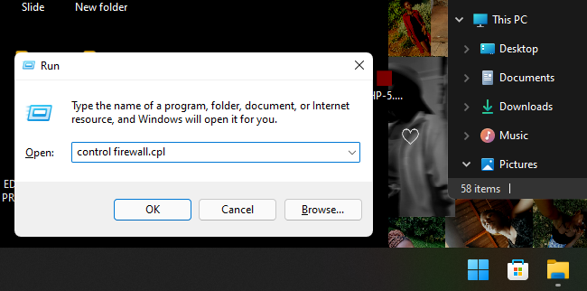

- The Windows Defender Firewall Setting Window
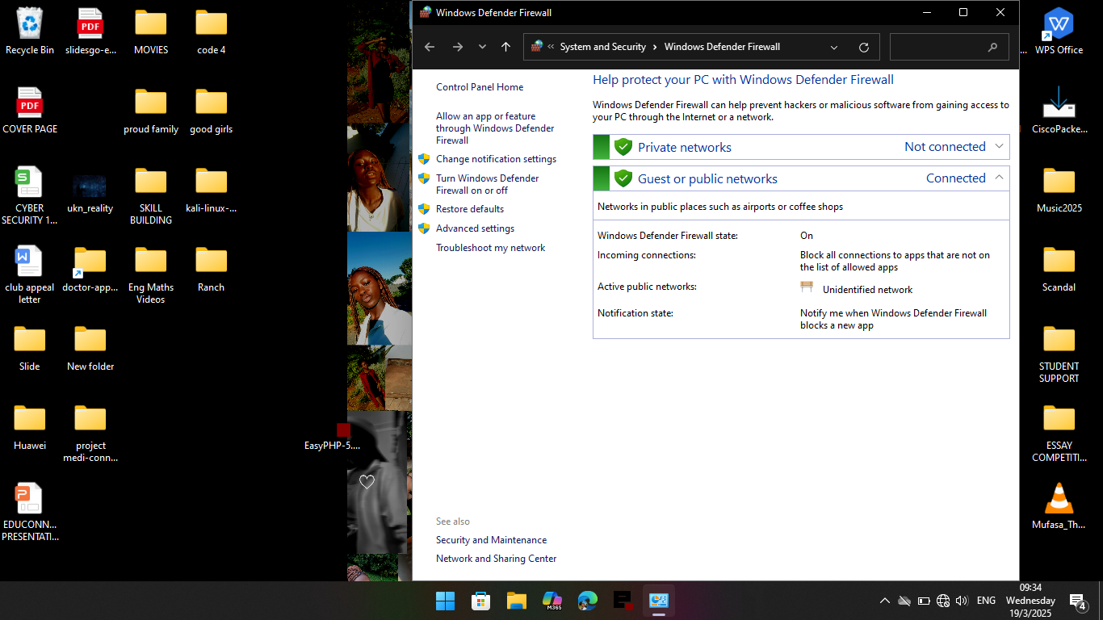
STEP 2: CREATING A NEW INBOUND RULE
- Inbound Rules are under “Advanced Settings” as they present specialized options that allow users to fine-tune a network system to ones preference

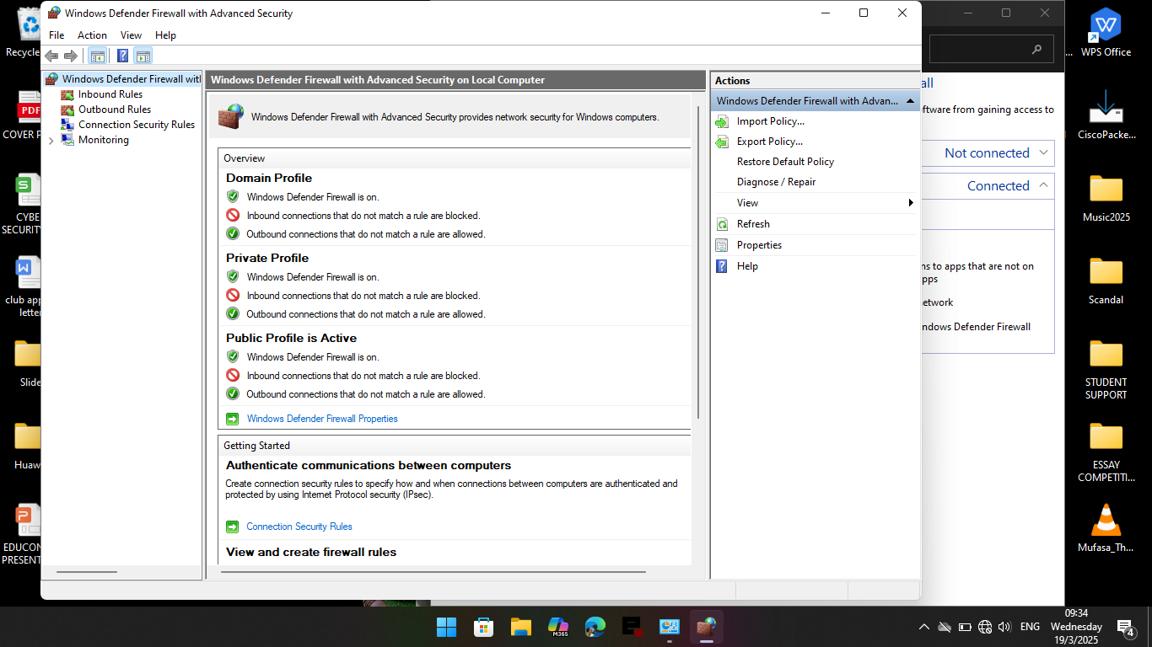

- These rules ,are sets of configurations that govern incoming traffic ,requests and data ,analyzing whether it should be allowed or blocked based of of a certain criteria like IP addresses ,ports,protocols,packet content and user authentication.

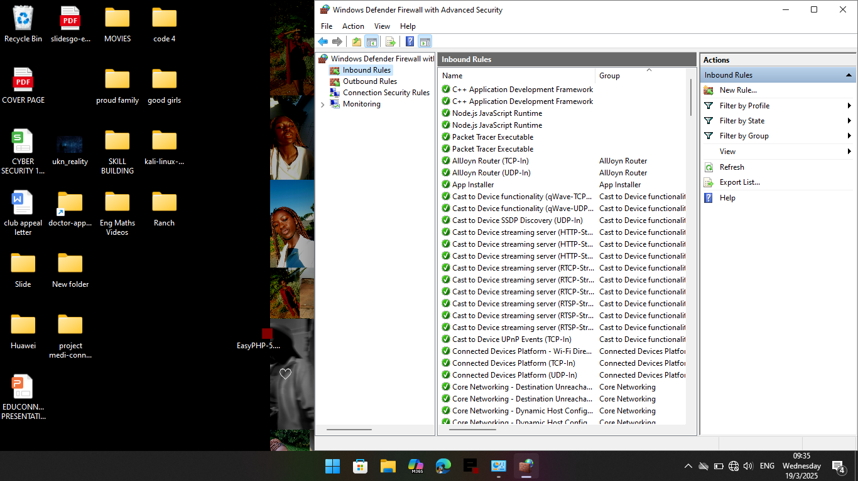

- Selecting an Inbound Rule type aids to the classification of the inbound rule
For example :
- Program Rule-This governs traffic based on the predefined rules of the recipient also including the IP address
- Port Rule-This governs traffic coming in from a specified port either allowing it,blocking it or conditionalizing it (allowing it when it is only secure or blocking it when it is not secure )
- Predefined Rule-These are standardized pre-configured rules that controls and manages incoming traffic like Allow HTTP traffic
- Custom Rule-these are user-defined rules that controls and manages incoming traffic

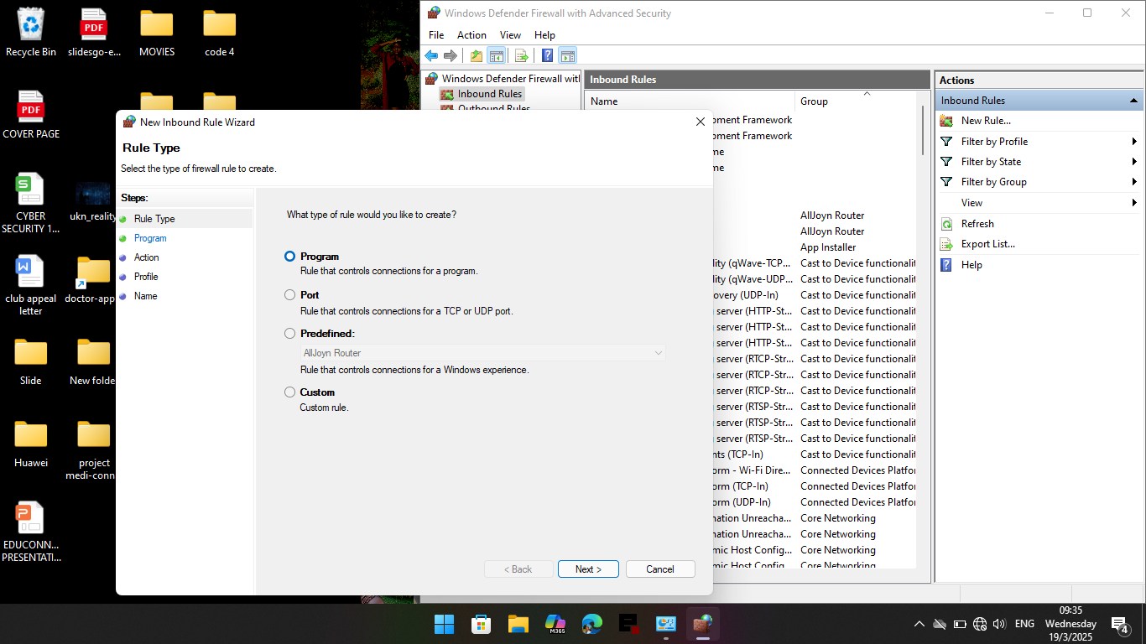

STEP 2(ii):Selecting an Inbound Rule Type

- For this task we created an Inbound Port Rule
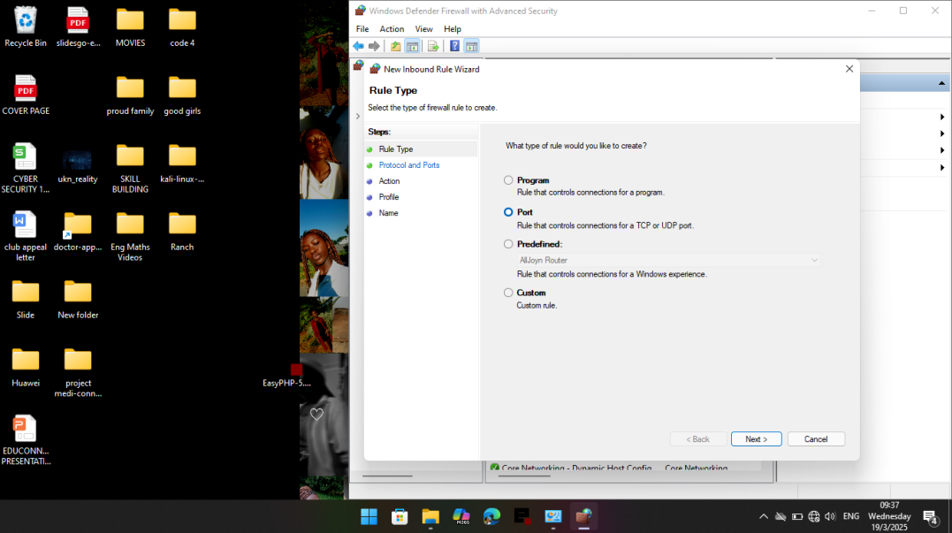
- There a two types of Inbound Port Rule namely TCP or UDP

FEATURE | TCP | UDP
PROTOCOL | Transmission Control Protocol | User Datagram Protocol
CONNECTION | Connection Oriented | Connectionless
RELIABILITY | Ensures reliable delivery with acknowledgement | No guaranteed of delivery or error
ORDERING | Ensures data arrives in the correct sequence | Data arrives in no particular sequence
SPEED | Slower due to connection set-up and error-checking | Faster due to connection set up
USE CASES | Web browsing  (HTTP) | Video streaming  VoIP
SECURITY | More secure | Less secure

- The below rule made id a TCP Inbound Rule for a specified to block connection to Port 455

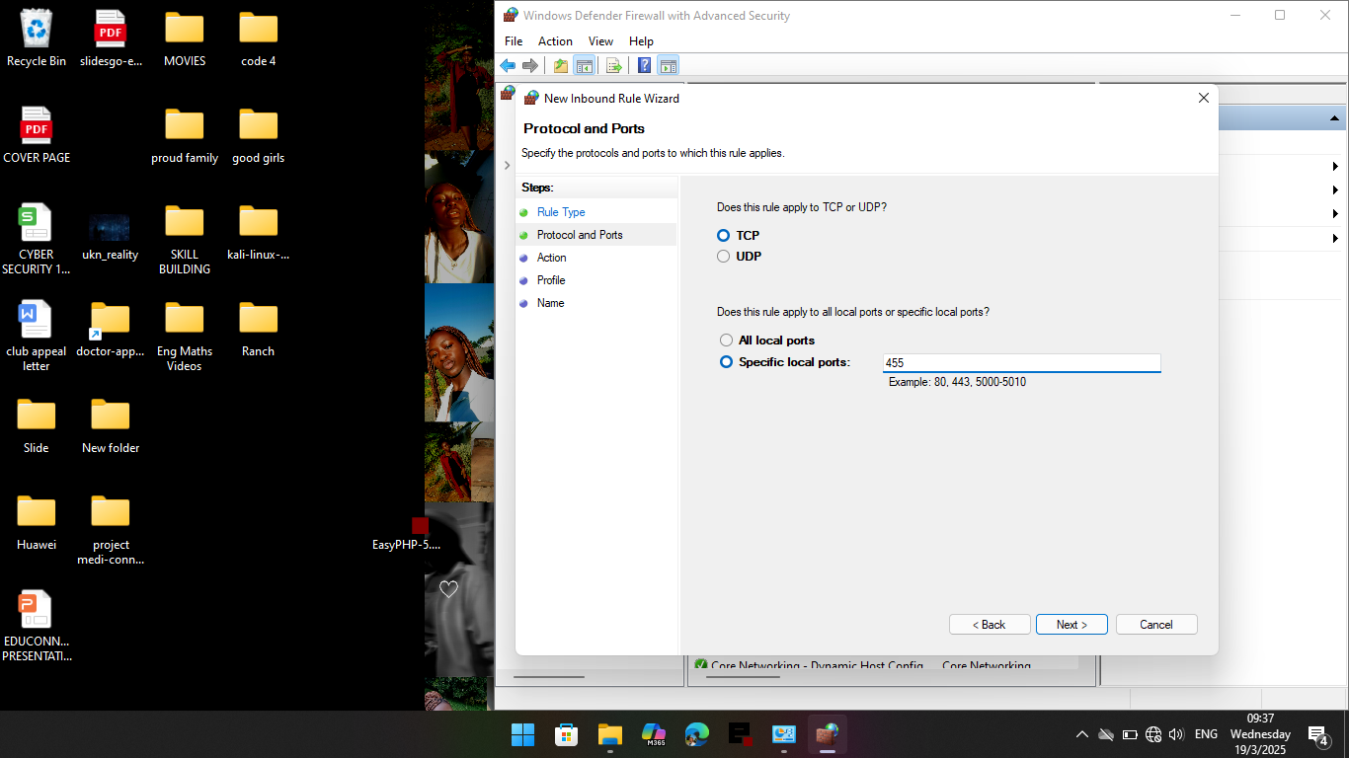
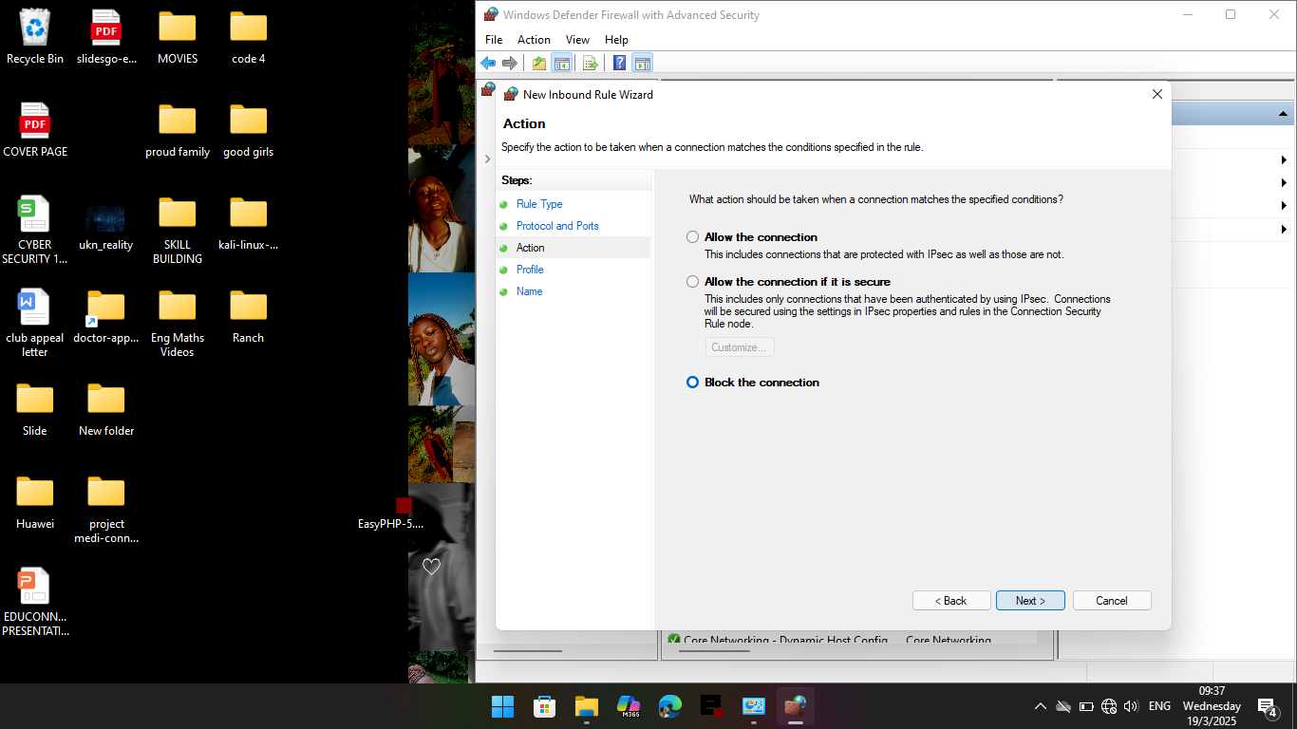

- Restriction access is cut across all profiles so as to ensure there are no loopholes existing where a device could be vulnerable due to mis-configuring or overlooking network type .

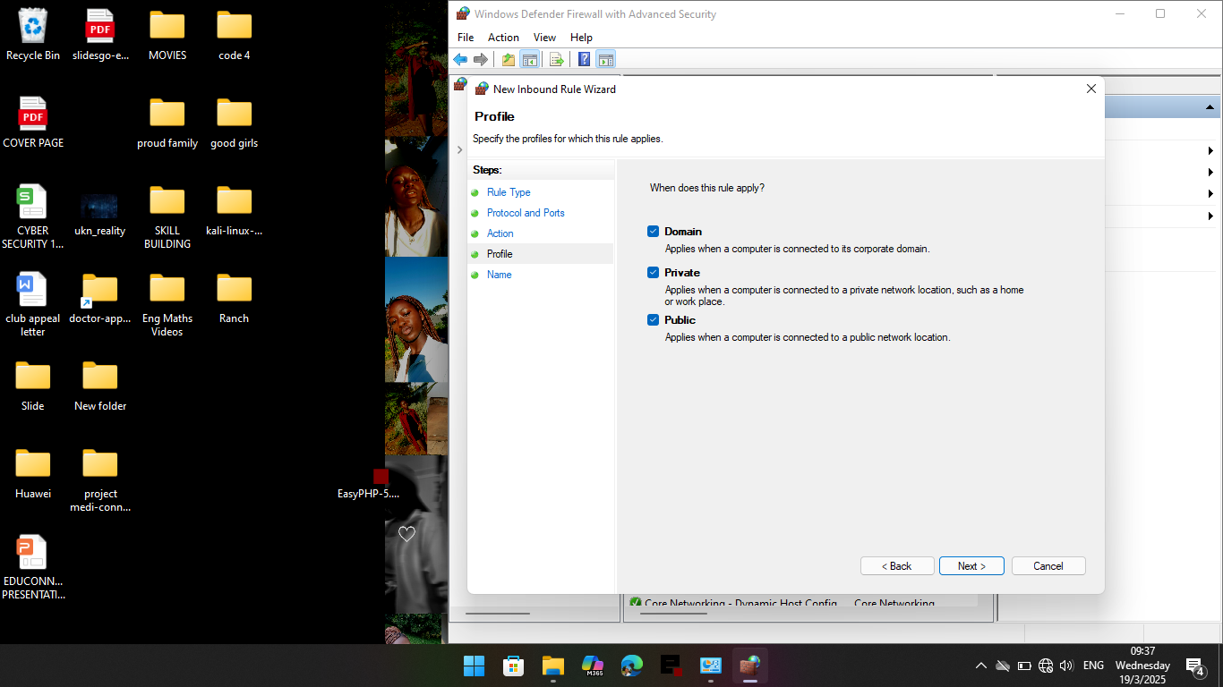

- As the restriction of profiles is the last step this then signifies the finalization of the nature of the rule then naming the rule is done.
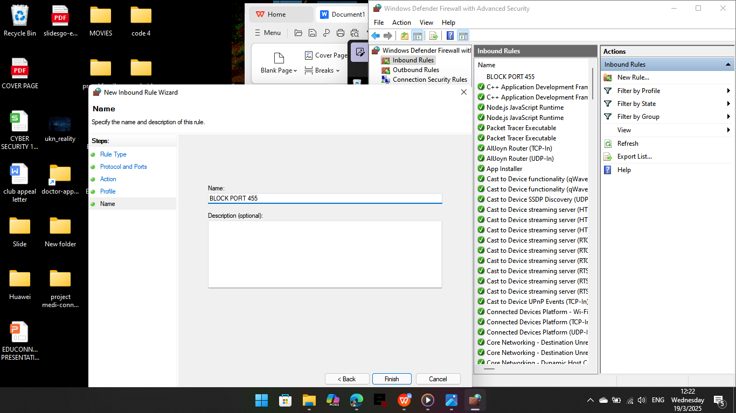

- Thus,You find the rule stated in the Actions Column

