**The columns selected for prediction,**

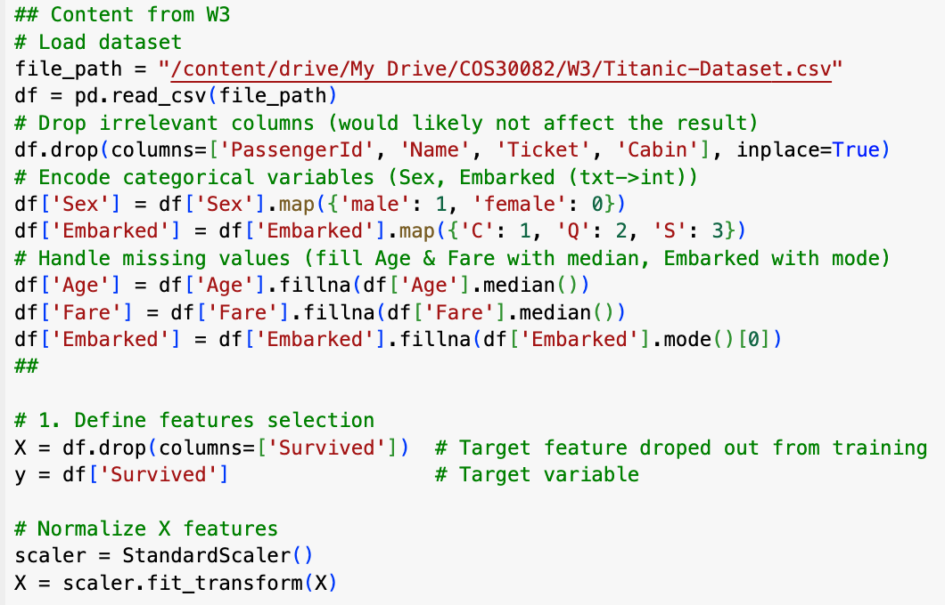

**The training and testing split,**



**The SVM model building, and**

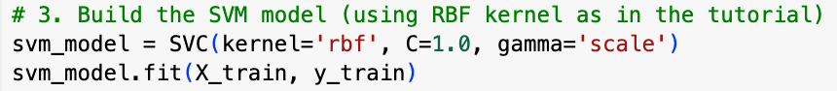

**The accuracy.**

