**Code snapshot that:**  
1. Upload image

2. Load/Read image

3. Load YOLOv8l from Ultralytics

4. Run model with the image

5. Annotating result

6. Visualisation

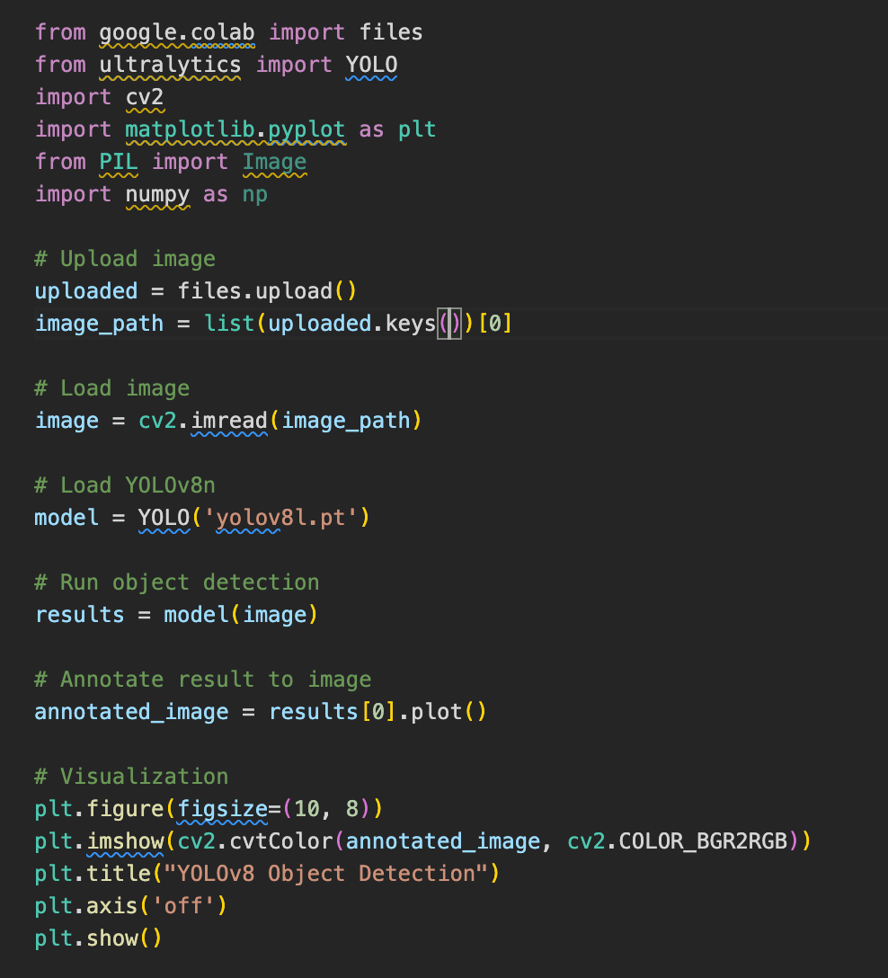

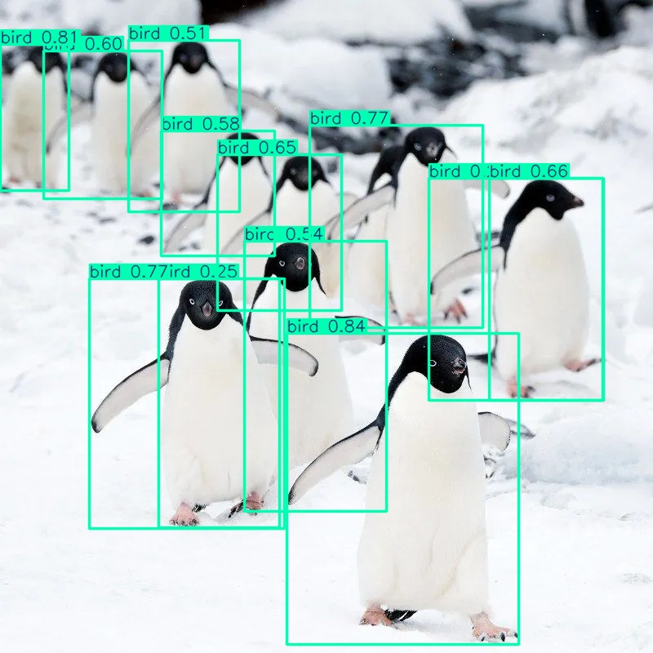**Result:**