AXION
STAKEHOLDER CRM
AI-Assisted Consulting & Delivery Intelligence
From fragmented conversations to approved, implementation-ready project truth
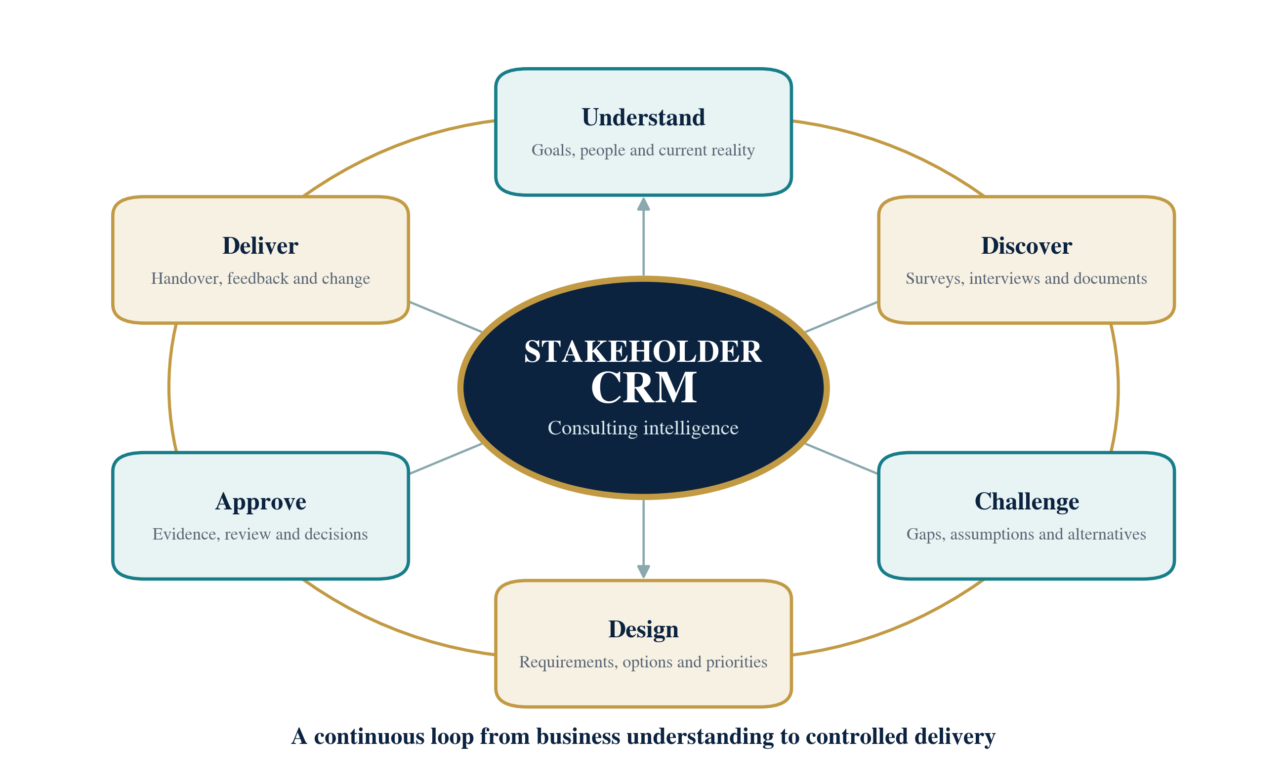
Consulting intelligence and value loop

Contents
1 Executive overview — the proposition and intended outcome
2 The opportunity — why current discovery and handover practices fall short
3 Vision and design principles — how the solution creates confidence
4 How an engagement works — the end-to-end operating journey
5 Solution concept — the major capability areas
6 Stakeholders and participation — roles, authority and contribution
7 Consulting intelligence — how AI supports analysis without taking control
8 Project truth and traceability — a shared record of facts, decisions and change
9 Quality gates and approvals — readiness, review and accountable decisions
10 Outputs and handover — the deliverables created from approved knowledge
11 Experience and collaboration — how teams use the workspace
12 Information protection and responsible use — trust, privacy and governance
13 Connected working — links with existing business tools
14 Management insight and value — measures, visibility and commercial outcomes
15 Scope and boundaries — what a usable first release must deliver
16 Progressive rollout — how capability is introduced and validated
17 Risk and adoption — what must be managed for success
18 Acceptance and next decisions — the evidence required to proceed

1. Executive Overview
Stakeholder CRM is an AI-assisted consulting and delivery system that helps Axion and its clients discover the right problem, understand the operating reality, agree a feasible response and maintain a reliable project baseline through delivery. It brings the discipline of a senior business analyst and software project manager into a repeatable workflow while preserving accountable human judgement.
The solution addresses a recurring weakness in bespoke software projects: important knowledge is dispersed across conversations, documents, spreadsheets, meetings and individual experience. Stakeholders often describe symptoms rather than root causes, different groups use the same words differently, and constraints emerge only after scope has already been committed. The result is avoidable rework, uncertain estimates, delayed decisions and specifications that lose connection with the original evidence.
Stakeholder CRM continuously turns stakeholder contributions into a structured, versioned project record. It distinguishes confirmed facts from assumptions, identifies contradictions and missing perspectives, links requirements to evidence and decisions, and produces consistent delivery outputs from the approved record. When new information appears, the system shows the likely impact and guides an authorised re-baselining decision rather than silently rewriting history.
Core proposition: better discovery, clearer decisions, more predictable scope and a traceable handover—supported by AI, governed by people.

Expected outcomes
- Reduce late discovery of missing stakeholders, exceptions, dependencies, constraints and operational requirements.
- Improve commercial predictability by separating confirmed scope from assumptions, options, exclusions and future opportunities.
- Raise the consistency of consulting work across engagements without losing client, industry or stakeholder context.
- Shorten the time needed to create high-quality analysis and delivery outputs while retaining structured review.
- Maintain continuity across multiple sessions, personnel changes and implementation feedback.
- Give managers clearer visibility of coverage, confidence, risk, scope stability, decision delays, progress and cost.

2. The Opportunity
Bespoke software initiatives rarely fail because teams cannot build features. More often, the decision context is incomplete, inconsistent or discovered too late. A technically sound solution can still be commercially weak if it addresses the wrong problem, ignores a key operating exception, relies on unavailable data or asks people to adopt a process that does not fit their work.

Common failure patterns
Solution-first framing. The conversation starts with “we need a CRM, ERP or AI assistant” before the business outcome and process problem are established.
Partial stakeholder coverage. A sponsor or subject-matter expert is treated as the complete organisational view, leaving end users, data owners, security, finance or operations under-represented.
Hidden rules and exceptions. The normal process is documented, but approval limits, unusual cases, peak periods, manual workarounds and policy exceptions remain in people’s heads.
Ambiguous language. Terms such as customer, order, approval, real-time or completion carry different meanings across teams.
Evidence scattered across channels. Key decisions and constraints are buried in meeting notes, email, spreadsheets, tickets and draft documents.
Commercial drift. Features accumulate without a clear link to value, estimated impact or an authorised change decision.
Document decay. Requirements, plans and design documents diverge after decisions change, leaving delivery teams unsure which version is current.

What changes with Stakeholder CRM
The platform creates a guided path from unclear needs to an approved delivery baseline. It asks outcome-focused and exception-focused questions, deliberately seeks missing perspectives, converts source material into reviewable knowledge, highlights conflicts and maintains a visible connection from business objective to requirement, decision, delivery work and acceptance evidence.

3. Vision and Design Principles
Stakeholder CRM is intended to become Axion’s reusable consulting intelligence layer for ERP, CRM, workflow automation, data platforms, AI systems, portals and other tailored software engagements. It should strengthen experienced consultants, provide structure to developing practitioners and improve the quality of information reaching delivery teams.

Design principles
Project truth before prose. The approved project record is the authority; documents are generated from it, not treated as disconnected copies.
Evidence before confidence. Material claims show where they came from, who reviewed them and whether they are confirmed, assumed, disputed or still unknown.
Multi-session by design. An engagement can continue over days or months without losing decisions, context, pending questions or stakeholder history.
Human authority. AI proposes, analyses and challenges; authorised people approve scope, trade-offs and commitments.
Challenge, not passive agreement. The system tests assumptions, asks for exceptions and presents alternatives with consequences.
Minimum necessary information. Only information needed for the engagement is collected, with appropriate access, retention and deletion controls.
Visible uncertainty. Unknowns and conflicts remain visible until resolved, accepted as risk or formally deferred.
Operational readiness. Every major workflow includes ownership, monitoring, recovery and measurable acceptance expectations.
The platform is valuable because it can say “not enough evidence yet” and explain what is missing—not because it always produces an answer.

4. How an Engagement Works
An engagement moves through controlled stages rather than a sequence of unrestricted chats. Each stage has a clear purpose, expected outputs, accountable roles and a readiness decision. New evidence can return the project to an earlier stage, but previous approvals and versions remain visible.
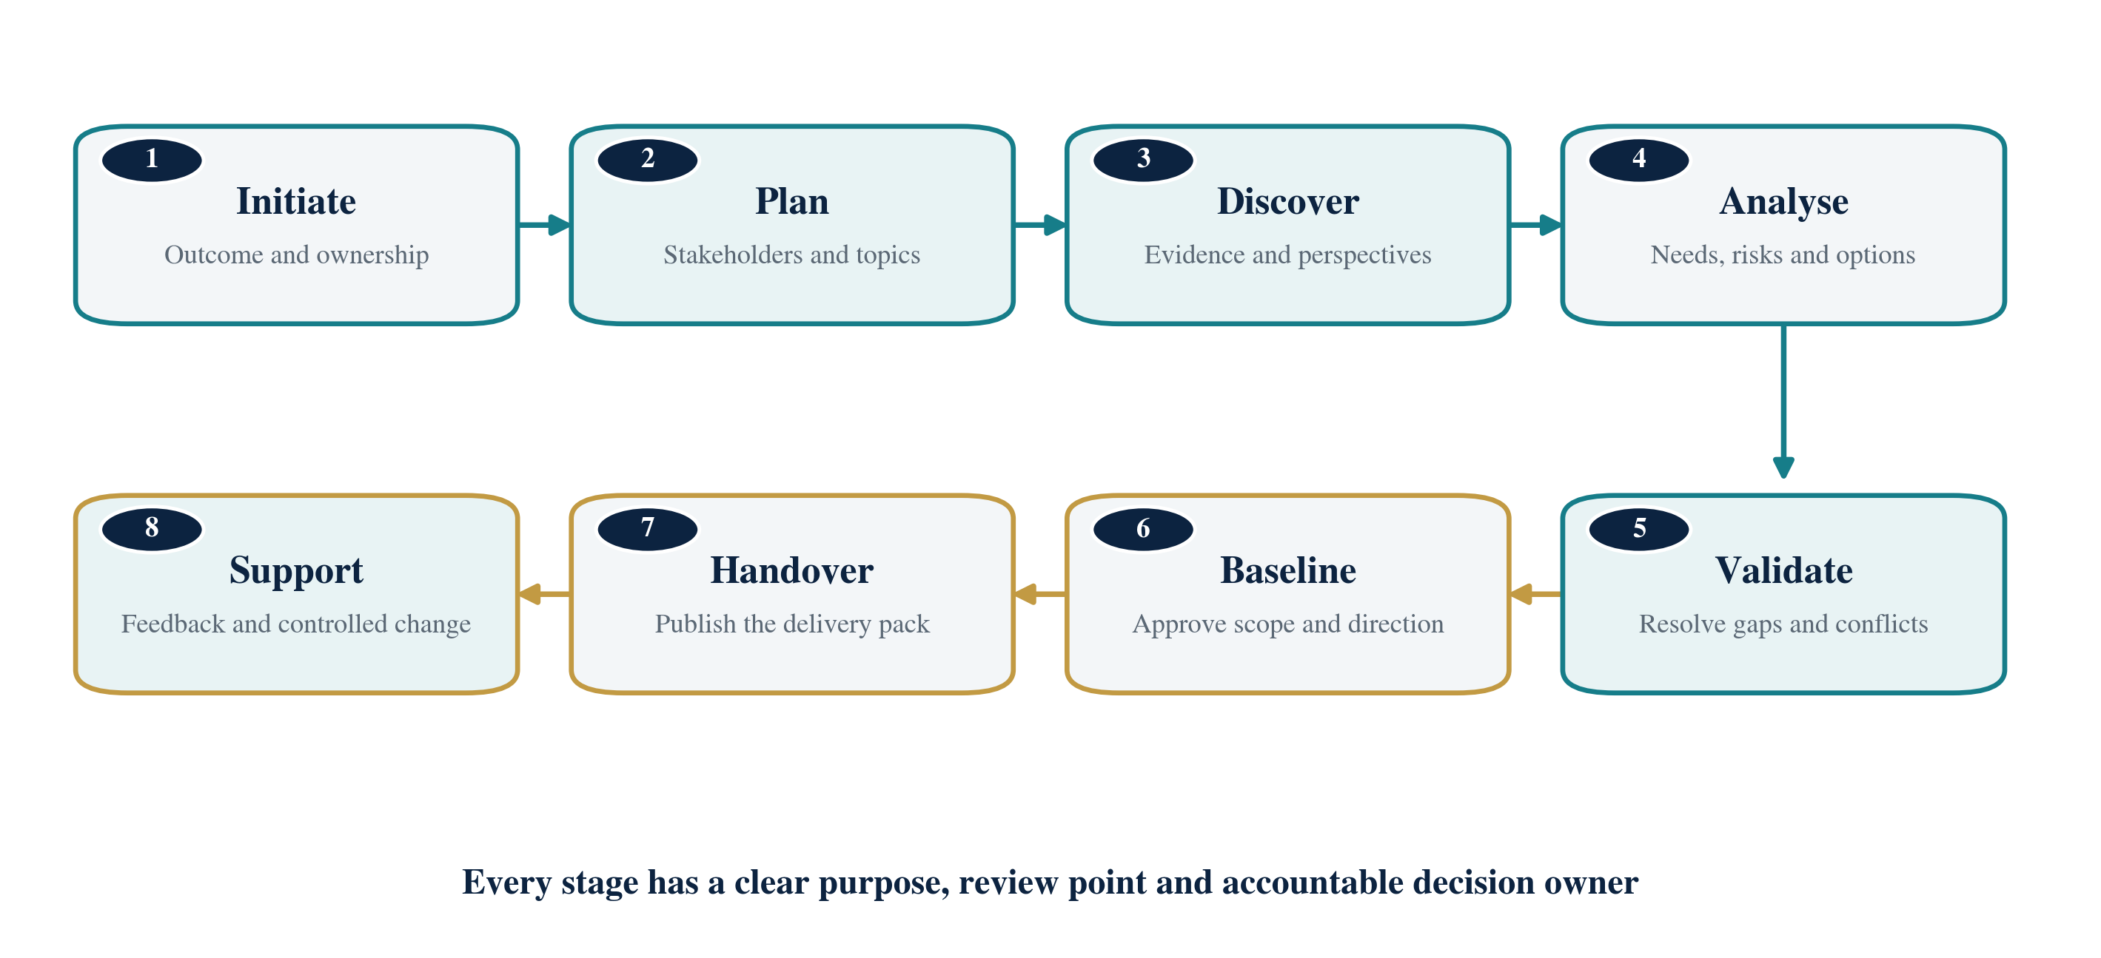
End-to-end engagement journey
Initiate. Record the intended outcome, sponsor, initial scope boundary, commercial context and information sensitivity.
Plan. Map stakeholder roles, decision rights, knowledge areas, required documents, discovery topics and participation gaps.
Discover. Run guided surveys, interviews and workshops; review documents; capture facts, pain points, processes, rules and exceptions.
Analyse. Model goals, current and future processes, options, value, risks, requirements, dependencies and delivery implications.
Validate. Return material findings to stakeholders and specialists; resolve contradictions, test feasibility and close critical gaps.
Baseline. Approve the agreed scope, requirements, decisions, assumptions, risks and delivery direction as a protected version.
Handover. Publish the agreed analysis, requirements, process, risk, roadmap and traceability pack for delivery.
Support. Receive delivery questions and feasibility feedback, assess changes and keep approved artefacts aligned.

Supported engagement modes
- Consultant-led workshops where AI supports preparation, capture, gap analysis and synthesis.
- AI-guided stakeholder surveys or text/voice sessions with clear consent, boundaries and human review.
- Document-first discovery where existing specifications, policies, tenders or tickets seed questions and hypotheses.
- Rapid assessments that are explicitly time-boxed and confidence-labelled rather than presented as complete discovery.
- Continuous product discovery using rolling baselines, recurring stakeholder input and release-level decisions.

5. Solution Concept
The product is organised as a connected consulting workspace rather than a single conversation screen. Participation channels, consulting workflows, intelligence, the approved project record and governance controls work together to create a coherent experience.
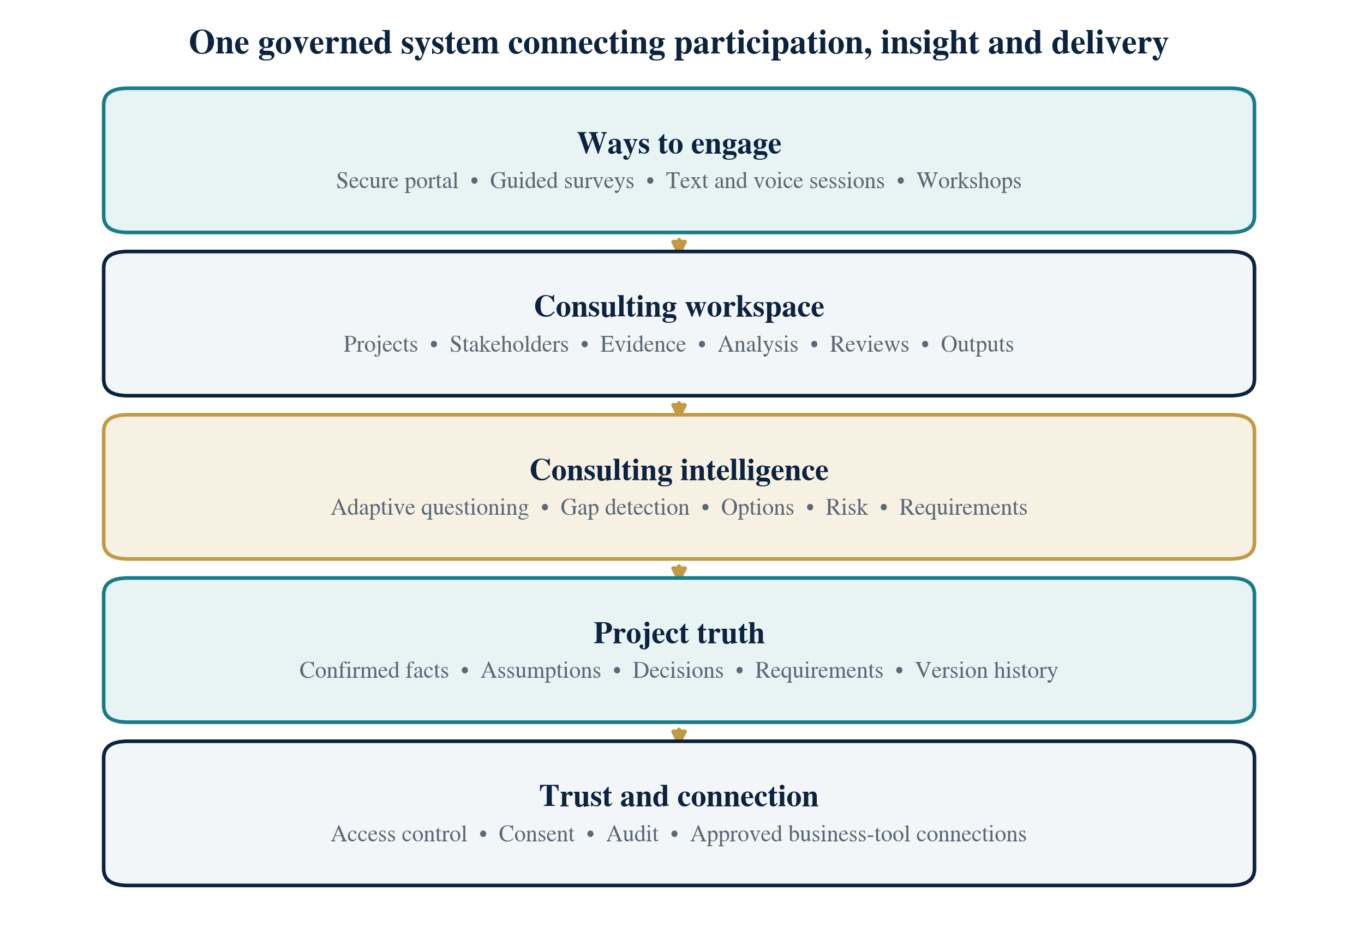
High-level solution model
Workspace and governance. Create secure client and project workspaces, manage membership, define policies and control the engagement lifecycle.
Stakeholder intelligence. Map roles, authority, impact, knowledge, concerns, availability and participation gaps.
Discovery planning. Define the topics, expected evidence, documents, participants and sessions needed to support each decision.
Conversation and survey. Support structured forms, guided text and voice sessions, workshops, facilitator controls and resumable participation.
Evidence and knowledge. Bring together source material, reviewed facts, requirements, assumptions, decisions, conflicts and their origins.
Analysis workbench. Examine processes, capabilities, data, value, root causes, options, feasibility, priority and risk.
Quality and validation. Measure coverage, detect contradictions, assess requirement quality, route reviews and manage approval gates.
Output studio. Create, compare, approve, publish and export consistent project documents and diagrams.
Delivery collaboration. Link implementation questions, work items, decisions, change requests and readiness evidence back to the baseline.
Administration and insight. Manage reusable methods, approved AI policies, usage, support, evaluation and audit history.

6. Stakeholders and Participation
The stakeholder map is more than a contact list. It records who owns the outcome, who understands each process or data domain, who is affected, who can approve decisions and which important groups are not yet represented. This allows the system to direct questions to people who can answer them reliably and to flag when a claim has no accountable owner.

Core participation roles
Executive sponsor. sets the strategic outcome, investment boundary and major trade-offs.
Axion engagement lead. plans and facilitates discovery, reviews analysis, manages stakeholder communication and recommends readiness.
Client product owner or subject expert. explains processes, rules, data and exceptions and validates proposed behaviour.
End user. contributes real operating experience, pain points, workarounds and usability needs.
Delivery lead. owns planning, dependencies, risks, changes and readiness for implementation.
Solution and specialist reviewers. test feasibility, security, privacy, compliance, data and integration implications.
Developer and quality team. consume approved specifications, ask questions and return implementation or testing feedback.

Participation choices
A participant may use an authenticated workspace, a time-limited secure survey link, a consultant-mediated interview or an approved meeting or document import. The system keeps the participant’s business role, identity confidence, source and consent status visible so that contributions are interpreted appropriately.
Decision authority is explicit: the person who knows the process is not automatically the person who can approve budget, scope, security or operational change.

7. Consulting Intelligence
The AI capability is best understood as a coordinated consulting support team. Different specialist functions plan discovery, select questions, extract structured knowledge, detect contradictions, assess business options, improve requirements, identify risks, support delivery planning and compose project outputs. Their work is coordinated by the application and returned as proposals for validation.
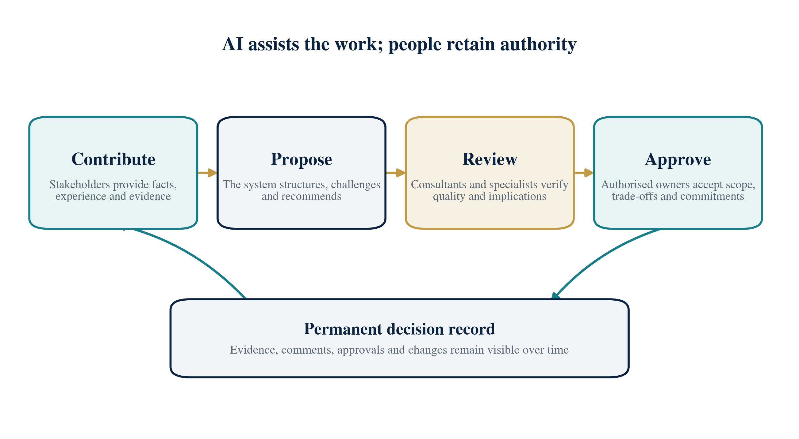
Human authority and AI-assisted decision flow

What the intelligence does
- Plans the next most valuable questions based on risk, missing evidence, decision importance and the participant’s knowledge.
- Turns conversations and documents into reviewable facts, requirements, assumptions, risks, decisions and open questions.
- Detects conflicting claims, unexplained terminology, missing owners and gaps between desired outcomes and requested features.
- Examines root causes, process alternatives, feasibility, dependencies, trade-offs and likely delivery implications.
- Improves the clarity, testability and traceability of requirements and acceptance expectations.
- Produces concise rationales, supporting sources, uncertainty and recommended follow-up—not hidden or unsupported authority.

What the intelligence does not do
- It does not approve contracts, scope, budgets, security exceptions or delivery commitments.
- It does not silently turn a generated suggestion into confirmed project truth.
- It does not treat one stakeholder’s statement as an organisation-wide fact without review or scope.
- It does not conceal uncertainty when evidence is missing, contradictory or outdated.

8. Project Truth and Traceability
The centre of the solution is a governed project truth: a current, versioned record of what the organisation is trying to achieve, how work operates today, what must change, what has been decided and what remains uncertain. It brings together goals, stakeholders, processes, capabilities, pain points, requirements, constraints, assumptions, risks, dependencies, data, integrations, decisions and open questions.

How information is classified
Confirmed. Supported by reliable evidence and accepted by an authorised reviewer.
Inferred. A reasoned conclusion supported by evidence but not yet directly confirmed.
Assumed. A planning premise that must be validated or managed as exposure.
Disputed. Materially conflicting views or sources that require resolution or scoping.
Unknown. A missing answer whose impact and owner are visible.
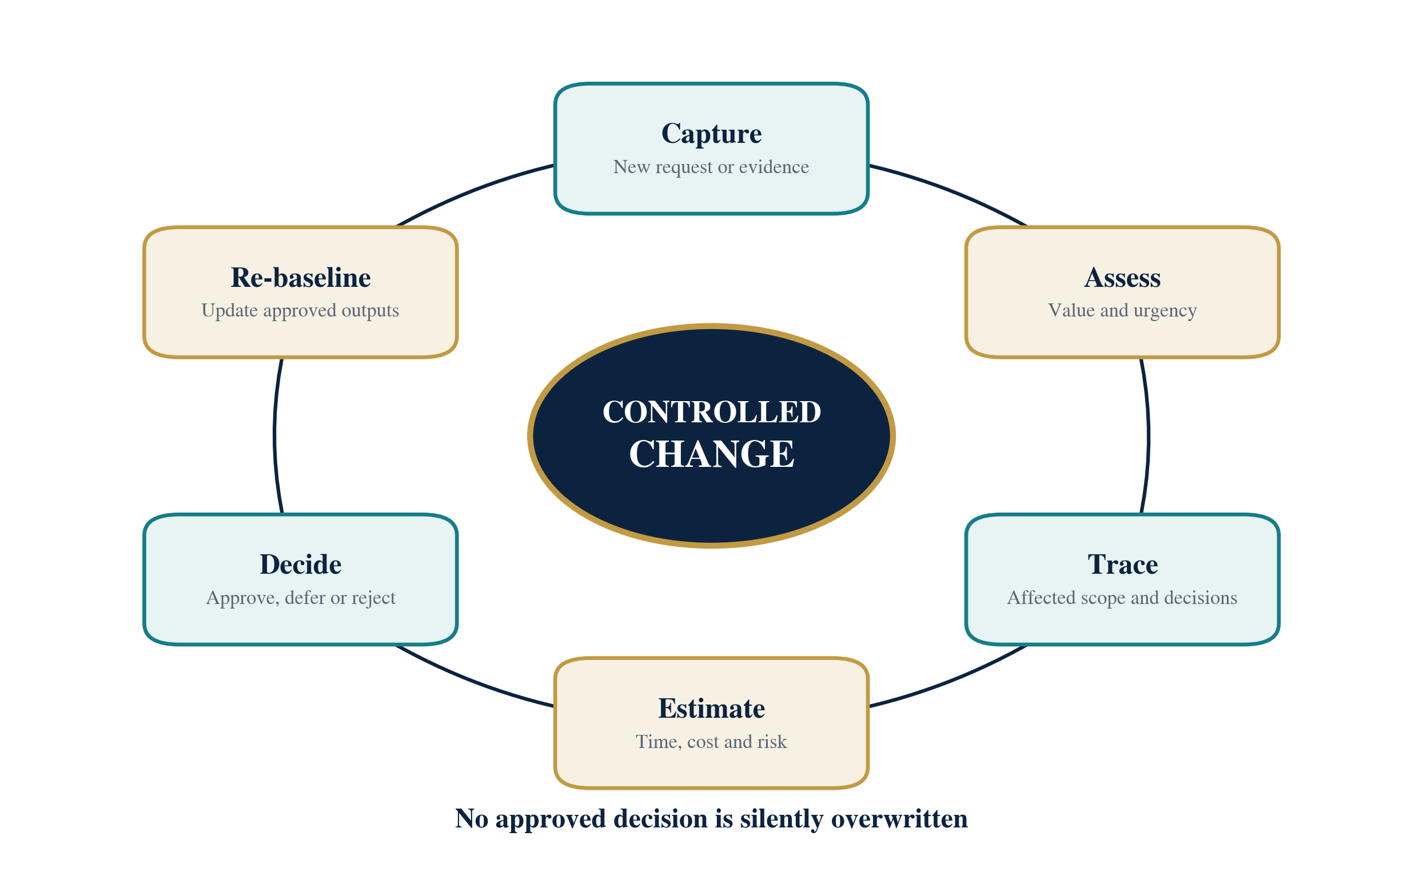
Controlled change and re-baselining loop

Why traceability matters
A manager can move from a proposed requirement back to the business objective, stakeholder contribution, supporting document and decision that justify it. Delivery teams can move forward from the same requirement to work items, tests, release evidence and later changes. This creates a defensible chain of reasoning and makes the effect of new information easier to assess.
The latest document is not the truth. The approved project record is the truth, and documents are controlled views of that record.

Continuity across sessions
Each new session begins with the relevant project version, participant role, prior contributions, unresolved questions and recent decisions. A short recap can be corrected before the conversation continues. Sessions end with confirmed items, disputes, assumptions, actions, owners and next topics—not only a transcript.

Controlled change
When new evidence or a delivery request affects an approved baseline, the system traces the likely consequences before a decision is made. Value, scope, time, cost, risk, acceptance and dependent outputs are considered together, and the authorised outcome is recorded without erasing the previous position.

9. Quality Gates and Approvals
The platform prevents progress from being confused with readiness. A stage is complete only when the information needed for the next decision is sufficiently reliable, important conflicts are understood and authorised reviewers have accepted the remaining exposure.

Readiness questions
- Are the intended outcomes, scope boundaries and decision owners clear?
- Have the right stakeholder groups participated, or have missing perspectives been explicitly accepted?
- Are critical business rules, exceptions, data sources, dependencies and constraints supported by evidence?
- Are material contradictions resolved, scoped to different contexts or accepted as risk?
- Are requirements understandable, feasible, testable, prioritised and linked to objectives?
- Are open assumptions, waivers, residual risks and future decisions visible to the people accepting the baseline?

Key approval points
Engagement authorised. Outcome, sponsor, commercial boundary and information sensitivity are recorded.
Discovery ready. Stakeholders, consent, topics, documents and participation plan are reviewed.
Discovery sufficient. Critical coverage is achieved and remaining unknowns are classified.
Solution feasible. Options, dependencies, delivery assumptions and specialist constraints have been tested.
Requirements baselined. Requirements and acceptance expectations are clear, traceable and approved.
Handover accepted. The delivery pack is complete, open items are visible and the receiving team acknowledges it.
Change accepted. The impact on value, scope, time, cost, risk, quality and documents is understood and approved.
A gate can pass, fail, remain blocked or pass with a formally accepted waiver. Waivers identify the owner, reason, expiry and residual risk.

10. Outputs and Handover
The system generates consistent outputs from the reviewed project record. This reduces contradictions between documents and allows an approved change to flow through every affected view. Users can compare versions, see supporting evidence and identify unresolved items before publication.

Core output set
Project charter. problem, outcomes, boundaries, stakeholders, constraints, assumptions, risks and approvals.
Discovery plan. topics, expected evidence, participant and document plan, dependencies and readiness criteria.
Business analysis. current and future operating view, root causes, gaps, options, value, recommendations and risk.
Requirements and acceptance pack. capabilities, user needs, business rules, exceptions, quality expectations and acceptance criteria.
Process and role pack. current and future processes, handoffs, responsibilities, controls, pain points and improvement opportunities.
Solution brief. recommended option, alternatives, integrations, information needs, constraints, trade-offs and decisions.
Risk and decision pack. risks, assumptions, issues, dependencies, actions, decisions, owners and due dates.
Delivery roadmap. releases, deliverables, dependencies, milestones, estimates, readiness and decision points.
Traceability view. connection from objectives and evidence through requirements, decisions, delivery work and acceptance.
Change impact assessment. the requested change, rationale, options and effects on value, scope, time, cost, risk and outputs.
Handover and readiness pack. approved baseline, open items, delivery assumptions, acceptance approach, support and release evidence.

Publication discipline
Draft content remains clearly identified. Client-facing publication requires the relevant review and approval state. Restricted sources or internal facilitator notes are excluded unless the publication policy permits them. Every published version has a permanent record of its content, evidence base, reviewers and approval decision.

11. Experience and Collaboration
The experience is centred on a project workspace that makes the current state, coverage, decisions, risks and next actions easy to understand. It supports both focused stakeholder participation and deeper consultant analysis without exposing unnecessary complexity.

Principal workspace areas
- Portfolio and project overview with lifecycle stage, coverage, blockers, major risks, decisions and upcoming activity.
- Stakeholder and participation view showing roles, authority, knowledge areas, status and coverage gaps.
- Sessions and surveys for preparation, contribution, facilitation, recap, action capture and follow-up.
- Evidence and project truth views for source review, confirmation, conflict resolution and history.
- Analysis and requirements views for processes, options, priorities, risks, acceptance and specialist review.
- Approval and output views for readiness, waivers, version comparison, publication and handover.
- Delivery collaboration for clarification, implementation feedback, change and release readiness.

Usability principles
Explainability. Every AI-generated proposal shows why it was produced, the supporting sources and what review is required.
Durable progress. Long-running activities show their stage, outcome and recovery path rather than an indefinite loading indicator.
Visible impact. Edits to approved or linked items show downstream effects before they are accepted.
Inclusive access. Keyboard use, readable contrast, accessible labels, transcript alternatives and clear status wording are built into the experience.
Appropriate simplicity. Stakeholders see the questions and context they need; consultants see the deeper evidence and governance controls.

12. Information Protection and Responsible Use
The platform will hold commercially sensitive processes, organisational decisions, contracts, personal information, system details and potentially regulated material. Trust is therefore designed into identity, access, participation, storage, AI use, publication and support—not added after the workflow is built.

Protection principles
- Each client and project operates in an isolated workspace with access based on role, project membership, information sensitivity and current responsibility.
- Participants receive clear notice of AI involvement, recording or transcription, use of their contribution, access, correction and withdrawal choices.
- Only the minimum information needed for the engagement is collected, and retention or deletion follows the agreed policy.
- Sensitive actions—such as approval, publication, export, policy change or emergency support access—are recorded and subject to stronger controls.
- AI cannot bypass a person’s authority, disclose another project’s information or perform high-impact actions simply because a prompt requests it.
- Changes to AI behaviour are tested, reviewed, introduced gradually, monitored and reversible.

Responsible AI commitments
Grounded recommendations. Material findings link to reviewed sources, decisions or clearly labelled assumptions.
Visible uncertainty. The system distinguishes confidence from approval and supports insufficient or blocked outcomes.
Human accountability. People retain responsibility for commitments and high-impact decisions.
Safe boundaries. Untrusted content cannot silently change system rules, obtain new authority or publish information.
Ongoing measurement. Accuracy, unsupported claims, review corrections, coverage, privacy, cost and user outcomes are monitored over time.

13. Connected Working
Stakeholder CRM should complement the tools already used for meetings, document management, work tracking and client administration. Connections are introduced deliberately, with clear ownership of which system is authoritative and whether information can be read, proposed or written back.

Priority connection areas
- Meeting and calendar tools for approved invitations, meeting records and participation context.
- Document repositories for selected project files while respecting existing access restrictions.
- Delivery tracking tools so approved requirements can be linked to work items, status, comments and test evidence.
- Client administration systems for basic organisation, project and stakeholder metadata where permitted.
- Email or notification channels for approved invitations, reminders, reviews and decision requests.

Connection rules
Connections are read-only by default. Any write-back is limited to approved objects and fields. Where two systems disagree, the conflict is surfaced according to a documented source-of-truth rule rather than resolved through silent last-write-wins behaviour. Failures, duplicate events and prolonged outages are recoverable and visible to operations.
External tools can contribute information and receive approved outputs, but they do not bypass the project’s review, authority or change rules.

14. Management Insight and Value
Management visibility is a first-class outcome. Dashboards should connect engagement progress with evidence quality, stakeholder participation, decision latency, scope stability, risk and operating cost. The purpose is to support intervention and learning, not to reward superficial activity volume.

What managers can see
- Coverage of critical discovery topics and missing stakeholder roles.
- Confirmed, assumed, disputed and unknown items by importance and owner.
- Open decisions, review queues, overdue actions and the stages they are blocking.
- Requirement quality, traceability, scope movement and change impact.
- Risk exposure, dependency health, readiness status and delivery feedback.
- Usage, response quality, review correction, cost and recurring failure patterns.

Initial value and quality ambitions
Critical topic coverage.
Aim for at least 95 per cent weighted coverage before baseline, with complete coverage of mandatory legal, security, data ownership and acceptance topics. Any exception requires an explicit decision or waiver.
Unsupported claims.
Keep unsupported material below one per cent in reviewed outputs and at zero for contractual commitments.
Requirement quality.
Aim for at least 95 per cent of baseline requirements to pass clarity, testability, feasibility, consistency and traceability checks.
Rework avoidance.
After a reliable operating baseline is established, target a 30 per cent reduction in late changes attributable to omitted discovery topics.
These are initial guardrails from the source design and should be confirmed against Axion’s historical project data, client mix and pilot evidence before they become contractual service levels.

15. Scope and Boundaries
A usable first release is not defined by the presence of a chat screen. It is complete when a real engagement can be created, planned, conducted over multiple sessions, analysed into reviewed project knowledge, tested for gaps, approved through readiness gates, published into a delivery pack and updated through controlled change.

Minimum usable scope
- Secure client and project workspaces with controlled membership, settings, information policy and action history.
- Stakeholder mapping that records authority, responsibility, knowledge, impact, participation and coverage gaps.
- Adaptive surveys and multi-session text experiences, with voice introduced where consent and quality controls are ready.
- Document and conversation review that produces source-linked, structured project knowledge.
- Business analysis, requirements, risk, decision and delivery planning support.
- Transparent readiness checks and mandatory human approval before a baseline is published.
- Versioned project outputs, comparison, export and an acknowledged delivery handover.
- Developer clarification and feedback that can trigger controlled impact assessment and re-baselining.
- Operational monitoring, responsible AI controls, cost visibility, support ownership and recovery procedures.

Deliberate exclusions from the first release
- Autonomous contractual, legal, financial, security or delivery commitments.
- Automatic deployment into client environments or replacement of specialist build tools.
- A universal claim of industry expertise without curated methods and expert review.
- Unrestricted external research or unreviewed use of unknown sources.
- Employee surveillance, covert behavioural assessment or personnel decisions based on inferred sentiment.
- A full sales CRM for opportunities, quotations and invoicing.
- A promise that discovery will eliminate all change; the product makes uncertainty manageable rather than pretending it can remove learning.

16. Progressive Rollout
Capability should be introduced in evidence-based releases. Each stage must prove a complete business outcome with realistic engagement scenarios, appropriate role separation, user review and operating readiness. This avoids a large feature inventory that has never demonstrated consulting quality.
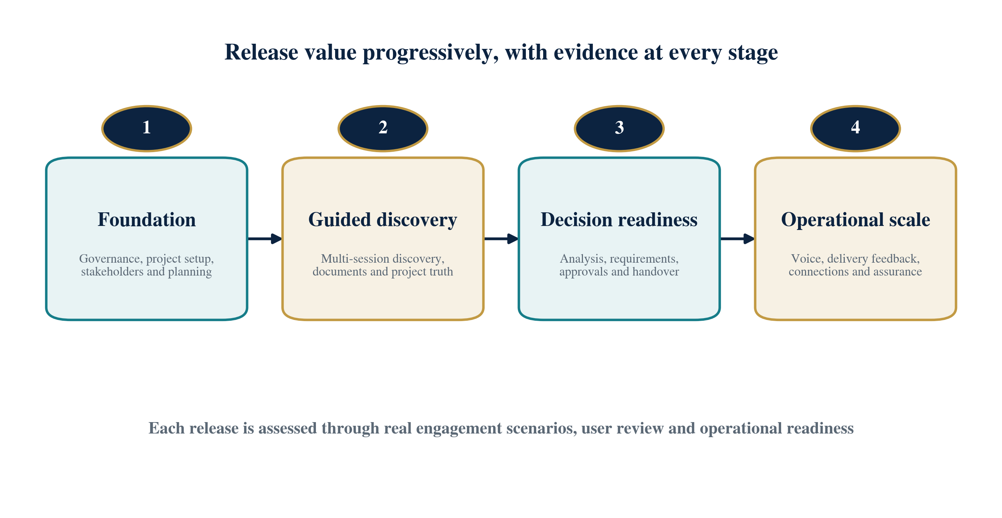
Progressive capability rollout

Stage 1 — Foundation
Establish governance, project setup, stakeholder mapping, engagement lifecycle, discovery methods, reusable topic packs, identity, privacy rules, audit and the first management view. Exit evidence is an approved discovery plan for a realistic client scenario.

Stage 2 — Guided discovery
Introduce resumable surveys and text sessions, document review, source-linked knowledge, conflict handling, session recap and human review. Exit evidence is a multi-session engagement that produces reviewed project truth rather than only a transcript.

Stage 3 — Decision readiness
Add business analysis, process and requirement support, risk and decision management, readiness gates, approvals, versioned outputs and delivery handover. Exit evidence is an approved baseline with traceable documents and visible open items.

Stage 4 — Operational scale
Add voice where appropriate, delivery-tool connections, controlled change, production assurance, resilience, accessibility, cost controls, support processes and staged client rollout. Exit evidence is a pilot-ready service with operational acceptance.

Rollout governance
Timelines and investment should be re-estimated after the foundation stage confirms Axion’s identity, hosting, compliance, design, data and connection constraints. Parallel work may be appropriate, but governance, project truth and evaluation foundations should precede broad feature expansion.

17. Risk and Adoption
The product’s main risks are not limited to software delivery. Success depends on consulting method ownership, participant trust, clear approval authority, disciplined use of evidence, useful outputs and adoption by both client-facing and delivery teams.

Key risks and responses
Automation bias. Users may accept a fluent recommendation too quickly. Show sources, uncertainty, counter-evidence and mandatory review for material decisions.
Poor stakeholder coverage. A neat output may still reflect only a narrow view. Measure representation, route questions by authority and make missing perspectives visible.
Weak source quality. Outdated or unreliable documents can bias analysis. Record source status, recency, ownership and reviewer confidence.
Method inconsistency. Different consultants may configure the system in incompatible ways. Govern reusable templates, topic packs, gates and approval rules.
Privacy or trust concerns. Participants may be reluctant to speak openly. Use clear notices, controlled recording, minimum collection and role-appropriate access.
Over-complex experience. Governance can become burdensome if every action needs the same level of control. Apply stronger review only where impact warrants it.
Output without adoption. Delivery teams may continue using disconnected documents or tickets. Co-design handover views and connect approved information to existing work practices.
Uncontrolled cost or quality drift. AI behaviour, usage and provider conditions can change. Set budgets, evaluation thresholds, staged releases, monitoring and rollback.

Adoption approach
- Co-design the discovery methods, output templates and approval gates with Axion’s senior consultants and delivery leaders.
- Pilot on representative but controlled engagements before using the platform for high-risk commitments.
- Train users on evidence status, review responsibility, insufficiency outcomes and change governance—not only on interface features.
- Measure participant effort, consultant correction, decision speed, handover quality and downstream rework, then improve the method iteratively.
- Maintain a clear support route for access, project configuration, data correction, workflow explanation and incident escalation.

18. Acceptance and Next Decisions
The first release should be accepted through complete, realistic consulting scenarios rather than isolated feature demonstrations. The evidence must show that the system creates better decisions and handover quality while protecting information and preserving human authority.

Acceptance evidence
- Multiple client projects can operate with verified information isolation and appropriate role separation.
- A discovery plan can map stakeholders, identify coverage gaps and publish the required sessions and document requests.
- A stakeholder can complete an asynchronous contribution and return for later sessions without loss of context or consent status.
- Documents and conversations produce exact source-linked knowledge that can be confirmed, corrected, disputed or superseded.
- The intelligence identifies material exceptions, contradictions, missing owners, vague requirements and unresolved delivery assumptions.
- The system correctly blocks progression when evidence is insufficient and explains how to remediate the gap.
- An approved analysis, requirements, risk, roadmap and traceability pack can be published and acknowledged by delivery.
- Delivery feedback can be linked to the baseline, assessed for impact and processed through an authorised change decision.
- Information protection, responsible AI, accessibility, recovery, monitoring and cost controls are demonstrated in a production-like environment.

Decisions required before detailed build
- Confirm the product owner, senior consulting-method owner and final authority for scope and readiness decisions.
- Select the first pilot engagement types and the client profiles appropriate for controlled validation.
- Approve the initial stakeholder, discovery, quality-gate and output templates that define the operating method.
- Confirm information classification, participant consent, retention, recording and external-access policies.
- Prioritise the first business-tool connections and define the authoritative source for each shared information type.
- Agree the pilot scorecard, baseline measures, investment guardrails and criteria for wider rollout.
Recommended next step: run a structured validation workshop using one representative Axion engagement, confirm the operating method and release boundaries, then convert the agreed scope into a costed delivery plan.

Closing perspective
Stakeholder CRM is designed to make uncertainty visible early, turn dispersed knowledge into an agreed project record and maintain that record through delivery. Its commercial value comes from stronger discovery, better-controlled decisions and more reliable handover—not from automating human accountability.

