EN20009-Engineering Technology Inquiry Project

**Project Brief**

**Hardware: The u-blox NEO-6M GPS Module** (with SDI-12)

Member 1

Dang Khoa Le  
ID: 103844421

Software Engineering Major

Project role: Software Engineer  
Project Brief’s Author

Member 2

Vudunaka Gunaseela  
ID: 103540431

Electrical and Electronics Major

Project role: Project Leader  
Team member

Member 3

Nethmi Jayarathne  
ID: 102888127

Robotic and Mechatronics Major

Project role: Testing and Quality Assurance Officer  
Team member

Member 4

Md Selehin Hossain  
ID: 103486946

Robotic and Mechatronics Major

Project role: Hardware Engineer  
Team member

Member 5

Niketha Dewmini Thota Hewage  
ID: 104057903

Software Engineering Major

Project role: Technical Officer  
Team member

# Project Plan

Commencing on April 11th, the Project Leader will start devising a project plan and assigning roles to team members. A schedule will be established to ensure that the project is executed within the allotted timeframe. Thereafter, the Hardware team will continue the execution of tests to ascertain that all hardware components perform optimally. The Software Engineer will proceed to compose and evaluate software that interfaces with sensors and the SD card.

By April 18th, the Testing and Quality Assurance Officer will initiate their duties by conducting a comprehensive evaluation of both hardware and software to ascertain conformity with project requirements. Concurrently, the Technical Officer will be responsible for the creation and upkeep of project documentation. The Hardware Engineer will then proceed to establish a connection between sensors and Arduino through I2C or UART.

By April 30th, the Software Engineer will develop software that facilitates the reading of sensor data and RTC, as well as saving this data to the SD card via an interrupt service routine. The engineer will also design software for the display of a menu on the LCD that enables sensor selection. By May 2nd, the Hardware Engineer will have established a connection between the LCD and Arduino.

The Software Engineer will then proceed to compose software that will present sensor data on the LCD, including graphical representations using event-driven programming with interrupts. This will be completed by May 9th. Finally, by May 16th, the Testing and Quality Assurance Officer will undertake a comprehensive evaluation of the entire system to ensure compliance with project requirements.

# **Abstract**:

The u-blox NEO-6M GPS module is a compact and low-power gadget, outlined to supply exact position and time data for different applications. The module is congruous with a wide range of microcontrollers and other gadgets, making it a flexible choice for numerous diverse ventures. Eventually, the NEO-6M GPS module is broadly connected due to its accuracy, moo control utilization, compact estimate, compatibility, and cost-effectiveness.

# Introduction

The u-blox NEO-6M is a GPS module created to deliver accurate position and time data for various applications. This module uses forefront satellite navigation technology to provide precise location information with less power usage. It works well for portable gadgets like tablets, smartphones, and wearables. The NEO-6M module with SDI-12 can receive signals from up to 22 GPS satellites at once, making it possible to give precise positioning data even in difficult terrain and conditions such urban canyons and places with a limited sky view. It also supports a variety of navigation protocols (A-GPS), making a wide range of GPS receivers and navigational applications compatible with it.

Above that, the sensor is easy to apply, install and integrating with other appliance, alongside with a simple serial interface and a variety of configuration options which allow users to modify its performance to your specific needs. It is compatible with a wide range of microcontrollers and other devices, making it a versatile choice for many different projects.

# Mainbody

## Key Features of the GPS Module

The u-blox NEO-6M GPS module has several impeccable features:

* Supports GPS, QZSS, and SBAS satellite systems (WAAS, EGNOS, MSAS).
* 50-channel GPS receiver with a maximum update rate of 5 Hz
* 1.5 m CEP accuracy
* UART, USB, and I2C interfaces
* Low power consumption (typically 50mA)
* Small form factor (16mm x 16mm)

## The u-blox NEO 6M Advantages

Simultaneously, the u-blox NEO-6M GPS module with SDI-12 is a widely used sensor due to its numerous benefits. There are some reasons that the u-blox's GPS sensor is preferred over other similar sensors:

* Precision: Pick up signals from up to 22 GPS satellites concurrently, providing accurate positioning information even in challenging environments.
* Low Power Usage: Enable operation on low power, appropriate for portable devices that have limited battery life.
* Compact Size: It is small and light in weight, making it easy to incorporate into various devices.
* Compatibility: Supports several navigation protocols, compatible with various GPS receivers and navigation software.
* Cost-Effective: Economical option for GPS applications, affordable for a wide range of users.

## Industrial Application

In addition to precise position data, the NEO-6M module with SDI-12 also provides precise time information, making it ideal for use in time-sensitive applications across a wide range of industries, such as:

Figure 1. GPS Chip

* Consumer Electronics: Portable devices such as smartphones, tablets, and wearables.
* Automotive: Car navigation and telematics.
* Aerospace and Defense: Aerospace, aerospace, and defensive applications.
* Agriculture: Precision agriculture such as tracking the farm equipment location and monitoring crop growth.
* Navy: Vessel navigation system for pleasure boats and merchant ships.
* Logistics and Supply Chain Management: Fleet management and logistics applications for tracking the location of vehicles and assets.
* Survey and Mapping: Surveying and mapping application that provides precise location data.

In brief, the module is a high-accuracy solution for a range of GPS applications, providing precise positioning and time information in a compact and low-power package.

## Economic integrations

There are several companies from different economical sectors using this sensor gadget as an exceptional and vital component to their devices manufacturing, including:

* DJI - A popular manufacturer of drones and other aerial imaging products.
* SparkFun Electronics - An online retailer of electronic components and development tools.
* Adafruit Industries - A popular online retailer of electronic components and development tools.
* Raspberry Pi - A popular single-board computer manufacturer that offers a GPS add-on module for their Raspberry Pi boards.
* Arduino - A popular open-source hardware and software platform that offers several GPS shield and breakout board options.

## Hardware Components

## NEO-6M GPS Chip

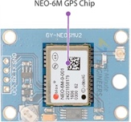 The heart of u-blox NEO-6M is a GPS chip, which is smaller than a postage stamp but being able to store a surprising amount of functionality into its tiny frame.

It can track up to 22 satellites on more than 50 channels and achieve the industry's highest tracking sensitivity of -161dB while consuming only 45mA of current.

The required data pins of the NEO-6M GPS chip are divided into 0.1-pitch” headers. It contains the pins needed to communicate with the microcontroller via UART. The module supports baud rates from 4800 bps to 230,400 bps with a default value of 9600 bps.

1. 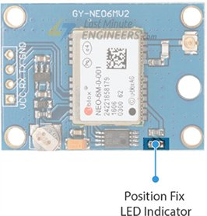*Position Fix LED Indicator*

Figure 2. Position Fix LED Indicator

The LED on the module indicates the status of the ‘Position Fix’. The LED blinks at different rates at whether the state of the u-blox NEO-6M module:

* **No blinking**: Searching for satellites.
* **Blink every 1s** – Position Fix is found.

Figure 5. Antenna and the U.FL connector

1. 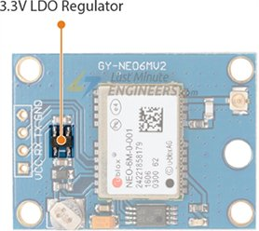*3.3V LDO Regulator*

Figure 3. 3.3V LDO Regulator

The NEO-6M module has a voltage range of 2.7 to 3.6V, but it comes with a MICREL's MIC5205 Ultra-Low Dropout 3V3 regulator, which helps regulate the voltage.

Additionally, the logic pins of the module are compatible with 5-volt, meaning it can be directly connected to a microcontroller with 5V logic like Arduino, without the need for a logic level converter.

1. *Battery & EEPROM*

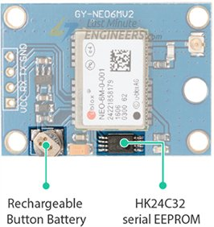 The NEO-6M module features an HK24C32 EEPROM that has a capacity of 4KB and is connected to the NEO-6M chip via I2C. The module also contains a rechargeable button battery that acts like a super-capacitor.

Figure 4. Battery and EEPROM

The EEPROM and battery work simultaneously to preserve the Battery Backed RAM (BBR) which holds clock data, latest position data, and module configuration. However, BBR is not meant for permanent data storage.

The battery automatically charges when power is supplied to the module and can retain data for up to two weeks without power. Because the battery retains clock and last position data, Time-To-First-Fix (TTFF) is reduced significantly to 1s, allowing for faster position locks. Without the battery, the GPS always undergoes a cold-start, which takes longer for the initial GPS lock.

1. *Antenna*

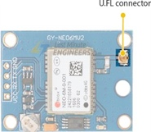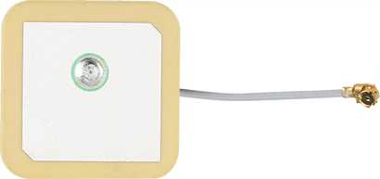 The NEO-6M module is equipped with a patch antenna that has a sensitivity of -161 dBm, which allows it to receive radio signals from GPS satellites.

This patch antenna can be easily connected to the module's small U.FL connector through snap-fitting. Although the patch antenna is suitable for most projects, attaching a 3V active GPS antenna can increase the module's sensitivity and accuracy if needed.

1. 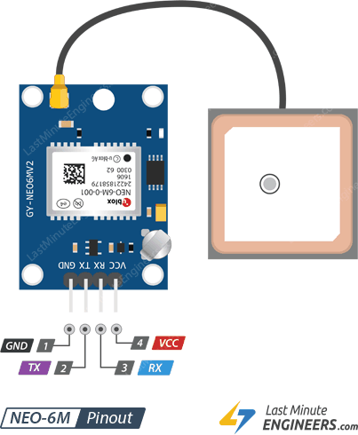*Pinout*

The pinout of the NEO-6M GPS module consists of 4 pins that enable it to interact with the external environment. The pins are identified as follows:

* GND connected to the GND pin on the Arduino board.
* TxD (Transmitter) pin is responsible for the module's serial communication output.
* RxD (Receiver) pin is responsible for the module's serial communication input.
* VCC pin provide power to the module and connected to the 3.3V pin on the Arduino board directly.

## Software Components

The u-blox NEO 6M GPS module can connect with Arduino board, in order to display time and locational output data, from the input variables recorded within the module.

Below is an example of a code that display time and location tracked on NEO 6M module onto the serial monitor of the Arduino board. On this code, the GPS module's TX pin to the Arduino's digital pin 4 and RX pin to the Arduino's digital pin 3, while the GND pin connects to Ground and VCC connect to the Voltage Supply (3.3V) correspondingly.

## Software Interface

The u-blox NEO 6M GPS module can interfacing with Arduino via numerous tools that are available on site:

* u-center: A software tool provided by u-blox to configure, test and evaluate u-blox GPS modules. It can be used to view GPS data output and setup the NEO 6M module.
* TinyGPS++ library: A compact GPS library that offers NMEA data parsing from GPS modules, including the NEO 6M.
* Adafruit_GPS library: A GPS library for Arduino that supports the NEO 6M module and offers NMEA data parsing.
* GPS Visualizer: A web-based utility which allows users to see GPS data in a variety of formats, including NMEA data produced by GPS modules like the NEO 6M.
* GPSBabel - A command-line tool that can read data from GPS modules like the u-blox NEO 6M and output data in formats that can be used by mapping software, such as Google Earth.
* OpenCPN - A free, open-source chart plotting software that can be used with GPS modules to display real-time vessel position, speed, and heading on digital charts. It supports a variety of GPS modules, including the u-blox NEO 6M.

These are several interfacing availabilities that is sourced widely on the internet, alongside with a myriad of different tools that are accessible with different modules and usages.

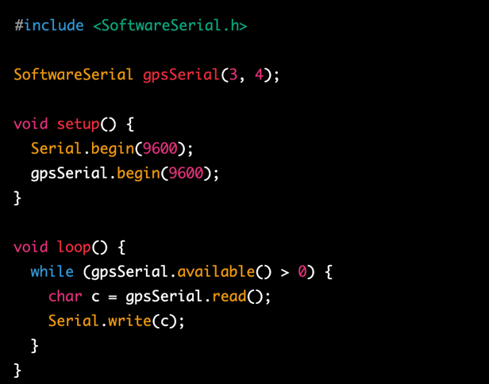

# Conclusion

Numerous advantages make the u-blox NEO-6M GPS module especially alongside with SDI-12 become a preferred and dependable option for several applications, particularly those that necessitate accurate positioning and time information in a low-energy and compact unit. The u-blox GPS sensor is an irreplaceable choice for technology business who are seeking for a reliable and efficient positioning and timing gadget in a small form factor, which highlights its ideal features that have opened up new possibilities for many businesses, from now and within the future.

Regarding this investigation, there are various things that is positively supporting me alongside with my Software Engineering major, in consist of:

* Embedding Systems: Understanding the basic identities of embedded systems, which combine hardware and software to perform a particular function.
* Communication Protocols: Studying the NMEA protocol, in order to visualise how data is transmitted between devices and recognise the essentials of standardized communication protocols.
* Real-Time Systems: Acknowledging real-time systems is important to understand the significance of timing and synchronization in software engineering.
* Data Processing: Studying algorithms and data processing techniques within the NEO 6M module is crucial to comprehend how software process large databases.

Nonetheless, the module is an executive gadget to study regardless different Engineering majors, in order to acquire the basic of Hardware and Software components.

# Task Progression

# References

1. u-blox AG, "NEO-6 u-blox 6 GPS Modules Data Sheet," GPS.G6-HW-09005, available: <https://content.u-blox.com/sites/default/files/products/documents/NEO-6_DataSheet_%28GPS.G6-HW-09005%29.pdf>
2. u-blox AG, "NEO-6 series Versatile u-blox 6 GPS modules Product description," GPS.G6-HW-09003, available: <https://content.u-blox.com/sites/default/files/products/documents/NEO-6_ProductSummary_%28GPS.G6-HW-09003%29.pdf>
3. T. Cozzens, "U-blox upgrades GNSS receivers for faster cm accuracy," GPS World, Nov. 30, 2021, available: <https://www.gpsworld.com/u-blox-upgrades-gnss-receivers-for-faster-cm-accuracy/>
4. "In-Depth: Interface u-blox NEO-6M GPS Module with Arduino," Last Minute Engineers, Nov. 11, 2018, available: <https://lastminuteengineers.com/neo6m-gps-arduino-tutorial/>