**UML Diagram of Association, Composition and Aggregation**

UML has different notations to denote aggregation, composition and association.  Association is denoted by the simple arrow while aggregation is denoted by  empty diamond-head arrow and composition is denoted by filled diamond-head arrow. When you draw UML diagram for two related class A and B, where A is associated with B then its denoted by A -> B. Similar way is used to show aggregation and composition between two classes. Here are UML notations for different kind of dependency between two classes.

[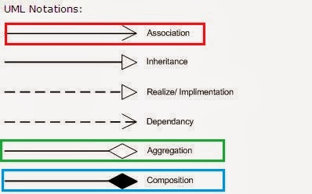](http://1.bp.blogspot.com/-VL_9cjhwEE4/UvJN__IvaBI/AAAAAAAABCc/IkDmShgM-Yc/s1600/Association,+Composition+UML.JPG)