Swinburne University of Technology

School of Science, Computing and Emerging Technologies

Contribution Document

Subject Code: SWE40006 Unit Title: Software Deployment and Evolution

Assignment title: Project Brief Due date: 5 October 2025

Tutorial Day and Time: _Friday 10:30-12.30______ Project Group: 5

Tutor: _____Naveed Ali_______________

- Time spent (hours) and contribution description

1.1 Fill in the time spent (hours) on each significant work item in the following table:

Work Item | Member 1 Name:  Dang Khoa Le | Member 2 Name: | Member 3 Name: | Member 4 Name:
Background of the Project | 3
Project goals and objectives
Selected tools and their justification | 7
Success metrics
Project scope and exclusions
Project Deliverables
Total hours | 10
Note: Please adjust and add more rows, as necessary.

1.2 Description of contributions (each member provides a brief description of their contributions):

Dang Khoa Le: Research on existing designs, find where relevant tech-stacks suit be well suitable for this project in terms of scalability, maintainability, CI/CD integration, cost and timeliness.

Member 2 Name:
… …

- Evidence of collaboration / teamwork on each significant work item (eg, discussions, mutual revisions and reviews, etc.):

Over this project brief report, our team held discussion on Discord where ideas and concerns are raised regularly. Below are screenshot evidences of collaborations:

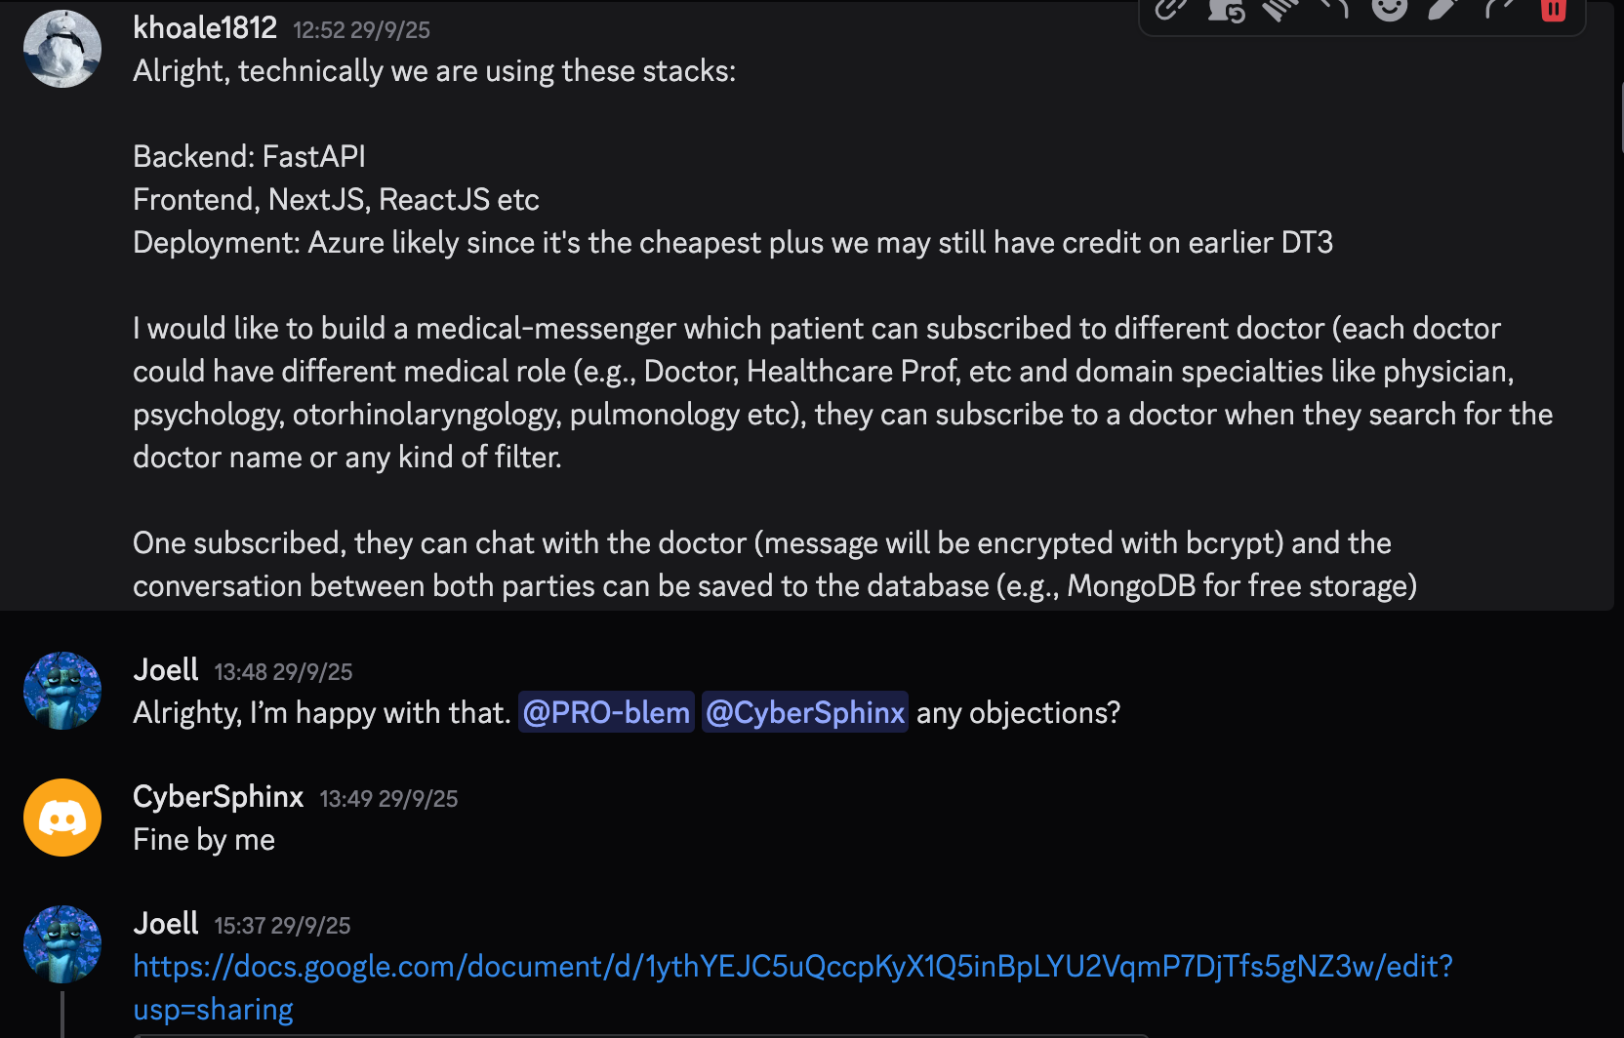
Figure 1. Discord chat 1

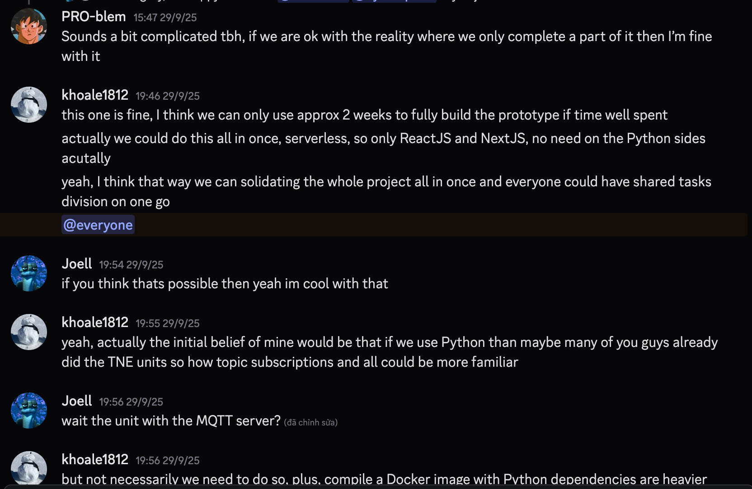
Figure 2. Discord chat 2

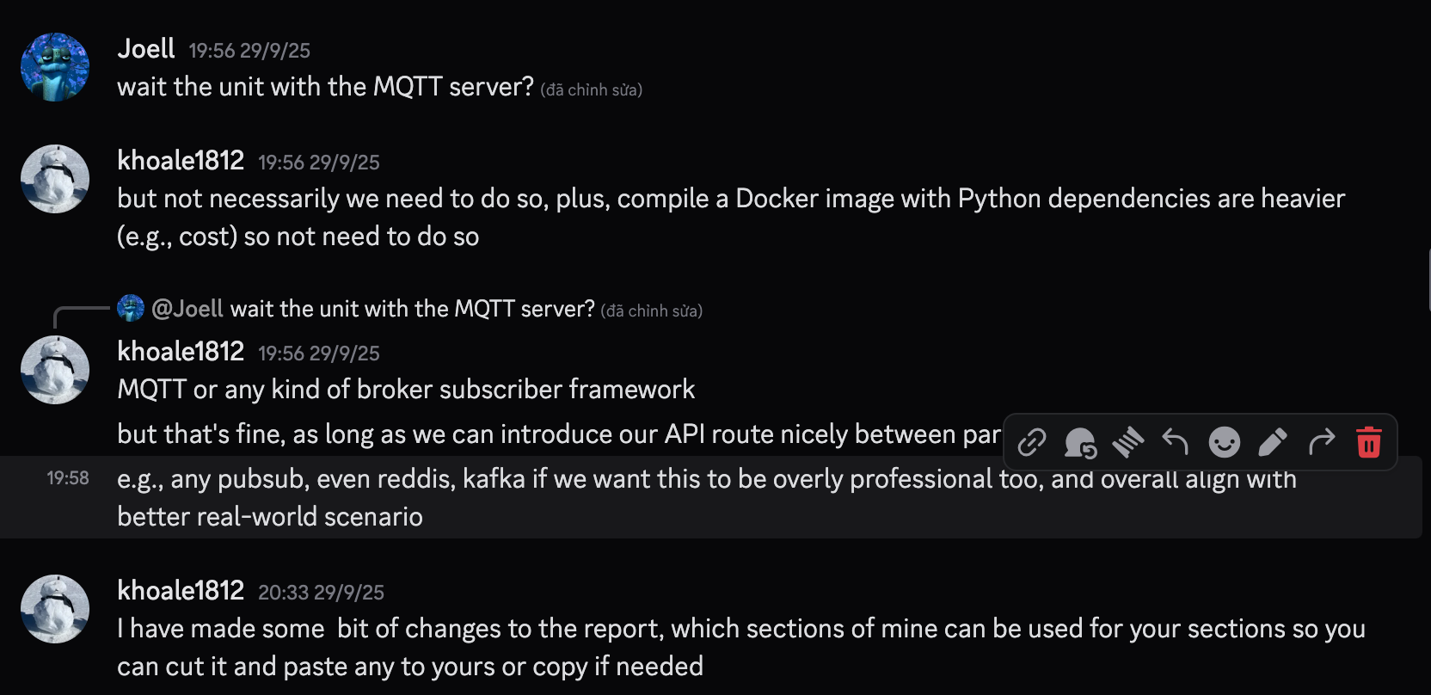
Figure 3. Discord chat 3

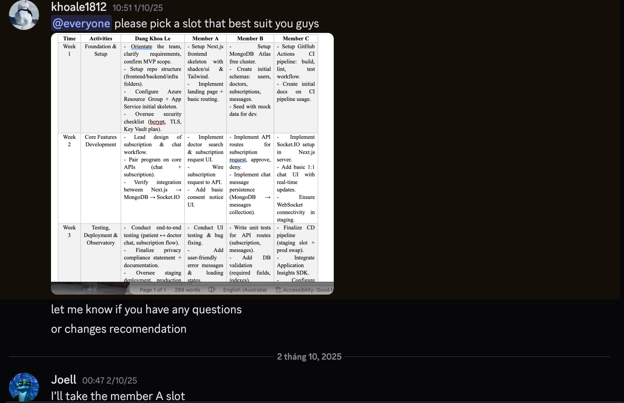
Figure 4. Discord chat 4

Our source codes will be located in this GitHub repo: https://github.com/Lelekhoa1812/SWE40006-System
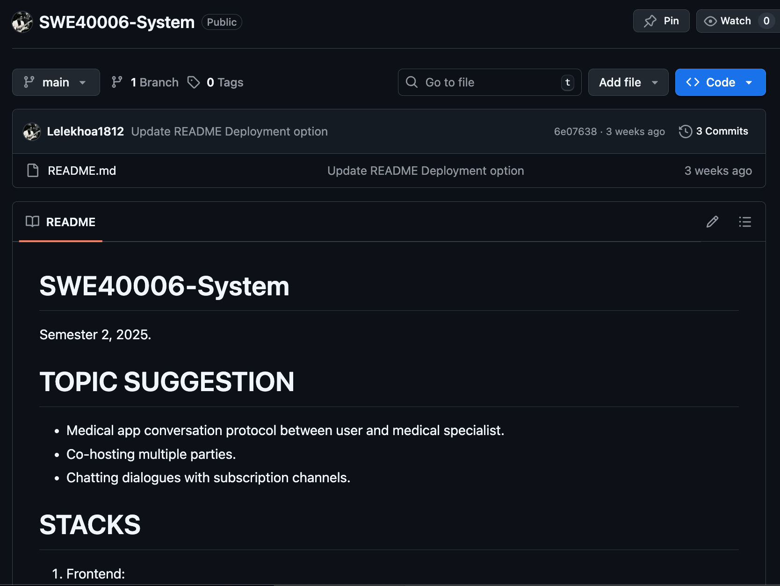
Figure 5. Team GitHub repository for this project

- Signed by all members:

ID Number Name Signature

103844421 Dang Khoa Le Khoa

