Assignment #1(part 1). HTML Basics (Page Structure)REPORT

Student: Alikhan Yerzhanuly

Group: Mt-2504

Step 0. Create a new HTML file named index.html
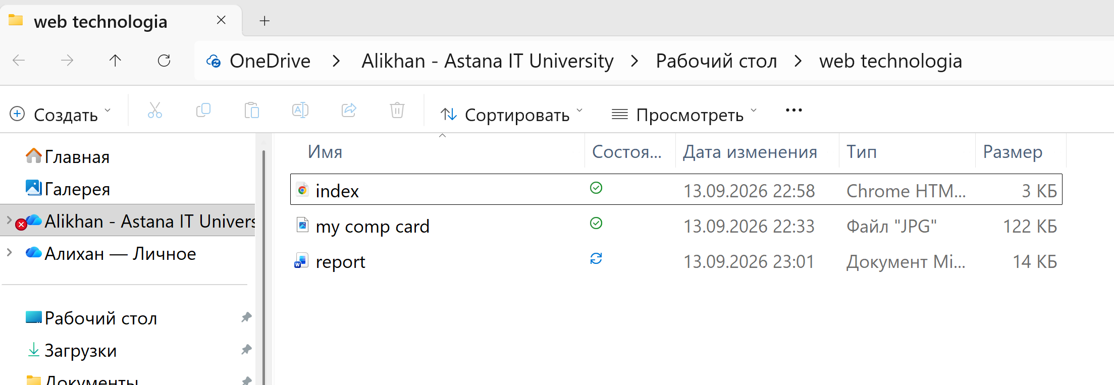
Step 1. Structure text using HTML tags
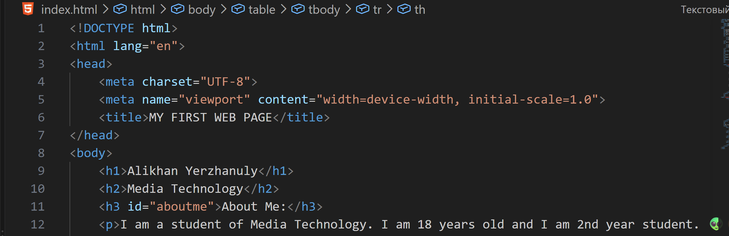
Step 2. HTML Lists
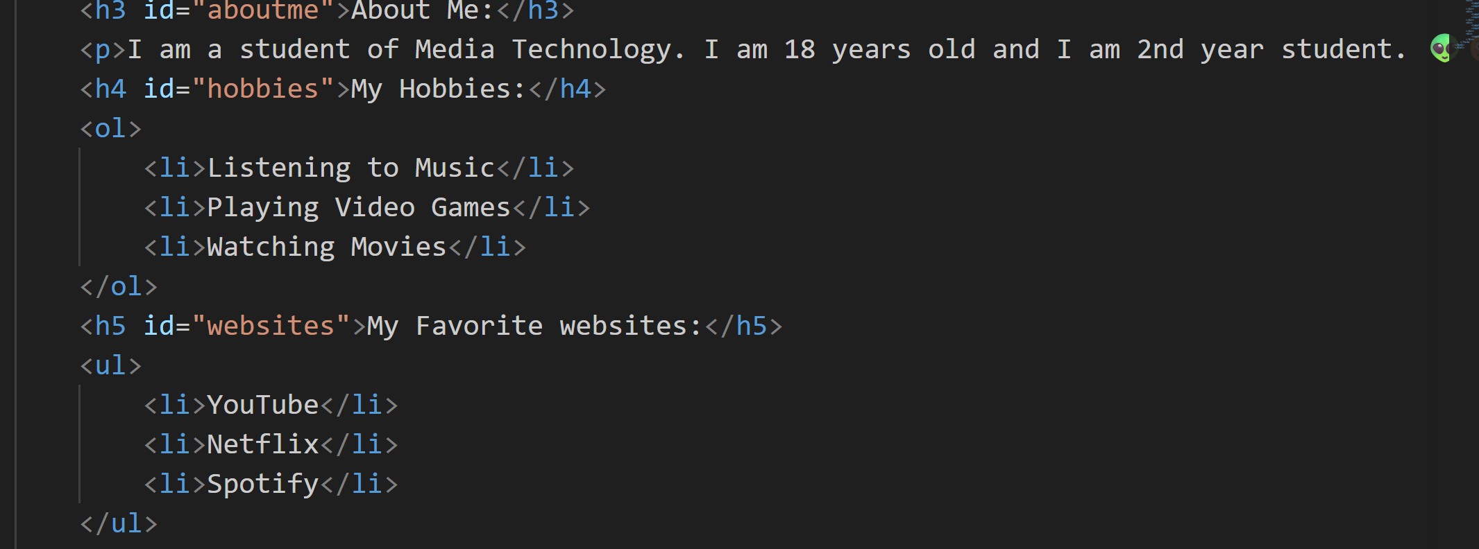

Step 3. Images and Links
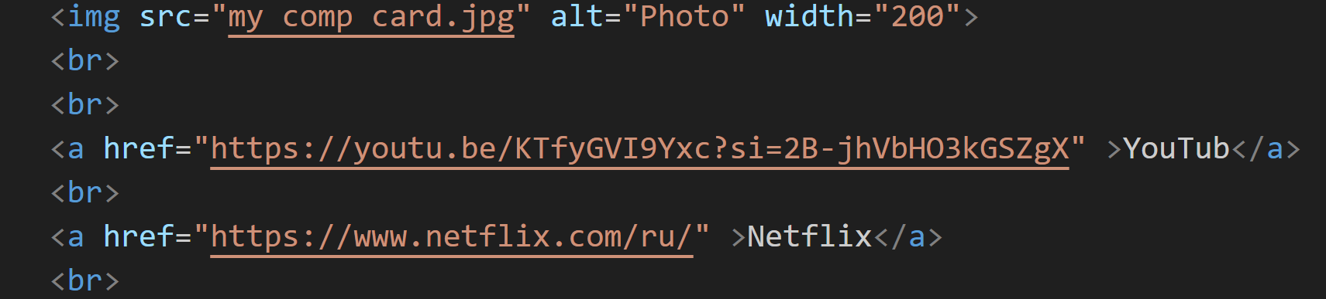

Step 4. HTML Buttons
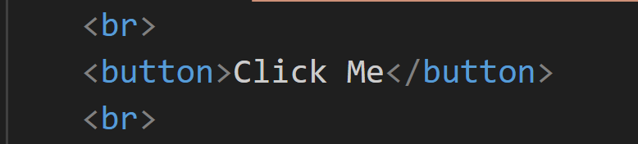
Step 5. Tables
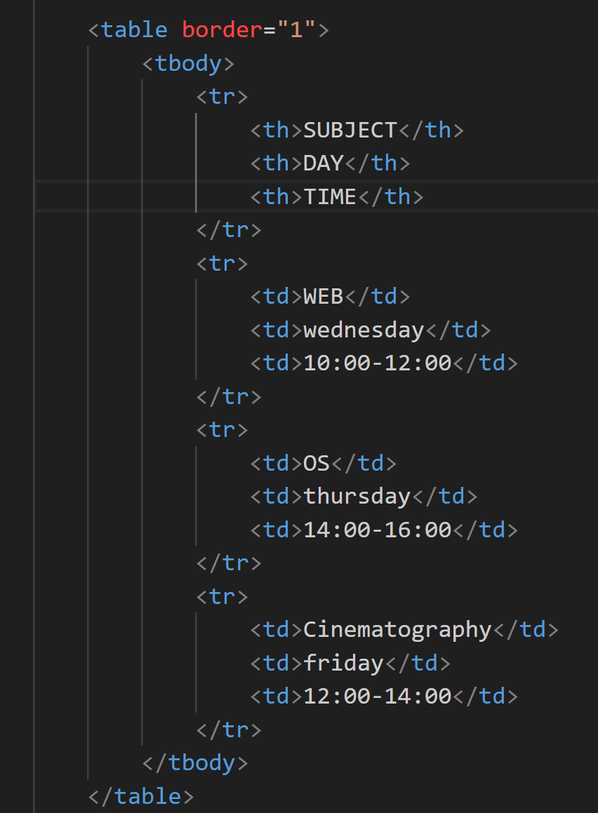

Step 6. Using Tables for Layout
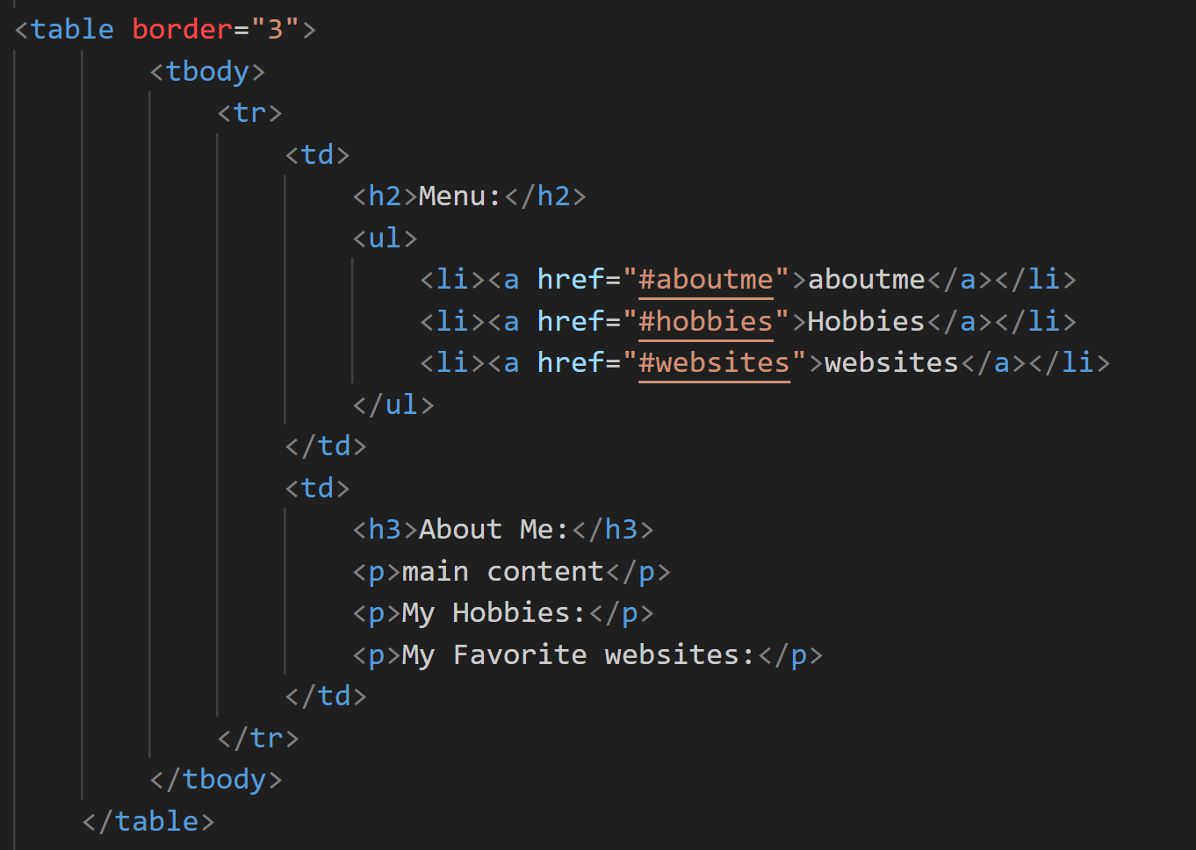
Step 7. Typing Emojis
Step 8. HTML Forms
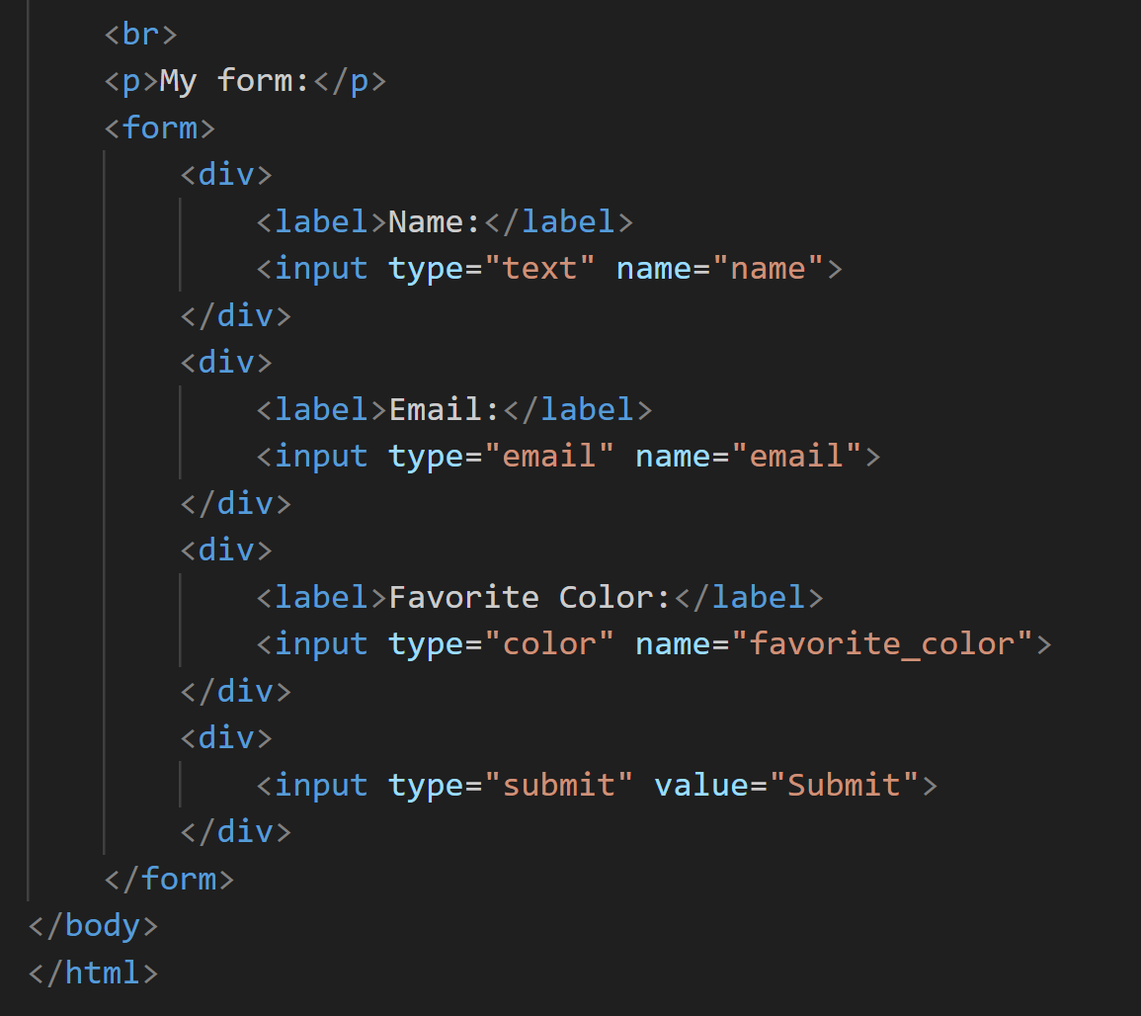
Step 9. Publish Your First Website
https://github.com/LelouchCode12/web-site.git

Thank you!

