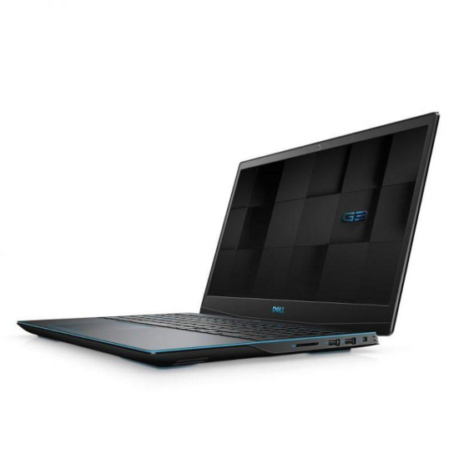DELL G3 INSPIRON 3590

Giá: **21.490.000₫**

Thông số kỹ thuật:

|  |  |
| --- | --- |
| **CPU** | [*Intel Core i5 9300H*](https://xgear.vn/cpu/intel-core-i5-9300h/) |
| **Hệ điều hành** | [*Windows 10 SL 64 Bit*](https://xgear.vn/he-dieu-hanh/windows-10-sl-64-bit/) |
| **RAM** | [*DDR4 8GB (2 x 4GB) 2666MHz, 2 slots, up to 32GB*](https://xgear.vn/ram/ddr4-8gb-2-x-4gb-2666mhz-2-slots-up-to-32gb/) |
| **GPU** | [*Geforce GTX 1050 3GB*](https://xgear.vn/gpu/geforce-gtx-1050-3gb/) |
| **Màn hình** | [*15.6" FHD (1920×1080), IPS*](https://xgear.vn/man-hinh/15-6-fhd-1920x1080-ips/) |
| **Ổ cứng SSD** | [*256GB SSD NVMe M.2 PCIe Gen 3×2*](https://xgear.vn/o-cung-ssd/256gb-ssd-nvme-m-2-pcie-gen-3x2/) |
| **Ổ cứng HDD** | [*1 slot HDD 2.5"*](https://xgear.vn/o-cung-hdd/1-slot-hdd-2-5-2/) |
| **Ổ đĩa quang** | [*No ODD*](https://xgear.vn/o-dia-quang/no-odd/) |
| **Lan** | [*Gigabit Ethernet*](https://xgear.vn/lan/gigabit-ethernet/) |
| **Wireless Lan** | [*802.11ac 2×2 Wi-Fi*](https://xgear.vn/wireless-lan/802-11ac-2x2-wi-fi/) |
| **Các cổng kết nối** | [*1x 2-in-1 SD/MicroMedia card 2x SuperSpeed USB 3.1 Gen 1 Type-A 1x Power/DC-in Jack 1x HDMI 2.0 1x Gigabit Ethernet RJ-45 1x Headphone/Mic*](https://xgear.vn/cac-cong-ket-noi/1x-2-in-1-sd-micromedia-card-2x-superspeed-usb-3-1-gen-1-type-a-1x-power-dc-in-jack-1x-hdmi-2-0-1x-gigabit-ethernet-rj-45-1x-headphone-mic/) |
| **Bàn phím** | * *Backlit keyboard* |
| **Pin** | [*4 Cells, 56WHrs*](https://xgear.vn/pin/4-cells-56whrs/) |
| **Kích thước** | [*389 x 274 x 24.95 mm*](https://xgear.vn/kich-thuoc/389-x-274-x-24-95-mm/) |
| **Trọng lượng** | [*2.5 kg*](https://xgear.vn/trong-luong/2-5-kg/) |