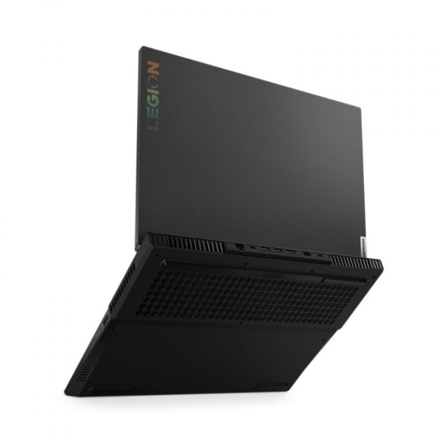LENOVO LEGION 5

Giá: **24.990.000₫**

Thông số kỹ thuật

|  |  |
| --- | --- |
| **CPU** | [*Intel Core i5 10300H*](https://xgear.vn/cpu/intel-core-i5-10300h/) |
| **Hệ điều hành** | [*Windows 10 SL 64 Bit*](https://xgear.vn/he-dieu-hanh/windows-10-sl-64-bit/) |
| **RAM** | [*DDR4 8GB (1 x 8GB) 3200MHz; 2 slots, up to 32GB*](https://xgear.vn/ram/ddr4-8gb-1-x-8gb-3200mhz-2-slots-up-to-32gb/) |
| **GPU** | [*Geforce GTX 1650 4GB*](https://xgear.vn/gpu/geforce-gtx-1650-4gb/) |
| **Màn hình** | [*15.6" Full HD ( 1920 x 1080 ), 120Hz, IPS Panel*](https://xgear.vn/man-hinh/15-6-full-hd-1920-x-1080-120hz-ips-panel/) |
| **Ổ cứng SSD** | [*512GB SSD NVMe M.2 PCIe Gen 3 x 4*](https://xgear.vn/o-cung-ssd/512gb-ssd-nvme-m-2-pcie-gen-3-x-4/) |
| **Ổ đĩa quang** | [*No ODD*](https://xgear.vn/o-dia-quang/no-odd/) |
| **Lan** | [*Dual 10/100/1000Mbps Ethernet*](https://xgear.vn/lan/dual-101001000mbps-ethernet/) |
| **Wireless Lan** | [*802.11 ac Wi-Fi + Bluetooth v4.1*](https://xgear.vn/wireless-lan/802-11-ac-wi-fi-bluetooth-v4-1/) |
| **Các cổng kết nối** | [*1 x USB 3.0 (Type-C); 2 x USB 3.0 ;1 x USB 2.0 ;1 x HDMI™ Audio Jack Microphone Jack RJ45 LAN 4-in-1 Card Reader (SD, SDHC, SDXC, MMC)*](https://xgear.vn/cac-cong-ket-noi/1-x-usb-3-0-type-c-2-x-usb-3-0-1-x-usb-2-0-1-x-hdmi-audio-jack-microphone-jack-rj45-lan-4-in-1-card-reader-sd-sdhc-sdxc-mmc/) |
| **Bàn phím** | * *Backlight Keyboard Multicolor* |
| **Pin** | [*3 Cell*](https://xgear.vn/pin/3-cell/) |
| **Kích thước** | [*380 x 265 x 25.8 (mm)*](https://xgear.vn/kich-thuoc/380-x-265-x-25-8-mm/) |
| **Trọng lượng** | [*2.4kg*](https://xgear.vn/trong-luong/2-4kg/) |