# **Overview**

This section should give a basic overview of the project and the team(s) behind it. An overview should include:

* **About your team** – A brief team information such as
  + **Members and their roles –** name, student id, email, and role
  + **Communication strategy** – meeting and brainstorming minutes
* **Motivation** – Why is the project needed?
* **High-level project scope** – Is it a redesign of a few pages, a complete website overhaul, or a brand-new website?
* **Target audience/market** – An overview of who this website is targeted at.

# **Project goals and team interests**

Briefly describe the goals of the project and what will your team gain from doing this project. This will give an idea of what you are trying to achieve, which will enable the most appropriate solutions.

For example:

Project goals

* Highlight the problem of air quality in Kazakhstan
* Increase the number of people taking public transport/walks or riding a bicycle by 10%
* Draw attention to coal heated households and trash burning cases

Team interests

* Understand HTML tags and CSS by building an air pollution-related website
* Establish a solid understanding of website design principles
* Improve team working skills by collaborating with different members of the group

# **Phases**

If this project is part of a bigger project, or there will be further phases following this project, it is useful to list these to give an indication of where this project fits into the bigger picture.

For example:

* Phase 1 – Basic air pollution website with HTML (Currently)
* Phase 2 – Add styles to improve the appearance and thus draw wider audience
* Phase 3 – Incorporate a forecasting API to show real-time air quality data

# **Content structure**

**Site map**

This is usually provided as a diagram which shows the ‘tree’ type, hierarchical structure of the website pages. It can also include which ‘page template’ (see below) to use for each page and content type. (gloomaps.com)

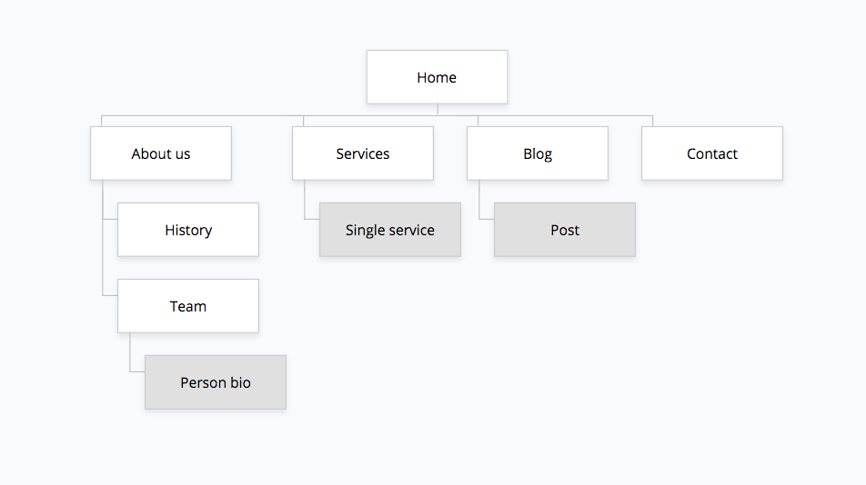

**Content types**

A website can contain many distinct types of content. At its most basic, there will usually be posts and pages. A page is timeless content, e.g. ‘About us’, whereas a post is chronological, e.g. a news or blog post.

Some other common examples of content types are:

* People
* Events
* Testimonials

**Design**

It is important to provide design assets and related references

There are many ways to provide design assets, for example:

* Reference links
* Image files
* Sketch files

It is also important to provide a style guide and/or annotations for information such as:

* colours
* typography rules
* hover states
* animations
* grid systems
* spacing

**Functionality**

Functionality is how your site actually works. This could be anything about specific parts of the website that need additional explanation.

For example, if you have a signup page, what fields are required? What happens to an entry on a contact form?

Many sites require integrations with third-party APIs. If this is the case, then these integrations should be outlined here in terms of how they will work and any additional information that is needed.

**Hosting**

This section should outline the hosting requirements of the site. For example, if you used Github pages, indicate steps you took.

**Accessibility**

Accessible websites benefit everyone, not just those with disabilities. On an accessible website, the user is put at the center of the experience. Text is more readable. Content is better organized. The design is clean and simple. This website will show you how to make your site accessible, and make it better for all, by using the latest web technology.

For example, search on the internet, which font should you use to incorporate people with disabilities.

This subsection should include description of guidelines you used to make the website accessible.

**Deadlines**

It’s still important to have an idea of the timescales involved, especially if there is a fixed deadline – an event, for example. If you have provided project phases, it is mandatory to provide it deadlines.

For example,

* Phase 1 – February 5, 12:00
* Phase 2 – February 7, 18:00
* Phase 3 – February 15, 20:00

# **Summary**

Write down a brief summary of your website. Have you achieved the project goals/team interests? What difficulties have you faced during the project implementation? What have you learned?

It is worth making assessment of your own work.