

Individual Assessment Coversheet
To be attached to the front of the assessment.

Campus: | Midrand
Faculty: | Information Technology
Module Code: | ITLSA
Group: | Group 2
Lecturer’s Name: | Sellwane nthutang
Student Full Name: | Smangaliso Marrocane
Student Number: | EDUV4871915

Indicate | Yes | No
Plagiarism report attached

Declaration:
I declare that this assessment is my own original work except for source material explicitly acknowledged. I also declare that this assessment or any other of my original work related to it has not been previously, or is not being simultaneously, submitted for this or any other course. I am aware of the AI policy and acknowledge that I have not used any AI technology to generate or manipulate data, other than as permitted by the assessment instructions. I also declare that I am aware of the Institution’s policy and regulations on honesty in academic work as set out in the Conditions of Enrolment, and of the disciplinary guidelines applicable to breaches of such policy and regulations.
Date
Signature

Lecturer’s Comments:
Marks Awarded: %
Date
Signature

Eduvos (Pty) Ltd. (formerly Pearson Institute of Higher Education) is registered with the Department of Higher Education and Training as a private higher education institution under the Higher Education Act, 101, of 1997. Registration Certificate number: 2001/HE07/008

QUESTION 1

1.1. Steps :
ChildrenAges=(13,12,15,11,19,12,17,14,10,18)

Max Age=max(childrenAges)
Max_index=childrenAges,index(max_age)

Print (“The highest age is”,max_age,”at position,max_index)

Therefore,the Output will be:
The highest age is 19 at position 6

1.2. Start

PROMPT "Enter Sandile's monthly salary: "
READ monthlySalary

SET contributionToParents = 1200
SET remainingSalary = monthlySalary – contributionToParents

SET generalExpenses = remainingSalary * 0.30
SET savingsAccount = remainingSalary * 0.20
SET emergencyFund = remainingSalary * 0.15
SET investments = remainingSalary * 0.20
SET vacationFund = remainingSalary - (generalExpenses + savingsAccount + emergencyFund + investments)

PRINT "Amount allocated for general expenses: R", generalExpenses
PRINT "Amount allocated into savings account: R", savingsAccount
PRINT "Amount allocated into emergency fund: R", emergencyFund
PRINT "Amount allocated for investments: R", investments
PRINT "Amount allocated for vacation fund: R", vacationFund
END

1.3.a. D < (E – 7) OR G and (A * C) >= (D – E * C)
-8 < (-6 – 7) OR TRUE AND (3 * 7) >= (-8 - (–6*7))
-8< -13 OR TRUE AND 21 >= -8 -(- 42) =8 + 42= 34

-8< -13 OR TRUE AND 21 >= 34
-8< -13 = FALSE
21 >= 34 = FALSE

TRUE AND FALSE = FALSE
FALSE AND FALSE = FALSE
=FALSE

b. C * 4 >= B^3 – 18 \ 5 AND F OR A <= D – 5
12 * 4 >= 2^3 – 18 \ 5 AND TRUE OR 5 <= -4 -5
48 >= 8 – 3.6 AND TRUE OR 5 <= -9

48 >= 4.4 AND TRUE OR 5 >= -9
48 >= 4.4 = TRUE
5 <= -9 = FALSE

TRUE AND TRUE = TRUE
TRUE OR FALSE = TRUE
=TRUE

QUESTION 2

2.1. BEGIN
PROMPT "Enter the total cost per paint can: "
READ totalCostPerCan

SET markupPercentage = 0.25
SET litresPerCan = 5

// Calculate the cost per litre before markup
SET costPerLitre = totalCostPerCan / litresPerCan

// Calculate the markup amount
SET markupAmount = costPerLitre * markupPercentage

// Calculate the price per litre after adding the markup
SET pricePerLitre = costPerLitre + markupAmount

// Round up the price per litre to the next full Rand amount
SET roundedPricePerLitre = CEIL(pricePerLitre)

// Display the rounded price per litre
PRINT "The price per litre of paint is: R", roundedPricePerLitre
END

2.2.
Step | Description | Calculation | Value
2-3 | Input total cost per paint can |  | Cost per paint can=R182,60
4 | Calculate Markup | Markup=total_cost_per_can*  0.25 | Markup=R182,60*0.25= R45,65
5 | Calculate Gross Price per Litre of paint | Gross price= cost per can + Markup | R182.60 + R45.65= R228.25/ 5=R45.65
6 | Calculate Price Per Litre of paint | Price Per litre=Gross price per can /5 | R228.25/5 =R46.65
7 | Round Price Per Litre to Next Rand | Rounded price per litre=round(price per litre) | R45,65=R46
8 | Display Rounded Price Per litre | Rounded price per litre = round(price per litre) | The price per litre of paint is R46
 | END

QUESTION 3
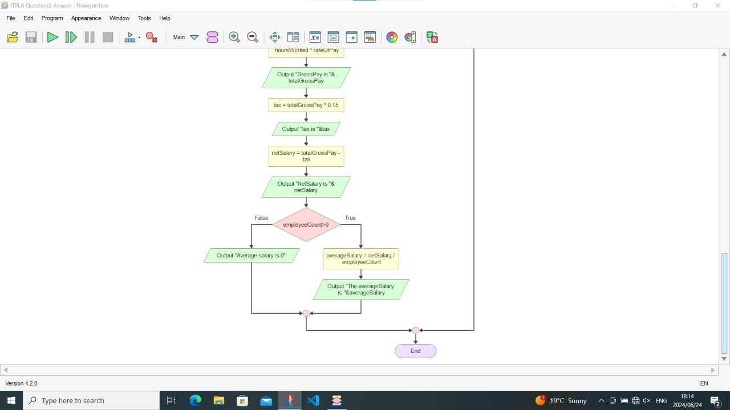

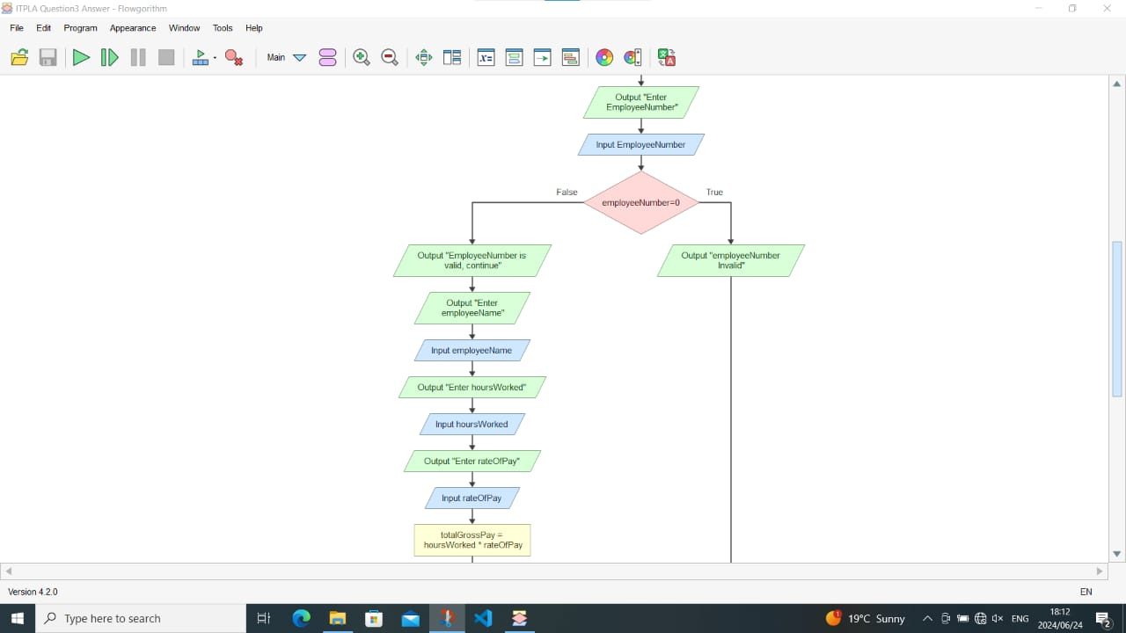

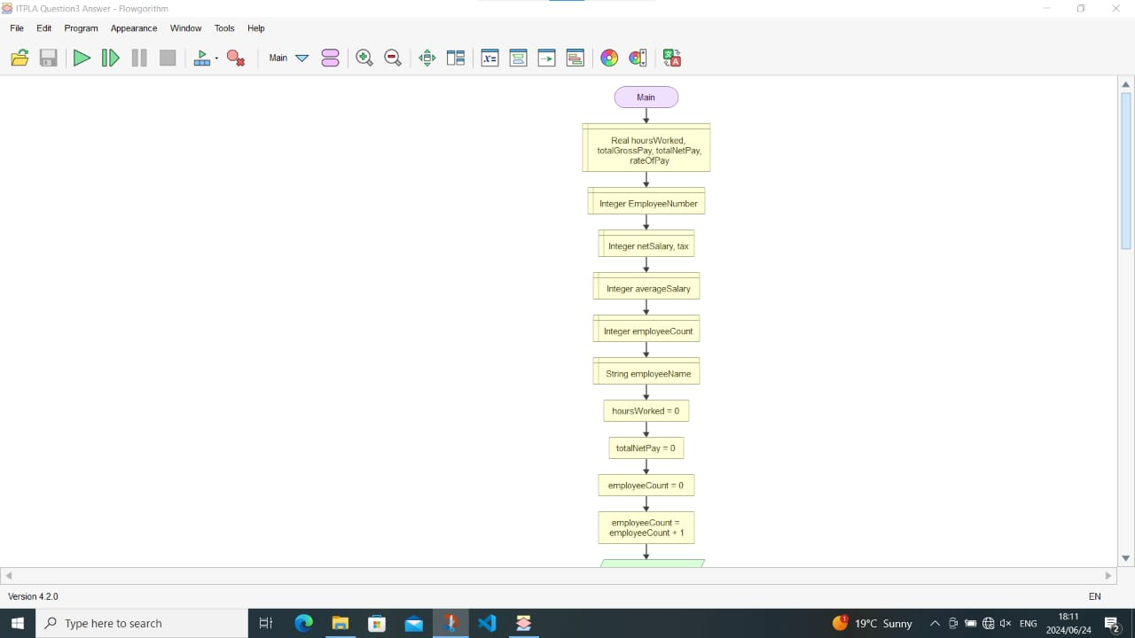

3.2 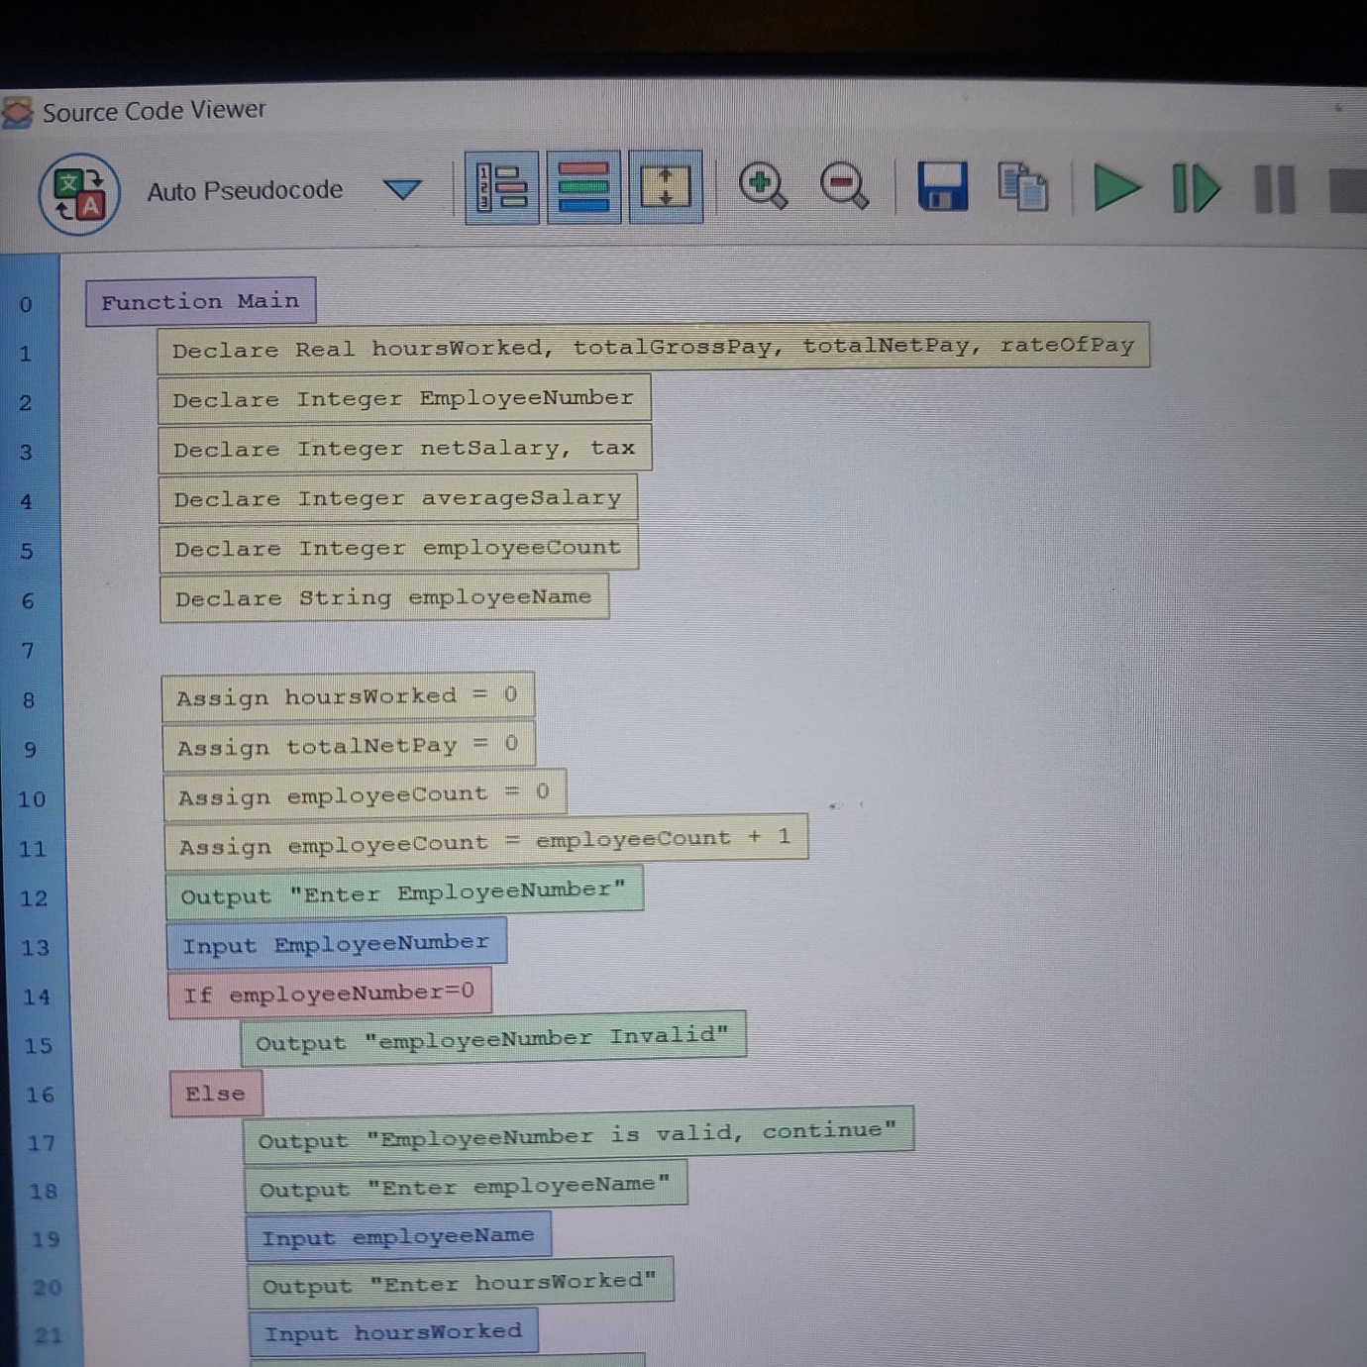
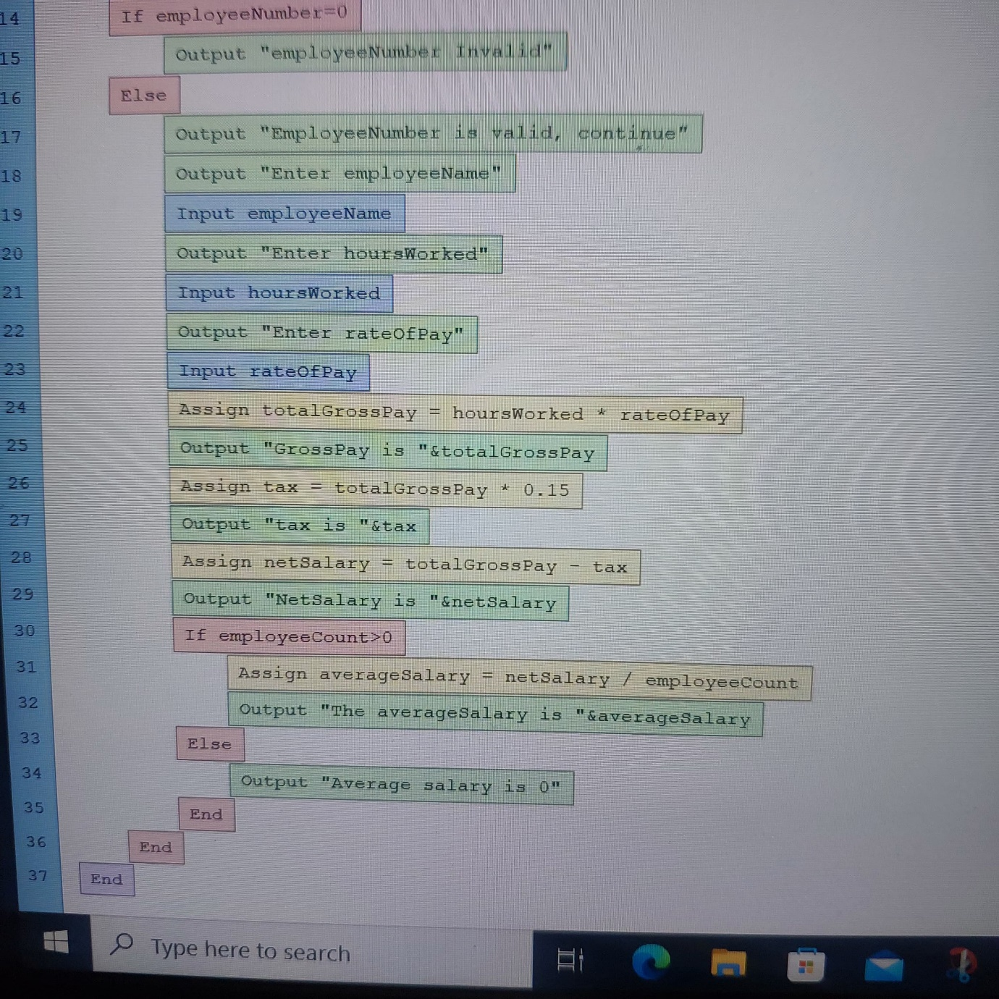

3.3 Input Data
- Employee Number
- Name
- Hours Worked
- Rate of pay
Output
- Weekly Pay(hours Worked*Rate of pay)
Table calculation of weekly pay
Employee Number | Name | Hours Worked | Rate of pay | Weekly Pay
101 | Johan | 184 | R20 | 184*20
102 | Sithole | 200 | R25 | 200*25
103 | Kamogelo | 222 | R32 | 222*32

Calculation of weekly pay for each employee

For employee 101(Johan)
- Hours Worked: 184
- Rate of pay: R20
- Weekly Pay: 184*20=R3680
For Employee 102(Sithole)
- Hours Worked: 200
- Rate of Pay: R25
- Weekly Pay: 200*25=R5000
For Employee 103(Kamogelo)
- Hours Worked:222
- Rate of pay: R32
- Weekly Pay: 222*32=R7104
The trace table with the calculated weekly pay for each employee would be:

Employee Number | Name | Hours Worked | Rate of Pay | Weekly Pay
101 | Johan | 184 | R20 | R3689
102 | Sithole | 200 | R25 | R5000
103 | Kamogelo | 222 | R32 | R7104

QUESTION 4

// Main procedure to execute the FinalMark algorithm
PROCEDURE FinalMark
// Declare an array to store the test marks
DECLARE testmarks[10]
DECLARE sumMarks, averageScore, I

// Initialize sumMarks to 0
SET sumMarks = 0

// Prompt the user to enter the ten test scores
FOR i FROM 1 TO 10 DO
PROMPT "Enter test score ", i, ": "
READ testmarks[i]
// Add the entered score to sumMarks
SET sumMarks = sumMarks + testmarks[i]
END FOR

// Call the CalculateAverage function to compute the average
SET averageScore = CalculateAverage(sumMarks, 10)

// Call the DetermineGrade sub-procedure to determine and display the letter grade
CALL DetermineGrade(averageScore)
END PROCEDURE

// Function to calculate the average of the marks
FUNCTION CalculateAverage(sumMarks, numberOfTests)
DECLARE average
// Calculate the average by dividing the sum of marks by the number of tests
SET average = sumMarks / numberOfTests
// Return the calculated average
RETURN average
END FUNCTION

// Sub-procedure to determine the letter grade based on the average score
PROCEDURE DetermineGrade(averageScore)
// Determine the letter grade based on the average score
IF averageScore >= 90 AND averageScore <= 100 THEN
PRINT "Grade: Distinction"
ELSE IF averageScore >= 80 AND averageScore <= 89 THEN
PRINT "Grade: Very Good"
ELSE IF averageScore >= 70 AND averageScore <= 79 THEN
PRINT "Grade: Good"
ELSE IF averageScore >= 60 AND averageScore <= 69 THEN
PRINT "Grade: Credit"
ELSE IF averageScore >= 50 AND averageScore <= 59 THEN
PRINT "Grade: Pass"
ELSE
PRINT "Grade: Fail"
END IF
END PROCEDURE

Explanation:

- Main Procedure: This is where the main flow of the algorithm occurs. It prompts the user to input 10 test scores, calculates their sums, calls CalculateAverage to compute the average, and then calls DetermineGrade to determine and display the corresponding grade.
- CalculateAverage function: Computes the average of the test scores by dividing the sum by 10.
- DetermineGrade Sub-procedure: Determines the letter grade based on the average score using conditional statements (IF-ELSE). It assigns the appropriate grade to the grade variable and displays it.

