Week 1 – Data Acquisition, Cleaning, and Preprocessing

- INTRODUCTION
For the first week of the internship, the main task was to work with a real-world dataset and prepare it for further analysis. The dataset selected for this work is related to diabetes risk and contains information about different factors such as age, BMI, lifestyle habits, blood sugar levels, blood pressure, and other health-related attributes.
Before performing any analysis, it is important to make sure that the data is clean and properly organized. Raw datasets can contain missing values, duplicate records, unusual values, or inconsistent entries. If these issues are not handled properly, they can affect the results of later analysis.
In this task, I used Python to load and examine the dataset, identify data quality issues, handle missing values, check for duplicates and inconsistencies, and investigate potential outliers. The cleaned dataset was then saved separately so that it could be used for the next stage of the project.

- DATASET DESCRIPTION
  - Dataset Source
For this project, I used a publicly available dataset named “diabetes_risk.csv”.
The dataset was obtained from: https://www.kaggle.com/datasets/mansiaggarwal88/diabetes-risk-prediction
The dataset was downloaded in CSV format and imported into Python using the Pandas library.
  - Dataset Characteristics
The dataset contains 15,000 rows and 19 columns. Each row represents one patient, while the columns contain different types of information about that patient.
The dataset contains both numerical and categorical data. Numerical data includes values such as age, BMI, blood sugar, HbA1c level, blood pressure, sleep duration, and waist circumference. Categorical data includes information such as gender, diet type, smoking status, physical activity level, and diabetes risk.
The patient_id column is used to uniquely identify each patient, while diabetes_risk represents the diabetes risk category associated with the individual.

- TOOLS AND TECHNOLOGY
The following tools were used during the project:
- Python – Used as the main programming language.
- Pandas – Used to load, inspect, clean, and modify the dataset.
- NumPy – Used for numerical operations.
- Matplotlib – Used to create graphs for examining the data and potential outliers.
- Jupyter Notebook – Used to write and run the Python code while documenting the different steps.
- GitHub – Used to store and manage the project files and code.

- DATA ACQUISITION
I started by importing the required Python libraries and setting a few Pandas display options so that more rows and columns could be viewed during the analysis.
import pandas as pd
import numpy as np
import matplotlib.pyplot as plt
import seaborn as sns

pd.set_option("display.max_columns", None)
pd.set_option("display.max_rows", 100)
The dataset was then loaded using Pandas:
df = pd.read_csv("diabetes_risk.csv")
After loading the dataset, I used df.head() to display the first few records and verify that the data had been loaded correctly.
I also used df.tail() to inspect the last few records of the dataset.

- INITIAL DATA EXPLORATION
After loading the dataset, I performed an initial exploration to understand its structure and the type of information it contained.
  - Dataset Dimensions
I used the following command to check the number of rows and columns:
df.shape
The dataset contains 15,000 rows and 19 columns.
This gave me an initial understanding of the size of the dataset before starting the cleaning process.
  - Data Types and Structure
I used df.info() to examine the structure of the dataset:
df.info()
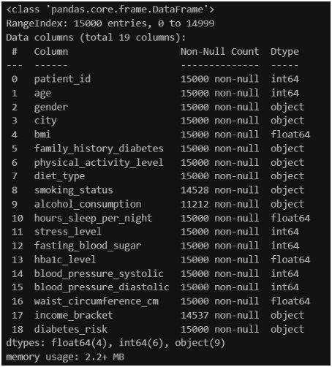
This helped me identify the data type of each column and determine which variables were numerical and which were categorical.
I also used df.dtypes to separately examine the data types.
This step was useful because numerical and categorical columns need to be handled differently during data preprocessing.
  - Categorical Data Exploration
To understand the categorical variables, I used:
df.describe(include="object")
This provided a summary of the categorical columns.
I also checked the number of unique values in each column using:
df.nunique()
This helped me understand how many different values or categories were present in each variable.
After identifying the categorical columns, I examined the individual categories using:
categorical_columns = df.select_dtypes(include="object").columns
for columns in categorical_columns:
print("\n", columns)
print(df[columns].value_counts(dropna=False))
This allowed me to inspect the distribution of the categories, including missing values.

  - Numerical Data Exploration
I used the following command to generate a statistical summary of the numerical variables:
df.describe().T
The summary included information such as the count, mean, standard deviation, minimum, maximum, and quartile values.
I also specifically checked the ranges of some important variables:
print("Age Range", df["age"].min(), "-", df["age"].max())
print("BMI Range", df["bmi"].min(), "-", df["bmi"].max())
print("Sleep Range", df["hours_sleep_per_night"].min(), "-", df["hours_sleep_per_night"].max())
This gave me a better idea of the range of values in the dataset and helped identify values that might need further investigation.

- DATA QUALITY ASSESSMENT
After understanding the basic structure of the dataset, I checked it for common data quality problems.
  - Missing Values
I first checked for missing values using:
missing = df.isnull().sum()
missing[missing > 0]
This showed that missing values were present in three columns:
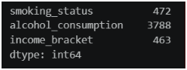
The dataset therefore contained a total of 4,723 missing values.
To get a clearer picture of the missing data, I also calculated the percentage of missing values:
missing_summary = pd.DataFrame({
"Missing Count": df.isnull().sum(),
"Missing Percentage": (df.isnull().sum() / len(df)) * 100
})

missing_summary = missing_summary[
missing_summary["Missing Count"] > 0
]
This showed that alcohol_consumption had the highest number of missing values among the three columns.
  - Duplicate Records
I checked whether the dataset contained any completely duplicated rows using:
duplicate_rows = df.duplicated().sum()
print("Number of duplicate rows:", duplicate_rows)
The result showed that there were no duplicate rows in the dataset.
Therefore, no records needed to be removed because of complete duplication.
  - Patient ID Check
Since every record represents a patient, I also checked whether the patient IDs were unique.
print("Total records:", len(df))
print("Unique patient IDs:", df["patient_id"].nunique())
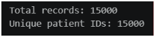
There were 15,000 records and 15,000 unique patient IDs.
This indicates that each record had a unique patient identifier.
  - Categorical Consistency
I examined all categorical columns using value_counts() to understand the categories present in the dataset.
categorical_columns = df.select_dtypes(include="object").columns

for columns in categorical_columns:
print("\n", columns)
print(df[columns].value_counts(dropna=False))
This was useful for checking the values present in each categorical variable and also confirmed where the missing values were located.
The missing categorical values were handled during the cleaning stage by assigning them an "Unknown" category.

  - Numerical Validity and Outlier Detection
The numerical columns were examined using:
df.describe().T
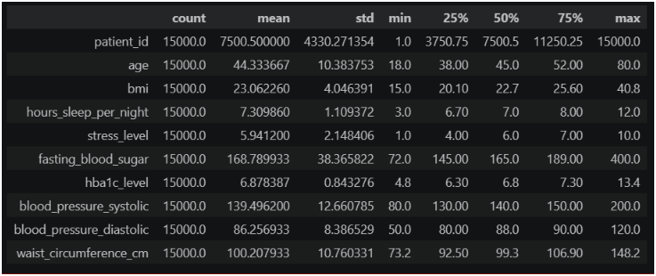
I then selected the numerical variables that needed to be checked for potential outliers:
numerical_columns = ["age", "bmi", "hours_sleep_per_night", "stress_level", "fasting_blood_sugar", "hba1c_level", "blood_pressure_systolic", "blood_pressure_diastolic", "waist_circumference_cm"]
For the outlier analysis, I used the Interquartile Range (IQR) method.
For each numerical column, Q1 and Q3 were calculated, followed by the IQR: IQR = Q3 − Q1
The lower and upper boundaries were then calculated as:
Lower Bound = Q1 − 1.5 × IQR
Upper Bound = Q3 + 1.5 × IQR
The purpose of this step was to identify values that were unusually far from the middle 50% of the data.
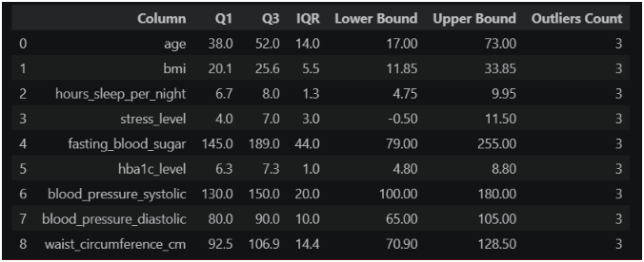

- DATA CLEANING
  - Handling Missing Values
The missing values were found in three categorical columns:
- smoking_status
- alcohol_consumption
- income_bracket
Instead of removing the rows containing missing values, I replaced the missing entries with "Unknown".
The following code was used:
df["smoking_status"] = df["smoking_status"].fillna("Unknown")
df["income_bracket"] = df["income_bracket"].fillna("Unknown")
df["alcohol_consumption"] = df["alcohol_consumption"].fillna("Unknown")
I chose this approach because deleting the rows would result in the loss of patient records. Using "Unknown" also makes it clear that the original information was not available rather than assuming a particular value.
  - Handling Duplicate Records
The duplicate check showed that there were no completely duplicated records.
Therefore, no rows were removed during this step.
The patient ID check also showed that all 15,000 patient IDs were unique.
  - Handling Categorical Data
The categorical variables were inspected using value_counts() before cleaning.
Since the main issue found in the categorical variables was missing information, the missing entries in the three affected columns were replaced with "Unknown".
No other categorical values were changed based on the checks performed in the notebook.
  - Outlier Investigation
Potential outliers were investigated using the IQR method.
I also created box plots for BMI and fasting blood sugar using Seaborn:
plt.figure(figsize=(8, 5))
sns.boxplot(x=df["bmi"])
plt.title("Box Plot of BMI")
plt.xlabel("BMI")
plt.show();
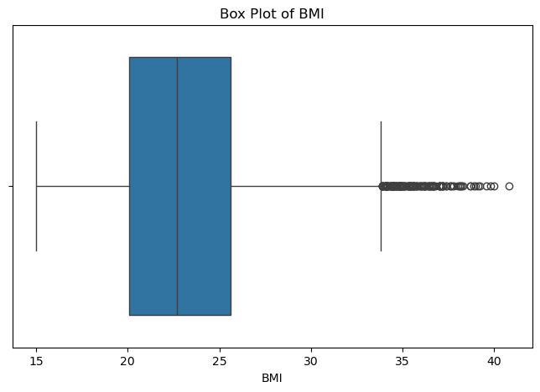
and:
plt.figure(figsize=(8, 5))
sns.boxplot(x=df["fasting_blood_sugar"])
plt.title("Box Plot of Fasting Blood Sugar")
plt.xlabel("Fasting Blood Sugar")
plt.show();
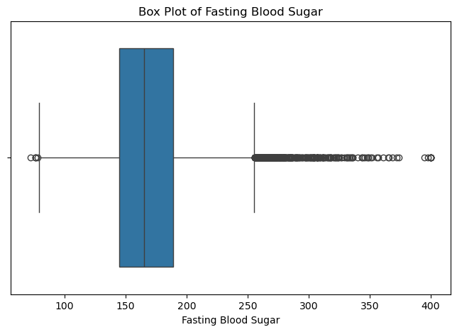
These plots made it easier to visually inspect the distribution of the variables and identify values that appeared far from the main distribution.
The potential outliers were not removed from the dataset because the notebook was focused on identifying and investigating unusual values rather than automatically deleting them. Since these variables represent health-related measurements, unusual values may still be legitimate observations.

- DATA PREPROCESSING
After the initial cleaning, I created a separate copy of the dataset:
cleaned_df = df.copy()
I then applied the missing-value treatment to the cleaned copy:
cleaned_df["smoking_status"] = cleaned_df["smoking_status"].fillna("Unknown")
cleaned_df["alcohol_consumption"] = cleaned_df["alcohol_consumption"].fillna("Unknown")
cleaned_df["income_bracket"] = cleaned_df["income_bracket"].fillna("Unknown")
The cleaned dataset was checked again for missing values:
cleaned_df.isnull().sum()
This allowed me to verify whether the missing values had been successfully handled.

- BEFORE AND AFTER CLEANING
After the cleaning process, I performed a final validation of the dataset using:
print("Shape:", cleaned_df.shape)
print("\nMissing Values:")
print(cleaned_df.isnull().sum())
print("Duplicate Rows:")
print(cleaned_df.duplicated().sum())
print("Unique Patient IDs:")
print(cleaned_df["patient_id"].nunique())

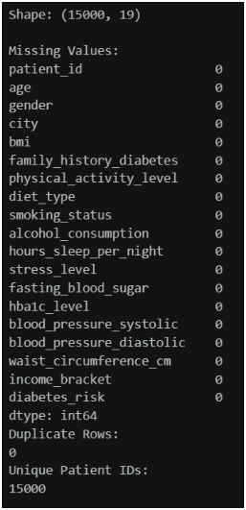
This final check allowed me to verify four important things:
- The overall size of the dataset remained unchanged.
- The missing values were handled.
- No duplicate rows were present.
- The patient IDs remained unique.
The cleaned dataset was then exported as:
cleaned_df.to_csv("cleaned_diabetes_risk.csv", index=False)
The original dataset was not overwritten. Instead, a new file named cleaned_diabetes_risk.csv was created.

- CHALLENGES FACED
One of the main challenges during the cleaning process was deciding how to handle the missing values.
There were a significant number of missing values in the alcohol_consumption column, so simply deleting those rows would have resulted in the loss of a considerable amount of data. I therefore decided to use "Unknown" instead.
Another challenge was dealing with potential outliers. The IQR method can identify values that are statistically unusual, but that does not necessarily mean that those values are incorrect. This was especially relevant for the health-related measurements in this dataset.
The dataset also contained both numerical and categorical variables, so I had to use different methods to inspect and understand them.
- IMPACT OF PREPROCESSING
The preprocessing mainly focused on handling missing categorical values while preserving the original records.
Replacing missing values with "Unknown" allowed the dataset to retain all 15,000 records instead of removing rows containing missing information.
The duplicate and patient ID checks confirmed that there were no duplicate rows and that each patient record had a unique identifier.
The numerical variables were also examined for potential outliers using both the IQR method and box plots. Rather than automatically removing unusual observations, these values were investigated and retained.
As a result, the cleaned dataset provides a better starting point for further analysis while preserving the information contained in the original records.

- CONCLUSION
In this week's task, I worked on the data acquisition, cleaning, and preprocessing of the diabetes_risk.csv dataset.
I first loaded the dataset using Pandas and explored its dimensions, data types, categorical variables, and numerical variables. The dataset contains 15,000 records and 19 columns.
I then checked the dataset for missing values and found missing data in smoking_status, alcohol_consumption, and income_bracket. Instead of deleting the affected records, I replaced the missing values with "Unknown".
I also checked for duplicate records and verified the uniqueness of the patient IDs. No duplicate rows were found, and all 15,000 patient IDs were unique.
For numerical data, I investigated potential outliers using the IQR method and created box plots for BMI and fasting blood sugar. The potential outliers were retained rather than automatically removed.
Finally, I created a separate cleaned dataset named cleaned_diabetes_risk.csv. This cleaned dataset will be used as the basis for the next stage of the project, which involves exploratory data analysis and visualization.

- REFERENCES

- Dataset source: https://www.kaggle.com/datasets/mansiaggarwal88/diabetes-risk-prediction
- Data Cleaning Techniques: https://www.geeksforgeeks.org/data-analysis/data-cleaning-introduction/

