Week 2 - Exploratory Data Analysis and Visualization of Diabetes Risk
1. Introduction
During the second week of my internship, I focused on exploratory data analysis (EDA) and visualization using a diabetes risk dataset. The main objective was to understand the dataset in greater detail, identify patterns among demographic, lifestyle, and health-related variables, and present the findings through meaningful visualizations.
I continued working with the cleaned dataset prepared during Week 1. Using Python libraries such as Pandas, Matplotlib, and Seaborn, I examined the distribution of diabetes-risk categories, studied numerical variables, compared groups, and explored correlations between health measurements.
The visualizations helped me understand how different variables were distributed and how certain measurements varied across diabetes-risk categories. The findings were interpreted based on the available data, without assuming that an observed relationship necessarily indicates causation.
2. Objectives
The main objectives of this week's work were:
- To perform exploratory data analysis on the cleaned diabetes risk dataset.
- To calculate descriptive statistics for numerical variables.
- To understand the distribution of diabetes-risk categories and patient ages.
- To compare health measurements across different diabetes-risk categories.
- To investigate relationships between numerical variables using a correlation heatmap.
- To examine the distribution of diabetes risk across family-history and physical-activity groups.
- To create clear and properly labelled visualizations using Matplotlib and Seaborn.
- To interpret the results and document the key findings in a structured report.

3. Dataset Description
The dataset used in this analysis contains 15,000 records and 19 columns. It includes demographic information, lifestyle characteristics, and health-related measurements associated with diabetes risk.
Some of the important variables include age, BMI, family history of diabetes, physical activity level, sleep duration, stress level, fasting blood sugar, HbA1c, blood pressure, waist circumference, and diabetes-risk category.
The cleaned dataset generated during Week 1 was used as the input for this analysis. This allowed me to continue directly from the data-cleaning stage without repeating the initial preprocessing work.
Dataset source: https://www.kaggle.com/datasets/mansiaggarwal88/diabetes-risk-prediction

4. Tools and Technologies Used
The following tools and libraries were used during the analysis:
- Python: Used to perform the analysis and organize the workflow.
- Pandas: Used for data loading, statistical summaries, grouping, and aggregation.
- NumPy: Available for numerical operations.
- Matplotlib: Used to create and format charts.
- Seaborn: Used to generate statistical visualizations, including count plots, histograms, box plots, and heatmaps.
- Jupyter Notebook: Used to execute the code and document the analysis step by step.
5. Methodology
I followed a step-by-step approach to explore the dataset and identify useful patterns.
First, I loaded the cleaned dataset into a Pandas DataFrame and examined its dimensions, structure, and data types. I then calculated descriptive statistics to understand the numerical variables and reviewed the distribution of diabetes-risk categories.
Next, I created visualizations to examine individual variable distributions and compare health measurements across risk categories. Grouped counts and percentages were used to compare family-history and physical-activity groups. I also calculated a correlation matrix for the numerical health and lifestyle variables and displayed it as a heatmap.
Where group sizes differed, I used percentages to make comparisons more meaningful. Finally, I interpreted the visualizations, noted important patterns, and considered the limitations of the findings.

6. Code Snippet
6.1 Calculating Summary Statistics
fasting_summary = (
df.groupby("diabetes_risk")["fasting_blood_sugar"]
.agg(["count", "mean", "median", "std", "min", "max"])
.reindex(["Low", "Moderate", "High"])
)

fasting_summary.round(2)

The groupby() function groups the records according to diabetes-risk category. The agg() function calculates the count, mean, median, standard deviation, minimum, and maximum fasting blood sugar values for each group. The results help compare the distribution and variability of fasting blood sugar across the three categories.

6.2 Correlation Analysis
numerical_df = df.select_dtypes(include="number").drop(
columns=["patient_id"],
errors="ignore"
)
correlation_matrix = numerical_df.corr()
plt.figure(figsize=(11, 7))

sns.heatmap(
correlation_matrix,
annot=True,
cmap="coolwarm",
fmt=".2f",
linewidths=0.5,
vmin=-1,
vmax=1,
center=0
)

plt.title("Correlation Heatmap of Health and Lifestyle Variables")
plt.tight_layout()
plt.show()

The numerical columns are selected from the dataset, excluding patient_id because it is an identifier rather than a health measurement. Pandas' corr() function calculates the pairwise correlations between numerical variables. Seaborn's heatmap() displays these values using colours and numerical annotations, making strong positive and negative relationships easier to identify.

6.3 Calculating Diabetes-Risk Percentages
risk_percentages = pd.crosstab(
df["family_history_diabetes"],
df["diabetes_risk"],
normalize="index"
) * 100

risk_percentages = risk_percentages.reindex(
columns=["Low", "Moderate", "High"]
)

print(risk_percentages.round(2))

The pd.crosstab() function compares family-history categories with diabetes-risk categories. Setting normalize="index" converts the counts into proportions within each family-history group. Multiplying by 100 expresses the results as percentages. This allows a fairer comparison between groups of different sizes. The results showed that 19.72% of records reporting a family history were High risk, compared with 12.46% of records reporting no family history.

7. Exploratory Data Analysis and Visualizations
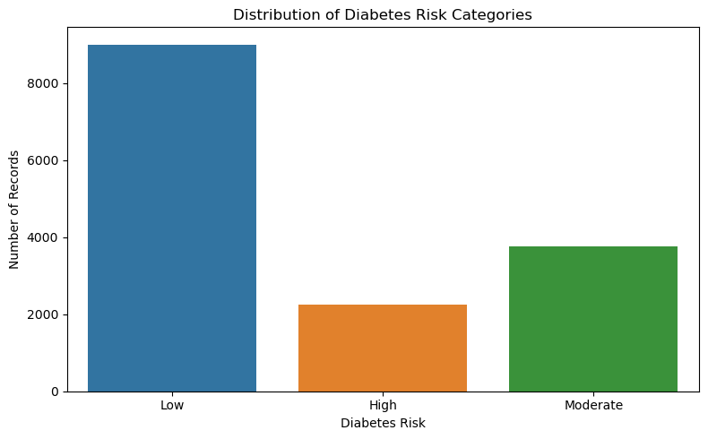
7.1 Distribution of Diabetes Risk Categories

A count plot was created to examine the number of records classified as Low, Moderate, and High risk.
The dataset contains 9,000 Low-risk records, 3,750 Moderate-risk records, and 2,250 High-risk records. These correspond to 60%, 25%, and 15% of the dataset, respectively.
The Low-risk category is the largest, while the High-risk category is the smallest. This shows that the dataset has an unequal distribution of diabetes-risk categories, which should be considered when interpreting subsequent comparisons.
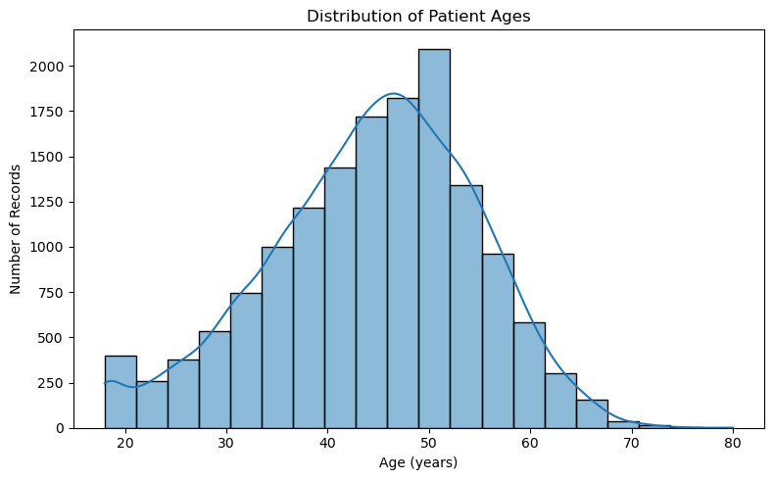
7.2 Distribution of Patient Ages

A histogram with a KDE curve was created to understand the age distribution of the records.
The chart shows that the largest concentration of observations occurs among adults approximately between 35 and 60 years of age. The highest frequency appears around the late 40s to early 50s. Comparatively fewer records occur among younger adults and at older ages, particularly above approximately 65 years.
This analysis provides an overview of the age composition of the dataset. However, the age histogram alone does not show whether diabetes risk differs by age.

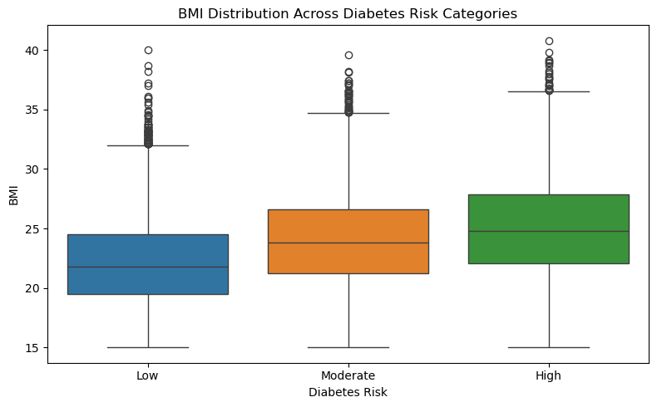
7.3 BMI Distribution Across Diabetes Risk Categories

A box plot was used to compare BMI distributions among the Low-, Moderate-, and High-risk categories.
The median BMI values are approximately 21.8 for Low risk, 23.8 for Moderate risk, and 24.8 for High risk. This upward pattern suggests that higher BMI is associated with higher recorded diabetes-risk categories in this dataset.
The distributions overlap, indicating that BMI values vary within each category and cannot completely distinguish the groups. Potential outliers appear above the upper whiskers in all three categories. These observations were not automatically removed because they may represent valid measurements rather than data-entry errors.
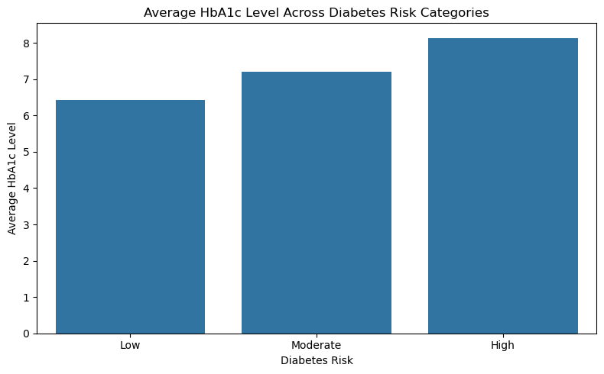
7.4 Average HbA1c Across Diabetes Risk Categories

The mean HbA1c level was calculated for each diabetes-risk category using Pandas grouping and aggregation.
The chart shows an increasing pattern in average HbA1c, from approximately 6.4 in the Low-risk category to 7.2 in Moderate risk and 8.1 in High risk.
This pattern indicates an association between higher average HbA1c and higher recorded diabetes-risk categories. Since HbA1c is a measure related to blood glucose, the result provides useful context for understanding the differences between the groups. However, the analysis does not establish causation or determine how the risk categories were assigned.

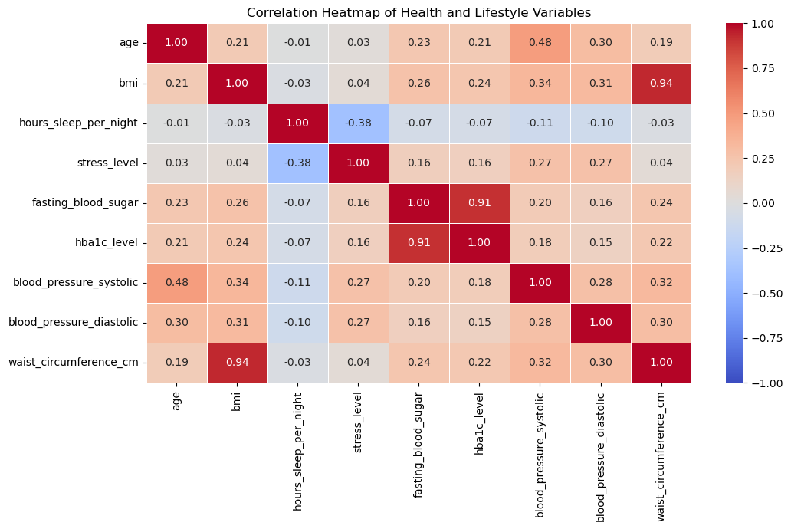
7.5 Correlation Analysis of Numerical Variables

A correlation heatmap was created to examine linear relationships between numerical health and lifestyle variables. The correlation matrix was calculated using Pandas corr() and visualized with Seaborn.
The strongest positive correlation was between BMI and waist circumference, with a coefficient of 0.94. Fasting blood sugar and HbA1c also showed a very strong positive correlation of 0.91.
Age and systolic blood pressure had a moderate positive correlation of 0.48. Sleep duration and stress level showed a negative correlation of -0.38, indicating that longer sleep duration tended to be associated with lower stress scores in the dataset.
The remaining variable pairs generally showed weaker relationships. The patient ID column was excluded from the final heatmap because it is an identifier rather than a meaningful health measurement.
These findings help identify relationships that may deserve further investigation. However, correlation measures association and does not prove causation.

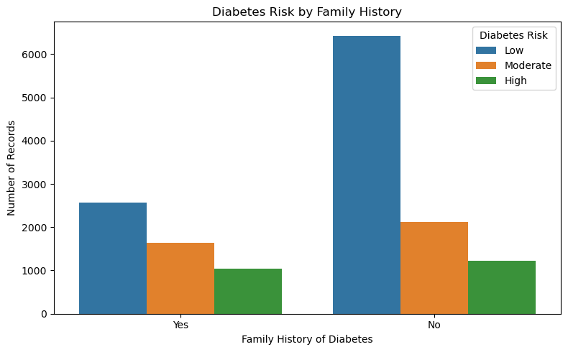
7.6 Diabetes Risk by Family History

A grouped bar chart was first used to compare the number of records in each risk category according to reported family history. Since the group sizes differed, percentages were then calculated within each family-history group using pd.crosstab() with row-wise normalization.
Among records without a reported family history, 65.86% were Low risk, 21.68% Moderate risk, and 12.46% High risk. Among records with a reported family history, 49.10% were Low risk, 31.18% Moderate risk, and 19.72% High risk.
The proportion of High-risk records was therefore 7.26 percentage points higher in the family-history group. The Low-risk proportion was lower, while the Moderate-risk proportion was higher.
This comparison suggests an association between reported family history and recorded diabetes risk in this dataset. However, the result is descriptive and does not establish causation or account for other factors that may influence risk.

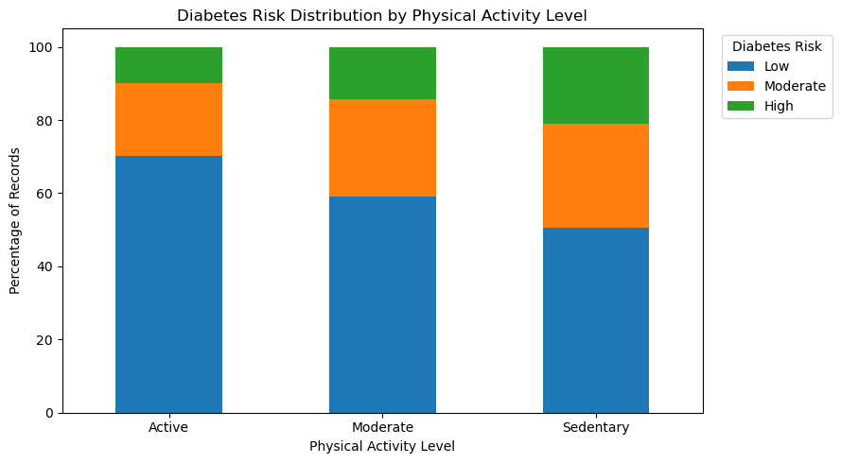
7.7 Diabetes Risk by Physical Activity Level

A percentage-based stacked bar chart was created to compare diabetes-risk categories across Active, Moderate, and Sedentary physical activity levels.
In the Active group, 70.12% of records were Low risk, 20.10% Moderate risk, and 9.78% High risk. In the Moderate activity group, the corresponding percentages were 59.09%, 26.55%, and 14.36%. In the Sedentary group, 50.48% were Low risk, 28.51% Moderate risk, and 21.01% High risk.
The proportion of High-risk records increased from 9.78% in the Active group to 21.01% in the Sedentary group, a difference of 11.23 percentage points. The Low-risk proportion showed the opposite pattern.
These observations suggest an association between physical activity level and recorded diabetes risk. However, the chart does not establish that physical activity alone explains the differences.

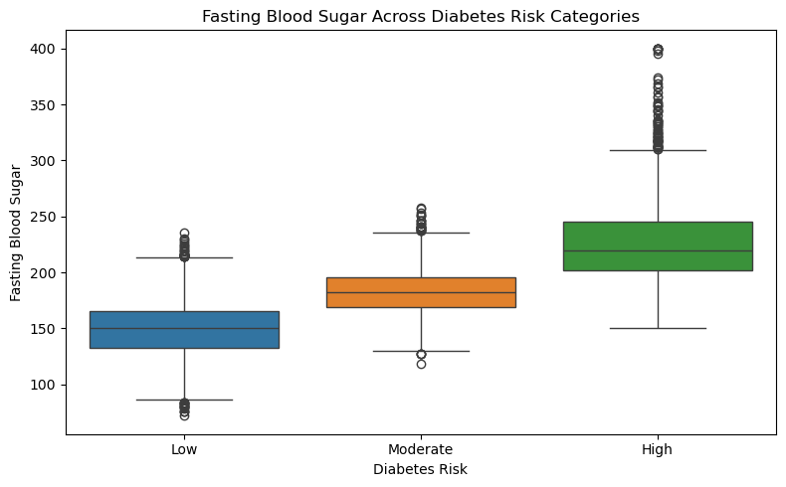
7.8 Fasting Blood Sugar Across Diabetes Risk Categories

A box plot and summary statistics table were used to compare fasting blood sugar levels across the three diabetes-risk categories.
The mean fasting blood sugar was 148.30 in the Low-risk group, 183.32 in the Moderate-risk group, and 226.54 in the High-risk group. The median values were 150, 182, and 220, respectively.
The High-risk group had the largest standard deviation at 36.40, compared with 24.87 in the Low-risk group and 19.73 in the Moderate-risk group. Its maximum value was 400, while the Low-risk group's minimum was 72.
The increasing mean and median values indicate an association between higher fasting blood sugar and higher recorded diabetes-risk categories. Potential outliers were retained because unusual measurements may be valid observations.

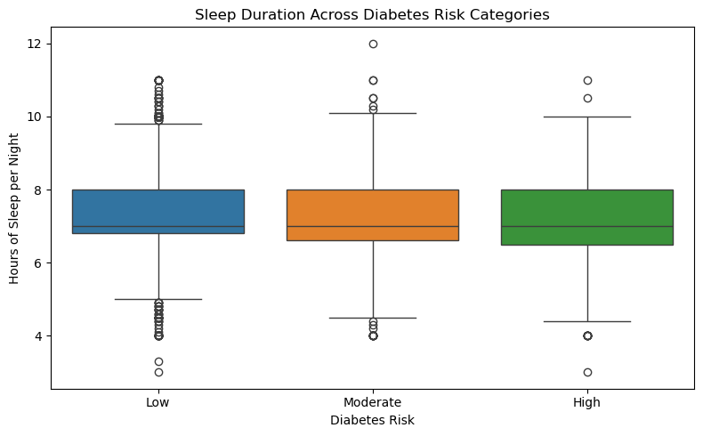
7.9 Sleep Duration Across Diabetes Risk Categories

A box plot and summary statistics table were used to compare sleep duration across the diabetes-risk categories.
All three groups had a median sleep duration of 7 hours per night. The mean values were 7.35 hours for Low risk, 7.27 hours for Moderate risk, and 7.23 hours for High risk. The standard deviations were also similar, ranging from 1.10 to 1.12 hours.
Compared with fasting blood sugar and HbA1c, sleep duration showed relatively little difference across the recorded risk categories. Potential outliers were visible in each group, including unusually low and high sleep durations.
This result indicates that sleep duration alone showed limited separation between the categories in this descriptive analysis. It does not establish whether sleep duration influences diabetes risk.
8. Summary of Key Findings
The analysis produced several important observations:
- Risk distribution: Low-risk records accounted for 60% of the dataset, followed by Moderate risk at 25% and High risk at 15%.
- Age distribution: Most records were concentrated among adults approximately 35–60 years old.
- BMI: Median BMI increased across the Low-, Moderate-, and High-risk categories.
- HbA1c: Average HbA1c increased across the recorded risk categories.
- Correlation: BMI and waist circumference had a correlation of 0.94, while fasting blood sugar and HbA1c had a correlation of 0.91.
- Family history: High-risk records accounted for 19.72% of the group reporting a family history, compared with 12.46% of the group reporting no family history.
- Physical activity: The proportion of High-risk records was 9.78% in the Active group and 21.01% in the Sedentary group.
- Fasting blood sugar: Both mean and median values increased across the risk categories.
- Sleep duration: Median sleep duration was 7 hours in all three categories, with only small differences in the group averages.
Taken together, these findings highlight differences in several health measurements and lifestyle groups. They also demonstrate how visualizations and descriptive statistics can be used to explore a dataset from multiple perspectives.
9. Limitations
Although the analysis revealed several patterns, some limitations should be considered.
First, the findings describe the available dataset and should not automatically be generalized to the wider population. The method used to assign the diabetes-risk categories is not established in this analysis. If variables such as HbA1c or fasting blood sugar were used to create those categories, their association with risk may partly reflect the category-generation method.
Second, correlation does not imply causation. Observed relationships may be influenced by other variables that were not investigated. Some comparisons are descriptive and do not include statistical significance tests or confidence intervals.
Finally, potential outliers were identified in some numerical variables. They were retained because they may represent genuine observations, but their validity cannot be confirmed from the visualizations alone.

10. Conclusion
During Week 2, I performed exploratory data analysis and visualization on the cleaned diabetes risk dataset containing 15,000 records and 19 columns. Using Pandas, Matplotlib, and Seaborn, I examined variable distributions, compared health measurements across diabetes-risk categories, and investigated correlations between numerical variables.
The analysis highlighted clear differences in BMI, HbA1c, and fasting blood sugar across the recorded risk categories. It also showed differences in the distribution of diabetes risk across family-history and physical-activity groups. In contrast, sleep duration showed relatively similar distributions and median values across the categories.
This work helped me develop practical experience in descriptive statistics, data grouping, percentage-based comparisons, correlation analysis, and visualization. It also reinforced the importance of interpreting results carefully and distinguishing association from causation.
Overall, the EDA process provided a clearer understanding of the dataset and demonstrated how visual analysis can help identify patterns and generate questions for further investigation.
11. References
- Dataset: https://www.kaggle.com/datasets/mansiaggarwal88/diabetes-risk-prediction
- Pandas documentation: https://pandas.pydata.org/docs/
- Matplotlib documentation: https://matplotlib.org/stable/
- Seaborn documentation: https://seaborn.pydata.org/
- Jupyter documentation: https://docs.jupyter.org/

