**Background**

For Singapore, the challenge of an ageing population is a real one. As mentioned by Mr Gan Kim Yong, Minister for Health at the SG50 Scientific Conference, the number of seniors aged over 65 years will more than double from 430,000 today to over 900,000 in 2030

<https://www.moh.gov.sg/content/moh_web/home/pressRoom/speeches_d/2015/speech-by-mr-gan-kim-yong--minister-for-health--at-the-sg50-scie.html>.

This brings with it a lot of economic and social challenges, and will greatly affect Singapore in the future.

Knowing this, Singapore has begun preparations to accommodate the growing ageing population. In his speech, Mr Gan has highlighted various changes in the workplace, health and Urban Planning that needs to take place. For my assignment, I would like to focus on the problem of Urban Planning, which I feel is the most important of the three. As we spend the most amount of time in our homes, I feel that a convenient home and community is essential for a high quality of life. This is even more so for the elderly, as moving around becomes increasingly difficult for them due to their physical limitations.

As such, I will be looking at the efforts of the Building and Construction Authority (BCA) in their construction of accessible residences and MRT stations, and hope to help the BCA identify regions that require more attentions.

http://www.bca.gov.sg/friendlybuilding/Contents/Contents.aspx?Id=44

**Implementation**

**Data Preparation**

I will be using data from a dataset of accessible buildings(BFA dataset) provided by the BCA, which can be obtained from Data.gov.sg. However, the dataset includes all buildings, including train stations, community centres and many others. Furthermore, the dataset lacks information that would allow me to extract the residence data. As a result, I had to use another method to filter the results. Using the search and filter function provided by the BCA website, I managed to locate accessible MRT stations, I then crawled the site for the list of station names, and joined the table with the one I had obtained from Data.gov. This allowed me to obtain the coordinates of the stations.

<http://www.bca.gov.sg/friendlybuilding/FindBuilding/FriendlyFeatures.aspx>

Joining this table with the dataset of all MRT stations obtained from DataMall @MyTransport.SG, I get a final dataset of all MRT stations, which can be classified according to whether it is accessible or not.

I attempted to use the same procedure for accessible residences, however perhaps due to the difference in versions of the databases, a large number of results were lost. The query on the BCA website returned 346 results, however after joining the residence names with the BFA dataset, I was left with 279 results. To remedy that, I had to crawl the BCA website for the residence names and postal codes, and geocode it using the geocode introduced in the lab.

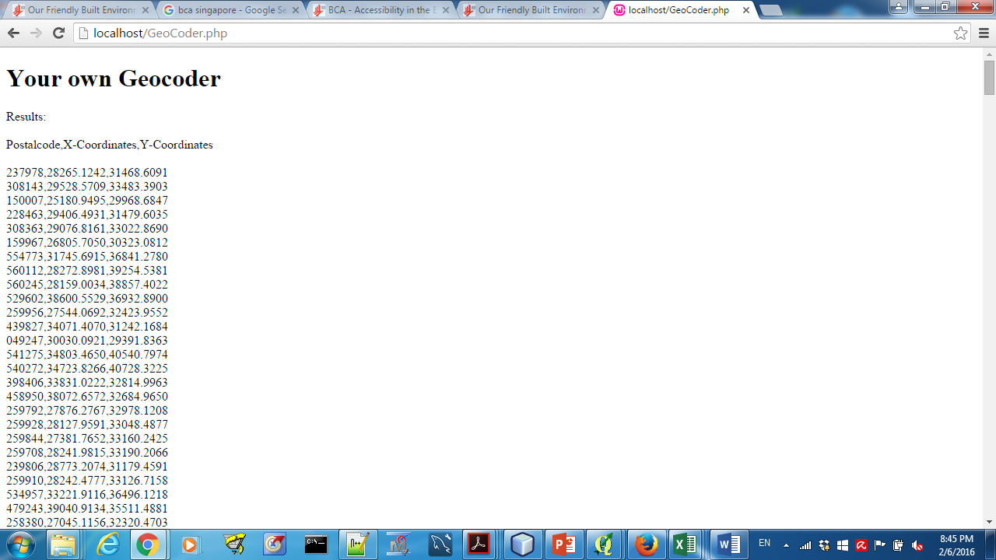

As expected, the geocoder produced some errors.

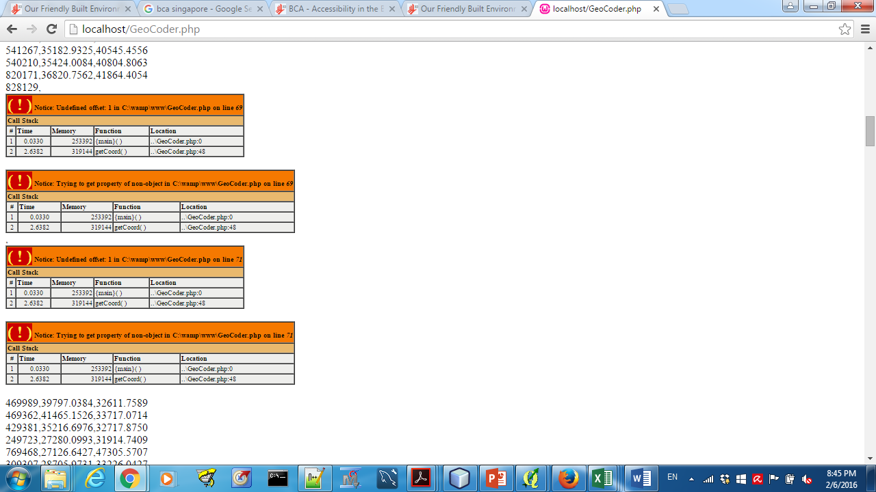

For the postal codes that could not be geocoded, I used batchgeocoder <http://www.findlatitudeandlongitude.com/batch-geocode/#.VrYBjrJ942x> to get the latitude and longitude, then converted it to SVY21 using onemap http://onemap.sg/api/help/htmlsource/convertcords.aspx

Map

**Base layer**

For the base layer of my web application, I will be using the base map from Open Street Map

**Layers**

In addition to the base map, I have added several layers that can be accessed by the layer control on the top right corner of the map. All layers have features that will generate a popup showing its attributes when clicked on, and the color-coded layers like the choropleth and MRT station layers have legends that will appear when the layers are added to the map.

Choropleth Layer

The choropleth layer is created using the 2014 Master Plan data obtained from data.gov.sg. Using QGis, I summed up the population of residents aged 60 and above for each subzone. I used the age of 60 and not 65 as a cut-off point because I would like to provide a view of the demographic distribution 5 years into the future. The choropleth map is created by classifying this value into 5 categories, differentiated by color. The choropleth map is used to show the distribution of the elderly across the country. From the map, it can be seen that the Tampines and Bedok regions have a high number of residents above the age of 60.

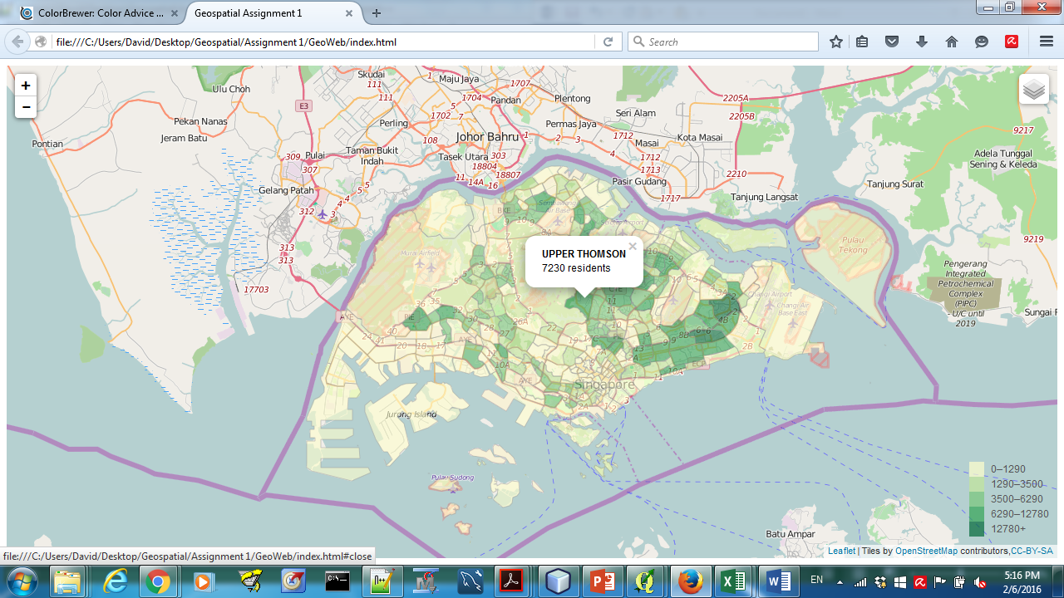

Point Symbol Map

This layer consists of a point symbol map, with each point showing the location of an accessible residence. From the map, 3 main clusters of accessible residences can be observed.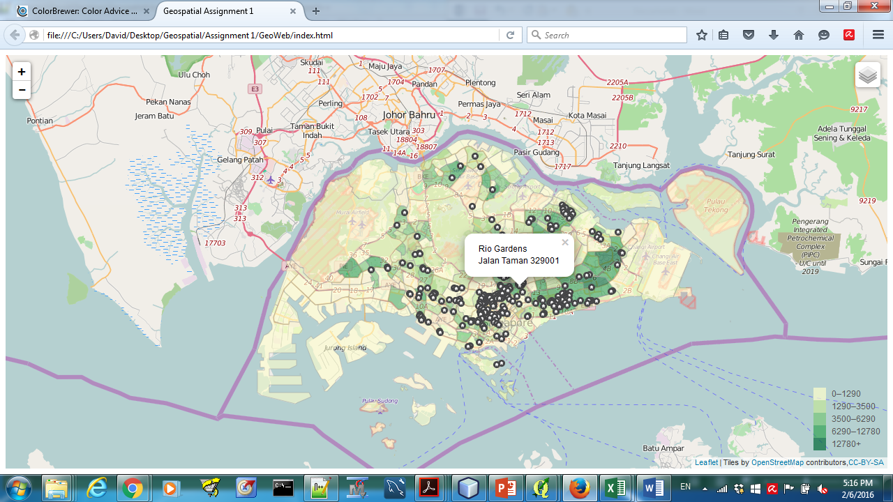

Proportional Symbol Map-Number of residences in subzone

This proportional symbol map is created by counting the number of accessible residences in each subzone using the points in polygon method in QGis. The points of the proportional symbol map are placed at the centroid of each subzone, and the area of the circles are proportional to the number of residences in the subzone. Combining both the choropleth and proportional symbol map, we should expect to see bigger circles in darker areas, symbolizing large number of accessible residences in subzones with many elderly residents.

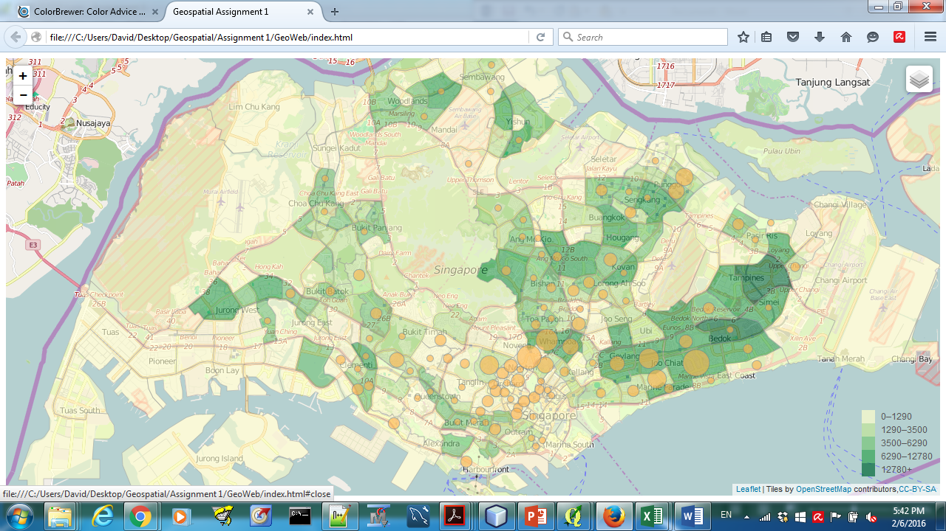

We are however presented with a different picture. There is a large number of residences in central, which has low elderly population, and some of the most heavily populated subzones like Tampines, Bedok and Jurong don’t have a low number of residences.

Line Symbol Map

This layer consists of Singapore’s MRT lines, to help users visualize the connectivity of the country. As expected, the subway line passes through most of the populated regions. This layer can be viewed along with the fourth layer, which is Singapore’s MRT stations, to help users visualize “breaks” in the MRT connectivity.

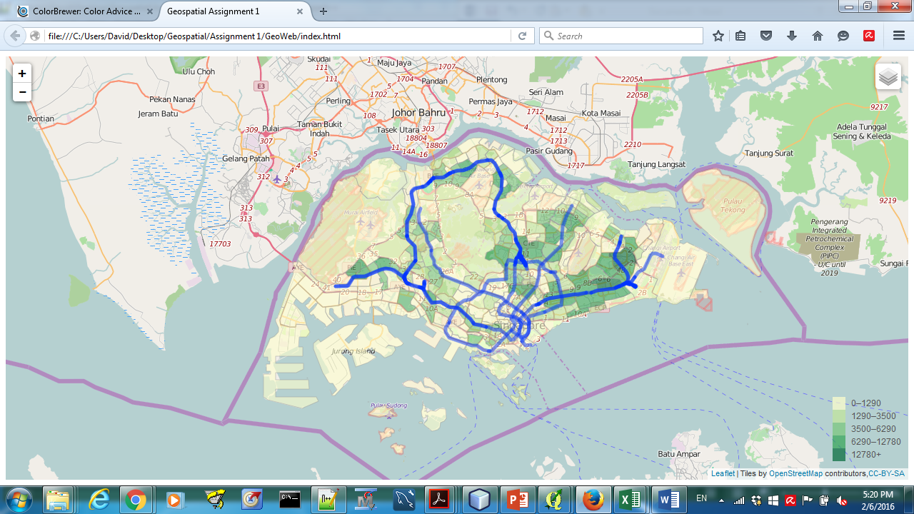

Point Symbol Map-MRT Stations

This layer is another point symbol map, with each point representing a MRT station. By joining data obtained from the BCA website and joining it with the MRT Station data obtained from DataMall @MyTransport.SG, I have been able to differentiate accessible stations with those that are not. Accessible stations are blue in color while regular ones are in red. The legend can be found at the bottom right of the map and appears with the layer.

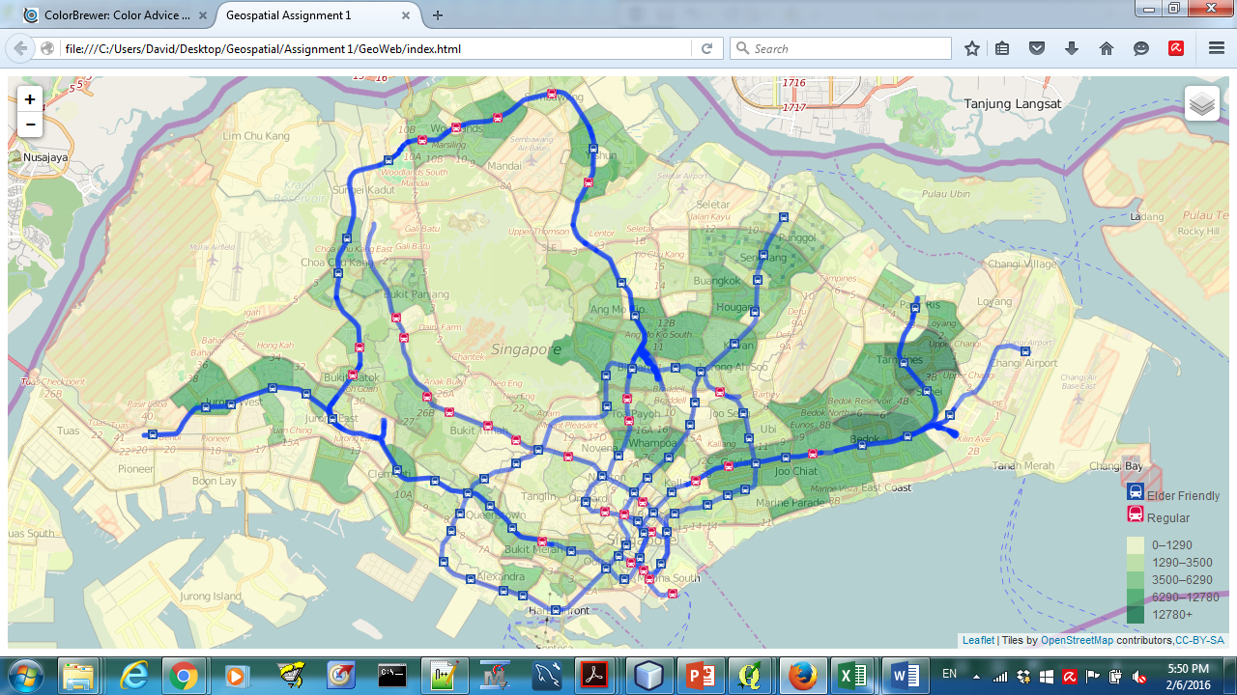

Thankfully, the areas with the highest number of elderly citizens have accessible MRT stations. However, it is worth noting that there is a long stretch in the northern area, from Marsiling to Sembawang with no accessible stations. There is a moderate number of elderly residents living in the area, who will find travel to and from their home difficult.

Buffer layer

This last layer is implemented using QGis, by creating a buffer of 500m with accessible MRT stations as the center. This, coupled with the accessible residence layer, shows a correlation between the location of accessible MRT stations and Residences. However, it is interesting to note that the Eunos and Ponggol stations are rather far away from the majority of accessible buildings in its vicinity.