Отчёт по учебной практике

Работа №3

Студента группы ИСП11-322АП
Максимов М.М
Проверил: Ильин А.А.

Москва 2025

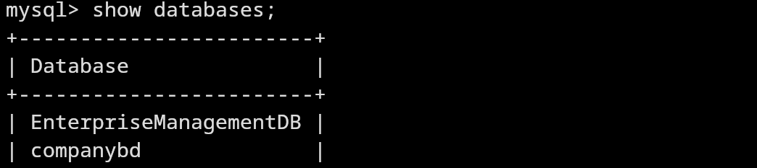

Рисунок 1. создание базы данных EnterpriseManagementDB

Создание таблиц базы данных
use EnterpriseManagementDB;
CREATE TABLE Departments (
DepartmentID INT AUTO_INCREMENT PRIMARY KEY,
DepartmentName VARCHAR(255) NOT NULL UNIQUE,
ManagerID INT NULL,
Budget DECIMAL(15,2) NOT NULL CHECK (Budget >= 0),
CreatedAt DATE NOT NULL DEFAULT (CURRENT_DATE),
CONSTRAINT fk_manager FOREIGN KEY (ManagerID) REFERENCES Employees(EmployeeID) ON DELETE SET NULL
);

CREATE TABLE Employees (
EmployeeID INT AUTO_INCREMENT PRIMARY KEY,
LastName VARCHAR(255) NOT NULL,
FirstName VARCHAR(255) NOT NULL,
BirthDate DATE NOT NULL,
HireDate DATE NOT NULL,
Position VARCHAR(255) NOT NULL,
Salary DECIMAL(15,2) NOT NULL CHECK (Salary >= 30000),
DepartmentID INT NOT NULL,
CONSTRAINT fk_department FOREIGN KEY (DepartmentID) REFERENCES Departments(DepartmentID) ON DELETE SET NULL,
CONSTRAINT chk_age CHECK (BirthDate <= DATE_SUB(CURRENT_DATE, INTERVAL 18 YEAR)),
CONSTRAINT chk_hire CHECK (HireDate >= DATE_ADD(BirthDate, INTERVAL 18 YEAR))
);

ALTER TABLE Departments ADD CONSTRAINT fk_manager FOREIGN KEY (ManagerID) REFERENCES Employees(EmployeeID) ON DELETE SET NULL;

CREATE TABLE Projects (
ProjectID INT AUTO_INCREMENT PRIMARY KEY,
ProjectName VARCHAR(255) NOT NULL UNIQUE,
StartDate DATE NOT NULL CHECK (StartDate >= CURRENT_DATE),
EndDate DATE NULL CHECK (EndDate IS NULL OR EndDate >= StartDate),
Budget DECIMAL(15,2) NOT NULL CHECK (Budget >= 0),
DepartmentID INT NOT NULL,
CONSTRAINT fk_project_department FOREIGN KEY (DepartmentID) REFERENCES Departments(DepartmentID) ON DELETE CASCADE
);

CREATE TABLE EmployeeProjects (
EmployeeID INT NOT NULL,
ProjectID INT NOT NULL,
Role VARCHAR(255) NOT NULL,
HoursWorked INT NOT NULL CHECK (HoursWorked >= 0),
PRIMARY KEY (EmployeeID, ProjectID),
CONSTRAINT fk_emp_proj_employee FOREIGN KEY (EmployeeID) REFERENCES Employees(EmployeeID) ON DELETE CASCADE,
CONSTRAINT fk_emp_proj_project FOREIGN KEY (ProjectID) REFERENCES Projects(ProjectID) ON DELETE CASCADE
);

CREATE TABLE Salaries (
SalaryID INT AUTO_INCREMENT PRIMARY KEY,
EmployeeID INT NOT NULL,
Amount DECIMAL(15,2) NOT NULL CHECK (Amount >= 30000),
PaymentDate DATE NOT NULL CHECK (PaymentDate <= CURRENT_DATE),
CONSTRAINT fk_salaries_employee FOREIGN KEY (EmployeeID) REFERENCES Employees(EmployeeID) ON DELETE CASCADE
);

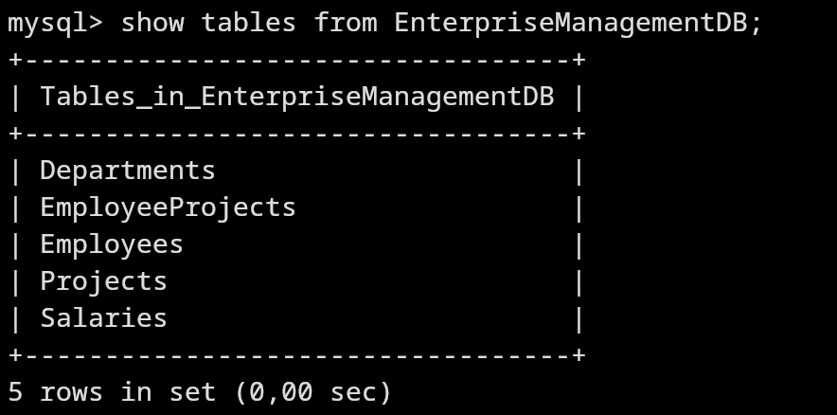

Рисунок 2. созданные таблицы

use EnterpriseManagementDB;
INSERT INTO Employees (LastName, FirstName, BirthDate, HireDate, Position, Salary, DepartmentID) VALUES
('Чичиков','Артемий',2006-02-17,2025-02-05,'разработчик','5000',3),
('Башкиров', 'Илья', '2004-04-01', '2010-11-30', 'Team Lead', 150000, 2),
('Макаров', 'Женя', '2004-06-06', '2010-11-30', 'копирайтер', 100, 3),
('Семечаевский', 'Паша', '2004-02-08', '2010-11-10', 'техподдержка', 65000, 1),
('Сидорова', 'Аня', '1992-07-22', '2018-08-05', 'Менеджер', 50000, 2),

INSERT INTO Projects (ProjectName, StartDate, EndDate, Budget, DepartmentID) VALUES
('Разработка CRM-системы', '2025-04-01', '2025-12-31', 150000.00, 1),
('Запуск мобильного приложения', '2025-05-15', NULL, 200000.00, 2);

INSERT INTO EmployeeProjects (EmployeeID, ProjectID, Role, HoursWorked) VALUES
(1, 1, 'Backend-разработчик', 40),
(2, 1, 'Технический руководитель', 35),
(3, 2, 'Контент-менеджер', 25),
(4, 1, 'Тестировщик', 30),
(5, 2, 'Проджект-менеджер', 45);

SELECT
e.EmployeeID,
CONCAT(e.LastName, ' ', e.FirstName) AS FullName,
d.DepartmentName
FROM Employees e
LEFT JOIN Departments d ON e.DepartmentID = d.DepartmentID;

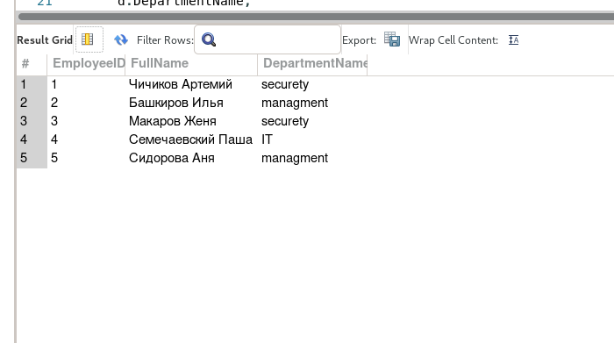
Рисунок 3. Список сотрудников с названиями отделов
SELECT
ep.ProjectID,
p.ProjectName,
CONCAT(e.LastName, ' ', e.FirstName) AS Employee,
ep.Role
FROM EmployeeProjects ep
JOIN Employees e ON ep.EmployeeID = e.EmployeeID
JOIN Projects p ON ep.ProjectID = p.ProjectID;
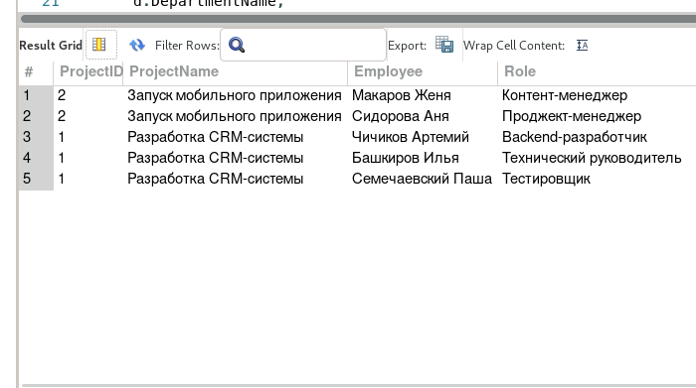
Рисунок 4. Участники проектов с ролями
SELECT
d.DepartmentName,
ROUND(AVG(e.Salary), 2) AS AvgSalary
FROM Employees e
JOIN Departments d ON e.DepartmentID = d.DepartmentID
GROUP BY d.DepartmentName;
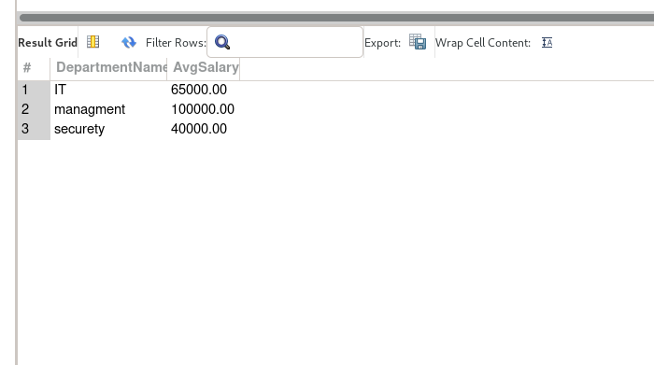
Рисунок 5. Средняя зарплата по отделам
SELECT
CONCAT(LastName, ' ', FirstName) AS Employee,
Salary
FROM Employees
WHERE Salary > (SELECT AVG(Salary) FROM Employees);
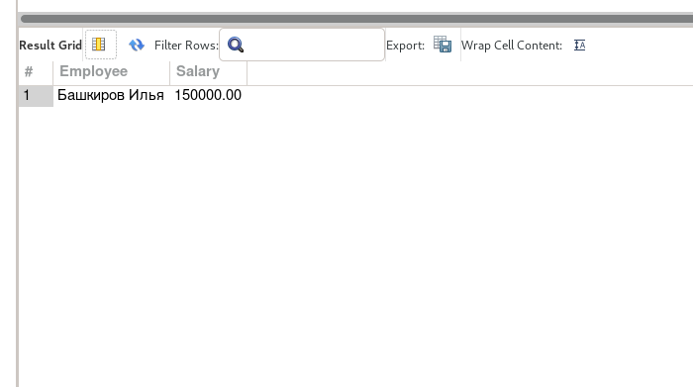
Рисунок 6. Сотрудники с зарплатой выше средней
SELECT
e.EmployeeID,
CONCAT(e.LastName, ' ', e.FirstName) AS Employee,
e.Position
FROM Employees e
LEFT JOIN Salaries s ON e.EmployeeID = s.EmployeeIDEmployeeIDProjectID
WHERE s.SalaryID IS NULL;
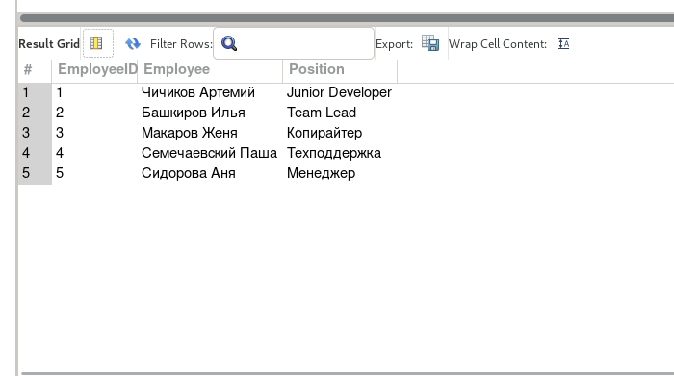
Рисунок 7. Сотрудники без выплат

