README

- raw_data.pdf can serve as an example of unstructured data from the lab to be fed to an AI workflow to structure data.
- structured_data.xlsx can be the output of the data processing workflow. It could be displayed in a polished fashion in some viewer in the GUI.
- test_set_predictons.csv consists of batch-wise predictions of a real hybrid model trained on a synthetic lactic acid dataset (based on real literature data). Once model fitting is done, model metrics can be shown in a table for all outputs (test_metrics.csv). Trajectories and experimental points can be shown on such plots for various variables (can cycle through them in GUI)
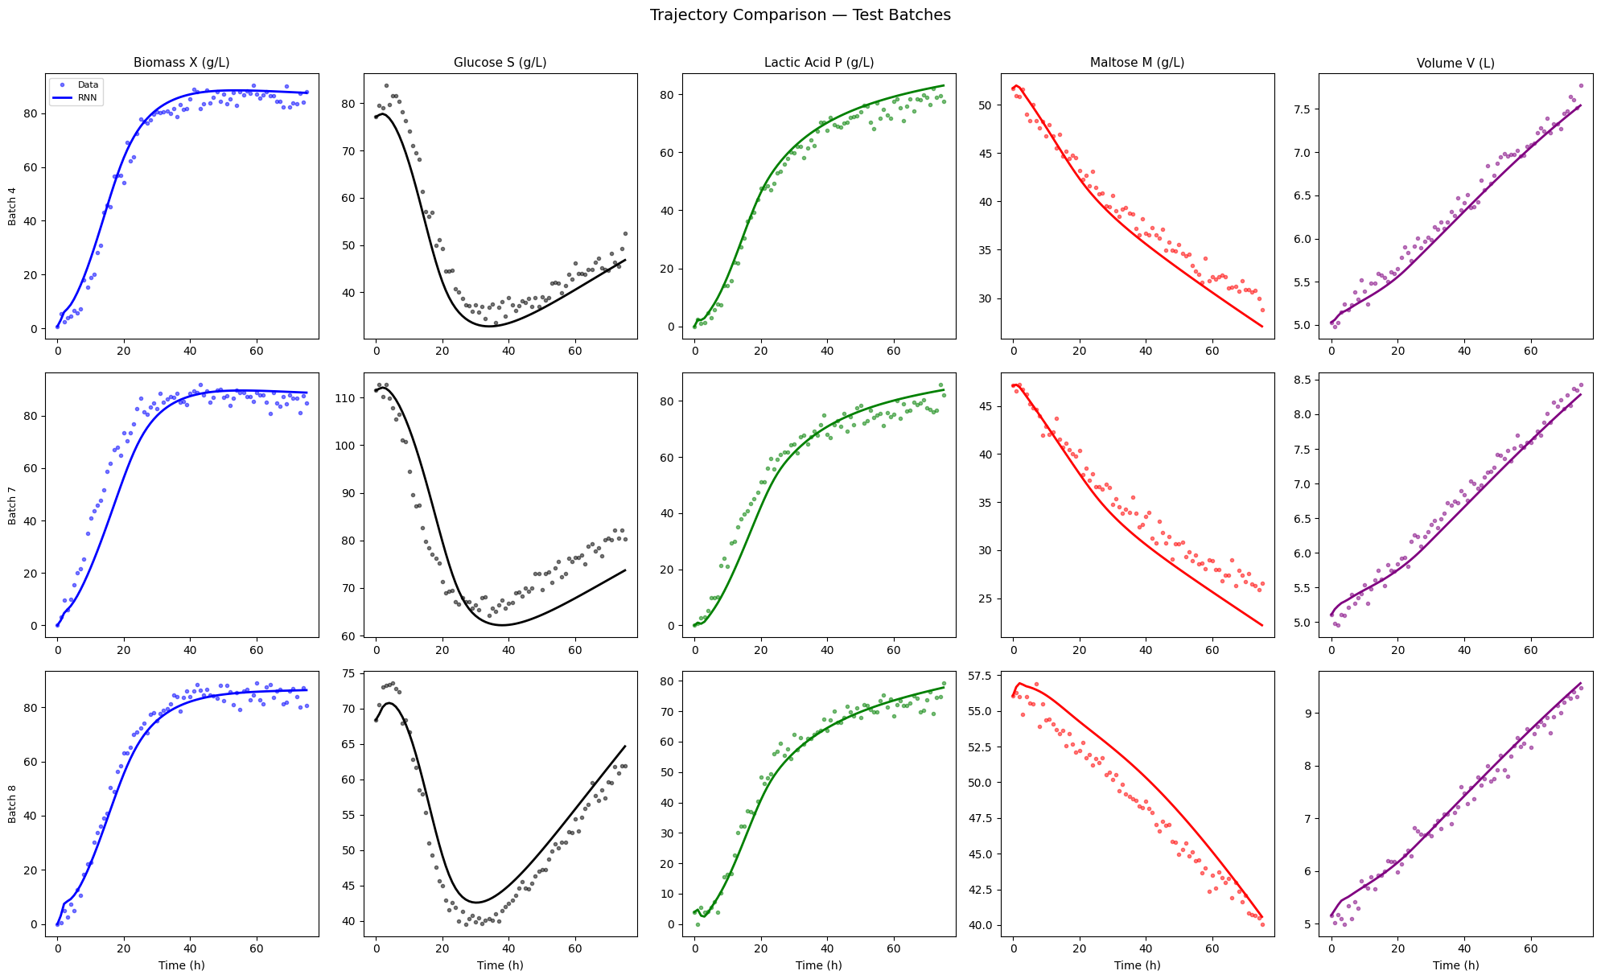

Scenario 1:
- Golden batch trajectory is in golden_batch_trajectory.csv, showing ideal product concentration as a function of time.
- Noisy measurements up to 15 hours (when anomaly is detected) is given in suboptimal_noisy_measurements.csv.
- Then, the suggestion is to reduce feed flowrate, and different scenarios are shown, where the input flow rate is 1x (no change), 0.8x, 0.6x, and 0.5x the current flowrate. For each of these trajectories are provided which can be continued from where the noisy measurements end to show prediction for final product concentration as a function of time.
- The tool can then highlight 0.5x as the recommended action.
- The reason for the deviation is that feed composition is not what was expected (higher fraction of maltose as compared to glucose than expected). The reason for the action is that reducing flowrate reduces dilution and hence keeps concentration of biomass and glucose high to raise rate.

