© Copyright Broadsword Interactive 1997

AI Architectural Design
This document is a brief overview of the architecture of the artificial intelligence module of “Spirit of Speed”

Shona M^{c}Neill (smcn@broadsword.demon.co.uk)
Revision: 1.2

Created: 17/2/98
Last Revised: 08/11/26
Document State: Draft

Introduction

The AI consists of 2 distinct layers of behaviours. The low-level behaviours can be thought of as instincts. These control such basic activities as following a racing line, using accelerator and brakes to drive at a desired speed, and changing gear when appropriate. These are implemented using simple feedback techniques from Control Systems Theory. The high-level behaviours are concerned with the actual strategy elements of racing - passing and blocking rival drivers - and are implemented using more advanced AI techniques.

Overview

The simple low-level behaviours make use of a Control Systems Theory technique known as a PID Control. This is a simple but effective technique for quickly homing in on a goal commonly used in thermostats. The change to make at any time (be it in steering or heating) is calculated from the error (difference between current and goal positions). The change is the sum of 3 components - one proportional to the error, one proportional to the Integral of the error (the total sum of all errors so far), and one porportional to the Differential of the error ( difference between current and previous errors). The exact relationship between the 3 components varies depending on the sort of problem the control is being applied to. In our case, the values are found using the Genetic Algorithm.

The high-level behaviours are implemented using a more typical AI approach. The AIController object contains an array of ‘behaviour objects’ connected into a Spreading Activation Threshold Network - an artificial intelligence technique which allows complex behaviour patterns to emerge from several simple behaviours. Each of these behaviour objects represents a pattern of behaviour the driver can adopt - for example, attempting to overtake the car in front, blocking a car from overtaking or staying on the racing line.

When the AIController object is asked for a control packet, it tells each of its component behaviours to examine the current state of the entire game world (e.g. the state of the car, where the other cars are, position on the track). Each behaviour then assigns a score to itself - the higher the score, the closer to ‘activation’ that behaviour is. The behaviour can then pass a portion of its score onto some other behaviours, so that they become more likely to happen too. These behaviours can then pass some of that score on, so that the activation of one behaviour spreads throughout the network - hence ‘Spreading Activation Threshold Network’.

Finally, the AIController looks through all its behaviours, finding those whose score exceeds the behaviour activation threshold. It then picks one of these behaviours in a weighted random fashion, and calls its Action method to actually run the behaviour. This, in combination with the lower-level ‘instinctive’ behaviours, produces a control packet which the AIController returns.

Example Iteration

Consider the following network:

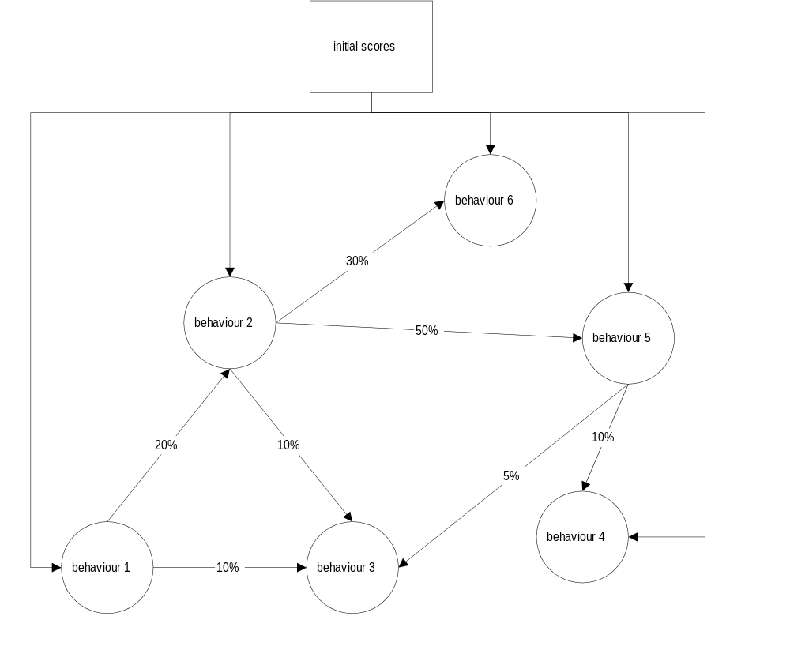

If behaviour 1 is given an intial score of, say, 10, then it will pass 1 point onto behaviour 3, and 2 points onto behaviour 2, and add the remaining 7 onto its total score.

Behaviour 2 will pass 1 point onto behaviour 5, but pass nothing to behaviours 3 and 6 as the scores added would be less than 1. It will then add the remaining point to its total score.

Behaviour 3 will add its 1 point to its total score as it doesn’t pass any points on to other behaviours, and behaviour 5 will add its one point to its total score.

Thus the activation points spread through the network of behaviours as each initial score is processed.

Tuning

The final AI, with its multiple behaviours each with its many passing percentages will be far too complex to tune by hand. Instead, a Genetic Algorithm will be used to “breed” the best drivers.

Genetic Algorithms are a class of optimisation technique which work by mimicking natural selection. The values of the various variables that affect the behaviour to be optimised are concatenated to form a “genome”. Initially, a population of randomly-generated individuals is created. These are then tested for how well they fit the desired behaviour. The fittest individuals are allowed to breed, and their genomes are crossed randomly with a small chance of mutation to produce new individuals to replace the least fit members of the population. Thus, over several generations the individuals in the population come to fit the desired behaviour.

The advantages of a Genetic Algorithm is that it doesn’t get caught in local maxima of the solution space and makes no assumption about what the exact solution will be. It is also well suited to automation - a computer can be left running overnight to breed many generations unattended.

For this application, our genome will be the concatenation of all the passing percentages of the behaviours that make up the AI with the activation threshold. This will be processed in Gray-coded form, which will make the genome much more stable under mutation.

Individuals will be awarded points for:
- Winning a race
- Finishing in the top 2 in a race
- Finishing in the top 3 in a race
- Breaking the lap record
- Breaking the race record

Individuals will have points taken away for:
- Failing to finish
- Finishing last
- Finishing in the last 2 in a race
- Finishing in the last 3 in a race
- Wandering off the track
- Sitting around doing nothing

The Genetic Algorithm will be enclosed in a separate stand-alone program that will generate AI personality files to be loaded by the game, and will process results files generated by the game.
Results will be generated over 20 races for each generation. Randomly-chosen tracks will be used to prevent breeding of a track-specific AI, though car-specific AI will probably have to be bred. There will be a population size of 16 individuals.

Genetic Algorithm Program Details

The Genetic Algorithm program takes 3 command line arguments - an input directory, an output directory, and a results file. The persona/genome files are named numerically from 00 to 15 within the specified directories. In addition the Genetic Algorithm uses a Records file to store lap and race records for each track, which are updated each generation.

Genomes are read from the input directory, scored using the results file, bred, and then the new generation is written to the output directory.

The RNDAI program takes just one command line argument - an output directory. It randomly generates a population of genomes and writes them, in numerically named files 00 to 15 to the output directory. It is used to generate an initial generation for the Genetic Algorithm.

The INITPARM program takes no command line arguments and generates a new Records file with all track race and lap records reset to 0.

The WTAI program allows a genome file to be edited by hand, which can be useful for building a non-random intial population in those cases where there is some idea of where the solution may lie.

Object Details

AIController::LocalController::Controller

overview
This is the class which encapsulates the overall AIController object. It has the same interface as the LocalController object, which is described in the Overview document. It is subclassed from the LocalController so that in a network game with AI drivers, all AI will run on the server machine reducing the need for synchronisation of random number generators over the network.

public methods

AIController
Constructor for AIController class. Loads AI Persona, creates the Behaviours, and points them at the persona data.

class ctrlpckt GetControlPacket()
Implementation of generic Controller class pure virtual function. Generates a ctrlpckt which is returned as well as being copied to the network via LocalController::SendControlPacket.

Behaviour

overview
This is an abstract class from which are subclassed the behaviour objects.

methods

void ExamineInput()
Calls CalculateScore to generate the new score, then passes this to AcceptScore.

void AcceptScore(int score)
Passes the appropriate percentages of the score to other linked Behaviours via their AcceptScore methods and then adds the points left to totalscore.

pure virtual methods
These are methods which are not implemented in the Behaviour class, but are implemented in the subclasses.

void Action()
The action taken by the behaviour. Called when the Behaviour is activated.

int CalculateScore()
Returns a score based on the current world state.

Persona

overview
The Persona class encapsulates all the data for the AI that is bred through the Genetic Algorithm.

methods

void Load(char *name)
Loads the persona data from the specified file.

RaceResults

overview
The RaceResults object collates results data for the race and saves it to a results file for the use of the Genetic Algorithm. The results are entered into the structure from the main game, and the Save method called once the race ends and all results are in.

methods

int Load(HFILE h)
Loads a RaceResults from the open file h. Used by the Genetic Algorithm program only.

Int Save(HFILE h)
Writes a RaceResults to the open file h.

Void Clear()
Clears the RaceResults object.

