Combining Multiple Objects Inside
3D Studio Max

Broadsword Interactive Limited
04 December 1998
1.0
Andy Nicholas

Table Of Contents

Table Of Contents 2

Combining Multiple Objects Inside 3D Studio Max 3

Document Change History 5

Combining Multiple Objects Inside 3D Studio Max

By following the steps below, it is possible to combine a number of seperate objects into an editable mesh object with a single multi-sub material applied.

- Select the utilities panel, and start the Max Script Utility.
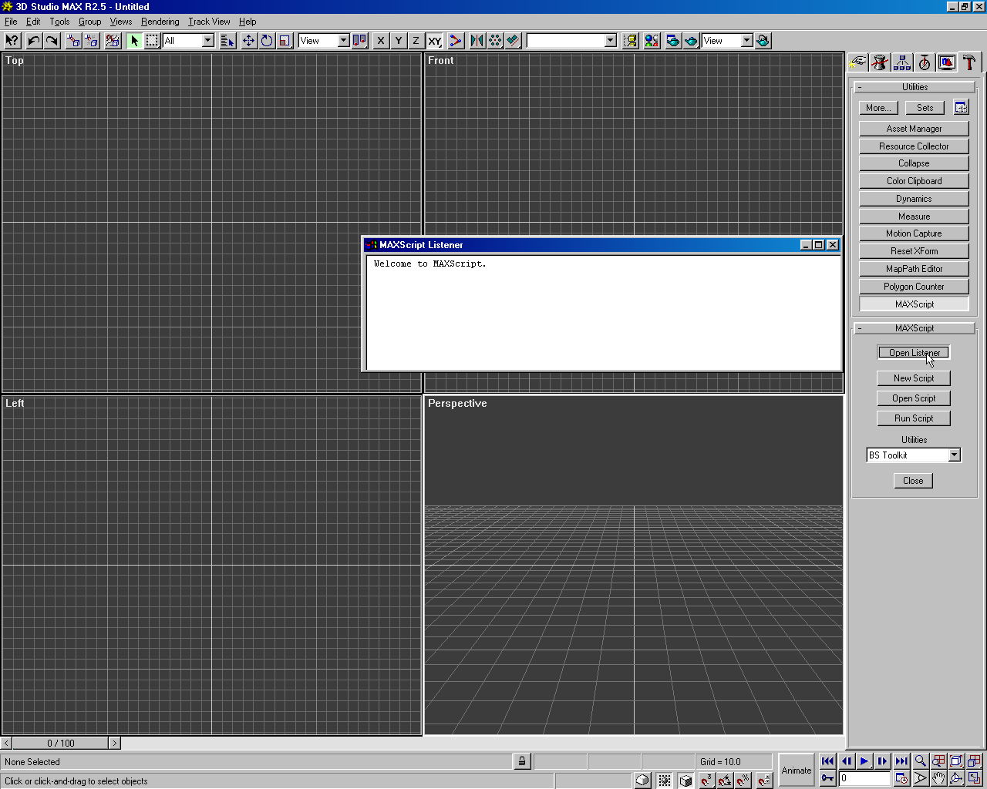
- Click on the ‘Open Listener’ button, and a text window will appear.

- Type “ConvertToMesh $*” and press Enter.
- Close the ‘Listener’ window and Max Script, and go to the modify panel.
- Select any object.
- Make sure you are outside the Sub-Object level, and click on ‘Attach Multiple’
- In the dialogue box that appears, click on ‘All’ underneath the list box, and press ‘Attach’
- Another dialogue box will now appear. Select the top option (‘Match material Ids to Material’) with the ‘Condense Material and Ids’ check box selected,and press OK.

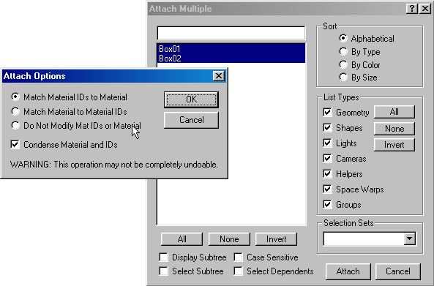

- Save the scene with any name. This is just a temporary file to be used in step 12.
- Go to the file menu and select ‘Reset’. Click on ‘Yes’ to confirm that you wish to reset.
- After 3D Studio has reset, go back to the file menu and select ‘Merge’.
- Select the 3D Studio scene file that you saved in step 9, and click on ‘Open’.
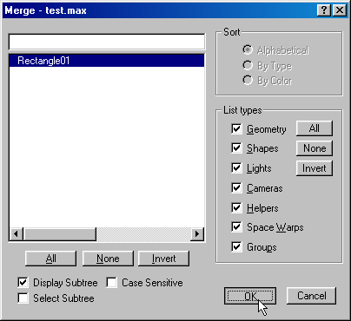
- In the dialogue box that appears, there should only be one object. Select this object and click on ‘OK’. If there is more than one object listed, then you did not select all objects in step 7.

- 3D Studio will now load in the object with the single material applied.
- To view the multi-sub material, open the 3D Studio Material Editor and either use the eydropper tool on the object, or click on the ‘Get Material’ button and select the ‘From Scene’ check box to view the material name.

Document Change History

Revision number | Date of change | Nature of change | Changed by

