3D Studio Max 2.5
MaxScript Plugin Documentation

Broadsword Interactive Limited
13 November 1998
Version 1.1
Andy Nicholas

Table Of Contents

Table Of Contents 2

MaxScript Launcher 3
Material Properties Plugin 4
Rename Bitmaps Plugin 6
Point Dropper Plugin 7
Set Points Plugin 9

Document Change History 13

MaxScript Launcher

Installation

To install the MaxScript plugins, the following files should be copied to the appropriate directories as show below:

Broadserver Library:/MaxScript Plugins/BSToolKit_n.ms → 3DSMax2.5/Scripts/
Broadserver Library:/MaxScript Plugins/Startup.ms → 3DSMax2.5/Scripts/Startup/

To complete installation, either restart 3DSMax or call Startup.ms directly from MaxScript.

Overview

The plugins consist of a main dialogue which launches a number of other plugins. This dialogue may be turned into a normal window by clicking ‘Float’ to provide easy access to the MaxScript plugins. There are currently 6 plugins that may be accessed from this dialogue:

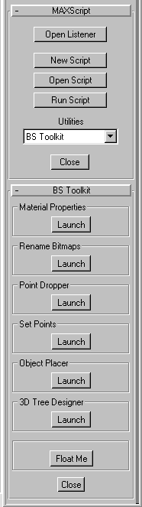
Material Properties: Allows easy suffixing of materials within 3DSMax scenes for compatability with the real time 3D graphics engine naming conventions.

Rename Bitmaps: Renames bitmap filenames on disk (including up to two extra specified paths for any existing backups), while automatically updating materials that reference the filenames.

Point Dropper: Allows vertices of an Editable Mesh object to be dropped in the negative Z direction onto a specified object.

Set Points: One or more vertices may be set to specific values along specified world coordinates, or aligned to the coordinates of an existing vertex.

Object Placer: Clones a specified object and places it at coordinates specified by a text file.

3D Tree Designer: Creates low polygon trees of a specified size, type and number. This plugin is currently incomplete, hence no documentation is included at present.

By clicking on ‘Launch’, the desired plugin will appear in its own floating window.
Material Properties Plugin

Allows easy suffixing of materials within 3DSMax scenes for compatability with the real time 3D graphics engine naming conventions.
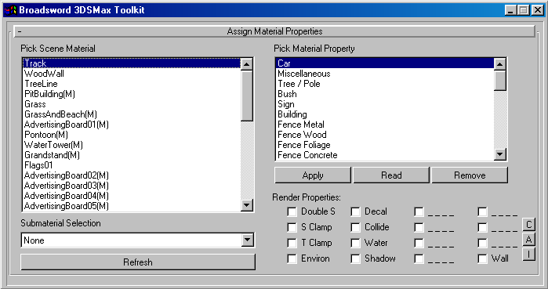

Reference

Button descriptions:

Apply - Applies the panel settings to the currently selected material/submaterial.
Read - Copies the settings from the material/submaterial to the panel.
Remove - Deletes the material code from the currently selected material/submaterial
C - Clears the render properties check boxes.
A - Sets all the render properties check boxes.
I - Inverts the current selection of check boxes.
Refresh - Updates the Scene Material list and the Material Property list.

It is strongly recommended that ‘Refresh’ is used when re-entering the plugin after any work has been done in the main 3DMax editor window if the plugin has been left active.

Due to the nature of the seven character suffix, it is more than possible that the user may enter such a material name that it itself could represent a valid code (a valid code would include anything with the last seven characters being A-F or 0-9). As a result the plugin will always confirm with the user if it should overwrite or append a possible code. If the user selects to remove a code, the plugin will also check to see if there is a valid code present. This prevents unwanted truncation of user defined material names.

Note: The plugin still has a couple of bugs remaining that can cause error messages. If this should occur then simply close down the plugin along with any other windows that appeared, and restart the plugin. Once restarted, the plugin will no longer crash.

How To

To name a Standard material

- Select a Standard Scene Material in the left hand list box.
- Choose a Material Property from the right hand list box, and choose appropriate rendering properties.
- Click Apply. If a code already exists then you will be prompted to either overwrite the old code, or you may choose to append the code.

To name a Multi-sub material

- Choose a Multisub Scene Material in the left hand list box. They are designated by the suffix ‘(M)’.
- Select the submaterial from the Submaterial Selection dropdown list (shown below).
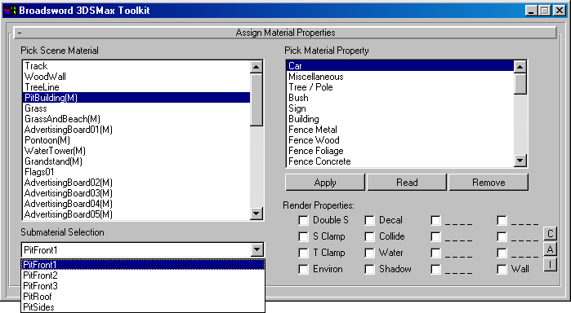

- Choose a Material Property from the right hand list box, and choose appropriate rendering properties.
- Click Apply. If a code already exists then you will be prompted to either overwrite the old code, or you may choose to append the code.

To rename a material/submaterial

- Follow the steps for naming a material/submaterial, and when prompted, click ‘Yes’ to replace the code.

To remove a material code

- Select the material/submaterial.
- Click ‘Remove’ to delete the code. You will be prompted to confirm.

To copy the code from one material/submaterial to another

- Select the material/submaterial.
- Click ‘Read’ to copy the material settings to the panel.
- Select the material/submaterial to copy the settings to.
- Click ‘Apply’ to copy the material settings to the material/submaterial.
Rename Bitmaps Plugin

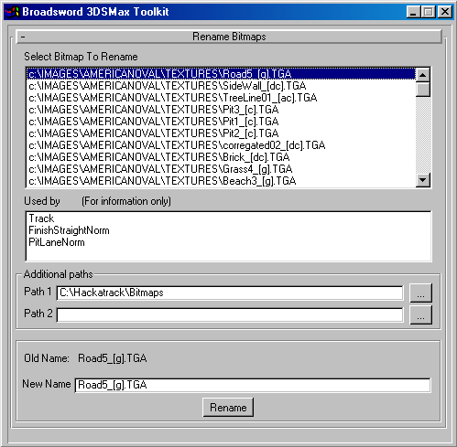
Renames bitmap filenames on disk (including up to two extra specified paths for any existing backups), while automatically updating materials that reference the filenames.

Reference

The main listbox shows all bitmaps used as diffuse maps in the current scene. When a bitmap is selected, the ‘Used by’ list box will show which materials currently reference it.

By specifying up to two additional paths, the user may rename duplicate bitmaps elsewhere on the system at the same time as the original. An interactive path requester can be accessed for each path by clicking on the ellipsis button to the right of the path entry box.

When a bitmap is renamed, any materials that reference the bitmap as either a diffuse map or as an opacity map will be adjusted accordingly.

If a bitmap does not exist at a specified path, the plugin will not generate an error. However, the bitmap will still be renamed inside any material references.

How to

To rename a bitmap

- Select the bitmap in the top listbox.
- Supply up to two additional paths in the path entry entry boxes.
- Enter the new name of the bitmap in the ‘New Name’ entry box.
- Press the ‘Rename’ button.
Point Dropper Plugin

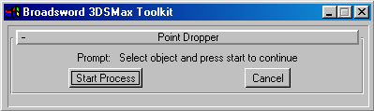
Allows vertices of an Editable Mesh object to be dropped in the negative Z direction onto a specified object.

Reference

The point dropper plugin is extremely useful for situations where an object must sit perfectly on another object’s surface. For example, this could be used to place a building on an undulating terrain.
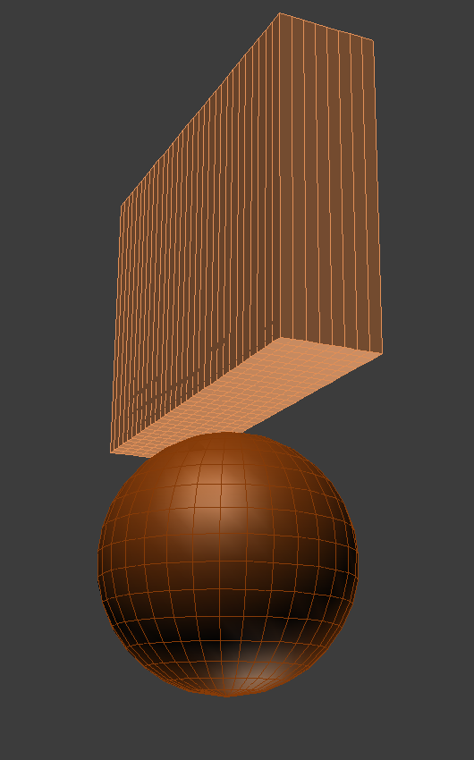
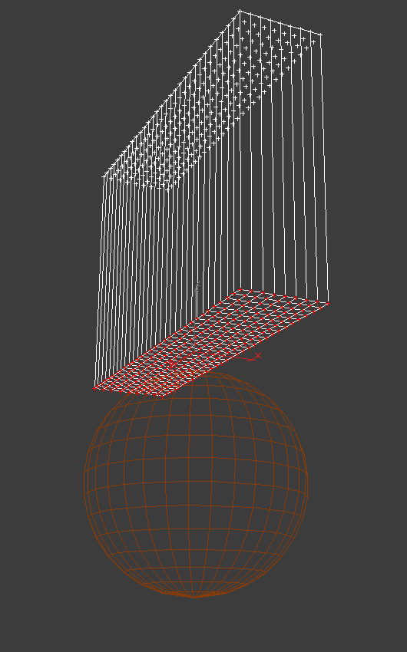
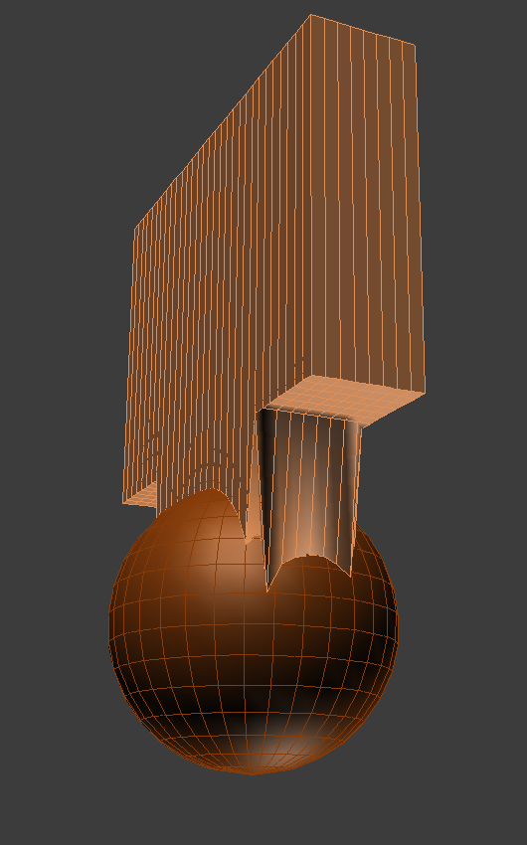

Both objects involved must be editable meshes without any modifiers in the modifier stack.

Quite often, point dropping is required of an editable mesh object which already has various mapping modifiers contained in the modifier stack. In this case, the user can save extra work by simply cutting the modifiers from the stack, performing the point drop, and then pasting the modifiers back in to the stack. This can of course be done with any modifier, but could lead to undesirable results if geometric modifiers are cut and pasted.

The plugin is designed to take the user throught the process a stage at a time, and will prompt the user over any errors they may make.

To keep calculation times short, minimise the value of the number of dropping points multiplied by the number of faces to be dropped on to.

The points of an editable mesh may be dropped on to itself if desired.
At present there is no way to undo this process. It is recommended that the user performs an Edit menu-> Hold before proceding with the plugin. This allows retrieval of the unmodified scene by performing an Edit menu-> Fetch.

How to

To drop the points of an editable mesh on to another editable mesh

- Launch the Point Dropper plugin.
- Select the editable mesh that is to have it’s points dropped.
- Click the ‘Start Process’ button on plugin floater.
- Enter Vertex sub-object mode.
- Select vertices to be dropped.
- Click the ‘Next’ button on plugin floater.
- Exit sub-object mode and select the editable mesh to drop the points on to.
- Click the ‘Next’ button on plugin floater.
- Click ‘the Drop’ button to drop the points on to the surface.

Set Points Plugin

One or more vertices may be set to specific values along specified world coordinates, or aligned to the coordinates of an existing vertex.
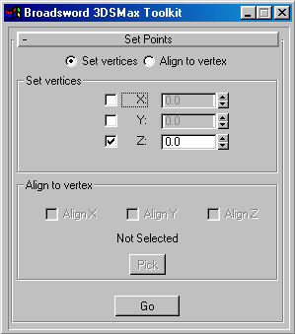
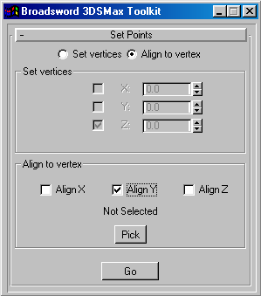

Reference

This plugin may be used in either of two modes. It can set the coordinates of a number of points simultaneously, or it can allow sub-object alignment of vertices to a reference vertex along any specified axis.

The plugin can only work with an editable mesh object which has no modifiers present in the modifier stack. For information about ways around this, refer to the Point Dropper plugin documentation.

At present there is no way to undo this process. It is recommended that the user performs an Edit menu-> Hold before proceding with the plugin. This allows retrieval of the unmodified scene by performing an Edit menu-> Fetch.

How to

To set the coordinates of a number of vertices to a position in the world

- Launch the Set Points plugin and select the ‘Set vertices’ radiobutton.
- Enter ‘Vertex’ sub-object mode and select the vertices to be set.
- Select the appropriate check box to enable the coordinate entry box for the axis. In most cases the user will only want to select one axis for alteration.
- Click ‘Go’ to perform the operation.

To align a number of vertices to another specified vertex

- Launch the Set Points plugin and select the ‘Align to vertex’ radio button.
- Enter ‘Vertex’ sub-object mode of any editable mesh object and select the vertex with which to align to.
- Click the ‘Pick’ button to identify this vertex to the plugin.
- Enter ‘Vertex’ sub-object mode of the same object or any other editable mesh object, and select the vertices to align.
- Select the axes to align. In most cases the user will only want to select one axis for alteration.
- Click ‘Go’ to perform the operation.
Object Placer Plugin

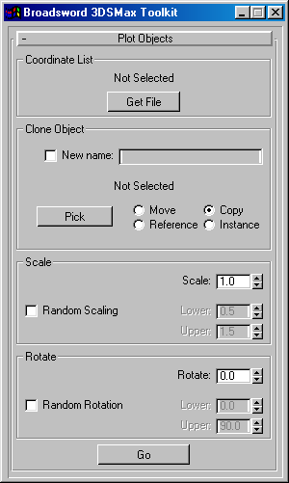
Clones a specified object and places it at coordinates specified by a text file.

Reference

This plugin allows the user to create objects inside 3DSMax using coordinates from an external source. Once the user has specified the coordinate file and the object to be cloned, they may also specify random amounts of scaling and rotation to be applied in a similar way to the Scatter compound object.

The text file consists of one line for each point, with the (x,y,z) components seperated by a single space. Any number of points may be included in the list.

How to

To clone an object using coordinates specified by a text file

- Click the ‘Get File’ button to open a file requester, and select the text file containing the coordinate data.
- Select the object to be cloned, and select the ‘Pick’ button.
- If desired, provide a new name for the cloned objects by selecting the ‘New name’ check box, and entering the name in the newly activated edit box.
- Specify whether the currently selected object is to be moved, copied, referenced, or instanced in the cloning procedure.
- Specify any scaling factor or rotation offset for the cloned objects.
- Click ‘Go’ to proceed with the cloning of the object.

To clone an object with random scaling and/or rotation

- Follow steps 1 to 4 above.
- If random scaling is required, select the ‘Random Scaling’ check box, and enter the lower and upper limits for scaling. The plugin uses a uniform distribution for these values.
- If random rotation is required, select the ‘Random Rotation’ check box, and enter the lower and upper limits for scaling.
- Click ‘Go’ to proceed with the cloning of the object.

Document Change History

Revision number | Date of change | Nature of change | Changed by
1.1 | 03/12/98 | Added Object Placer plugin | APN

