On-screen displays

On screen Graphics and messages

Overhead map section on screen during racing.
Dials to show - Rev Counter, Oil pressure, Temperature, MPH/KPH. These are to be semi-transparent when any view but ‘In-car’ is chosen. They can be generic for all modes but ‘In car’, where they will obviously be more specific.

When designing the dashboard for the ‘In-car’ mode, reference must be made to the body colour of that model of car in the game for the sake of continuity.. Needles should be modeled and saved separately, with their position and rotation noted. Likewise, steering wheels should be modeled and saved, with the same information noted.

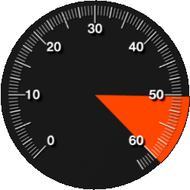
Rev Counter

The dials are displayed on the dashboard of the chosen car when the ‘In-car’ view is selected.

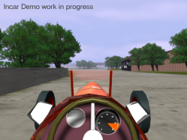

Current Lap Time, Best Lap Time, current race position shown as text - Washblack.
In car view to show dials on the dashboard rather than as head up display.
Wrong Way to be indicated by the words ‘Wrong Way’.

Each car must have its own in car model, based upon the actual interior of that car, but taking into account the requirements we have for the gauges to be displayed.

