Art Department Progress Report by Nathaniel Reed

Broadsword Interactive Limited, Aberystwyth

Date : 23 / 11 / 98

Race Tracks : Tripoli, Sitges, Pau

Modelling procedure

Kinetix’ 3D Studio Max r2.5 has been used to construct the model for the Tripoli Grand Prix. A NURB spline is introduced that follows the rotoscoped image of the contemporary map. This is then sub-divided to shorter, more manageable sections, from which the detailed circuit will be swept, or lofted.

Standard splines are used to create simple cross-sectional profiles of the track and immediate landscape, each with a single common pivot point centre. The procedure that follows involves using the NURB splines as masters and selecting each segment of the Profile in turn : the track sections are thus built up around the NURB master. If it is found that a face normal on a lofted section is projecting the wrong way, then the order of vertices on the profile splines can be easily rearranged.

Different shapes can be smoothly incorporated into the section by picking a new profile at a specified percentage along the loft. Additionally, greater detail and smoothness can be introduced by increasing the step number of the loft ; this, of course, increases the polygon count of the model.

Lofting also utilises its own UVW mapping for bitmap textures. A repeat value is inputed, and can be matched on the neighbouring lofts, even if the geometrical step values differ.

The design of the circuit follows the strip or trench principle, where only the track and immediate landscape are stitched together, allowing for easier future editing. The ‘far’ landscape can thus be at a much lower polygon count and can be edited separately to the track.

Once all the sections are lofted, they are stitched together with a point-snap tool. The vertices can subsequently be transformed further to introduce a more ‘natural’ feel to the landscape.
Tripoli

Reference material

‘Grand Prix Tripoli 1925 – 1940’, Valerio Moretti, Automobilia Books, 1994.

History

This famous and popular circuit was run between 1925 and 1940 near Mellaha, south of Tripoli in Libya. In 1933, the site was relocated and designed at the shorter length of 13.10 km, whereas the earlier course was 26.20 km in length. It is this later development of the Grand Prix, with a purpose built Grandstand and Timing Tower, that has been rebuilt by Broadsword Interactive.

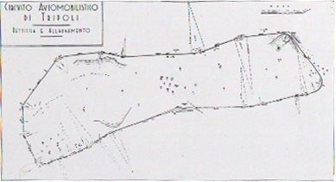
Tripoli

The funding for this Grand Prix was integrated with a National Lottery, and apart from some initial controversy, the Tripoli circuit attracted huge interest. In spite of the exposure in places to strong winds it became known for its high speeds. The fastest ever lap was 229.234 km/hr recorded in 1937 and achieved by Hans Stuck driving an Auto Union.

Notable drivers who returned to Mellaha each year were Varzi, Caracciola, Fagioli, Lang, and Farina. The car manufacturers were also well represented, including Auto Union, Mercedes–Benz, and Alfa Romeo.

Development

The circuit was designed on paper after studying the contemporary plan reproduced in the book, ‘Grand Prix Tripoli’. This allowed one to lay out the path of the circuit as closely as possible, while at the same time being determined by polygon budget requirements. Since the track would be quite large in physical size, the decision was made early on to reduce all ‘near straight’ sections to ‘straights’ that would require a minimum number of polygons. This allowed a greater number of polygons, and thus higher detail and smoothness, in the curves.

The reference photographs described banked and raised tracks, and forested areas. A cliff gorge was also incorporated to add to the visual variety and gameplay.

One area has been ‘forested’ to gain an early insight into the juxtaposition of the track and the trees. This involved a loft of trees following the course of the track at the furthest distance, with simple 2D editable meshes as clumps of trees in the middle distance. 3D trees built as three inverted triangles in a ‘Y’ plan view are placed against the track. The three ‘levels’ of tree give a sense of depth and parallax, necessary to promote the illusion of geography and speed.

Sitges

Reference material

‘The Complete History of Grand Prix Motor Racing’, Adriano Cimarosti, Aurum Books, 1986.

History

The Sitges Terramar circuit near Barcelona in Spain was raced for only two years in 1923 and 1924. Although at the time the rival tracks were Brooklands in Great Britain and Monza in Italy, the spanish track was poorly designed for safety and became virtually obsolete with the rapid technological developments of the racing engines.

The track was 2 km in length and the width varied between 18m and 22m. It was kidney-shaped in plan, with two steep banked curves nestling between rock faces. The interior radius of the curves was 100m and the straights totalled 1500m.

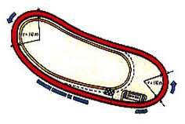
Sitges

Development

The circuit was sketched on paper and lofted. Since the track is so small, the polygon budget was kept quite low : the game engine performance is determined by polygon per view, which can be affected by a driver view that is consistently looking back on itself.

The banked curves were a problematic issue for the polygon budget. The lofted meshes had to be kept quite low in step value but smooth enough to give the impression of the curving track. The Lofting tool Deformation allowed one to retain the overall number of geometrical steps but cluster them at a specified percentage point along the path. Similarly, the immediate neighbouring lofts for the landscape could be matched to this deformation value.

Small clumps of 3D trees were placed near the track verge, with a handful of 2D trees placed at a further distance. Contemporary photographs of European grandstands were used to inspire designs for the Sitges buildings. Iron pedestrian bridges and advertising boards have been introduced to provide visual interest and parallax for gameplay.

Pau

Reference material

‘The Complete History of Grand Prix Motor Racing’, Adriano Cimarosti, Aurum Books, 1986.
‘The World Atlas of Motor Racing’, Joe Saward, Guild Publishing, 1989.

History

Pau in the south west of France is still used today as a premier circuit for the Formula 3000. The very first local race was in 1901, earning the title of ‘Grand Prix’. This ‘round-the-houses’ circuit was inaugurated as an international event in 1938. It was 2.769km long and snaked about the eastern end of the old University town, circling the Parc Beaumont and Casino Municipal. The Grandstands were arranged at the southern tip of the track, near the railway station.

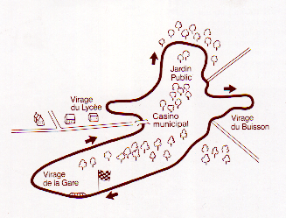 | 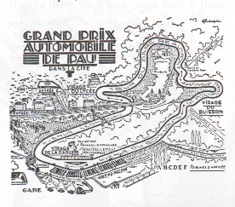
Pau

Although it covers a small area, the circuit involves many tight bends and hairpins arranged on the hillside Two straights lead to and from the starting position at the southern end. Simple boards and hay bales and high vantage points would be all that protected the spectators from the speeding cars.

Development

The Pau circuit has been firstly sketched and then lofted. The master NURB splines are elevated to match the impression of the hillside : the lofted sections follow the path of these splines. The secondary roads have been built as ‘off-shoots’ to give a sense of locality and depth, and the roads on the inside of the circuit could be used as ‘short-cuts’.

Many of the road junctions have been widened out with subsequent vertex editing, and some of these have been detached from the loft in order to map independently.

The model is currently at an early working stage.

