P1:

p2

a)

b)

P3:

P4

1. A diagram of a circuit

   Description automatically generated with low confidence5.6 k

1. A diagram of a circuit

   Description automatically generated with low confidence56k

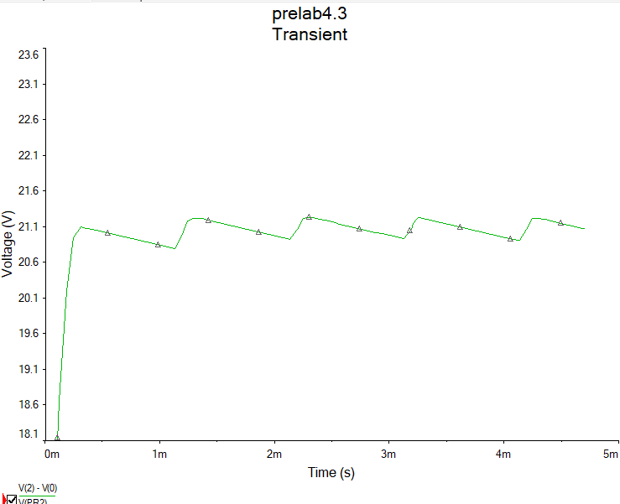

1. A diagram of a circuit

   Description automatically generated with low confidence560

