Pt 3

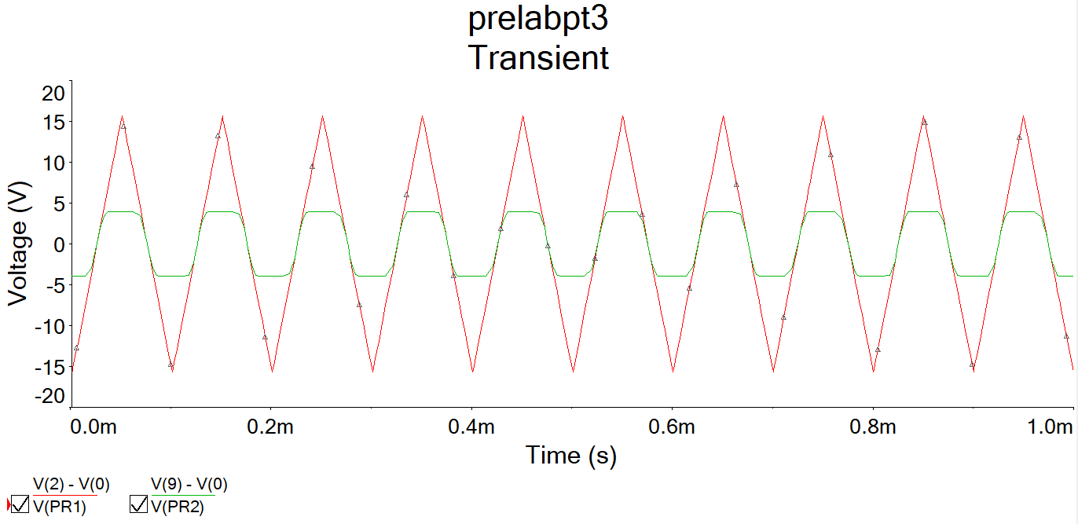

Pt 5

vi:

vo

Pt 6

Pt 7

Ta sig:

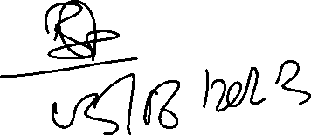

2023-06-06