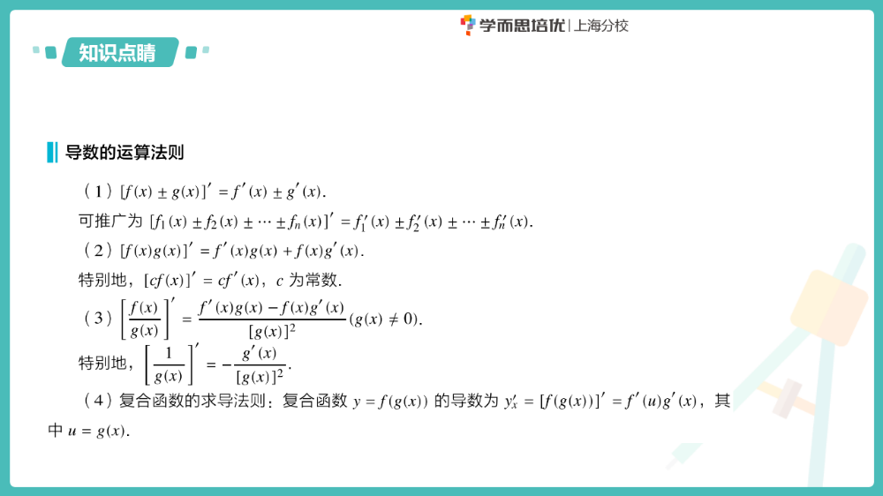
求导法则与求导练习

一、求下列函数的导数：
$\left(1\right)y=x^{3}-2x^{2}-8x+7 \left(2\right)y=x^{2}+lnx$

$$\left(3\right)y=xlnx \left(4\right)y=x^{2}e^{x}$$

$$\left(5\right)y=\frac{lnx}{x} \left(6\right)y=\frac{sinx}{x}$$

二、求下列函数的导数：
$\left(1\right)f\left(x\right)=x\left(x^{2}+\frac{1}{x}+\frac{1}{x^{2}}\right) \left(2\right)y=(x+1)(x^{2}-x+1)$

$$\left(3\right)y=tanx \left(4\right)y=(x+1)(x+2)(x+3)$$

$$\left(5\right)y={(2x+1)}^{6} \left(6\right)y=\frac{1}{{(1-3x)}^{4}}$$

$$\left(7\right)y=\ln\left(2x-1\right) \left(8\right)y=e^{3-x}$$

$$\left(9\right)y=\sqrt{1+lnx} \left(10\right)y=e^{sin⁡(x+b)} (b是常数)$$

