LABORATORY EXERCISE 9

SEARCH AND FILTERING SYSTEM

Learning Objectives
By the end of this laboratory exercise, students should be able to:
- Implement client-side search filtering using jQuery for dynamic user experience.
- Develop server-side search functionality using CodeIgniter's database queries.
- Create a responsive search interface using Bootstrap components.
- Integrate AJAX techniques to display search results without page reload.
- Understand the differences between client-side and server-side search approaches.

Prerequisite student experiences and knowledge
Before starting this exercise, students should have:
- Completed Laboratory Exercise 8 (Real-time Notifications with jQuery).
- Solid understanding of CodeIgniter's MVC architecture and database operations.
- Proficiency in writing jQuery and JavaScript code for DOM manipulation.
- Experience with AJAX requests and handling JSON responses.
- Familiarity with Bootstrap form components and grid system.
- Knowledge of SQL queries, particularly LIKE operators for search functionality.

Background
An effective search system is crucial for any Learning Management System (LMS) to help users quickly find relevant courses and content. This exercise focuses on implementing a dual-approach search system: client-side filtering for immediate feedback and server-side searching for comprehensive results. jQuery provides the tools for dynamic client-side filtering, while CodeIgniter's database class enables efficient server-side search using SQL LIKE queries. The combination creates a seamless user experience where search results update in real-time without page refreshes, enhancing the overall usability of the application.

Materials/Resources
- Personal Computer with Internet Access
- XAMPP/WAMP/LAMP server installed
- CodeIgniter Framework
- Visual Studio Code or any code editor
- Git and GitHub Account
- Web Browser (Chrome, Firefox, etc.)
Laboratory Activity
Step 1: Project Setup
- Open your existing ITE311-LASTNAME CodeIgniter project.
- Ensure your database has a courses table with sample data for testing search functionality.
- Verify that your course listing page is functional from previous exercises.

Step 2: Create Search Controller Method
- Navigate to your Course.php controller in app/Controllers/.
- Add a new method named search():
  - This method should accept GET or POST requests with a search term parameter.
  - Use CodeIgniter's Query Builder to search the courses table using LIKE queries.
  - Return the results as JSON for AJAX requests or render a view for regular requests.
- Implement the search logic
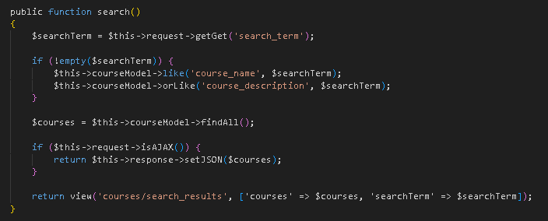

Step 3: Add Search Route
- Open app/Config/Routes.php.
- Add routes for the search functionality:
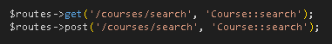

Step 4: Create Search Interface
- Modify your courses view file (app/Views/courses/index.php).
- Add a search form with Bootstrap styling
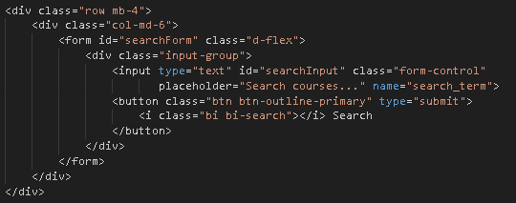

Step 5: Implement Client-Side Filtering with jQuery
- Add jQuery script for instant client-side filtering
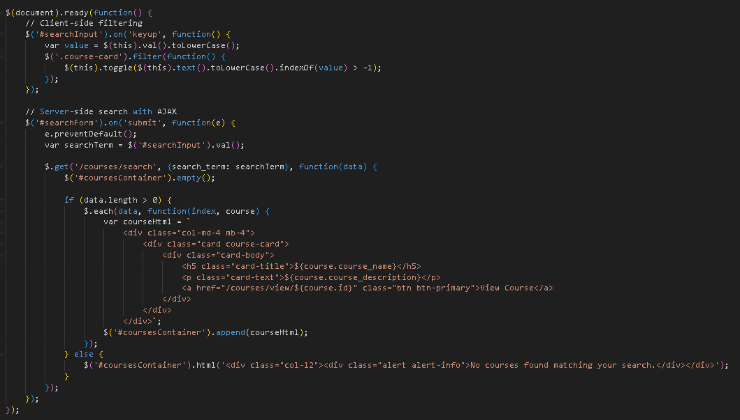

Step 6: Update Courses View Structure
- Modify your courses listing to work with the search functionality
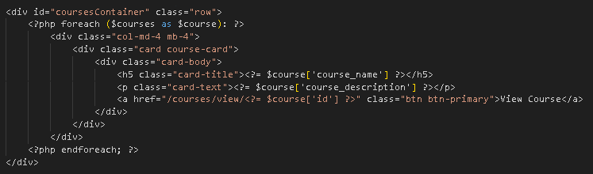
- To simulate real-time updates, you can set an interval to fetch notifications every 60 seconds (optional advanced task).

Step 7: Test the Search Functionality
- Load the courses page in your browser.
- Test the client-side filtering by typing in the search box courses should filter instantly.
- Test the server-side search by submitting the form results should load via AJAX without page refresh.
- Verify that both empty search results and successful searches display appropriate messages.

Step 9: Push to GitHub
- Stage and commit your search functionality
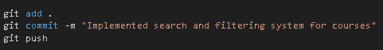

Output / Results
- Screenshot of the courses page with the search interface implemented.
- Screenshot showing filtered courses during client-side search.
- Screenshot of browser Developer Tools Network tab showing AJAX request to server-side search.
- Screenshot of search results displaying when no courses match the search term.
- Screenshot of GitHub repository with the latest commit.

Output / Results


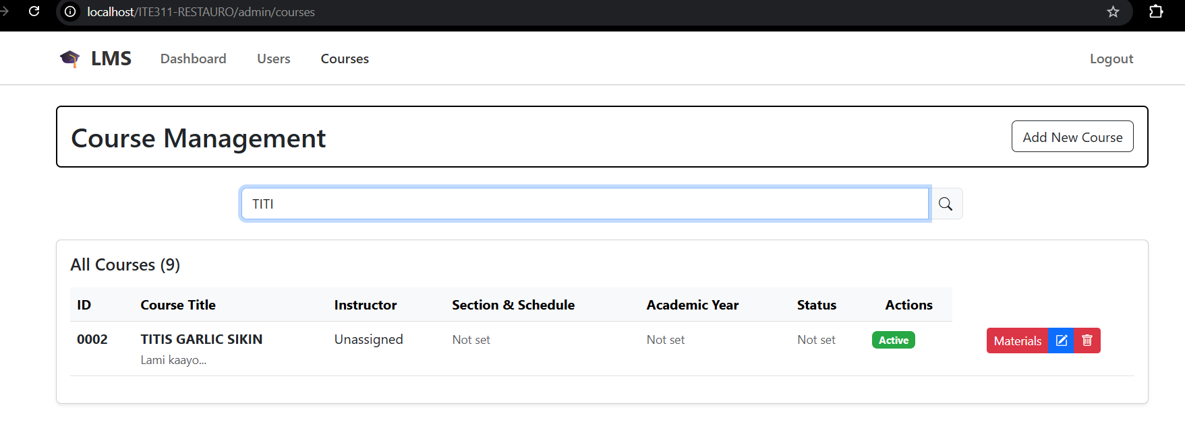

QUESTIONS:
- What are the advantages and limitations of client-side filtering compared to server-side search?
-Client-side filtering provides instant results since all data is already loaded in the browser, making searches feel immediate and responsive. However, it becomes impractical with large datasets because loading thousands of records upfront slows down the initial page load and can crash browsers. Server-side search handles massive amounts of data efficiently by only returning relevant results, but requires network requests that introduce slight delays. Client-side works well for small lists while server-side is necessary for extensive databases.

- How does using AJAX for search improve the user experience compared to traditional form submission?
- AJAX transforms search from a disruptive experience into a smooth, continuous interaction that keeps users engaged. Traditional form submissions force complete page reloads, causing users to lose their position and wait for everything to refresh. AJAX allows results to appear instantly in the same view, enabling users to refine searches without interruption. Users can see results as they type, making the search process feel natural and encouraging them to explore further.

- What security considerations should be taken when implementing search functionality with user input?
- Search functionality introduces security vulnerabilities that require careful protection to prevent system compromise. SQL injection attacks occur when malicious users input database commands instead of search terms, potentially accessing or destroying data. Cross-site scripting happens when search results display harmful code that can affect other users. Proper security involves sanitizing all user input, validating search terms for length and content, implementing rate limiting to prevent abuse, and ensuring users can only access data they're authorized to view.

Conclusion

- In conclusion, effective search implementation requires balancing performance, user experience, and security considerations. The choice between client-side and server-side filtering depends on data size and user needs, while AJAX enhances the search experience by eliminating disruptive page reloads. Most importantly, robust security measures must be implemented to protect against common attacks, ensuring that improved functionality doesn't compromise system integrity. A well-designed search system combines the right technical approach with proper security practices to deliver both excellent user experience and reliable protection.

