回归分析课后作业
2.15 2
3.11 5
4.16 8
4.9 9
4.14 11
5.10 15
8.3 & 8.4 19

2.15
准备工作
x = c(825, 215, 1070, 550, 480, 920, 1350, 325, 670, 1215) # 新保单数目
y = c(3.5, 1.0, 4.0, 2.0, 1.0, 3.0, 4.5, 1.5, 3.0, 5.0) # 加班时间
insurance_data = data.frame(week = week, x = x, y = y)
(1)画散点图
plot(x, y, main = "保险公司加班时间与新保单数量关系",
xlab = "新保单数目(x)", ylab = "加班时间(y)(小时)",
pch = 16, col = "blue", cex = 1.2)
grid()
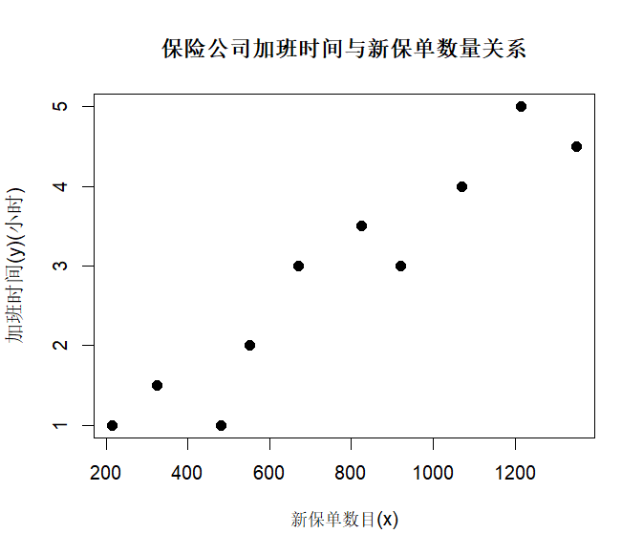
(2) x与y之间是否大致呈线性关系?
从散点图可以看出，x与y之间大致呈线性关系。
(3)用最小二乘估计求出回归方程。
model = lm(y ~ x, data = insurance_data)
summary_model = summary(model)
cat("y =", round(coef(model)[1],4), "+", round(coef(model)[2],4), "x\n")
y = 0.1181 + 0.0036 x
(4)求回归标准误差$\hat{σ}$
sigma_hat = summary_model$sigma
cat("sigma_hat =", round(sigma_hat, 4),"\n")
sigma_hat = 0.48
(5)给出$\hat{β_{0}}$与$\hat{β_{1}}$的置信度为95%的区间估计。
conf_int = confint(model, level = 0.95)
cat("β0-hat的置信区间", "[",round(conf_int[1],4),",",round(conf_int[3],4),"]","\n")
cat("β1-hat的置信区间", "[",round(conf_int[2],4),",",round(conf_int[4],4),"]","\n")
β0-hat的置信区间 [ -0.7008 , 0.9371 ]
β1-hat的置信区间 [ 0.0026 , 0.0046 ]
(6)计算x与y的决定系数。
r_squared = summary_model$r.squared
cat("决定系数为",round(r_squared,4),"\n")
决定系数为 0.9005
(7)对回归方程做方差分析。
anova_result = anova(model)
print(anova_result)
由表知，方程整体显著性p-value为2.795e-05，表明方程整体显著，x与y有显著的线性关系。
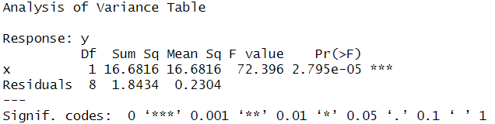
(8)做回归系数$\hat{β_{1}}$的显著性检验。
summary_model$coefficients
cat("β1-hat显著性检验的p-value为",round(summary_model$coefficients[2,4],4),"\n")
β1-hat显著性检验的p-value为 0 ，可知β1-hat显著。
(9)做相关系数的显著性检验。
cor_test = cor.test(x, y)
print(cor_test)
cat("相关系数的p-value为",round(cor_test$p.value,4))
相关系数的p-value为 0.000，可知相关系数显著。
(10)对回归方程作残差图并做相应的分析。
y_hat = predict(model, data = your_data)
e = y - y_hat
plot(x, e, main = "残差图",
xlab = "x", ylab = "e",
pch = 16, col = "black", cex = 1.2, abline(h=0))
由图知，残差是围绕e=0随机波动，满足模型的基本假定。
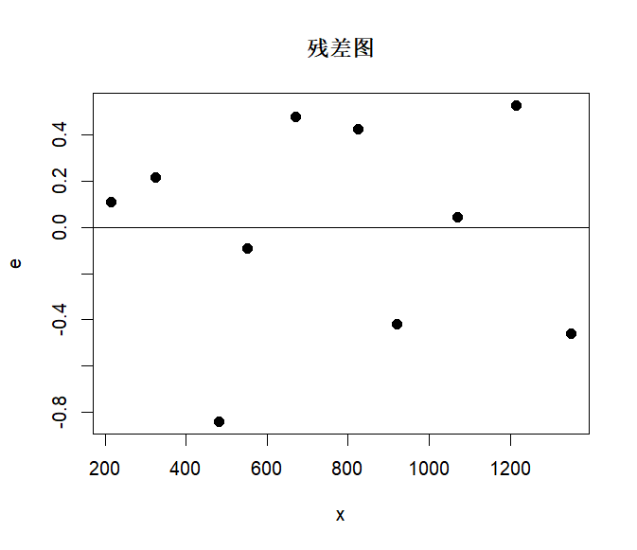
(11)该公司预计下一周签发新保单$x_{0}$=1000张，需要的加班时间是多少?
x0 = 1000
y0_hat = predict(model, newdata = data.frame(x = x0))
cat("该公司预计下一周签发新保单x_0=1000张，需要的加班时间为",round(y0_hat,4),"小时\n")
该公司预计下一周签发新保单x_0=1000张，需要的加班时间为 3.7033 小时
(12)给出$y_{0}$的置信度为95%的精确预测区间和近似预测区间。
n = length(y)
L_xx = sum((x - mean(x))^2)
h_00 = 1 / n + (x0 - mean(x))^2 / L_xx
t_value = qt(0.975, df = n-2)
margin_error = t_value * sqrt(1 + h_00) * sigma_hat
precise_lower = y0_hat - margin_error
precise_upper = y0_hat + margin_error
cat("y0的精确预测区间为[", round(precise_lower,4), ",",round(precise_upper,4), "]\n")
approx_lower = y0_hat - 2 * sigma_hat
approx_upper = y0_hat + 2 * sigma_hat
cat("y0的近似预测区间为[", round(approx_lower,4), ",",round(approx_upper,4), "]\n")
y0的精确预测区间为[ 2.5195 , 4.887 ]
y0的近似预测区间为[ 2.7432 , 4.6633 ]
(13)给出E($y_{0}$)的置信度为95%的区间估计。
conf_interval = predict(model, newdata = data.frame(x = x0), interval = "confidence", level = 0.95)
margin_error2 = t_value * sqrt(h_00) * sigma_hat
conf_lower = y0_hat - margin_error2
conf_upper = y0_hat + margin_error2
cat("E(y0)的95%的区间估计为[", round(conf_lower,4), ",",round(conf_upper,4), "]\n")
y0的精确预测区间为[ 3.2837 , 4.1228 ]

3.11
准备工作
y = c(160,260,210,265,240,220,275,160,275,250)
x1 = c(70,75,65,74,72,68,78,66,70,65)
x2 = c(65,40,40,42,38,45,42,36,44,42)
x3 = c(1.0,2.4,2.0,3.0,1.2,1.5,4.0,2.0,3.2,3.0)
freight_data = data.frame(id = id, x1 = x1,x2 = x2, x3 = x3, y = y)
(1) 计算出 y，x1，x2，x3的相关系数矩阵。
cor_matrix = cor(freight_data[, c("y", "x1", "x2", "x3")])
print(round(cor_matrix, 4))
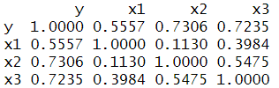
(2)求y关于x1，x2，x3的三元线性回归方程。
model = lm(y ~ x1 + x2 + x3, data = freight_data)
summary_model = summary(model)
cat("y =", round(coef(model)[1],4), "+", round(coef(model)[2],4), "x1", "+", round(coef(model)[3],4), "x2","+", round(coef(model)[4],4), "x3")
y = -348.2802 + 3.754 x1 + 7.1007 x2 + 12.4475 x3
(3)对所求得的方程做拟合优度检验。
cat("决定系数 R² =", round(summary_model$r.squared,4))
cat("调整R² =", round(summary_model$adj.r.squared,4))
决定系数 R² = 0.8055
调整R² = 0.7083
由结果可知，方程拟合效果较好
(4)对回归方程做显著性检验。
print(summary_model)
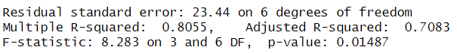
由表知，F统计量的值为8.283，p-value=0.01487，在显著性水平a=0.05的水平上显著，即回归方程的系数不全为0。
(5)对每一个回归系数做显著性检验。
coef_summary = summary_model$coefficients
print(coef_summary)
由表可知，x1和 x2的系数显著，x3不显著
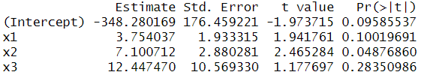
(6)如果有的回归系数没通过显著性检验，将其剔除，重新建立回归方程，再做回归方程的显著性检验和回归系数的显著性检验。
new_model = lm(y ~ x1 + x2, data = freight_data)
summary_new_model = summary(new_model)
cat("y=", round(coef(new_model)[1],4), "+", round(coef(new_model)[2],4), "x1", "+", round(coef(new_model)[3],4), "x2")
print(summary_new_model)
y= -459.6237 + 4.6756 x1 + 8.971 x2
由表知，F统计量的观测值为11.12，对应的概率P值为0.006718，在显著性水平a=0.01的水平上显著，即回归方程的系数不全为0。
对于每个回归系数，都在5%水平通过显著性检验。
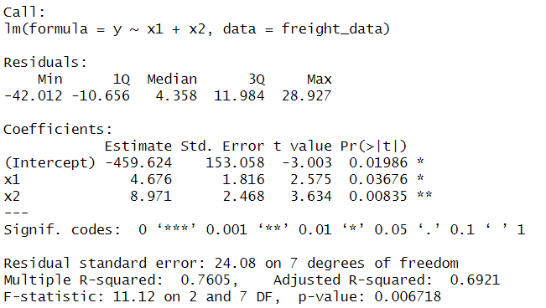
(7)求出每一个回归系数的置信水平为95%的置信区间。
conf_int = confint(new_model, level = 0.95)
cat("常数项系数95%的置信区间为","[",round(conf_int[1],4),",",round(conf_int[4],4),"]\n")
cat("x1系数95%的置信区间为","[",round(conf_int[2],4),",",round(conf_int[5],4),"]\n")
cat("x2系数95%的置信区间为","[",round(conf_int[3],4),",",round(conf_int[6],4),"]\n")
常数项系数95%的置信区间为 [ -821.5473 , -97.7 ]
x1系数95%的置信区间为 [ 0.3813 , 8.97 ]
x2系数95%的置信区间为 [ 3.134 , 14.8079 ]
(8)求标准化回归方程。
L_11 = sum((x1 - mean(x1))^2)
x1_stand = (x1 - mean(x1)) / sqrt(L_11)
L_22 = sum((x2 - mean(x2))^2)
x2_stand = (x2 - mean(x2)) / sqrt(L_22)
L_yy = sum((y - mean(y))^2)
y_stand = (y - mean(y)) / sqrt(L_yy)
model_stand = lm(y_stand ~ x1_stand + x2_stand , data = freight_data)
summary_stand_model = summary(model_stand)
cat("y =", round(coef(model_stand)[1],4), "+", round(coef(model_stand)[2],4), "x1", "+", round(coef(model_stand)[3],4), "x2\n")
y = 0 + 0.4792 x1 + 0.6765 x2
(9)求当x01=75，x02=42，x03=3.1时的y0-hat，给定置信水平为 95%，用SPSS 软件计算精确置信区间，用手工计算近似预测区间。
x01 = 75
x02 = 42
x0 = data.frame(x1 = x01, x2 = x02)
y0_hat = predict(new_model, newdata = x0)
cat("当x01=75，x02=42，x03=3.1时的y0为",y0_hat)
pred_interval = predict(new_model, newdata = x0, interval = "prediction", level = 0.95)
print(pred_interval)
cat("y0_hat的精确置信区间为[",round(pred_interval[2],4),",",round(pred_interval[3],4),"]\n")
sigma_hat = summary_new_model$sigma
approx_lower = y0_hat - 2 * sigma_hat
approx_upper = y0_hat + 2 * sigma_hat
cat("y0_hat的近似置信区间为[", round(approx_lower,4), ",",round(approx_upper,4), "]\n")
当x01=75，x02=42，x03=3.1时的y0为 267.829
y0_hat的精确置信区间为[ 204.4355 , 331.2225 ]
y0_hat的近似置信区间为[ 219.6668 , 315.9912 ]
(10)结合回归方程对问题做一些基本分析。
剔除x3后，方程更加显著性提升，系数更加显著，拟合效果更好。

4.16
准备工作
y = c(160,260,210,265,240,220,275,160,275,250)
x1 = c(70,75,65,74,72,68,78,66,70,65)
x2 = c(35,40,40,42,38,45,42,36,44,42)
x3 = c(1.0,2.4,2.0,3.0,1.2,1.5,4.0,2.0,3.2,3.0)
freight_data = data.frame(x1 = x1,x2 = x2, x3 = x3, y = y)
y异常值检验-删除学生化残差
X = cbind(1, x1, x2, x3)
H = X %*% solve(t(X) %*% X) %*% t(X)
h_ii = diag(H)
sigma_hat = summary_model$sigma
e = residuals(model)
SRE = e / sigma_hat / sqrt(1 - h_ii)
n = length(y)
SRE_d = SRE * sqrt((n - 3 - 2) / (n - 3 - 1 - SRE^2))
print(SRE_d)
which(abs(SRE_d)>3)
6
可知第六个数据是异常值
x异常值检验-库克距离
D = e^2 * h_ii / ((3 + 1) * sigma_hat^2 * (1 - h_ii)^2)
which(D > 1)
6
可知第六个数据是异常值
综上，通过计算删除学生化残差和库克距离，可知第六个数据是异常值。

4.9
准备工作
data = read.csv("E:/研究生阶段作业/应用回归分析数据/4.9.csv")
y = data$Y
x = data$X
(1)用普通最小二乘法建立y与x的回归方程，并画出残差散点图
model = lm(y ~ x, data = data)
cat("y =", round(coef(model)[1],4), "+", round(coef(model)[2],4), "x\n")
e = residuals(model)
plot(x, e, main = "残差图",
xlab = "x", ylab = "e",
pch = 16, col = "black", cex = 1.2, abline(h=0))
y = -0.8313 + 0.0037 x
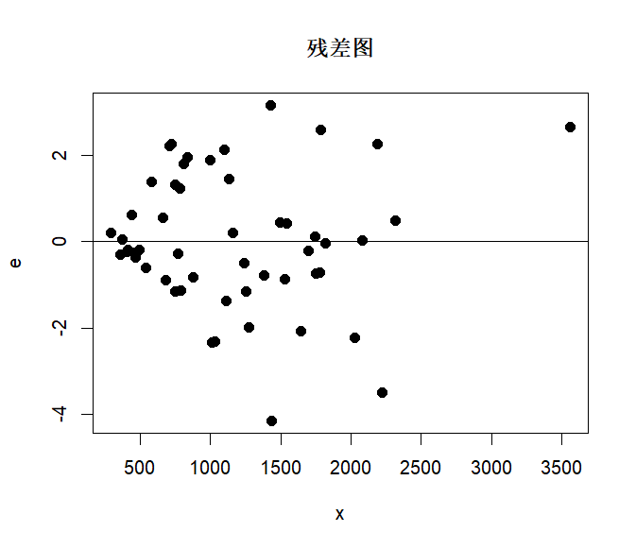
(2)诊断该问题是否存在异方差性
e_abs = abs(e)
hete_data = data.frame(x = x, e_abs = e_abs)
hete_data$rank_x = rank(hete_data$x)
hete_data$rank_e_abs = rank(hete_data$e_abs)
rank_x = hete_data$rank_x
rank_e_abs = hete_data$rank_e_abs
d = rank_e_abs - rank_x
n = length(x)
r = 1 - 6 / (n*(n^2 - 1)) * sum(d^2)
t_value = sqrt(n - 2) * r / sqrt(1 - r^2)
t = qt(0.975, df = n-2)
abs(t_value) > t # Spearman检验结果
①由残差图知，残差值随着x的增大而增大，因此可能存在异方差。
②通过Spearman检验，可知在95%的置信水平下，t统计量的绝对值大于临界值，说明xi与ei之间存在系统关系，异方差性问题存在。
(3)如果存在异方差性，用幂指数型的权函数建立加权最小二乘回归方程。
results = data.frame(Power = numeric(0), LogLikelihood = numeric(0))
possible_k = c(-2.0, -1.5, -1.0, -0.5, 0, 0.5, 1.0, 1.5, 2.0)
for (k in possible_k) {
w_try = 1 / x^k
wls_model = lm(y ~ x, data = data, weights = w_try)
e_try = residuals(wls_model)
n = length(residuals)
sigma_hat_try = sum(w_try * e_try^2) / n
log_likelihood = -n/2 * log(2 * pi * sigma_hat_try) - 1/(2 * sigma_hat_try) * sum(w_try * e_try^2) - 1/2 * sum(log(w_try))
new_row = data.frame(Power = k, LogLikelihood = log_likelihood)
results = rbind(results, new_row)
}
best_k = results$Power[which.max(results$LogLikelihood)]
cat("\n最优幂指数 k =", best_k, "\n")
w = 1 / x^best_k
new_model = lm(y ~ x, data = data, weights = w)
cat("y* =", round(coef(new_model)[1],4), "+", round(coef(new_model)[2],4), "x*\n")
最优幂指数 k = 2
幂指数型的权函数建立加权最小二乘回归方程y* = -0.7324 + 0.0036 x*
(4)用方差稳定变换y’=√y消除异方差性
data$y_sqrt = sqrt(data$Y)
stable_model = lm(y_sqrt ~ x, data = data)
cat("√y =", round(coef(stable_model)[1],4), "+", round(coef(stable_model)[2],4), "x*\n")
e_stable = residuals(stable_model)
plot(x, e_stable, main = "残差图",
xlab = "x", ylab = "e'",
pch = 16, col = "black", cex = 1.2, abline(h=0))

e_stable_abs = abs(e_stable)
stable_hete_data = data.frame(x = x, e_stable_abs = e_stable_abs)
stable_hete_data$rank_x = rank(stable_hete_data$x)
stable_hete_data$rank_e_abs = rank(stable_hete_data$e_stable_abs)
stable_d = stable_hete_data$rank_e_abs - stable_hete_data$rank_x
n = length(x)
stable_r = 1 - 6 / (n*(n^2 - 1)) * sum(stable_d^2)
stable_t_value = sqrt(n - 2) * r / sqrt(1 - stable_r^2)
t = qt(0.975, df = n-2)
abs(stable_t_value) > t # Spearman检验结果
①由残差图知，残差值随着x的增大而增大，因此可能存在异方差。
②通过Spearman检验，可知在95%的置信水平下，t统计量的绝对值大于临界值，说明xi与ei之间存在系统关系，异方差性问题存在。
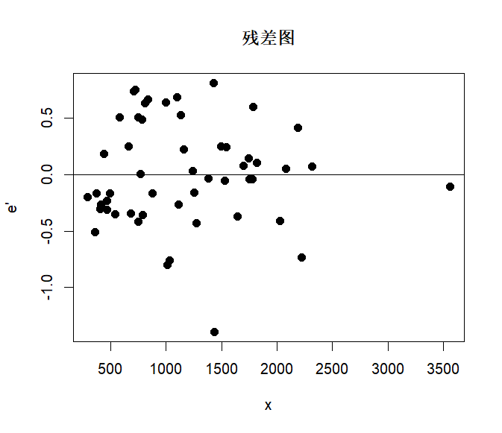

4.14
准备工作
data = read.csv("E:/研究生阶段作业/应用回归分析数据/4.13.csv")
(1)用普通最小二乘法建立y与x1和x2的回归方程，用残差图及 DW 检验诊断序列的自相关性。
model = lm(data$y ~ data$x1 + data$x2, data = data)
e = residuals(model)
plot(data$y, e, main = "残差图",
xlab = "y", ylab = "e",
pch = 16, col = "black", cex = 1.2, abline(h=0))
plot(data$week, e, main = "按时间顺序的残差图",
xlab = "t", ylab = "e",
pch = 16, col = "black", cex = 1.2, abline(h=0))
library(lmtest)
dwtest(model)
①图示检验法
由残差图知，随机扰动项存在正的序列相关；由按时间顺序的残差图可知，残差化随着t的变化逐次有规律地呈现锯齿形的变化。
②DW检验
DW统计量观测值为0.74526，对应的p-value为1.758e-07，因此认为随机误差项存在一阶自相关。
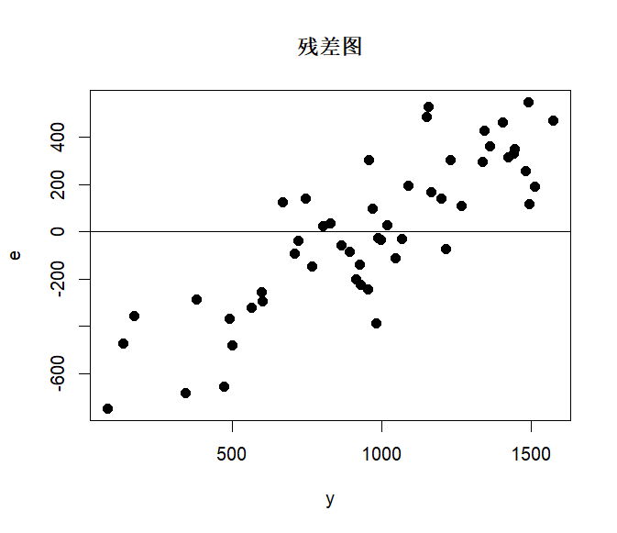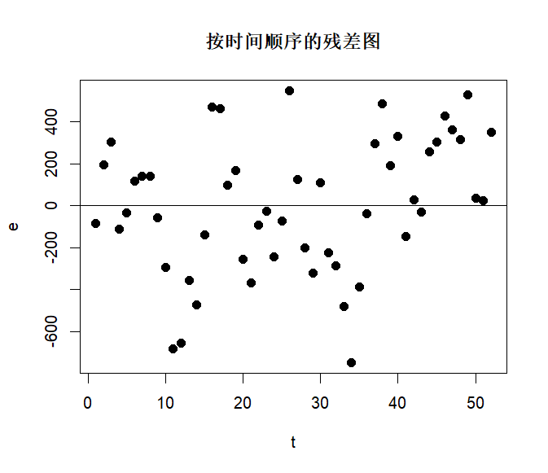
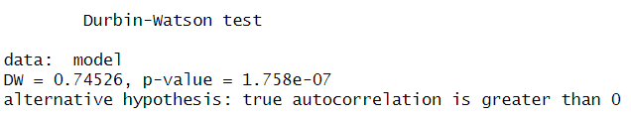
(2)用迭代法处理序列相关，并建立回归方程。
n = length(e)
data2 = data.frame(e_t = e[2:n], e_t_1 = e[1:(n-1)],
x1_t = data$x1[2:n], x1_t_1 = data$x1[1:(n-1)],
x2_t = data$x2[2:n], x2_t_1 = data$x2[1:(n-1)],
y_t = data$y[2:n], y_t_1 = data$y[1:(n-1)],
week_2 = data$week[2:n])
rou_hat = 1 - DW$statistic/2
y_2 = data2$y_t - rou_hat * data2$y_t_1
x1_2 = data2$x1_t - rou_hat * data2$x1_t_1
x2_2 = data2$x2_t - rou_hat * data2$x2_t_1
model2 = lm(y_2 ~ x1_2 + x2_2, data = data2)
cat("y' =", round(coef(model2)[1],4), "+", round(coef(model2)[2],4), "x1'", "+", round(coef(model2)[3],4), "x2'\n")
y' = -178.8444 + 211.1096 x1' + 1.4365 x2'
(3)用一阶差分法处理数据，并建立回归方程。
data3 = data.frame(y_delta = data2$y_t - data2$y_t_1,
x1_delta = data2$x1_t - data2$x1_t_1,
x2_delta = data2$x2_t - data2$x2_t_1,
week_3 = data$week[2:n])
model3 = lm(y_delta ~ x1_delta + x2_delta, data = data3)
cat("y_delta =", round(coef(model3)[1],4), "+", round(coef(model3)[2],4), "x1_delta", "+", round(coef(model3)[3],4), "x2_delta\n")
y_delta = 7.6981 + 209.8911 x1_delta + 1.399 x2_delta
(4)比较以上各方法所建回归方程的优良性。
e2 = residuals(model2)
plot(data2$y_t, e2, main = "迭代法残差图",
xlab = "y", ylab = "e",
pch = 16, col = "black", cex = 1.2, abline(h=0))
plot(data2$week_2, e2, main = "按时间顺序的迭代法残差图",
xlab = "t", ylab = "e",
pch = 16, col = "black", cex = 1.2, abline(h=0))
DW2 = dwtest(model2)
print(DW2)

e3 = residuals(model3)
plot(data3$y_delta, e3, main = "差分法残差图",
xlab = "y_delta", ylab = "e",
pch = 16, col = "black", cex = 1.2, abline(h=0))
plot(data3$week_3, e3, main = "按时间顺序的差分法残差图",
xlab = "t", ylab = "e",
pch = 16, col = "black", cex = 1.2, abline(h=0))
DW3 = dwtest(model3)
print(DW3)

summary(model2)
summary(model3)
综合以下分析，差分法所建回归方程效果更好。
1. 迭代法
①图示检验法
由残差图知，随机扰动项仍有存在正的序列相关；由按时间顺序的残差图可知，残差化随着t的变化有部分呈现锯齿形的变化。
②DW检验
DW统计量观测值为1.7162，对应的p-value为0.1806，可认为随机误差项无明显一阶自相关。
③模型拟合效果
模型的决定系数为0.4731，调整后的决定系数为0.4511
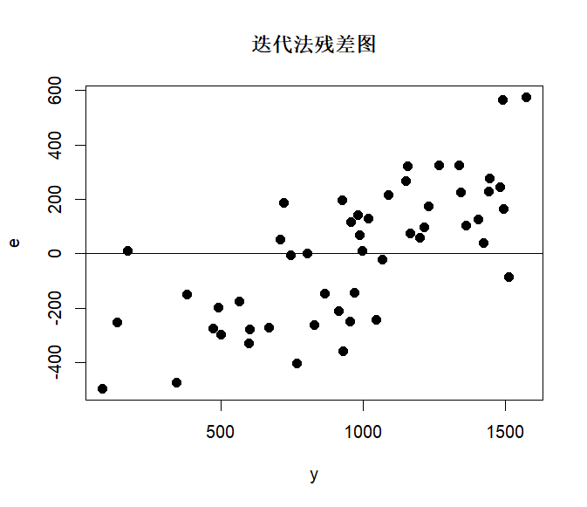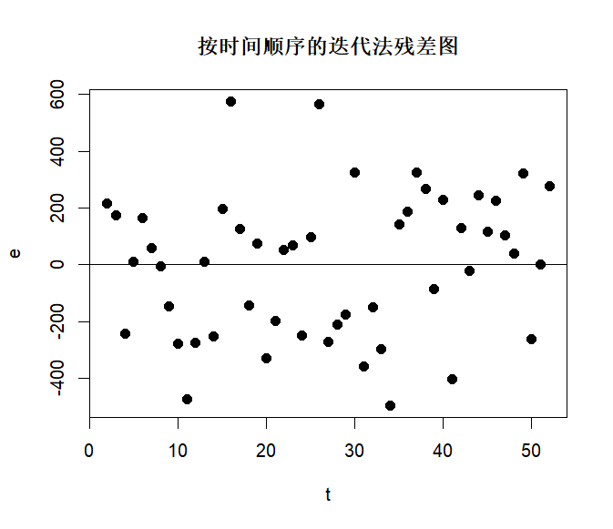
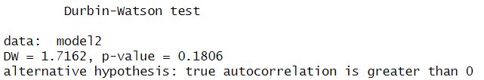
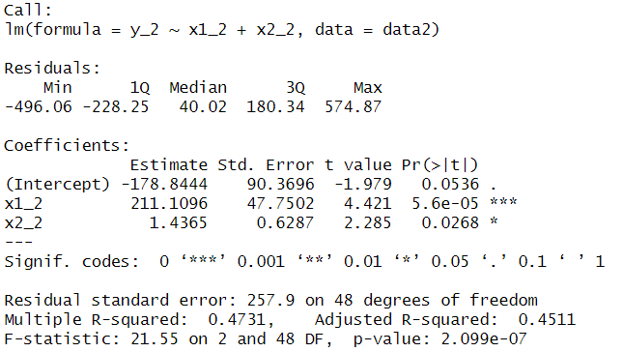
2. 差分法
①图示检验法
由残差图知，随机扰动项存在正的序列相关；由按时间顺序的残差图可知，残差化随着t的变化有部分呈现锯齿形的变化。
②DW检验
DW统计量观测值为2.0417，对应的p-value为0.6049，可认为随机误差项无明显一阶自相关。
③模型拟合效果
模型的决定系数为0.5106，调整后的决定系数为0.4902
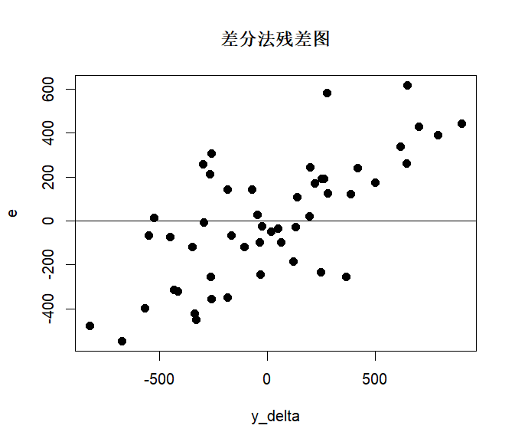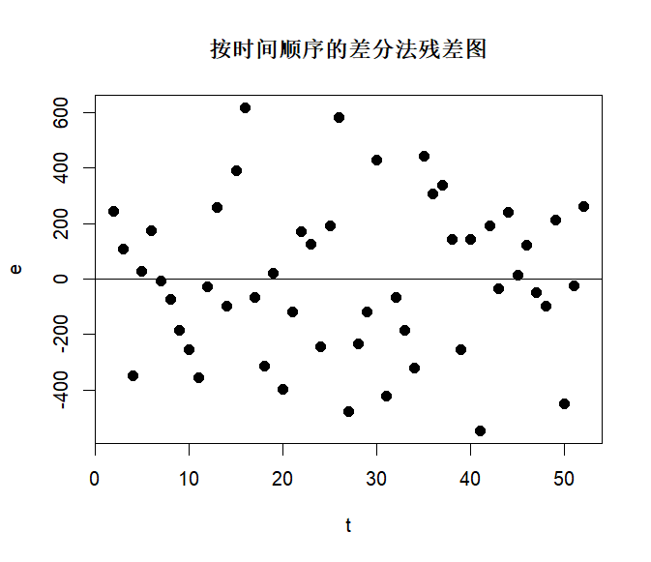
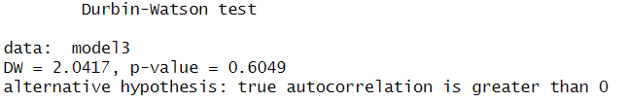
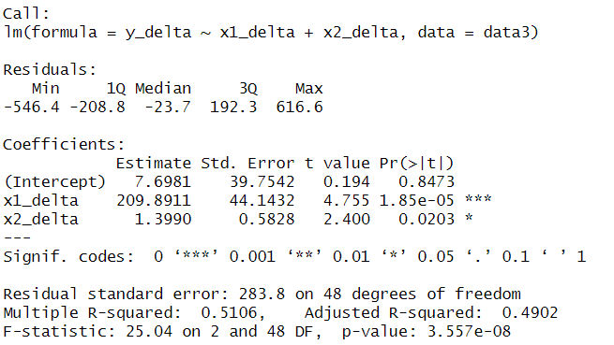

5.10
(1)建立y对x2~x6的线性回归方程
model = lm(y ~ x2 + x3 + x4 + x5 + x6, data = data)
summary(full_model)
y = 5922.827 + 4.8642 x2 + 2.3741 x3 -817.9013 x4 + 14.5387 x5 -846.8669 x6
(2)用后退法选择自变量
n = nrow(data)
all_vars = c("x2", "x3", "x4", "x5", "x6")
p_full = length(all_vars)
SSE_full = sum(full_model$residuals^2)
MSE_full = SSE_full / (n - p_full - 1)
for (var in all_vars) {
reduced_vars = setdiff(all_vars, var)
reduced_formula = paste("y ~", paste(reduced_vars, collapse = " + "))
reduced_model = lm(as.formula(reduced_formula), data = data)
SSE_reduced = sum(reduced_model$residuals^2)
SSR_partial = SSE_reduced - SSE_full
F_value = (SSR_partial / 1) / MSE_full
p_value = pf(F_value, 1, n - p_full - 1, lower.tail = FALSE)
cat("检验变量", var, "的F统计量值为", round(F_value, 4), "对应p值为", round(p_value, 4), "\n")}
# 剔除x5的情况下进行回归
reduced5_model = lm(y ~ x2 + x3 + x4 + x6, data = data)
reduced5_vars = c("x2", "x3", "x4", "x6")
p_reduced5 = length(reduced5_vars)
for (var in reduced5_vars) {
reduced_vars = setdiff(reduced5_vars, var)
reduced_formula = paste("y ~", paste(reduced_vars, collapse = " + "))
reduced_model = lm(as.formula(reduced_formula), data = data)
SSE_reduced = sum(reduced_model$residuals^2)
SSR_partial = SSE_reduced - SSE_full
F_value = (SSR_partial / 1) / MSE_full
p_value = pf(F_value, 1, n - p_full - 1, lower.tail = FALSE)
cat("检验变量", var, "的F统计量值为", round(F_value, 4), "对应p值为", round(p_value, 4), "\n")}
backward_model = lm(y ~ x2 + x3 + x4 + x6, data = data)
cat("y =",
round(coef(backward_model)[1],4), "+",
round(coef(backward_model)[2],4), "x2 +",
round(coef(backward_model)[3],4), "x3 +",
round(coef(backward_model)[4],4), "x4 +",
round(coef(backward_model)[5],4), "x6 \n")
1. 由以下结果可知，方程中应剔除x5
检验变量 x2 的F统计量值为 3.7633 对应p值为 0.0811
检验变量 x3 的F统计量值为 7.9429 对应p值为 0.0182
检验变量 x4 的F统计量值为 19.0733 对应p值为 0.0014
检验变量 x5 的F统计量值为 0.0098 对应p值为 0.9232
检验变量 x6 的F统计量值为 8.4325 对应p值为 0.0157
2. 由以下结果可知，以下四个自变量的F统计量对应的p值均在0.01水平下显著，也即，剩余的4个变量的F检验值均大于临界值，没有可剔除的自变量。
检验变量 x2 的F统计量值为 12.647 对应p值为 0.0052
检验变量 x3 的F统计量值为 20.541 对应p值为 0.0011
检验变量 x4 的F统计量值为 21.9732 对应p值为 9e-04
检验变量 x6 的F统计量值为 12.5396 对应p值为 0.0053
3. 最终得到回归方程
y = 6007.32 + 5.0681 x2 + 2.3078 x3 -824.2614 x4 -862.699 x6
(3)用逐步回归法选择自变量
# ①初始无变量
current_vars = character(0)
remaining_vars = c("x2", "x3", "x4", "x5", "x6")
for (var in remaining_vars) {
simple_model = lm(as.formula(paste("y ~", var)), data = data)
anova_result = anova(simple_model)
F_value = anova_result$`F value`[1]
p_value = anova_result$`Pr(>F)`[1]
cat("变量", var, "的单独F检验值为", round(F_value, 4), "对应p值为", round(p_value, 4), "\n")}
# ②在引入x3的情况下
current_vars = c("x3")
remaining_vars = setdiff(remaining_vars, "x3")
for (var in remaining_vars) {
candidate_vars = c(current_vars, var)
candidate_model = lm(as.formula(paste("y ~", paste(candidate_vars, collapse = " + "))), data = data)
drop1_result = drop1(candidate_model, test = "F")
var_row = which(rownames(drop1_result) == var)
F_value = drop1_result$`F value`[var_row]
p_value = drop1_result$`Pr(>F)`[var_row]
cat("引入变量", var, "的单独F检验统计量值为", round(F_value, 4), "对应p值为", round(p_value, 4),"\n")}
# 引入x5，检验3/5都在的时候显著性如何
model_3_5 = lm(y ~ x3 + x5, data = data)
drop1(model_3_5, test = "F")
# ③在3/5都存在的情况下
current_vars = c("x3", "x5")
remaining_vars = setdiff(remaining_vars, current_vars)
for (var in remaining_vars) {
candidate_vars = c(current_vars, var)
candidate_model = lm(as.formula(paste("y ~", paste(candidate_vars, collapse = " + "))), data = data)
drop1_result = drop1(candidate_model, test = "F")
var_row = which(rownames(drop1_result) == var)
F_value = drop1_result$`F value`[var_row]
p_value = drop1_result$`Pr(>F)`[var_row]
cat("引入变量", var, "的单独F检验统计量值为", round(F_value, 4), "对应p值为", round(p_value, 4),"\n")}
# 引入x4，检验3/4/5都在的时候显著性如何
model_3_4_5 = lm(y ~ x3 + x4 + x5, data = data)
drop1(model_3_4_5, test = "F")
# ④在3/4/5都存在的情况下
current_vars = c("x3", "x4", "x5")
remaining_vars = setdiff(remaining_vars, current_vars)
for (var in remaining_vars) {
candidate_vars = c(current_vars, var)
candidate_model = lm(as.formula(paste("y ~", paste(candidate_vars, collapse = " + "))), data = data)
drop1_result = drop1(candidate_model, test = "F")
var_row = which(rownames(drop1_result) == var)
F_value = drop1_result$`F value`[var_row]
p_value = drop1_result$`Pr(>F)`[var_row]
cat("引入变量", var, "的单独F检验统计量值为", round(F_value, 4), "对应p值为", round(p_value, 4),"\n")}
# 引入x6，检验3/4/5/6都在的时候显著性如何
model_3_4_5_6 = lm(y ~ x3 + x4 + x5 + x6, data = data)
drop1(model_3_4_5_6, test = "F")
# ⑤在3/4/5/6都存在的情况下
current_vars = c("x3", "x4", "x5", "x6")
remaining_vars = setdiff(remaining_vars, current_vars)
for (var in remaining_vars) {
candidate_vars = c(current_vars, var)
candidate_model = lm(as.formula(paste("y ~", paste(candidate_vars, collapse = " + "))), data = data)
drop1_result = drop1(candidate_model, test = "F")
var_row = which(rownames(drop1_result) == var)
F_value = drop1_result$`F value`[var_row]
p_value = drop1_result$`Pr(>F)`[var_row]
cat("引入变量", var, "的单独F检验统计量值为", round(F_value, 4), "对应p值为", round(p_value, 4),"\n")}
# 引入x2，检验2/3/4/5/6都在的时候显著性如何
model_2_3_4_5_6 = lm(y ~ x2 + x3 + x4 + x5 + x6, data = data)
drop1(model_2_3_4_5_6, test = "F")
# ⑥最终结果
stepwise_model = lm(y ~ x2 + x3 + x4 + x6, data = data)
cat("y =",
round(coef(stepwise_model)[1],4), "+",
round(coef(stepwise_model)[2],4), "x2 +",
round(coef(stepwise_model)[3],4), "x3 +",
round(coef(stepwise_model)[4],4), "x4 +",
round(coef(stepwise_model)[5],4), "x6 \n")
设定引入变量的显著性水平为0.1，剔除变量的显著性水平为0.15。
结论：综合一下所有分析，通过逐步回归法，方程决定引入变量x2、x3、x4和x6，最终得到方程
y = 6007.32 + 5.0681 x2 + 2.3078 x3 -824.2614 x4 -862.699 x6
1. 初始化无变量，单独检验F值，选择第一个引入的变量，由以下结果可知，选择先引入x3
变量 x2 的单独F检验值为 0.6488 对应p值为 0.434
变量 x3 的单独F检验值为 4.6071 对应p值为 0.0498
变量 x4 的单独F检验值为 1.0441 对应p值为 0.3242
变量 x5 的单独F检验值为 0.0354 对应p值为 0.8535
变量 x6 的单独F检验值为 0.0016 对应p值为 0.9684
2. (1)在已引入x3的情况下，依次引入其他变量检验，由以下结果可知，选择引入x5
引入变量 x2 的单独F检验统计量值为 3.7651 对应p值为 0.0743
引入变量 x4 的单独F检验统计量值为 0.0237 对应p值为 0.8799
引入变量 x5 的单独F检验统计量值为 6.0053 对应p值为 0.0292
引入变量 x6 的单独F检验统计量值为 2.8016 对应p值为 0.118
(2) x3和x5同时存在时，F检验均显著，保留
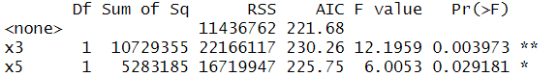
3. (1) 在已引入x3、x5的情况下，依次引入其他变量检验，由以下结果可知，选择引入x4
引入变量 x2 的单独F检验统计量值为 0.039 对应p值为 0.8467
引入变量 x4 的单独F检验统计量值为 6.0224 对应p值为 0.0304
引入变量 x6 的单独F检验统计量值为 0.0129 对应p值为 0.9116
(2) x3、x4和x5同时存在时，F检验均显著，保留
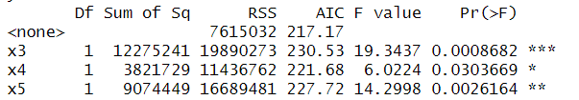
4. (1) 在已引入x3、x4、x5的情况下，依次引入其他变量检验，由以下结果可知，选择引入x6
引入变量 x2 的单独F检验统计量值为 0.601 对应p值为 0.4546
引入变量 x6 的单独F检验统计量值为 4.5366 对应p值为 0.0566
(2) x3、x4、x5和x6同时存在时，F检验均显著，保留
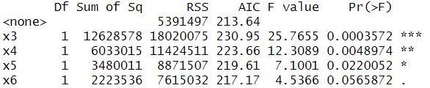
5. (1) 在已引入x3、x4、x5、x6的情况下，依次引入其他变量检验，由以下结果可知，选择引入x2
引入变量 x2 的单独F检验统计量值为 3.7633 对应p值为 0.0811
(2) x2、x3、x4、x5和x6同时存在时，x2、x3、x4和x6的F检验均显著，x5的F检验大于0.15，选择剔除x5
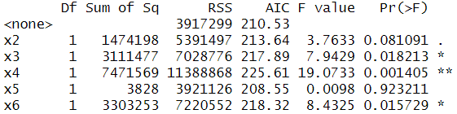
(4)根据以上计算结果分析后退法与逐步回归法的差异
①构建方程的步骤不同
后退法从包含所有自变量的完整模型开始，逐步剔除最不显著的变量，逐步回归法结合了前向选择和后退法，可以在每一步添加或删除变量。
②计算效率不同
后退法的明显不足是，一开始把全部自变量引入回归方程，这样计算量很大，有些不太重要的自变量，一开始就不引入，就可减少一些计算量，再就是一旦某个自变量被剔除，它就再也没有机会进入回归方程。
逐步回归从简单模型开始，逐步扩展，计算量小，能及时剔除不显著的变量。

8.3 & 8.4
8.3 用主成分回归方法建立模型，并与其他方法结果进行比较。
8.4 用偏最小二乘方法建立模型，并与其他方法结果进行比较。
变量说明：y表示水泥在凝固时放出的热量，x1为铝酸三钙的含量，x2为硅酸三钙的含量，x3为铁铝酸四钙的含量，x4为硅酸二钙的含量
模型说明：以下回答包含逐步回归法建立模型和主成分回归法建立模型，最后进行两结果的比较。
准备工作
data = read.csv("E:/研究生阶段作业/应用回归分析数据/8.3.csv")
# 标准化数据
datas = data.frame(scale(data))
#导包
library(car)
library(caret)
library(ggplot2)
library(reshape2)
library(pls)
library(GGally)
library(gridExtra)
法1：普通最小二乘法
ols = lm(y ~ x1 + x2 + x3 + x4 , data = data)
summary(ols)
使用普通最小二乘方法对数据做回归，得到结果如下。
由表知，各变量系数均不显著，但决定系数R²为0.9824，方程整体F检验显著，可以推测数据存在严重共线性问题。
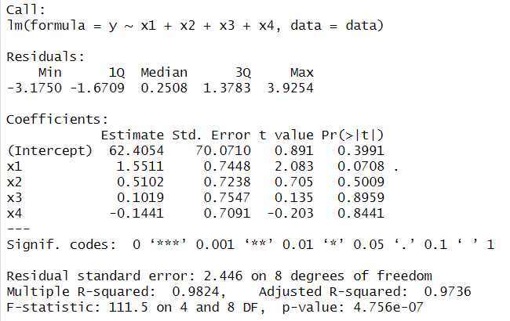
法2：变量选择-逐步回归法
stepwise = step(ols, direction = "both", trace = 0)
summary(stepwise)
采用逐步回归法引入变量，得到结果如下。
建立的模型中，引入了x1、x2、x4三个变量。方程整体显著，R²和Adjusted R²均在0.97以上，表示模型整体拟合很好。但在回归系数检验中，x2、x4的回归系数均未通过显著性检验，共线性问题仍存在。
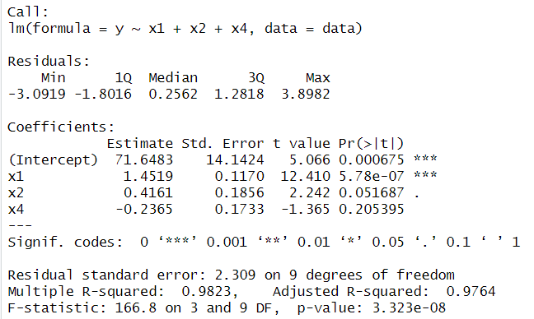
法3：主成分回归法
# 全数据标准化
datas = data.frame(scale(data))
# 计算累计贡献率
pca = prcomp(datas[, c("x1", "x2", "x3", "x4")])
summary(pca)
# 主成分回归PCR
scores = pca$x
pcr1 = lm(data$y ~ scores[,1:2])
summary(pcr1)
（1）累计贡献率
根据贡献率我们可以看到，第一个主成分的方差解释率为55.89%，第二个主成分的方差解释率为39.40%，此时累计贡献率为95.29%，第三个和第四个主成分对变异的解释力非常有限，因此选择由第一个和第二个主成分描述数据。
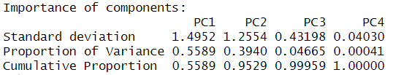
（2）主成分回归
采用主成分回归法对数据做回归，得到结果如下。
由表知，模型整体显著性极好，第一主成分显著，但是第二主成分不显著，虽然R²很高，但第二个主成分的加入可能没有实质贡献。
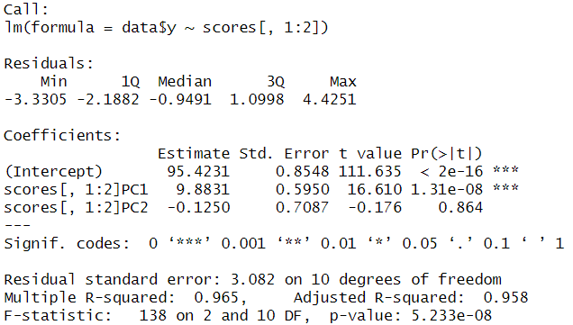
法4：偏最小二乘方法
# 全数据标准化
datas = data.frame(scale(data))
pls1 = plsr(y~., data = datas, validation = "LOO")
summary(pls1, what = "all")
# 还原回归系数
pls2 = plsr(y~.,data = datas, ncomp = 3, validation = "LOO", jackknife = TRUE)
coef(pls2)
（1）使用偏最小二乘方法对标准化后的数据做回归，得到结果如下。
根据plsr结果，应该选择3个潜在因子。
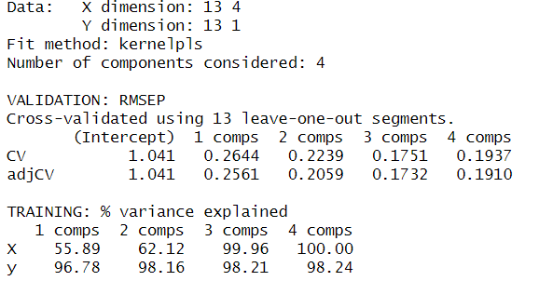
（2）还原为对原始变量的系数，得到方程
y = 0.4975 x1+ 0.2916 x2 -0.0562 x3 -0.4262 x4
结果比较
本题的比较从模型拟合优度RMSE、模型简洁性与解释性、预测误差比较综合比较，得到如下评价：
（1）普通最小二乘: 使用所有变量，受多重共线性影响较大，因为解释变量相关时，导致模型预测性能下降。
（2）逐步回归: 自动选择重要变量，提高模型简洁性，保留了解释性，系数意义明确。
（3）主成分回归法: 通过主成分变换，将原始高度相关的变量转换为正交的主成分，缓解共线性问题，基于特征值分解，计算过程数值稳定。
（4）偏最小二乘法: 同时考虑自变量变异和与因变量的协方差，既降维又最大化预测能力，在样本量较小的情况下仍能保持良好性能
综上，偏最小二乘回归（PLS）为最优选择，提供最优的预测性能，RMSE最小，预测精度最佳且模型简洁易解释。
1. 模型拟合优度比较
# 计算各模型的拟合指标
models = list(OLS = ols, Stepwise = stepwise, PCR = pcr_model, PLS = pls_model)
results = data.frame( Model = names(models), R2 = numeric(4), Adj_R2 = numeric(4), RMSE = numeric(4), AIC = numeric(4), BIC = numeric(4), Num_Vars = numeric(4))
for (i in 1:length(models)) {
model = models[[i]]
model_name = names(models)[i]
if (model_name %in% c("OLS", "Stepwise")) {
# 线性模型
y_pred = predict(model, data)
r2 = summary(model)$r.squared
adj_r2 = summary(model)$adj.r.squared
rmse = sqrt(mean((data$y - y_pred)^2))
aic_val = AIC(model)
bic_val = BIC(model)
num_vars = length(coef(model)) - 1 # 不包括截距
} else if (model_name == "PCR") {
# PCR模型 - 使用2个主成分
y_pred = predict(model, datas, ncomp = 2)
r2 = R2(model, ncomp = 2, estimate = "train")$val
adj_r2 = NA # PCR没有调整R²
rmse = RMSEP(model, ncomp = 2, estimate = "train")$val
aic_val = NA
bic_val = NA
num_vars = 2 # 使用的主成分数
} else if (model_name == "PLS") {
# PLS模型 - 使用2个成分
y_pred = predict(model, datas, ncomp = 2)
r2 = R2(model, ncomp = 2, estimate = "train")$val
adj_r2 = NA # PLS没有调整R²
rmse = RMSEP(model, ncomp = 2, estimate = "train")$val
aic_val = NA
bic_val = NA
num_vars = 2 # 使用的成分数
}
results[i, "R2"] = r2
results[i, "Adj_R2"] = adj_r2
results[i, "RMSE"] = rmse
results[i, "AIC"] = aic_val
results[i, "BIC"] = bic_val
results[i, "Num_Vars"] = num_vars}
# 显示结果
print("四种回归方法的比较结果：")
print(results)
# RMSE比较
p1 = ggplot(results, aes(x = Model, y = RMSE, fill = Model)) +
geom_bar(stat = "identity", alpha = 0.8) +
geom_text(aes(label = round(RMSE, 3)), vjust = -0.5, size = 4) +
labs(title = "模型RMSE比较", y = "RMSE", x = "模型") +
theme_minimal() +
theme(plot.title = element_text(hjust = 0.5, size = 14, face = "bold"))
print(p1)
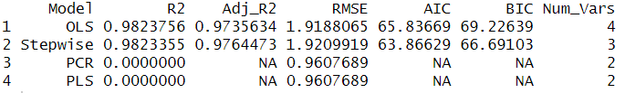

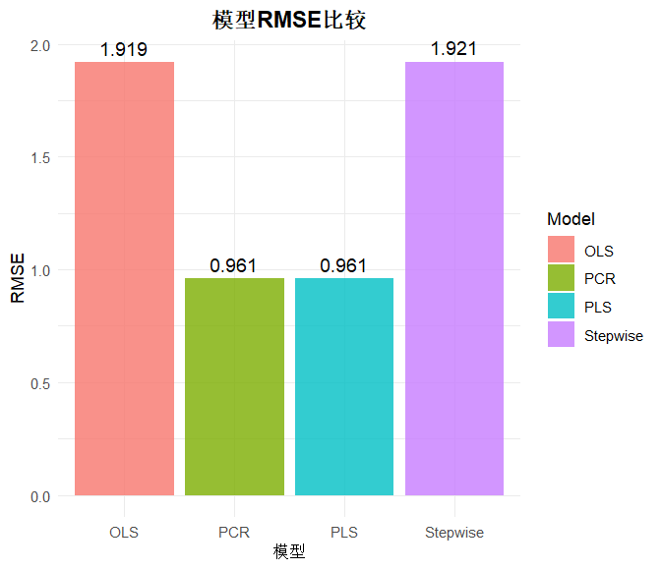
2. 模型简洁性与解释性
# 图3: 变量个数比较
p2 = ggplot(results, aes(x = Model, y = Num_Vars, fill = Model)) +
geom_bar(stat = "identity", alpha = 0.8) +
geom_text(aes(label = Num_Vars), vjust = -0.5, size = 4) +
labs(title = "模型变量数比较", y = "变量个数", x = "模型") +
theme_minimal() +
theme(plot.title = element_text(hjust = 0.5, size = 14, face = "bold"))
print(p2)
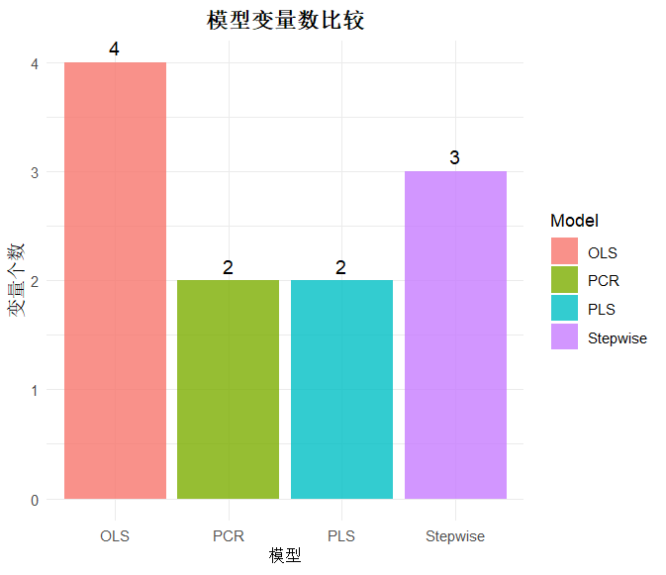
3. 预测误差比较
# 交叉验证预测误差比较
cv_results = data.frame(
Model = c("OLS", "Stepwise", "PCR", "PLS"),
RMSEP = c(
sqrt(mean((resid(ols))^2)),
sqrt(mean((resid(stepwise))^2)),
RMSEP(pcr_model, ncomp = 2, estimate = "train")$val,
RMSEP(pls_model, ncomp = 2, estimate = "train")$val))
print("交叉验证预测误差比较：")
print(cv_results)
# 图3: 预测误差比较图
p3 = ggplot(cv_results, aes(x = Model, y = RMSEP, fill = Model)) +
geom_bar(stat = "identity", alpha = 0.8) +
geom_text(aes(label = round(RMSEP, 3)), vjust = -0.5, size = 4) +
labs(title = "模型预测误差(RMSEP)比较", y = "RMSEP", x = "模型") +
theme_minimal() +
theme(plot.title = element_text(hjust = 0.5, size = 14, face = "bold"))
print(p3)

