1.

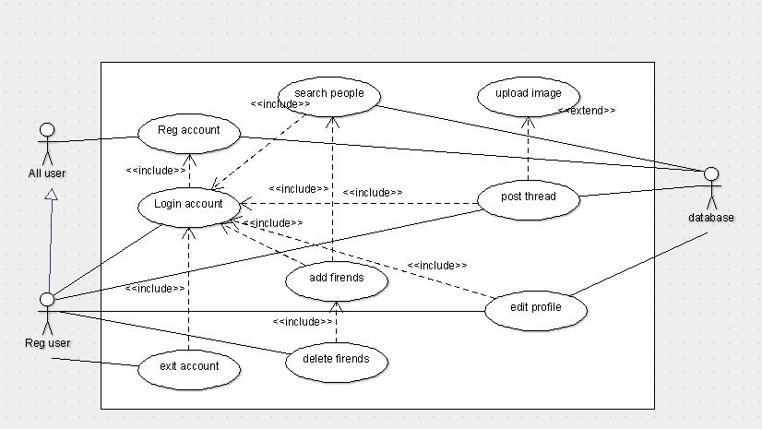

2.

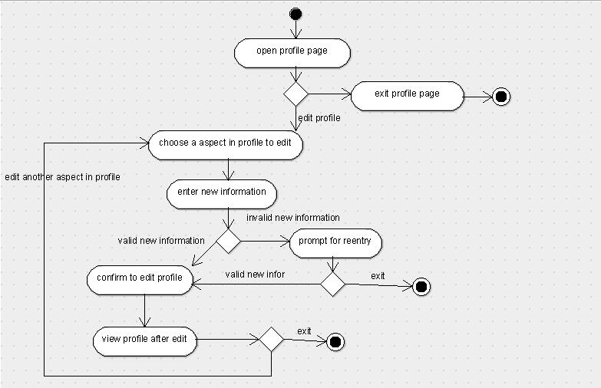

3.

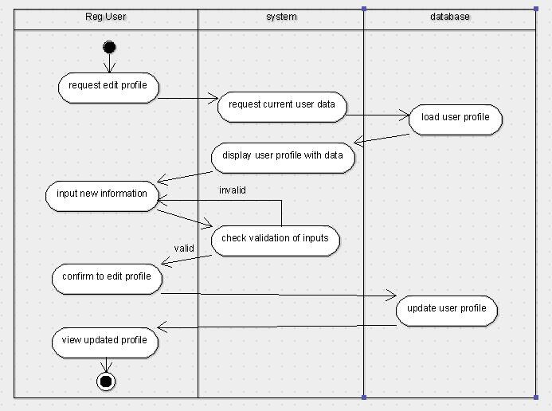

Question 1:

Many relationships are wrong.

Use case "Login" should not include such use cases.

Question 2:

We need database operation.