1.

Sequence diagram and Statechart diagram both are belonging to the behavior models.

Statechart diagram indicates how an individual class changes state based on external

Events. It represents the states of activities from class and events that how those states flow and related. Base on classes, or more concrete block of things.

Sequence diagram shows the behavior of the software as a function of time. it represents the states by lining up all the classes(actors), and show how data flows from state to state with respect of timeline between classes. Base on some action, like “placing an order” in question 3.

Eventually both of them show how data flow from state to state using similar activities and events.

2.

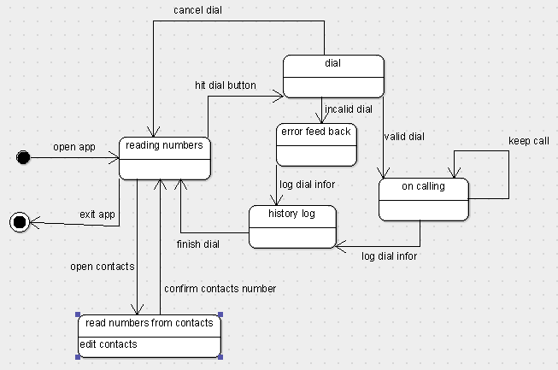

3. argouml, can’t control the white bock under /name, and no start and end state able for sequence diagram, so I grab them by using other software.

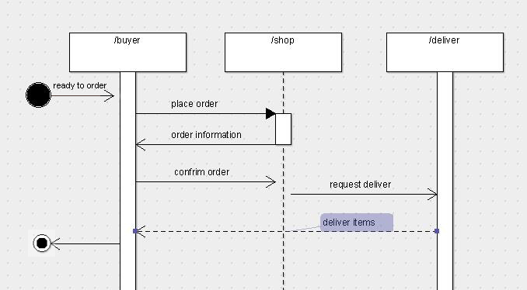

4.

Question 1:

Both diagrams are representations of system behaviors,providing a way of behavioral modeling, showing how the system behaves.

The sequence diagram emphasizes the temporal logical processing of the system carrying out a functional feature (a use case); it also shows how different classes (components)of the system interact internally in order to carry out that use case.

Question 3: the format of sequence diagram is not quite right. ﻿﻿﻿﻿﻿﻿﻿﻿﻿﻿﻿