Part I. Multiple Choices Questions (Two points per question)

(Put the letter corresponding to the best answer in the bracket.)

1. Which are all umbrella activities of the generic software process? ( b)

a. project tracking, planning, measurement, configuration management, deployment

b. measurement, technical rev

iew, quality assurance, risk management, production

c. communication, risk management, measurement, production, reviewing

d. analysis, designing, programming, debugging, maintenance

2. Which are the four framework activities in an XP process? ( a)

a. planning, design, coding, and testing

b. communication, planning, modeling, construction

c. analysis, coding, testing, deployment

d. planning, modeling, construction, validation

3. Which below is not an objective for building a requirements model? (c)

a. define set of software requirements that can be validated

b. describe customer requirements

c. develop an abbreviated solution for the problem

d. establish basis for software design

4. Which of the following must appear on a CRC index card? ( c)

a. data objects

b. attributes

c. responsibilities

d. operations

5. The composition relationship between classes is a special form of ( c)

a. dependency relationship

b. collaboration relationship

c. aggregation relationship

d. generalization relationship

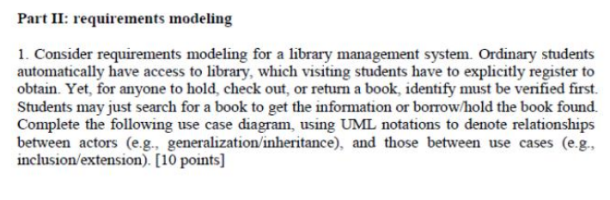

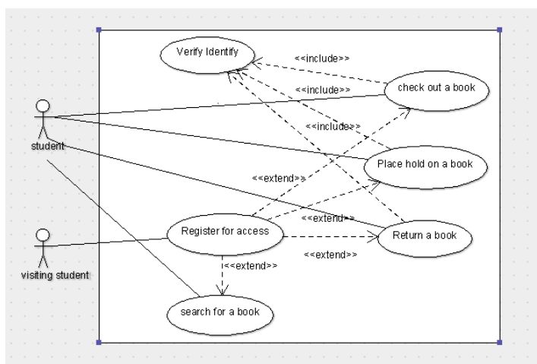

Part II:

1.  There should not be relationship between "Register for access" and "Search for a book".

    Use cases "Place hold a book" and "Check out a book" should have "exclude" relationships between "Search for a book".

2. The relationship between "Order" and "Payment" should be association.

   The relationships between "Payment" and "Credit card","Cash","Check" should be inheritance.

   "Customer" and "Payment" should not have relationship.