1. 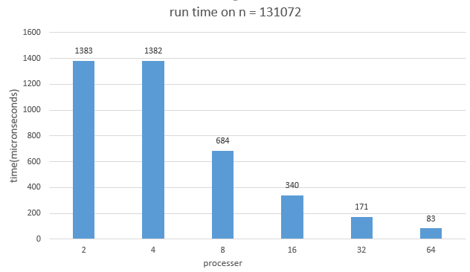

For the speed up here, on the try of processer 2 to 4, the time to run on input size 131072, dose not really change much of run time, but from processer 4, to 8 and after. The runtime decreases as about the invers rate of processer growth rate, which is about half of run time when ever processer doubles.

2.

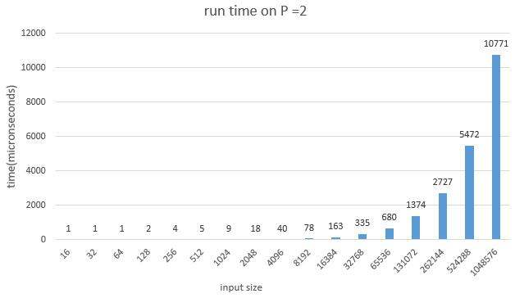

The run time here just simply grow in same rate as the input size grow, when the size of input grow twice, time grow twice too. So this is a linear runtime code.