This is the plot I got base on the data from runing send/receive code on cluster with 2 processor.

The package size in the plot are ranged from 0.125mb to 8 mb, I do have the data under 0.125 from runing the code, but they just kind of useless to put in this plot.

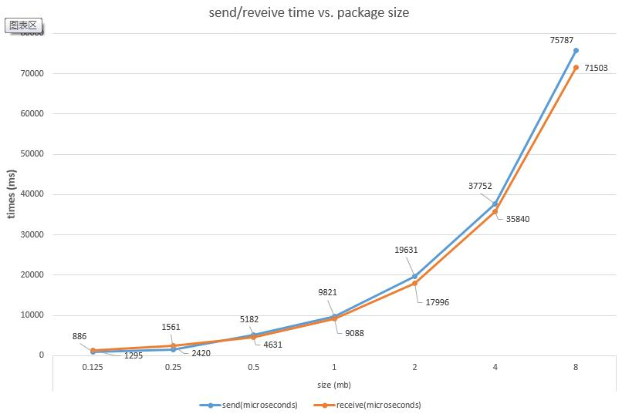

I got the latency of network from the time data running with package size under 0.1 mb, and for package size (1-1024 bytes), the **Send latency is about 9 microseconds.**

It is hard to tell the **receive latency** since the time data for small package size are different every run with in a range of 1 – 100ms, sometimes the receive time for data just 1ms. I think that is because the receive buffer. But generally, for package size 16384 bytes and under, the run time is under 100ms.

Since the latency is really small compare to larger package size (~mb), I dropped it when I calculate bandwidth while using data in plot above.

By equation Tcomm = Latency + ( (1/bandwidth) * m), I found out bandwidth. Base on my larger sets data, the **Bandwidth for sending is about 105Mbytes/s**; and **Bandwidth for receive is about 111Mbytes/s**

Base on my data sets, there are many times of receiving 512 bytes and few times of receiving 1024 bytes times are 1 microseconds. So, assuming the send buffer and receive buffer have same size, I **predict the network buffer size is 1024 bytes.**

Showing part of small data run time below:

