**Installing GreekBibleStudent**

You need to double-click the PKG file to run it instead of dragging it somewhere. You’ll see an interface not that different from Windows installation wizards.

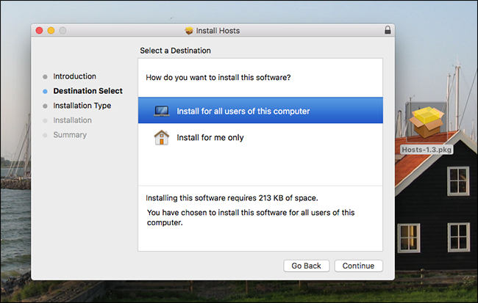

When you’re done installing the app, if you copied the PKG file onto your hard disk rather than simply running it from a CD, you can delete the PKG file.

## How to Bypass Gatekeeper and  Run the Application from “Unidentified Developers”

By default, your Mac won’t open any software made by “unidentified developers”. This is a security feature called “Gatekeeper”, intended to stop the spread of malware and other unwanted software, but every once and a while a program you want to run fall into this category, showing you a message like saying your program “can’t be opened because it is from an unidentified developer.”

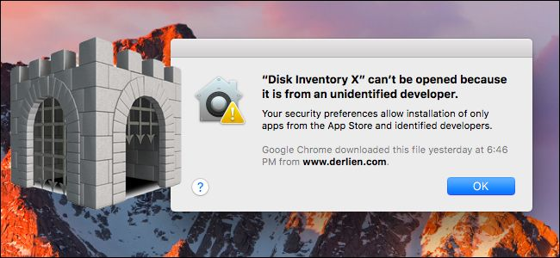

Since you’re absolutely certain the application in question is trustworthy, you can [open apps from unauthorized developers](https://www.howtogeek.com/205393/gatekeeper-101-why-your-mac-only-allows-apple-approved-software-by-default/) by holding Option, right-clicking the application, and clicking “Open.” You can also disable Gatekeeper entirely, if you so choose.

To disable Gatekeeper, open the System Preferences window—click the Apple icon at the top-left corner of your screen or click the System Preferences icon on your dock—and click the Security & Privacy icon. Click the lock icon, enter your password, and set the “Allow apps downloaded from” option to “Anywhere.” This will reduce your security as it allows unsigned apps to run, so be sure you know what you’re doing if you use this option.

