Input can be provided by GingerALE textfiles (Sleuth output) or Excel-Spreadsheets

Tags may be supplied in these files to filter experiments in the subsequent analysis

*Script1_ReadExcelFile* or *Script1_ReadSleuthTextFile* parse these and write out matfiles into ‘DataMatlab’

*Scripts_AnalysisFromSpreadsheet* runs all analyses as coded via Excel-files

**Input via Sleuth textfiles**

First line should be //reference=mni

Then each experiment should be represented as follows

// Author name or another experiment description [free text, just for identifying experiments]

// Subjects=24 [no spaces between the equal sign and the number]

// Tag 1 [optimal]

// Tag 2 [optimal]

// Tag 3 [optimal]

…

[Then leave a blank line between experiments]

**Input via Excel spreadsheets**

- The spreadsheet should have a title row that will not be read

- The order of the columns should be as in this example

- Tags are optional

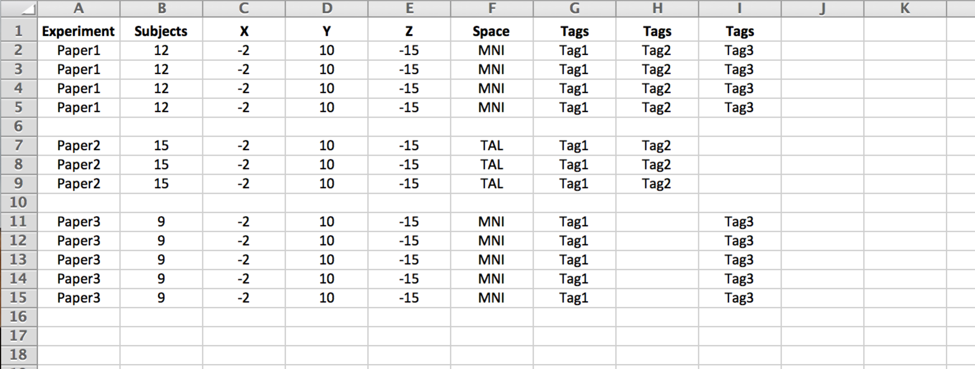

**Important note: In either case the tags are taken straight as they are, so please make sure that spelling (including spaces etc) is consistent throughout the file!**

**Analysis descriptions are provided via Excel spreadsheets**

**Please use the following format / syntax**

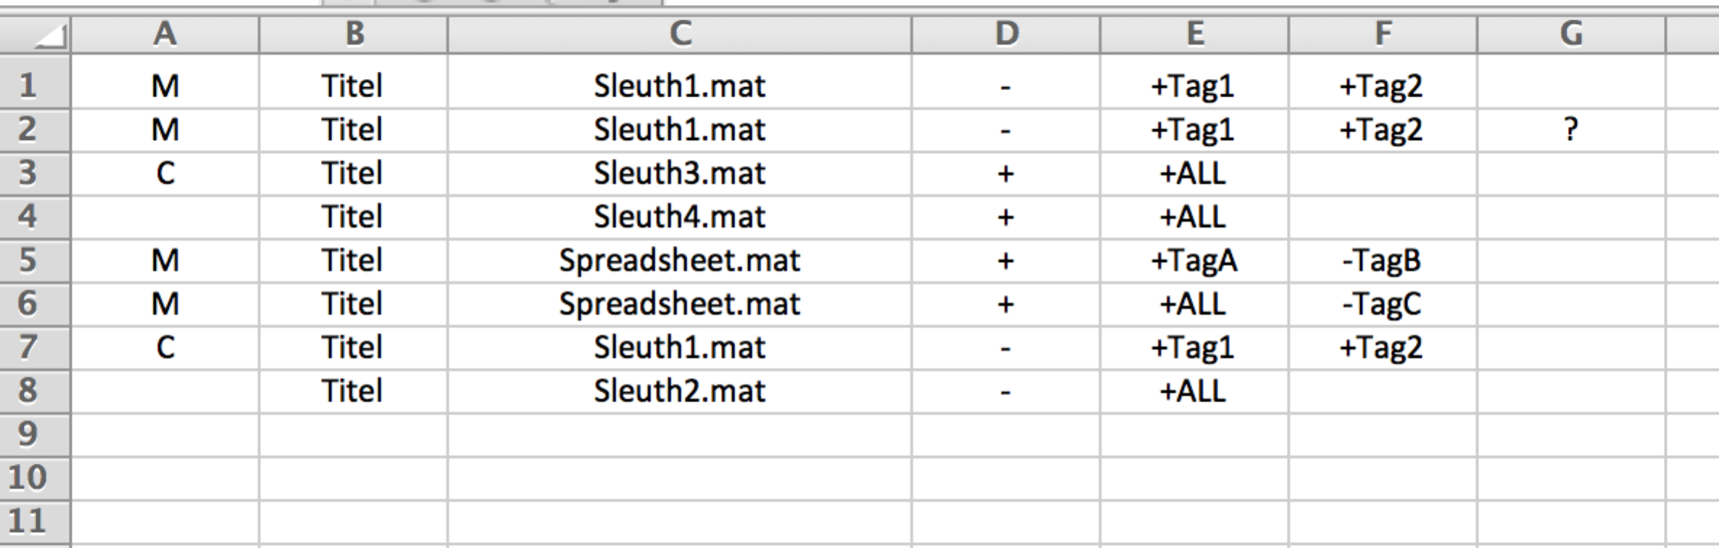

**1st column:**

- M denotes main effect (one line = one analysis)

- C denotes contrast (this line and the following are contrasted against each other). If the respective main effects in the two lines [e.g. 3 and 4] are not yet computed, they will be evaluated

**2nd column:**

Titel of the effect. Ideally avoid spaces and non file-name characters. When (re-) entering a title as part of a contrast, please keep naming/spelling consistent otherwise the “old” main effect is not recognized

**3rd column:**

Name of the data-matfile which must exist in ‘DataMatlab’. Contrasts can be performed between experiments stored in different files, in that case, however, there is no check for duplicates (which is performed when working from the same file)

**4th column:**

+ enables all screen and print output, - (hopefully) disables all, i.e., only computes the analyses without using any windows. Does not yet work for VOI analyses

**5th column onwards: Specify the analysis by tags.**

+ALL -> Include the entire set of experiments in that matfile

+Tag -> Include only those experiments that have the respective label

+Tag1 +Tag2 -> Conjunction, includes only experiments that have both labels

+Tag1 +Tag2 ? -> Logical ‘OR’, includes experiments that have either label

-Tag -> Exclude experiments that have the respective label

$VOI -> additionally to the voxel-wise analysis perform VOI analysis for the specified VOI [full path/filename, binary mask]. Multiple VOIs can be entered after each other and are evaluated at the same time

#VOI (not particularly well maintained) -> include only experiments activating the provided ROI [full path/filename, binary mask]

~VOI (not particularly well maintained) -> excludes experiments activating the provided ROI [full path/filename, binary mask]