**Processing Paleomagnetic Data on the JR using PmagPy**

There is a notebook set up to process paleomagnetic data generated on board the JR using PmagPy. PmagPy has been installed on the shipboard Macintosh computer next to the JR6. To get started, open a terminal window (type terminal into the search icon in the upper right hand corner of the Mac menu bar), click on it, and follow these steps:

* Refresh the PmagPy software to get the latest version:

Type after the $ prompt (case sensitive)

$ cd Desktop/PmagPy

$ git pull

* Set up your directory structure:

On Exp 382, the directory structure for the paleomagnetic working directory looked like this: DATA/Uservol/4_Paleomagnetism/02_Sites. The Jupyter notebook is designed to work within the 02_Sites level directory (or equivalent). It doesn’t matter what you call that directory and we will refer to it as the “working_directory”. Each hole will have its own Jupyter notebook which will will create a directory for each hole with the structure like this: working_directory/U999A. If you have not already done so, create a working directory and put the PmagPy_iodp_HOLE_template.ipynb in it.

* Launch a Jupyter notebook

In your terminal window, type the following (after the $ prompt):

$ cd

$ cd Desktop/PmagPy-data

$ jupyter notebook

This will open up a window something like this:

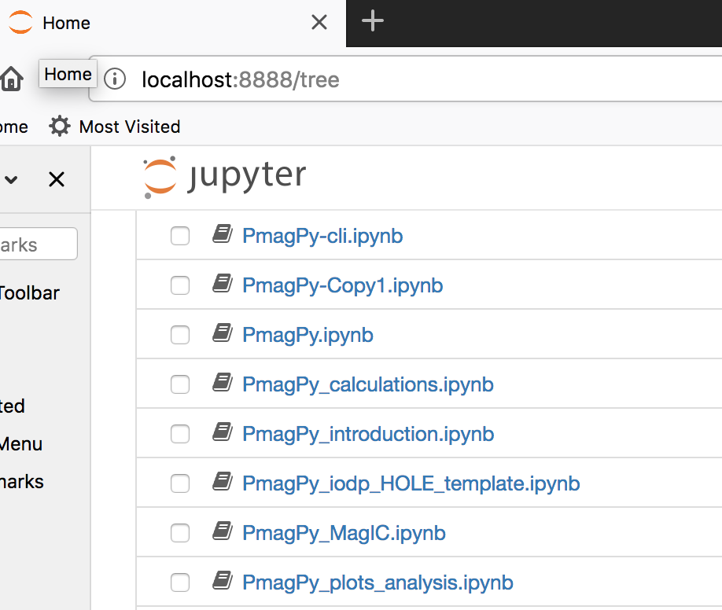

Click on the PmagPy_iodp_HOLE_template.ipynb link. This is a template for working with JR paleomagnetic data downloaded from LIMS.

* Learn the basics of Jupyter notebook operation:

There are two kinds of cells in a Jupyter notebook: “Markdown” and “Code”. The flavor can be picked in a dropdown menu at the top of the notebook (the cell labeled Markdown in the figure below). To “run” a cell, just click on the cell and then click on “Run” in the menu next to the “flavor” menu.

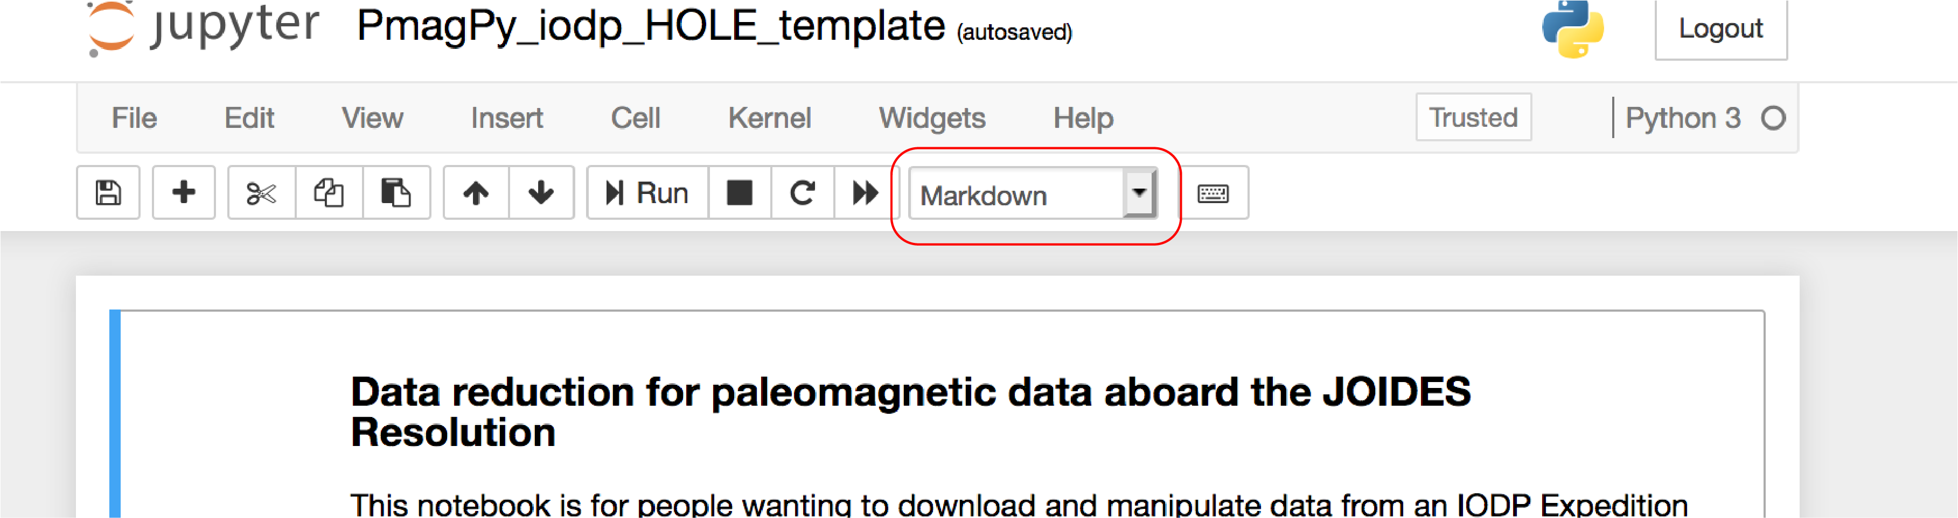

You don’t have to actually know Python to use this notebook, but the code cells contain Python scripts which do the data processing and visualization for you.

* Practice on FAKE data first:

There is a worked example of how to use the notebooks in the PmagPy-data folder. From your open notebook, look under the File menu in the notebook menu bar, click on ‘Open’, then click on data_files => iodp_magic and finally click on U999A.ipynb

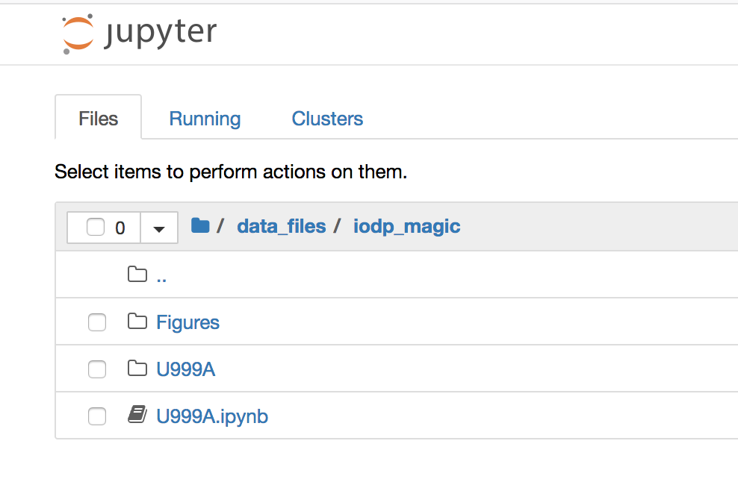

Read through the notebook and execute each cell in turn.

* Use a notebook on your own data:

Open the PmagPy_iodp_HOLE_template notebook either from your open notebook, or go back to the terminal window and type jupyter notebook again. Copy the notebook by selecting “Make a copy” from the File Menu on the notebook menu bar. Then select File => Rename and rename it for your HOLE (e.g., U999A). Place the copy in your working directory. Edit the cell with the HOLE name for your expedition, HOLE, set the mkdir variable to True and execute the cell. This sets up the directory structure that the notebook expects. Eventually, you should set the hole_lat and hole_lon variables too as this will correctly populate the MagIC tables with the required meta-data, but that is not necessary at first (although if you want the GAD inclination on you plots, you should do this as soon as the information is available (see Hole Summary under Summaries in the LIMS Reports window below).

To process paleomagnetic data generated on the ship, you need to download the data files from LORE. These data files will go into the directory structure you just created. To get the necessary files, open a new browser window and go to: ship.iodp.tamu.edu.

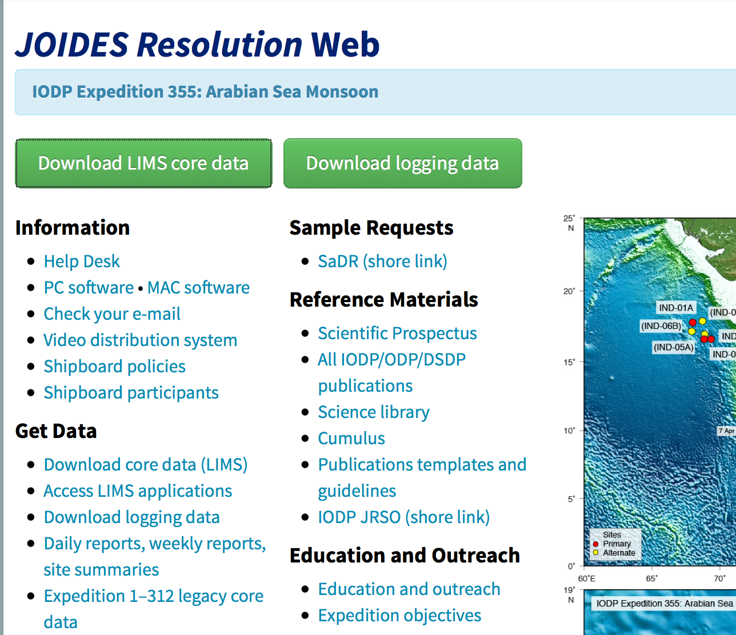

* Click on Download LIMS core data

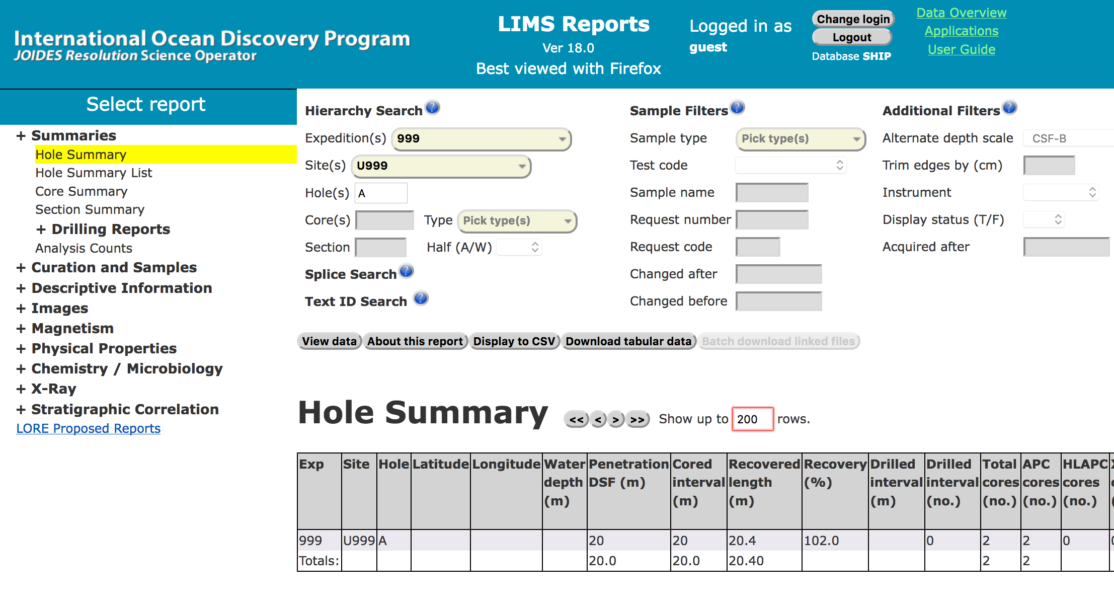

* Click on ‘Summaries’ and select “Hole Summary”. Select the Expedition, Site and Hole, then click on “view data”, then “Download tabular data”.
* Repeat for “Core Summary”.
* Then click on on 'Curation and Samples' and then select the 'Sample Report'. Then choose the sample type of Cube under Sample Filters and Pmag as the sample code. Click on the 'Download tabular data' tab.
* Click on Magnetism and download SRM archive data, discrete sample data, JR6 data and/or Kappabridge data.
* Follow the instructions in the notebook.