PROJECT DOCUMENTATION:

Project Overview
HandsMen Threads, a growing fashion and retail organization, initiated a Salesforce CRM implementation to centralize customer information, streamline business operations, and improve service quality. The CRM is designed with a robust data model to store essential business data—such as customer records, orders, stock details, and loyalty information—ensuring smooth data flow across departments.

Objectives
The primary objective of the CRM project is to equip HandsMen Threads with a unified, efficient, and automated system that supports customer management, order tracking, and inventory operations. The CRM aims to reduce manual work, minimize data errors, and establish automated communication with customers and warehouse teams, ultimately enhancing customer service and workflow efficiency.

Phase 1: Requirement Analysis & Planning
• Understanding Business Requirements
- Centralize customer, order, and inventory data.
- Automate repetitive processes.
- Ensure accurate UI-based data entry.
- Support loyalty program automation.
• Project Scope
- Build custom data model.
- Create flows, automation, and scheduled tasks.
- Configure UI layouts and validation.
• Data & Security Model
- Custom objects, fields, and relationships.
- Profiles, roles, and permission sets.
• Stakeholders
- Management, Sales Team, Warehouse Team, Admin.
• Execution Roadmap
1. Requirements 2. Data Model 3. Automation 4. UI 5. Testing 6. Deployment

Phase 2: Salesforce Development – Backend & Configurations
• Environment Setup & DevOps Workflow
• Custom Objects, Fields, Validation Rules
• Automation via Workflow Rules, Process Builder, Flows, Approval Processes
• Apex Classes & Triggers
• Implemented Automations:
- Automatic Order Confirmation Emails
- Loyalty Status Auto-Updates
- Stock Level Alerts (Stock < 5)
- Midnight Bulk Order Processing
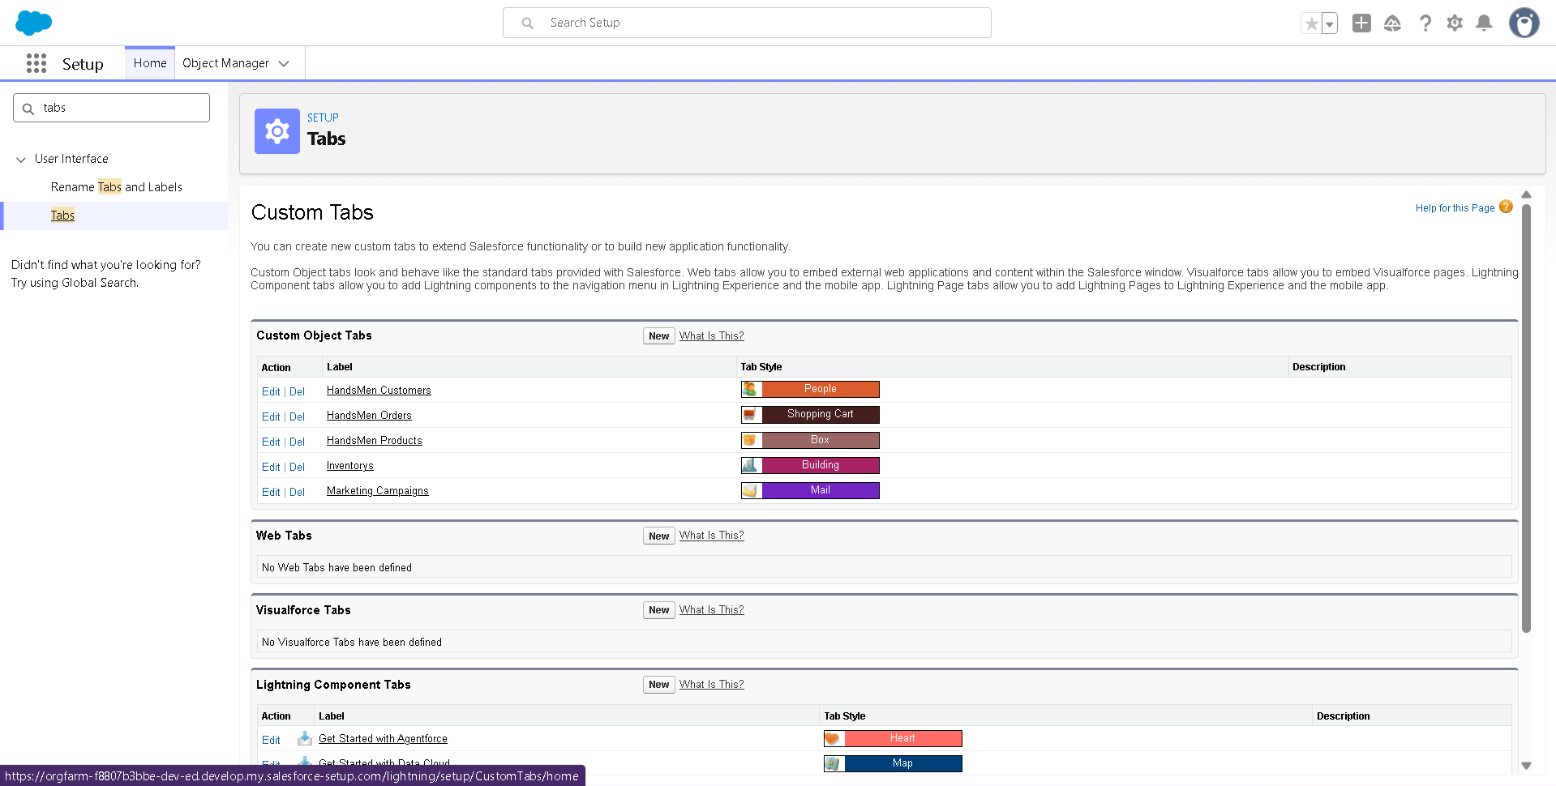
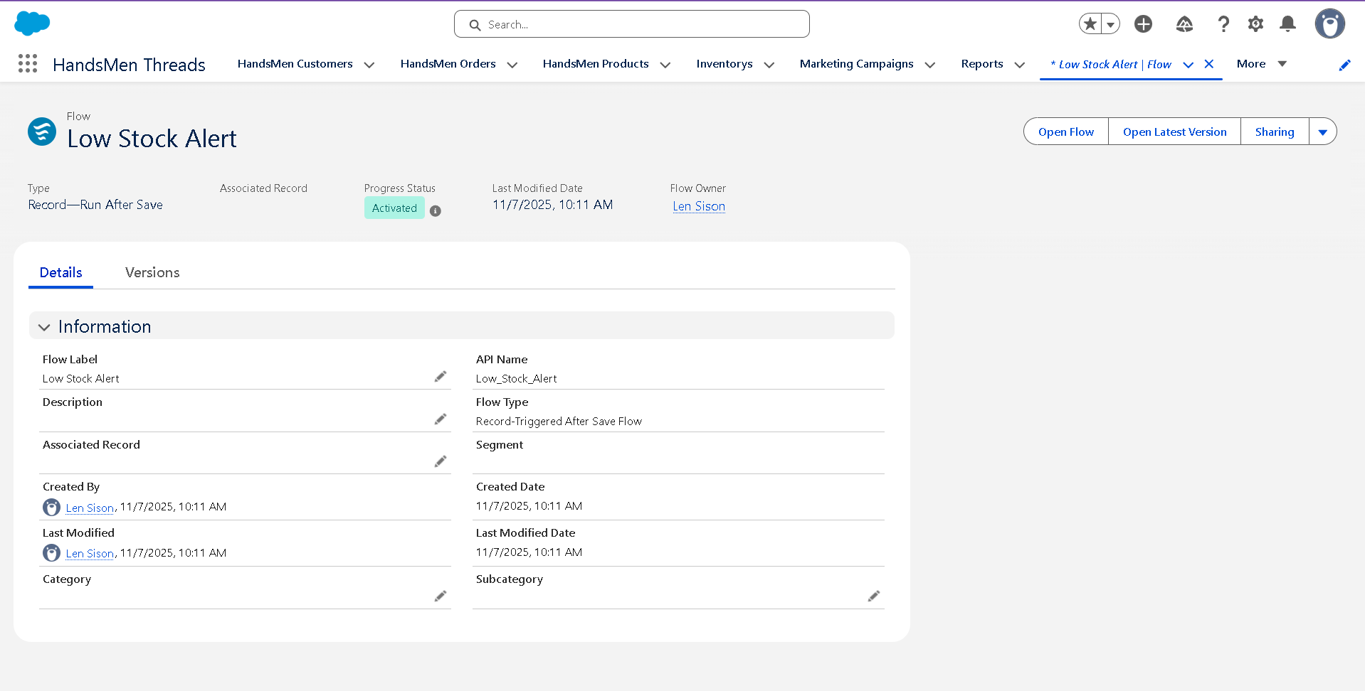
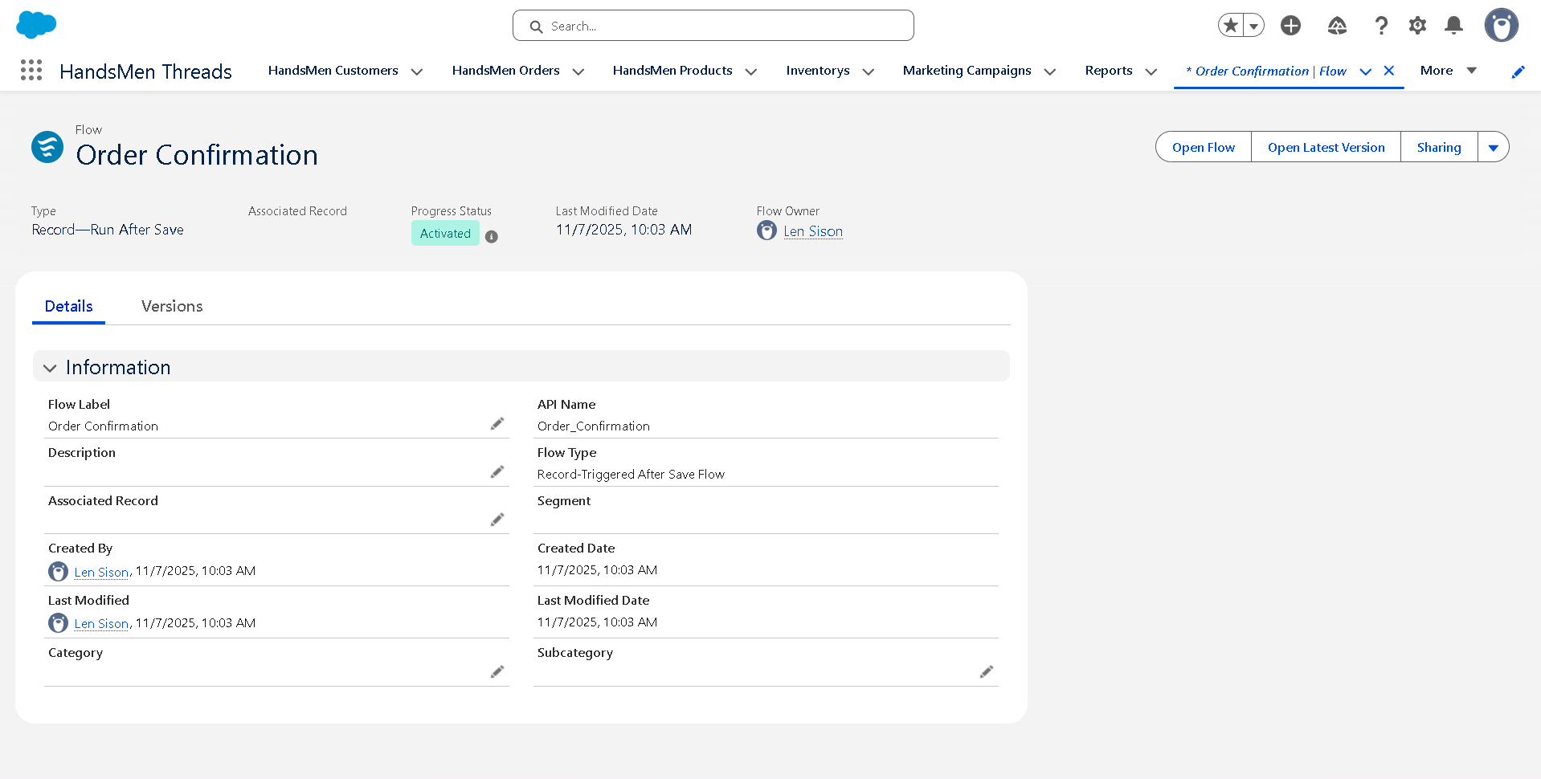
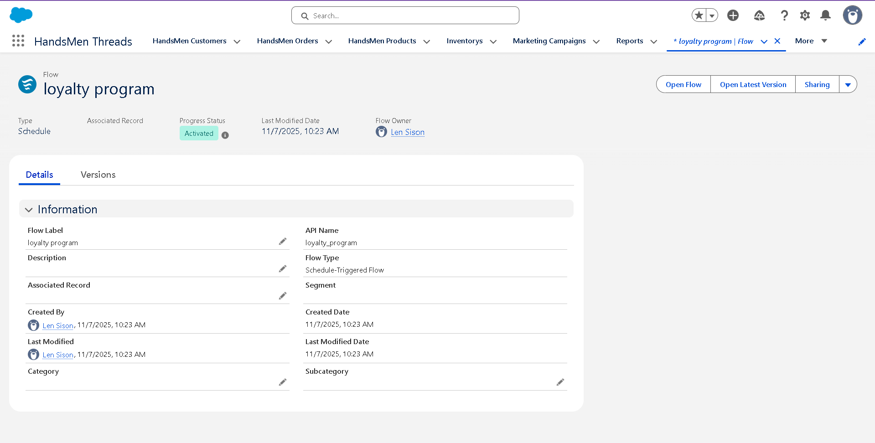

Phase 3: UI/UX Development & Customization
• Lightning App Setup
• Page Layouts, Dynamic Forms, Lightning Pages
• User Management
• Reports and Dashboards
• LWC Development (if applicable)

Phase 4: Data Migration, Testing & Security
• Data Migration via Data Loader / Wizard
• Field History Tracking, Duplicate Rules, Matching Rules
• Profiles, Roles, Permission Sets, Sharing Rules
• Test Classes for Apex
• Testing of booking creation, flows, triggers, approval processes, automations
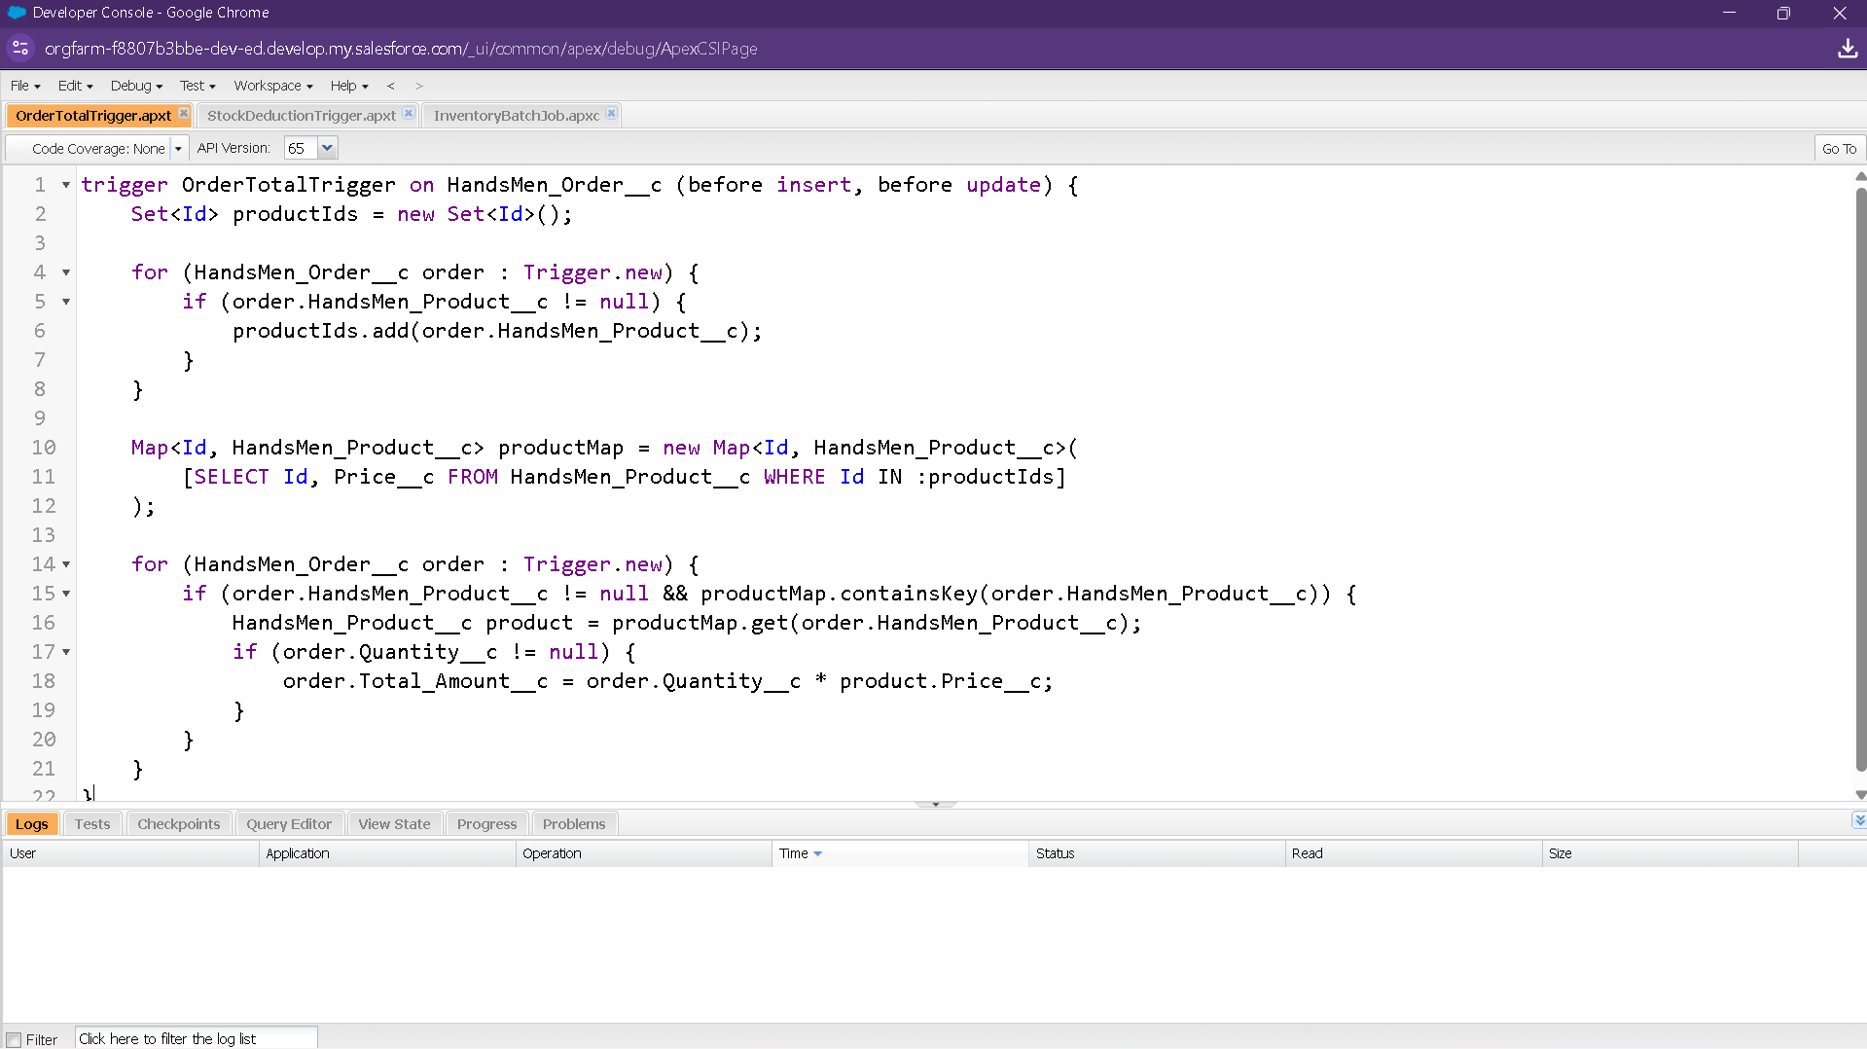
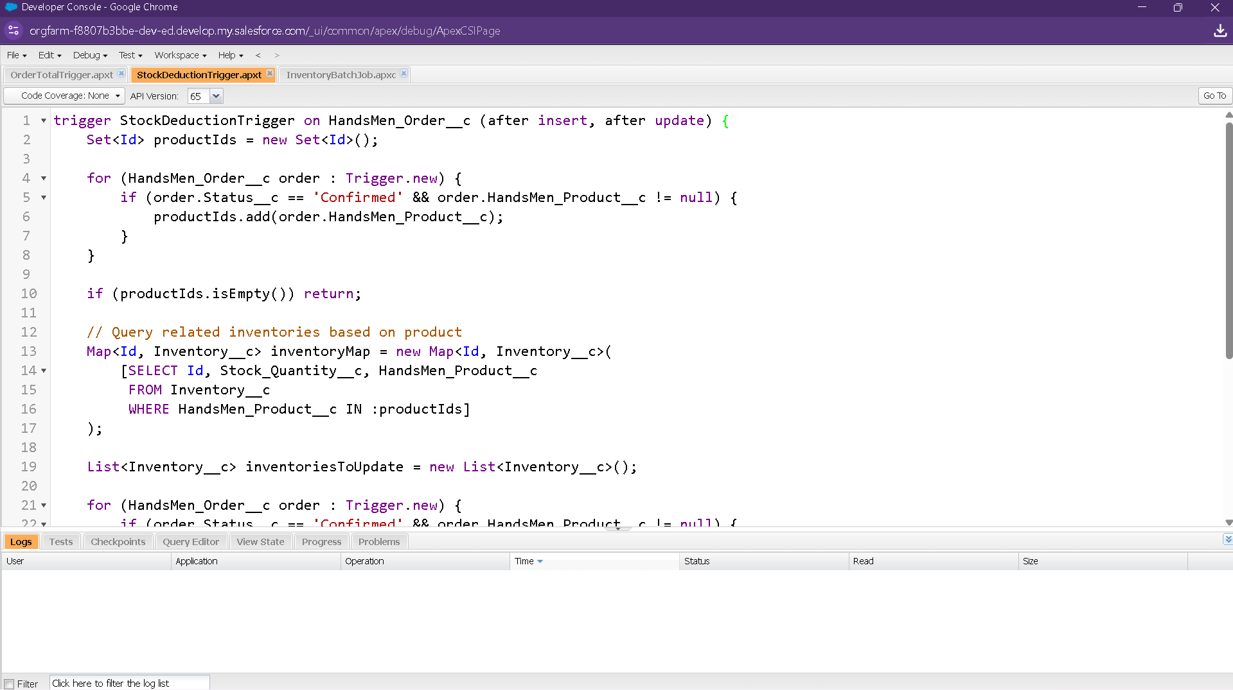
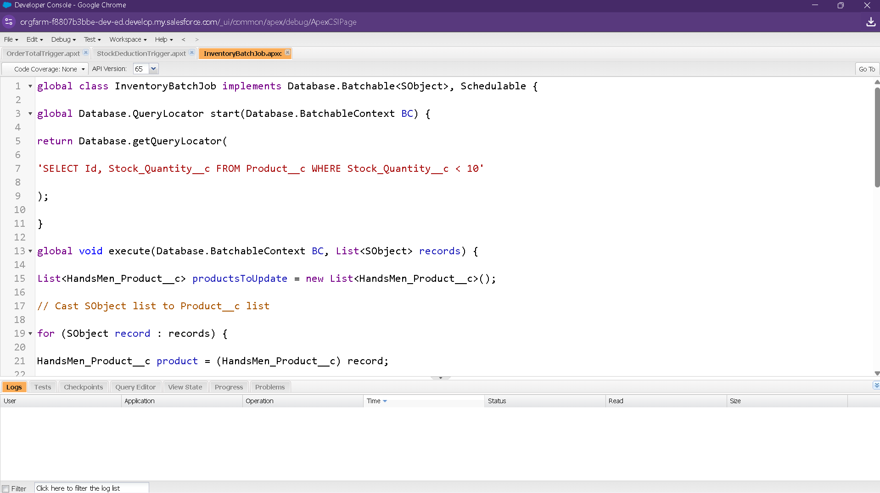

Phase 5: Deployment, Documentation & Maintenance
• Deployment via Change Sets
• Maintenance & Monitoring Guidelines
• Troubleshooting with Debug Logs, Apex Job Monitoring

Conclusion
The Salesforce CRM implementation for HandsMen Threads significantly upgrades their operational workflow by automating order processes, ensuring accurate data management, and enhancing customer engagement. The system provides a scalable and efficient platform that supports long-term growth and future enhancements.

Future Enhancements
• AI-based customer purchase prediction
• Chatbot integration

