**MOBILE APPLICATIONS LAB1**

**NAME: LENA GEO**

**REGISTER NUMBER: 2241139**

**CODE:**

**MainActivity.kt**

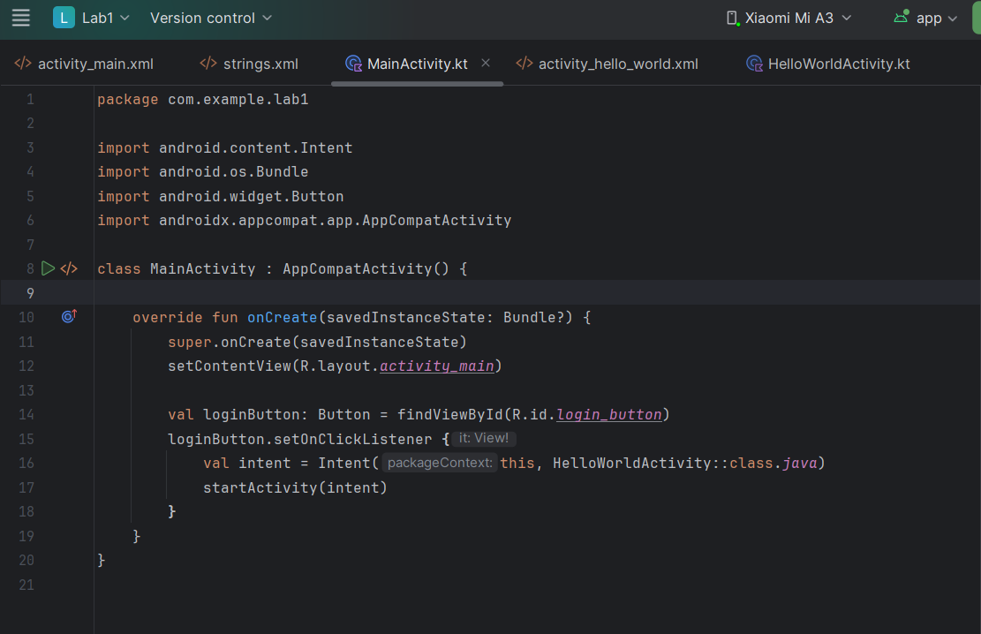

**HelloWorldActivity.kt**

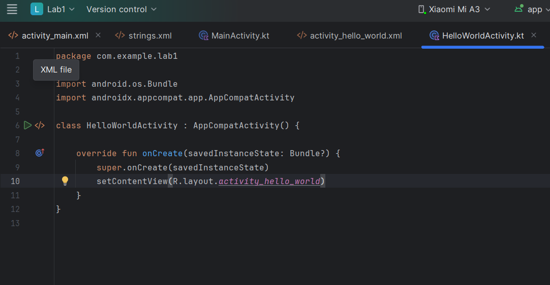

**activity_main.xml**

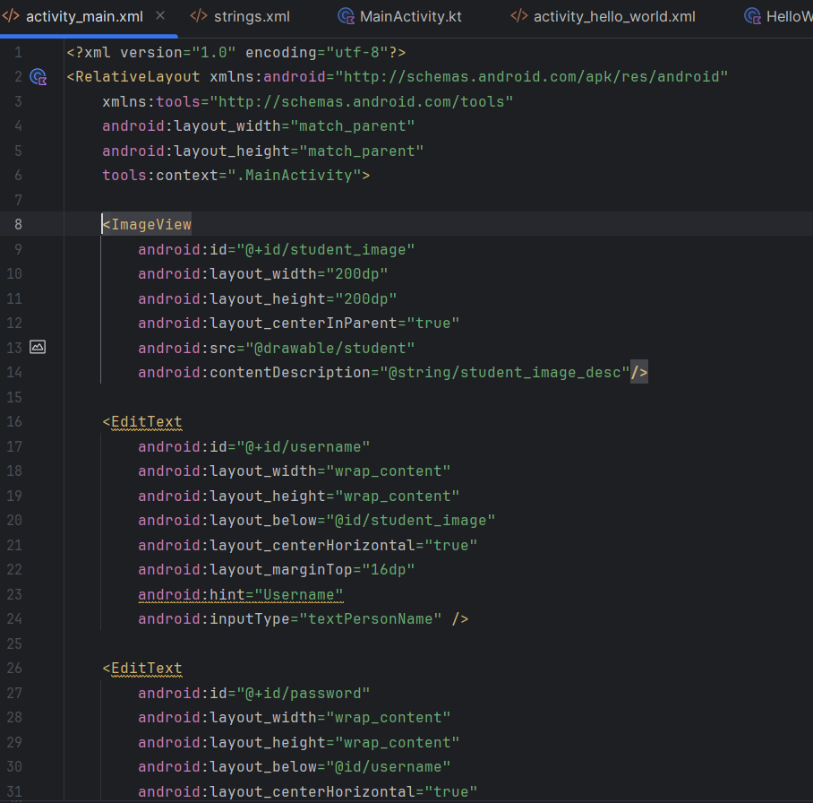

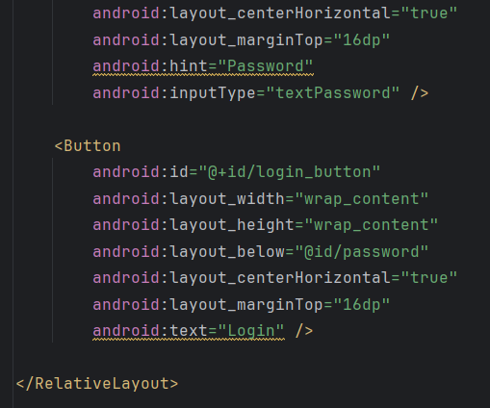

**activity_hello_world.xml**

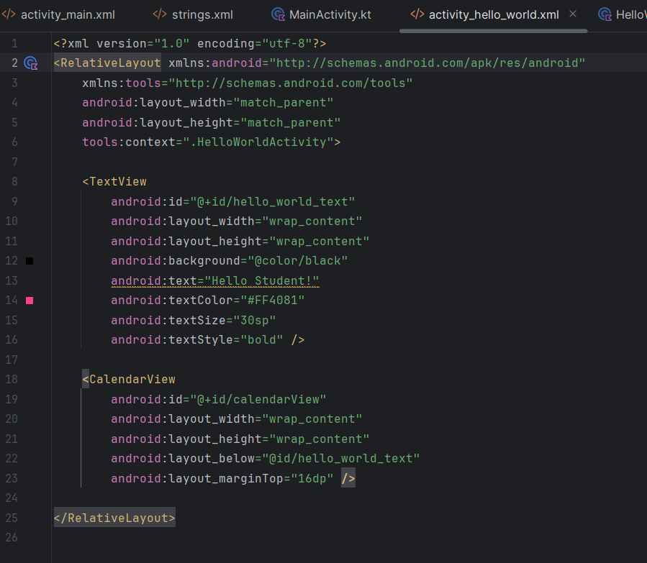

**Output**

