**MOBILE APPLICATIONS LAB 4**

**ACTIVITY LIFECYCLE DEMONSTRATION**

**NAME: LENA GEO**

**REGISTER NUMBER: 2241139**

**Lifecycle Methods**

1. **onCreate():**
   * General: Called when the activity is first created. This is where you initialize your activity. Most initialization should go here.
   * Context in App: Initializes the MediaPlayer, SeekBar, TextView, and sets up listeners. Logs and displays "onCreate called".
2. **onStart():**
   * General: Called when the activity becomes visible to the user.
   * Context in App: Logs and displays "onStart called".
3. **onResume():**
   * General: Called when the activity starts interacting with the user.
   * Context in App: Resumes playback if there was a saved position, updates the SeekBar, and starts the media player if needed. Logs and displays "onResume called".
4. **onPause():**
   * General: Called when the activity is partially obscured by another activity (e.g., a dialog or partially transparent activity).
   * Context in App: Saves the current playback position, pauses the media player, and stops updating the SeekBar. Logs and displays "onPause called".
5. **onStop():**
   * General: Called when the activity is no longer visible to the user.
   * Context in App: Stops and releases the MediaPlayer if it is playing. Removes callbacks to update the SeekBar. Logs and displays "onStop called".
6. **onDestroy():**
   * General: Called before the activity is destroyed.
   * Context in App: Logs and displays "onDestroy called".
7. **onSaveInstanceState():**
   * General: Called to save the current state before the activity is stopped or destroyed.
   * Context in App: Saves the current playback position. Logs and displays "onSaveInstanceState called".
8. **onRestoreInstanceState():**
   * General: Called to restore the state of the activity when it is recreated.
   * Context in App: Restores the playback position. Logs and displays "onRestoreInstanceState called".

**CODE:**

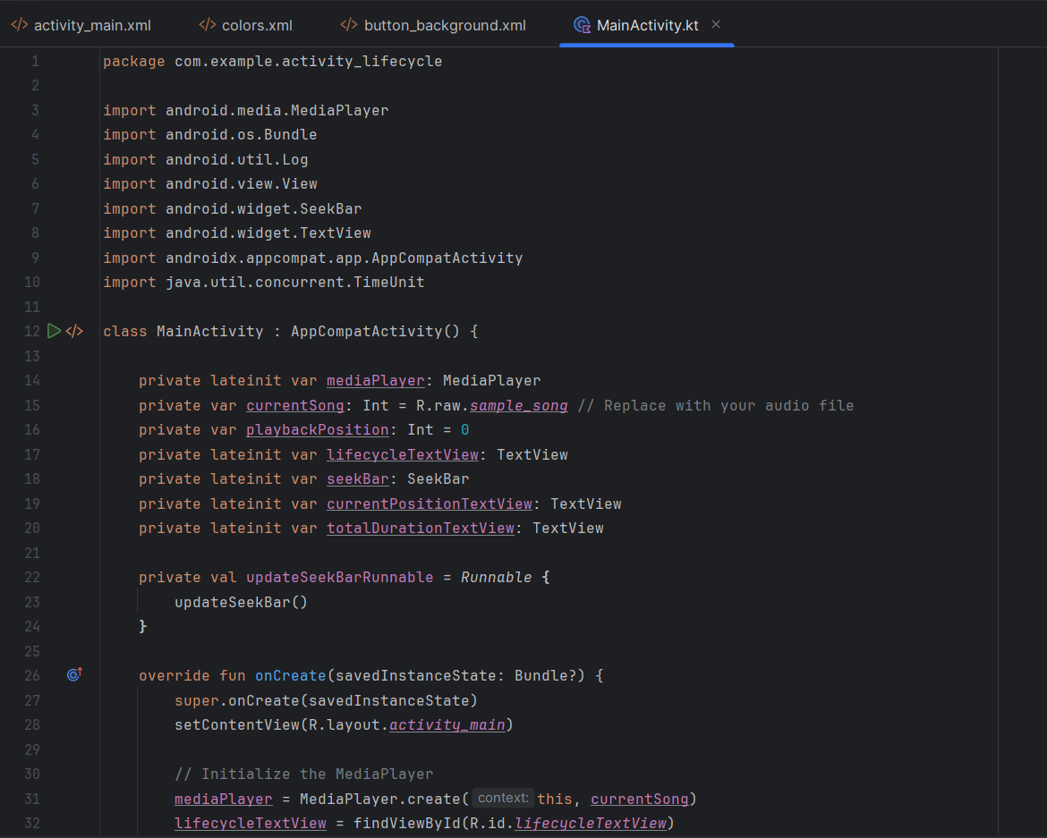

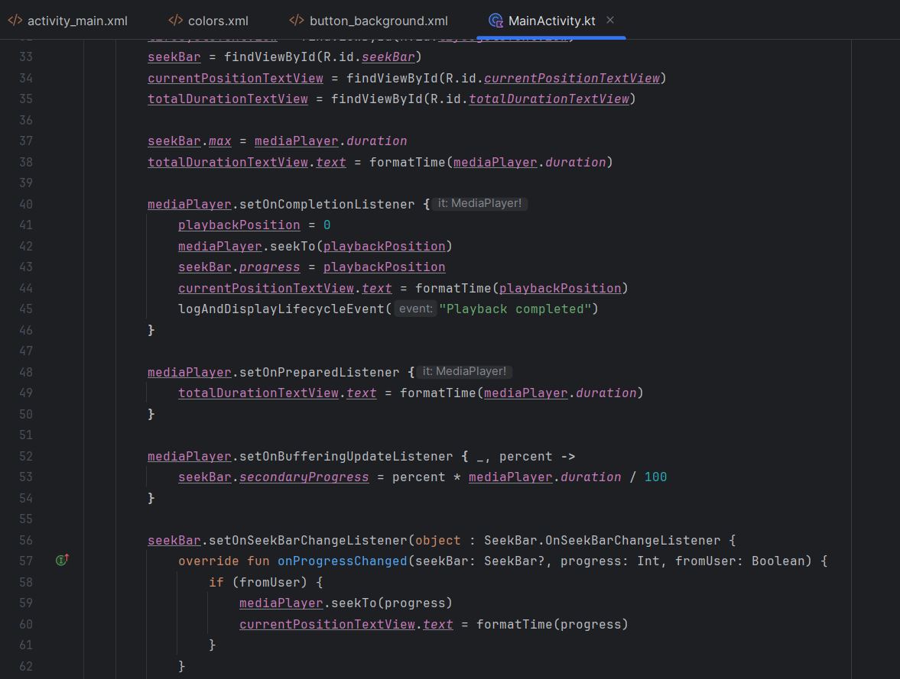

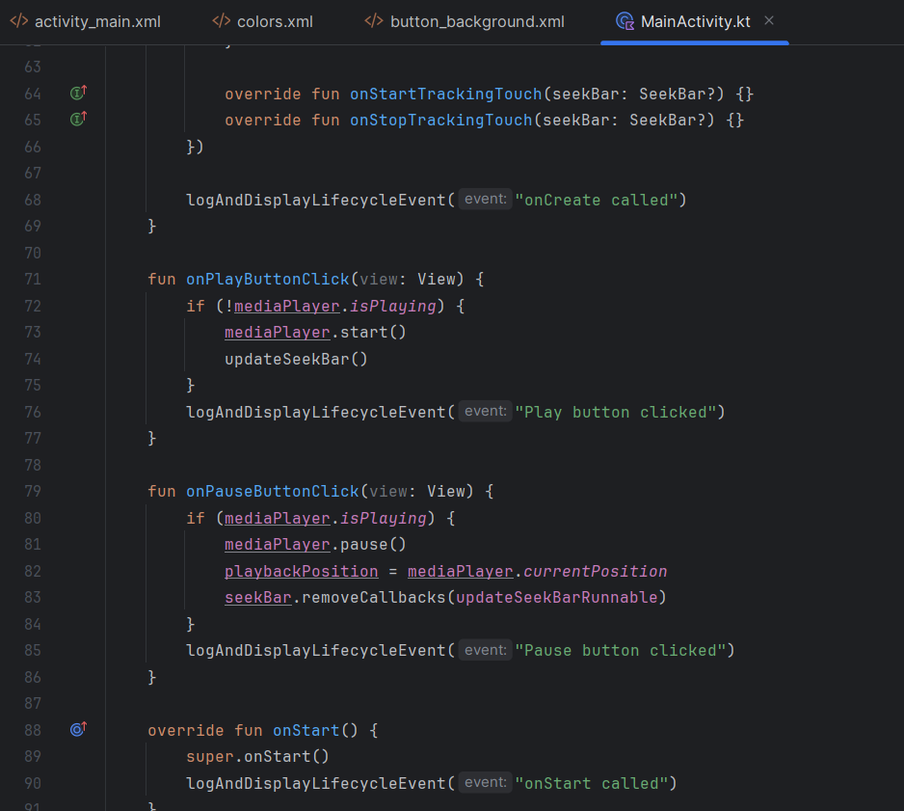

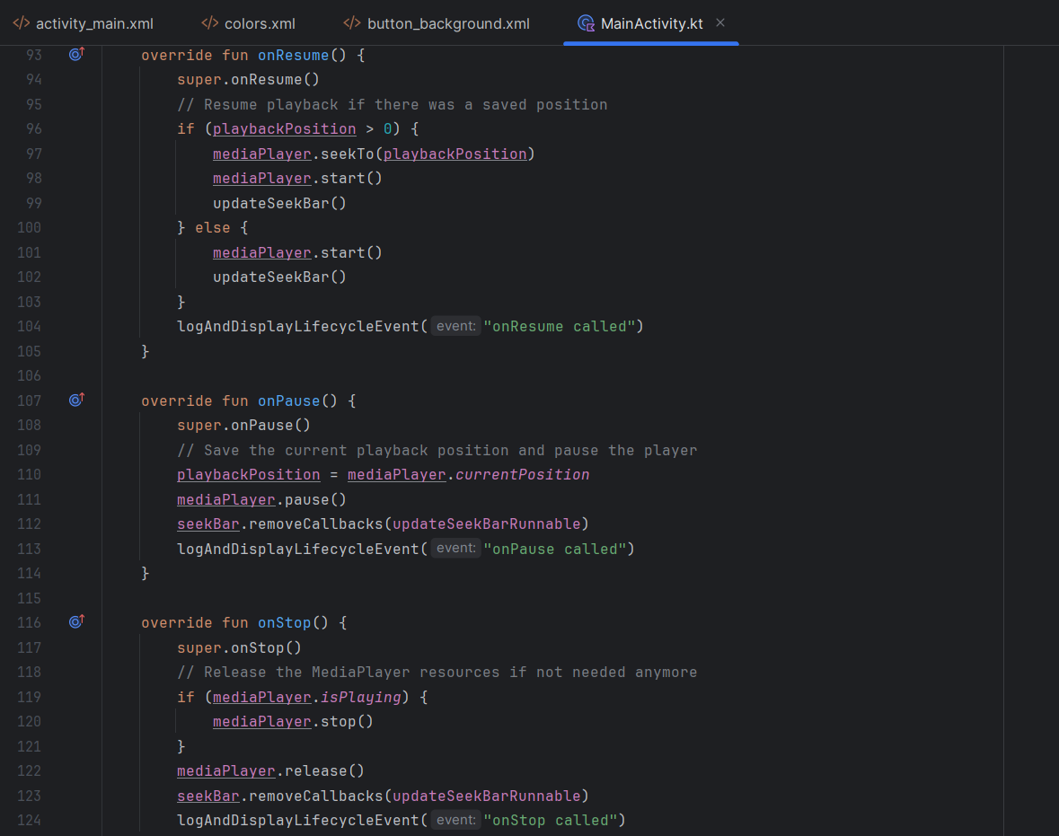

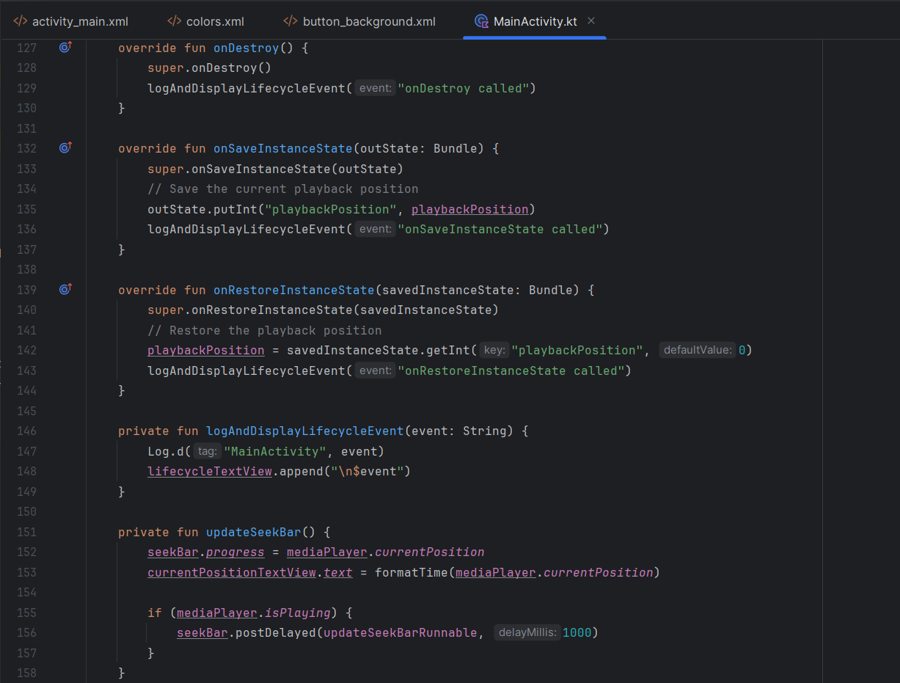

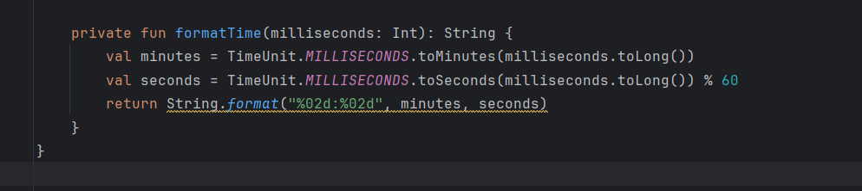

**OUTPUT:**

**When app is first installed and opened:**

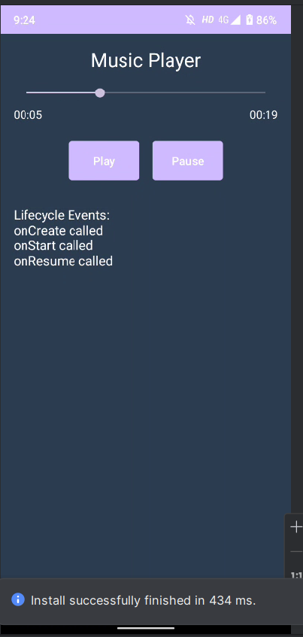

**When pause and play buttons are clicked:**

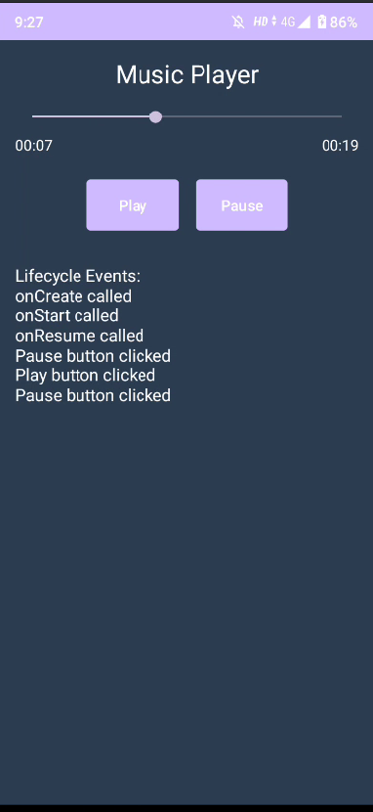

**When activity is destroyed and rebuilt:**

