Documentation - PlantPlan

Roles

Visitor
A User that does not have an account or is not logged into their account.

Gardener
A User with an account that is logged into that account. Gardeners are able to create GardenBeds and new Plants. They can only change their own GardenBeds.

Admin
A User with an account, that is logged into that account. They have more rights than a Gardender. Admins have access to all Users, GardenBeds and Plants. And are informed about new content via Logging.

DoD

Ui
- Has been shown to at least two testers, in order to reduce blind spots
- Has been checked via an Accessibility browser extension
- Has aria labels

Code
- Has been refactored
- Classes have comments with information about how to use / extend them

Design Decisions

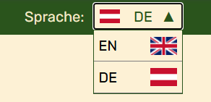
On Mobile devices the menu is positioned right, because most users are right-handed.


