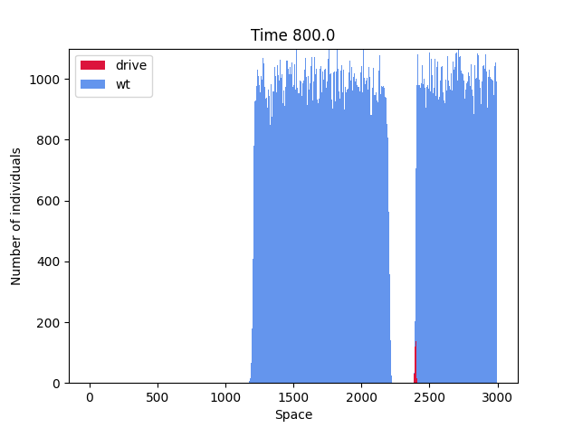
K = 10*3, dx = 1,
T = 1000, m = 0.2,
dt = np.round(m*dx**2/2,10)
conv_timing = "ger",
r = 0.1 , s = 0.5,
c = 0.85, h = 0.5

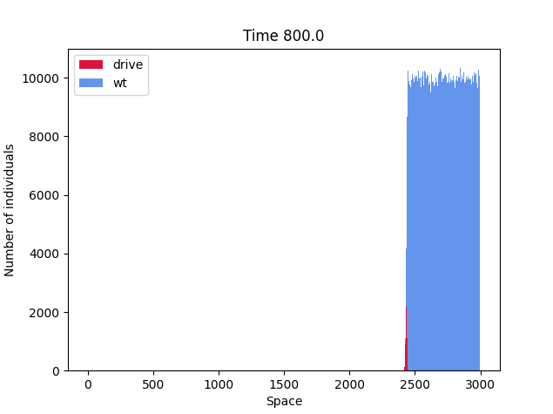

K = 10*4, dx = 1,
T = 1000, m = 0.2,
dt=np.round(m*dx**2/2,10)
conv_timing = "ger",
r = 0.1 , s = 0.5,
c = 0.85, h = 0.5

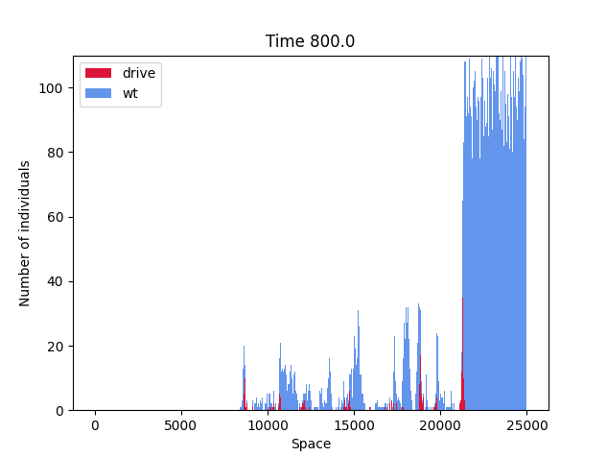

K = 10*3, dx = 0.1,
T = 1000, m = 0.2,
dt=np.round(m*dx**2/2,10)
conv_timing = "ger",
r = 0.1 , s = 0.5,
c = 0.85, h = 0.5

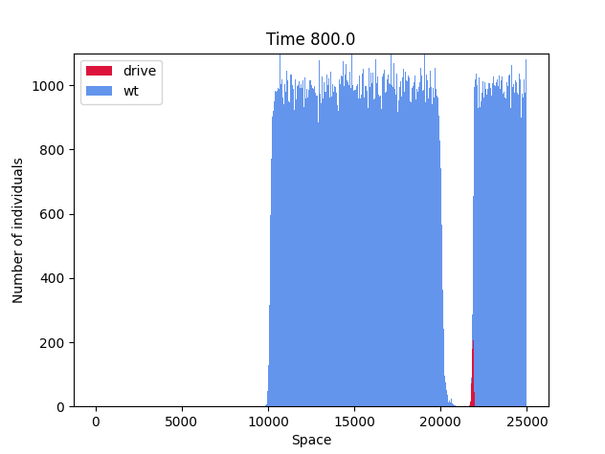

K = 10*4, dx = 0.1,
T = 1000, m = 0.2,
dt=np.round(m*dx**2/2,10)
conv_timing = "ger",
r = 0.1 , s = 0.5,
c = 0.85, h = 0.5

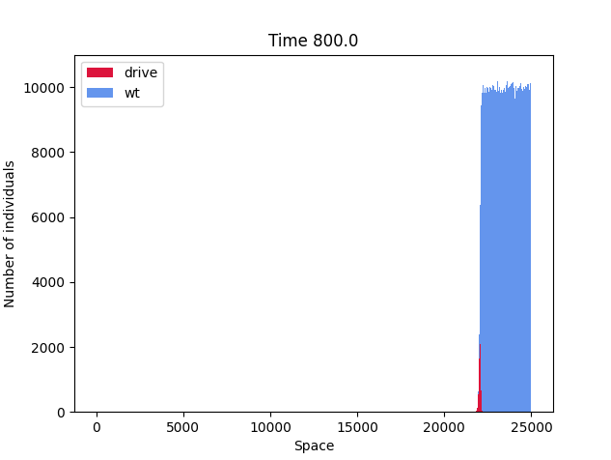

K = 10*5, dx = 0.1,
T = 1000, m = 0.2,
dt=np.round(m*dx**2/2,10)
conv_timing = "ger",
r = 0.1 , s = 0.5,
c = 0.85, h = 0.5c

