Hibernate One-Many Table We程式
- 建立 Maven Web 應用程式
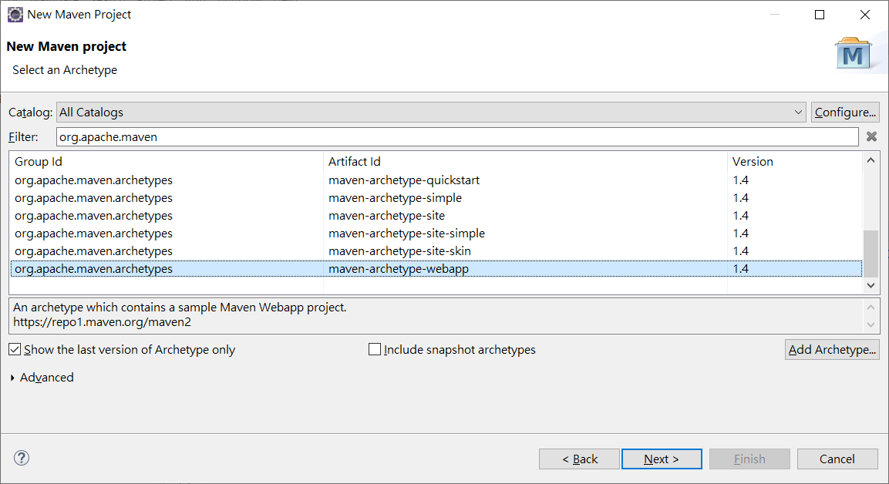
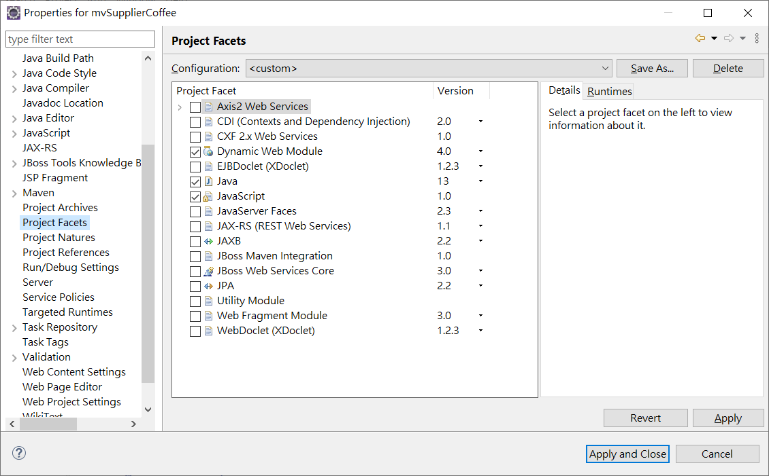
專案 Properties 下設定 Project Facets\Dynamic Web Module -> 4.0
並設定Java 到最新版本(這裡是JDK 13)
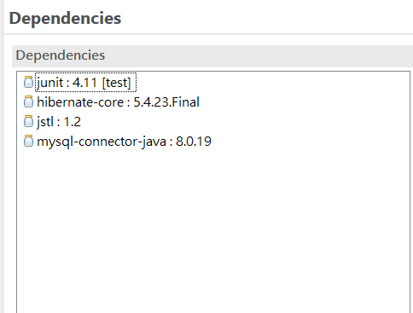
- 緊接著將資料表 Coffees , Suppliers 關聯表格的 xml 檔案設定完成

CREATE TABLE suppliers (
SUP_ID int(11) NOT NULL,
SUP_NAME varchar(40) NOT NULL,
STREET varchar(40) NOT NULL,
CITY varchar(20) NOT NULL,
STATE char(2) NOT NULL,
ZIP char(5) DEFAULT NULL,
PRIMARY KEY (SUP_ID)
) ENGINE=InnoDB DEFAULT CHARSET=utf8;

CREATE TABLE coffees (
COF_NAME varchar(32) NOT NULL,
SUP_ID int(11) NOT NULL,
PRICE decimal(10,2) NOT NULL,
SALES int(11) NOT NULL,
TOTAL int(11) NOT NULL,
PRIMARY KEY (COF_NAME),
KEY SUP_ID (SUP_ID),
CONSTRAINT coffees_ibfk_1 FOREIGN KEY (SUP_ID) REFERENCES suppliers (SUP_ID)
) ENGINE=InnoDB DEFAULT CHARSET=utf8;

insert into SUPPLIERS values(49, 'Superior Coffee', '1 Party Place', 'Mendocino', 'CA', '95460');
insert into SUPPLIERS values(101, 'Acme, Inc.', '99 Market Street', 'Groundsville', 'CA', '95199');
insert into SUPPLIERS values(150, 'The High Ground', '100 Coffee Lane', 'Meadows', 'CA', '93966');
insert into SUPPLIERS values(456, 'Restaurant Supplies, Inc.', '200 Magnolia Street', 'Meadows', 'CA', '93966');
insert into SUPPLIERS values(927, 'Professional Kitchen', '300 Daisy Avenue', 'Groundsville', 'CA', '95199');
insert into COFFEES values('Colombian', 101, 7.99, 0, 0);
insert into COFFEES values('French_Roast', 49, 8.99, 0, 0);
insert into COFFEES values('Espresso', 150, 9.99, 0, 0);
insert into COFFEES values('Colombian_Decaf', 101, 8.99, 0, 0);
insert into COFFEES values('French_Roast_Decaf', 049, 9.99, 0, 0);

hibernate.cfg.xml 資料庫連接設定檔案

<?xml version="1.0" encoding="UTF-8"?>
<!DOCTYPE hibernate-configuration PUBLIC "-//Hibernate/Hibernate Configuration DTD 3.0//EN" "http://www.hibernate.org/dtd/hibernate-configuration-3.0.dtd">
<hibernate-configuration>
<session-factory name="">
<property name="hibernate.connection.driver_class">com.mysql.cj.jdbc.Driver</property>
<property name="hibernate.connection.password">1234</property>
<property name="hibernate.connection.url">jdbc:mysql://localhost:3306/classicmodels?serverTimezone=CST</property>
<property name="hibernate.connection.username">root</property>
<property name="hibernate.dialect"> org.hibernate.dialect.MySQL5InnoDBDialect</property>
<mapping resource="model/Coffees.hbm.xml"/>
<mapping resource="model/Suppliers.hbm.xml"/>
</session-factory>
</hibernate-configuration>

記得設定 DBDialect MySQL5InnoDBDialect

Suppliers.hbm.xml

<?xml version="1.0" encoding="UTF-8" standalone="no"?>
<hibernate-mapping auto-import="true" default-access="property" default-cascade="none" default-lazy="true">
<class catalog="classicmodels" dynamic-insert="false" dynamic-update="false" mutable="true" name="model.Suppliers" optimistic-lock="version" polymorphism="implicit" select-before-update="false" table="suppliers">
<id name="supId" type="int">
<column name="SUP_ID"/>
<generator class="assigned"/>
</id>
<property generated="never" lazy="false" name="supName" optimistic-lock="true" type="string" unique="false">
<column length="40" name="SUP_NAME" not-null="true"/>
</property>
<property generated="never" lazy="false" name="street" optimistic-lock="true" type="string" unique="false">
<column length="40" name="STREET" not-null="true"/>
</property>
<property generated="never" lazy="false" name="city" optimistic-lock="true" type="string" unique="false">
<column length="20" name="CITY" not-null="true"/>
</property>
<property generated="never" lazy="false" name="state" optimistic-lock="true" type="string" unique="false">
<column length="2" name="STATE" not-null="true"/>
</property>
<property generated="never" lazy="false" name="zip" optimistic-lock="true" type="string" unique="false">
<column length="5" name="ZIP"/>
</property>
<set embed-xml="true" fetch="select" inverse="true" lazy="true" mutable="true" name="coffeeses" optimistic-lock="true" sort="unsorted" table="coffees">
<key on-delete="noaction">
<column name="SUP_ID" not-null="true"/>
</key>
<one-to-many class="model.Coffees" embed-xml="true" not-found="exception"/>
</set>
</class>
</hibernate-mapping>

Coffees.hbm.xml

<?xml version="1.0" encoding="UTF-8" standalone="no"?>
<hibernate-mapping auto-import="true" default-access="property" default-cascade="none" default-lazy="true">
<class catalog="classicmodels" dynamic-insert="false" dynamic-update="false" mutable="true" name="model.Coffees" optimistic-lock="version" polymorphism="implicit" select-before-update="false" table="coffees">
<id name="cofName" type="string">
<column length="32" name="COF_NAME"/>
<generator class="assigned"/>
</id>
<many-to-one class="model.Suppliers" embed-xml="true" fetch="select" insert="true" name="suppliers" not-found="exception" optimistic-lock="true" unique="false" update="true">
<column name="SUP_ID" not-null="true"/>
</many-to-one>
<property generated="never" lazy="false" name="price" optimistic-lock="true" type="double" unique="false">
<column name="PRICE" not-null="true" precision="10"/>
</property>
<property generated="never" lazy="false" name="sales" optimistic-lock="true" type="int" unique="false">
<column name="SALES" not-null="true"/>
</property>
<property generated="never" lazy="false" name="total" optimistic-lock="true" type="int" unique="false">
<column name="TOTAL" not-null="true"/>
</property>
</class>
</hibernate-mapping>

package model;
import java.util.HashSet;
import java.util.Set;
/**
* Suppliers generated by hbm2java
*/
public class Suppliers implements java.io.Serializable {
private int supId;
private String supName;
private String street;
private String city;
private String state;
private String zip;
private Set<Coffees> coffeeses = new HashSet<>();
public Suppliers() {
}
public Suppliers(int supId, String supName, String street, String city, String state) {
this.supId = supId;
this.supName = supName;
this.street = street;
this.city = city;
this.state = state;
}

public Suppliers(int supId, String supName, String street, String city, String state, String zip, Set<Coffees> coffeeses) {
this.supId = supId;
this.supName = supName;
this.street = street;
this.city = city;
this.state = state;
this.zip = zip;
this.coffeeses = coffeeses;
}
public int getSupId() {
return this.supId;
}
public void setSupId(int supId) {
this.supId = supId;
}
public String getSupName() {
return this.supName;
}
public void setSupName(String supName) {
this.supName = supName;
}
public String getStreet() {
return this.street;
}
public void setStreet(String street) {
this.street = street;
}
public String getCity() {
return this.city;
}
public void setCity(String city) {
this.city = city;
}
public String getState() {
return this.state;
}
public void setState(String state) {
this.state = state;
}
public String getZip() {
return this.zip;
}
public void setZip(String zip) {
this.zip = zip;
}
public Set<Coffees> getCoffeeses() {
return this.coffeeses;
}
public void setCoffeeses(Set<Coffees> coffeeses) {
this.coffeeses = coffeeses;
}
}

package model;
/**
* Coffees generated by hbm2java
*/
public class Coffees implements java.io.Serializable {
private String cofName;
private Suppliers suppliers;
private double price;
private int sales;
private int total;

public Coffees() {
}
public Coffees(String cofName, Suppliers suppliers, double price, int sales, int total) {
this.cofName = cofName;
this.suppliers = suppliers;
this.price = price;
this.sales = sales;
this.total = total;
}
public String getCofName() {
return this.cofName;
}
public void setCofName(String cofName) {
this.cofName = cofName;
}
public Suppliers getSuppliers() {
return this.suppliers;
}
public void setSuppliers(Suppliers suppliers) {
this.suppliers = suppliers;
}
public double getPrice() {
return this.price;
}
public void setPrice(double price) {
this.price = price;
}
public int getSales() {
return this.sales;
}
public void setSales(int sales) {
this.sales = sales;
}
public int getTotal() {
return this.total;
}
public void setTotal(int total) {
this.total = total;
}

}

- 建立一支Servlet 程式輸入下述程式:
private static SessionFactory sessionFactory;
private SessionFactory buildSessionFactory() {
ServiceRegistry serviceRegistry = new StandardServiceRegistryBuilder().configure("/model/hibernate.cfg.xml").build();
Metadata metadata = new MetadataSources(serviceRegistry).getMetadataBuilder().build();
SessionFactory sessionFactory = metadata.getSessionFactoryBuilder().build();
return sessionFactory;
}
public SessionFactory getSessionFactory() {
if (sessionFactory == null)
sessionFactory = buildSessionFactory();
return sessionFactory;
}

protected void doGet(HttpServletRequest request, HttpServletResponse response) throws ServletException, IOException {
sessionFactory = getSessionFactory();
Session session = sessionFactory.openSession();
System.out.println("Session created");
Transaction tx = session.beginTransaction();
TypedQuery<Suppliers> query= session.createQuery("from Suppliers a where a.supId= :sup_id", Suppliers.class);
query.setParameter("sup_id", 49);
List<Suppliers> sups=query.getResultList();
Set<Coffees> cofs=sups.get(0).getCoffeeses();
List<Coffees> cofss=new ArrayList<>(cofs);
request.setAttribute("sups", sups);
request.setAttribute("coffees", cofs);
request.getRequestDispatcher("viewTables.jsp").forward(request, response);
tx.commit();
}

viewTables.jsp

<%@ page language="java" contentType="text/html; charset=UTF-8"
pageEncoding="UTF-8"%>
<%@taglib prefix="c" uri="http://java.sun.com/jsp/jstl/core"%>
<!DOCTYPE html>
<html>
<head>
<meta charset="UTF-8">
<title>Tables</title>
</head>
<body>
Supplier ID : ${sups.get(0).supId}<br>
Supplier Name:${sups.get(0).supName}
<table border="1" width="70%">
<tr>
<th>Coffee Name</th>
<th>Sales</th>
<th>Total</th>
<th>Price</th>
</tr>
<c:forEach var="current" items="${coffees}" >
<tr>
<td><c:out value="${current.cofName}" /></td>
<td><c:out value="${current.sales}" /></td>
<td><c:out value="${current.total}" /></td>
<td><c:out value="${current.price}" /></td>
</tr>
</c:forEach>
</table>

</body>
</html>

