**Q1.**

Consider a table called Product_Details having a columns of Product id, Product Name, Supplier id. Also consider a table called Supplier_Info with columns of Supplier Id,Supplier Name, Address,City,ContactNo,Email.

Create a web application that should display all product and supplier details by using the class created above. Provide link to add/update/delete the Product_details/SupplierInfo table separately.

Q2.

Create a web page that should provide a search criteria by Division, Region, Supplier id, Supplier Name, category code. Display base the records based on the search criteria given in table format.

The output should have the link on Category Code and direct the user to different page when they click on the category code.

In the new page, display the same details in controls which ever is required in editable mode except supplier id and supplier name. So that they can update the details. It should update into database.

Use table called Category with columns category_code,category_name,division,region,

supplier_id,supplier_name.

Controls:

category code - textbox

division,region – dropdownlist

supplierid,supplier name – textbox (non-editable)

**Q3.** Create a web application to submit a request of leave approval of an employee.

Allow the user to login based on their roles such as employee, manager

-If the role is employee, display the total no of leaves available for that employee.

And display the leave details including pending approval, approved leaves.

Provide link to apply leave. In the page, display the calender control to select From date and To

date. Reason for the leave, and contact no.

By selecting the From date and To date, need to calculate the total no of days applied for leave.

Once the employee submits, the manager should be able to see the request of that employee.

In Manager home page, Display the no of employees on leave for the current day. Also display pending leave request from the employees.

Once he approves the leave of an employee, It should reflect in employee home page.

Use web user control to display the leave details in both manger and employee page. Create appropriate table to use.

Q4.

Create a table named 'Employee' with the columns employee_id,employee_name,designation,grade,address,city,state, phone_no,email. Create another

Create a table called 'RoleTagging' with Role,manager_id,manager_name, email,employee_id.

Create a web application for administrator who must have the ability to add/ delete an employee table.

He much also able to map an employee under a manager.

Once he maps the employee under any one of the manger with role, it should reflect into the database.

Design:

Employee table- use necessary controls

RoleTagging

Role -predefined -dropdownlist

employee name - dropdown

manager name- dropdown

Display the employee details with role and manger information of that particular employee by using web user control.

Use required validation controls.

Q5.

create a class file that should include methods for making ado.net such as execute reader, executescalar etc.

Call method which states about executescalar in web page to display the total no of students, total no of students passed for the year.

Call method which states about executereader to display the student details.

Create table called 'StudentsDetils' with Regno,student name,Sub1,Sub2,Sub3,Sub4,Sub5,Total,Avg, Result.

Use web.config to make connection string.

Q6.

Create a web application to do the following operations:

* Adding an Employee with the fields empno,firstname,last name ,department,projectname ,role,start date.
* Update the project info (project name,role,start date) of an employee when he moves from one project to another .
* Deleting an employee by giving his employee id

Design:

empno, firstname, lastname -text box

department,project name -text box

role – text box

start date calender control (Validation is : Select today's date or future date) ,

Apply necessary validation to the fields. Apply exception handling.

**Q7.** Create a webapplication containing 2 buttons

* 1. Readfromcookie button
  2. Writetocookie button
* Create an arraylist containing country names(india, Canada, chaina)
* The user should able to store and read arraylistobject in the cookie file.

Q8. Design the web application as displayed below

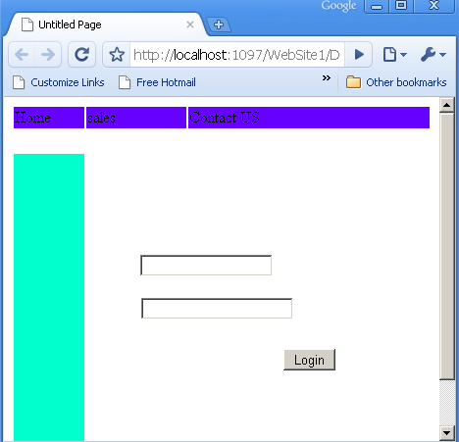

* Design the login screen as displayed above using forms authentication in home.aspx
* Validate username as “Admin” and password as “TCS”
* Once the user is authenticated display sales page as displayed below

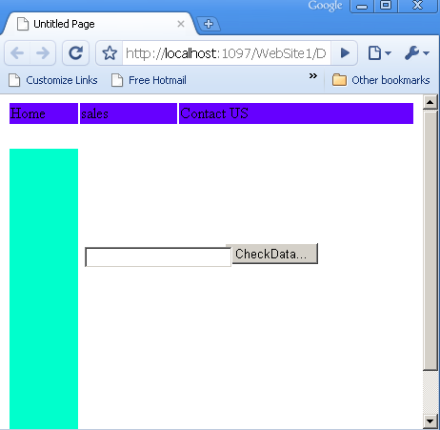

Notes :

1. When the user clicks on checkdata button it should check the value entered in the textbox should contain one these following value (Books , CDS , Computer)
2. Use custom validation control for above validation
3. For layout use masterpages.

**Q9.** Web Application

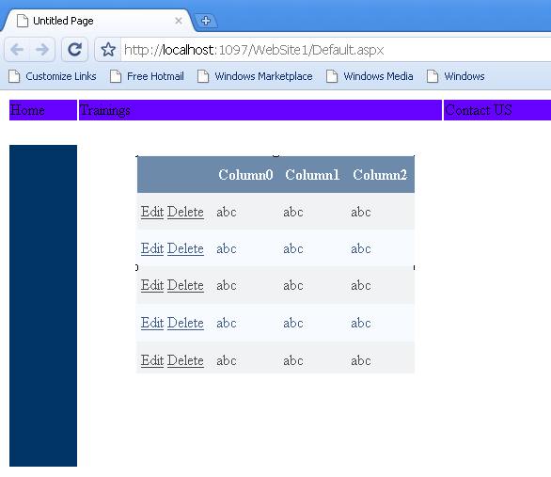

Notes

1. Design the web application as displayed above
2. Create a masterpage for layout and themes for grid control
3. The training page should contain the grid control as displayed above.
4. The grid should allow for the user to update and delete the item.
5. U can display custom message for home and contact us page
6. use sqldatasource to perform this task

To store the data create a following table structure in sql database

Tablename : Training

|  |  |  |  |
| --- | --- | --- | --- |
| **trainingID** | **Subject** | **Type** | **venue** |
| T001 | C# | Software | Cdac |
| T002 | Asp.net | Software | CDAC |

Q10. Create default.aspx as displed below

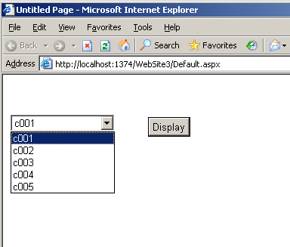

1. the default.aspx should contain dropdownlist and button control
2. the dropdownlist should extract custid from customer table .(from database)
   1. the customer table should contain the fields(custid, custname, age, address phone)

3.the selected custid should be displayed in the gridview control in default2.aspx as displayed below (if user selects c003 , on clicking on the button the c003’s name , age , address & phone to be displayed in default2.aspx)

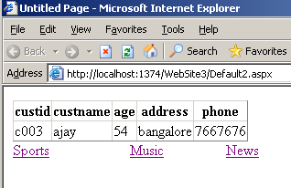

1. the default2.aspx should contain also contain the links (sports, music and news as displayed below)
2. display custom messages for above link pages

Q11. Create a usercontrol containing gridviewcontrol which diplays customer record

* 1. Create a custom property by name customerid in the usercontrol
  2. The user should able to pass the value for custid from aspx page
  3. Display the corresponding custid record in the grid control
  4. The fields for the customer table is as follows

custid, custname, age, address phone

Q12. Create a usercontrol containing 2 textboxes and 1 button

Onclicking on the button it has to validate the username and password stored in the database

On successful validation display google.com page

Create events for the same.

Q13. Create a Web Application called Shuttle Management System which has details about different Cab Facilities available in the organization.

Only Employees of ABC organization has access to SMS.

At any point of time they should be able to get details like

1. Shuttle Timings
2. Cab Type (Indica , Sumo,TempoTraveller,Bus)
3. Capacity
4. Seat Availability

By giving From and To Location as Input.

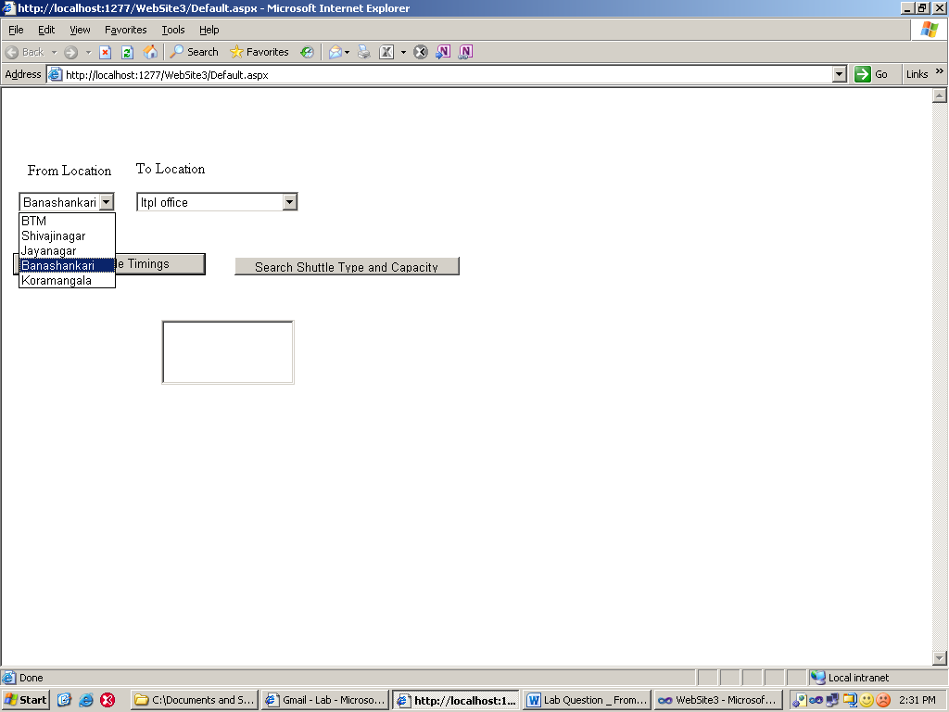

A sample screen shot is given above.

Table Structure – Create these tables with data to arrive at the solution

Route Table

RouteIDint primary Key

From varchar(50) not null

To varchar(50) not null

Shuttle_Details

RouteIDint foreign key (reference is RouteID from Route Table)

VehicleTypevarchar(25) not null – Data should be Indica,Sumo,Tavera,TempoTraveller and Bus.

Capacity int

Availability int

Timings DateTime

Q14..Create a MovieInfo Web Application which can give details about Movie Name , Release Dates and Actors/Actress

If search is based on Actor then it has to display all movies acted by him, release dates and actress of those movies.

If search is based on Actress then it has to display all movies acted by her, release dates and actor of those movies.

Table Structure – Create these tables with data to arrive at the solution

MovieIDint primary Key

MovieNamevarchar(50)

ReleaseDateDateTime

Actor varchar(50)

Actress varchar(50)

Populate 2 different dropdown lists which contain unique actor / actress name from the database.

Sample Screen Shot

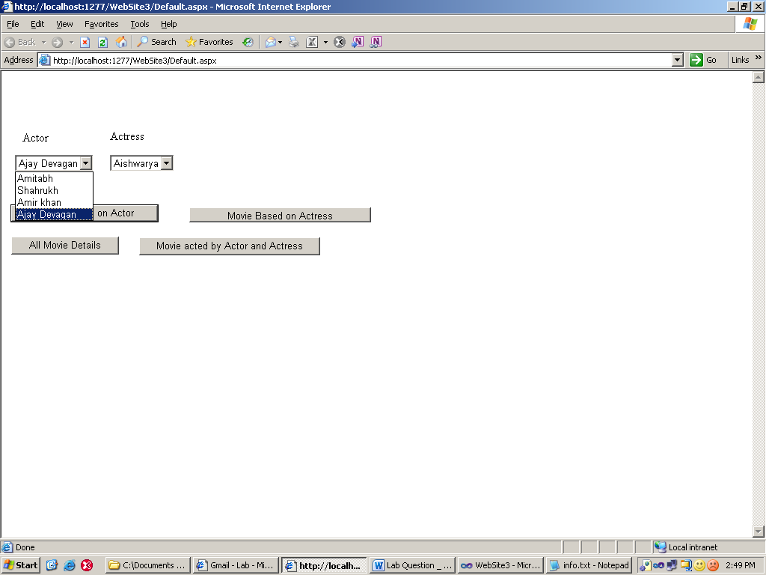

Q15..Create a Web Application called Employee Search Engine which stores info about employees like

EmpIDint primary Key

EmpNamevarchar(50)

Department varchar(50)

Designation varchar(50)

Salary money

Verticals varchar(50)

The search engine should display employee details

* 1. Based on Department
  2. Based on Designation
  3. Based on salary
  4. Based on industry verticals like Financial, Supply Chain,Manufacturing,Hospital,Hotel etc.

For solution create the above table with some data

=================================================================

Q16.Create a web application that reads data from XML file whose structure is shown below

And inserts into the Database tables and displays data as per different books category

<BookDetails>

<Book id=”1”>

<title>ASP.NET 3.5</title>

<authorname>Scott Muller</authorname>

<publisherName>Wrox Publication</publisherName>

<category>IT<category>

<price>750.00<price>

<availability>Yes</availability>

Use XMLDataSource.

Different Categories of books can be IT,Novel,Comedy,Fiction.

Create table with structure as given below

BookIdint primary key

Title varchar(50)

Anamevarchar(50)

Pnamevarchar(50)

Category varchar(50)

Available nvarchar(10)

Q17..Display the data of EmployeeInfo table in GridView and populate the grid view with columns containing Check box and Button.

Increase the salary of the employee which is checked by 10% and display his new salary.

Create an employee table with data to complete the solution

Structure of employee table is

EmpIDint primary Key

EmpNamevarchar(50)

Department varchar(50)

Designation varchar(50)

Salary money

Verticals varchar(50)

Sample screen shot would be

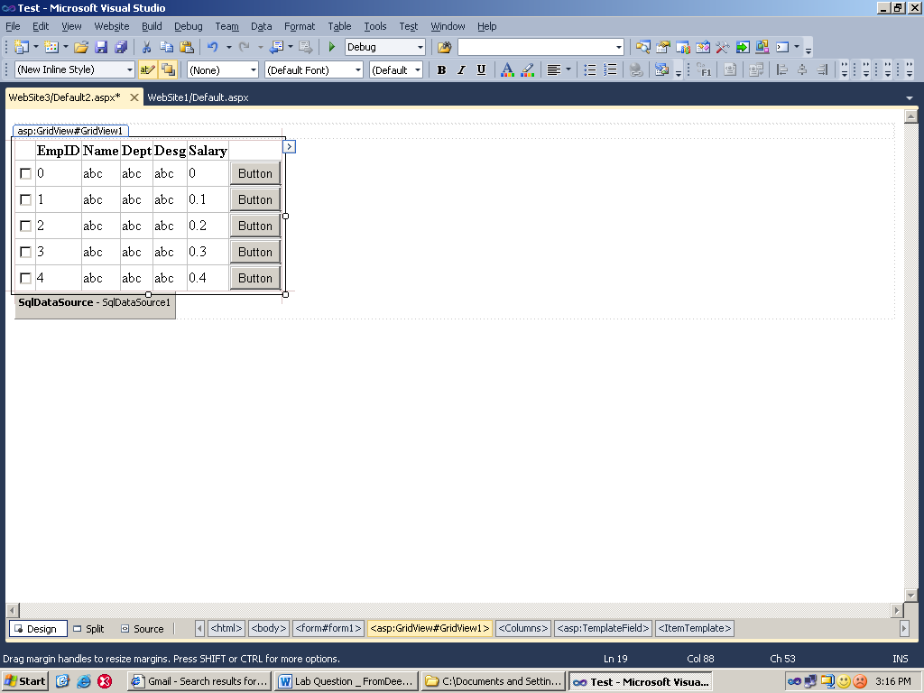

Q18. Create a Student Registration web page, which would register a student and insert his details into DB Table. Use the validators for the fields

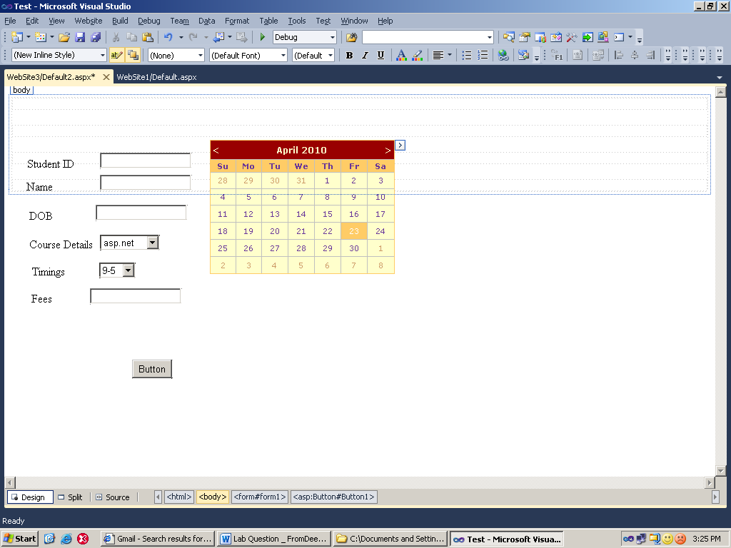

Create a table structure with same fields and insert the data into the table.

Q19. Create a web application which displays all data about city names stored in an Array List Collection into a ListBox.

Create a Button Contols called Sort Ascending and Sort Descending

Based on the button click,it should display the city names in Ascending or Descending Order.

Q20. Create a XML document with the following structure

<Employee_details>

<employee id=”1”>

<name>

<firstname>

<lastname>

</name>

<Department>

<designation>

<contact_information>

<address>

<DoorNo>

<area>

<City>

<State>

<pincode>

</address>

<phone_number>

<mobile>

<landline>

</phone_number>

</contact_information>

<gender/>

<DateOfJoining>

<Qualification>

Check for well formness of the XML Document

Give 3 different employee details

Q21. Create a DTD to Validate the XML

Q22. Create a XSD to validate the XML

Q23. Write XSL code to retrieve

* + 1. All Employee whose qualification is BE
    2. All Employee whose gender is ‘Female’
    3. All Employee whose DOJ is lesser than Today’s Date

Q24. Create a webservice function which return a dataset and accepts custaddress as a parameter The fields for the customer table is as follows

custid, custname, age, address phone

Q25. Create a web service method, which converts Fahrenheit to Celsius and Celsius to Fahrenheit.

Call the web service in a windows application and test if both the methods are working fine.

Q26. Create a Web Service which has a web method

Public DataSetDisplayData(string tblname)

Based on the table name given as parameter it should retrieve the data from the table and store it in Dataset.

Create a Asp.net Web Application which consumes the web services and displays the data in a grid view.

Q27. Create a web service, which inserts customer Info like custid, custname, age, address and phone into the table.

Create a web application to test the Web Service.