Entity-Relationship Diagram
- PLSP Questionnaire Project

Document Title | PLSP ER Diagram Documentation
Version | 1.1 (Reviewed)
Date | 21 May 2026
Related Documents | PLSP SRS v1.1 | Data Dictionary v1.1 | Sequence Diagram v1.1 | Menu and Permission Matrix | Functional Requirement

1. Introduction

This document presents the Entity-Relationship (ER) Diagram for the PLSP system. It describes all database entities, their attributes, primary keys, foreign keys, and the relationships between them. This diagram serves as the foundation for database design and implementation.

1.1 Purpose
- To define all data entities and their attributes
- To document primary key (PK) and foreign key (FK) relationships
- To establish the structural foundation for the PLSP database schema
- To serve as a reference for developers and database administrators

1.2 Scope
The ER diagram covers all 9 entities in the PLSP system: User, Questionnaire, Question, Category, Status, Submissions, Answer, Result, and AuditLog.

2. Entity-Relationship Diagram
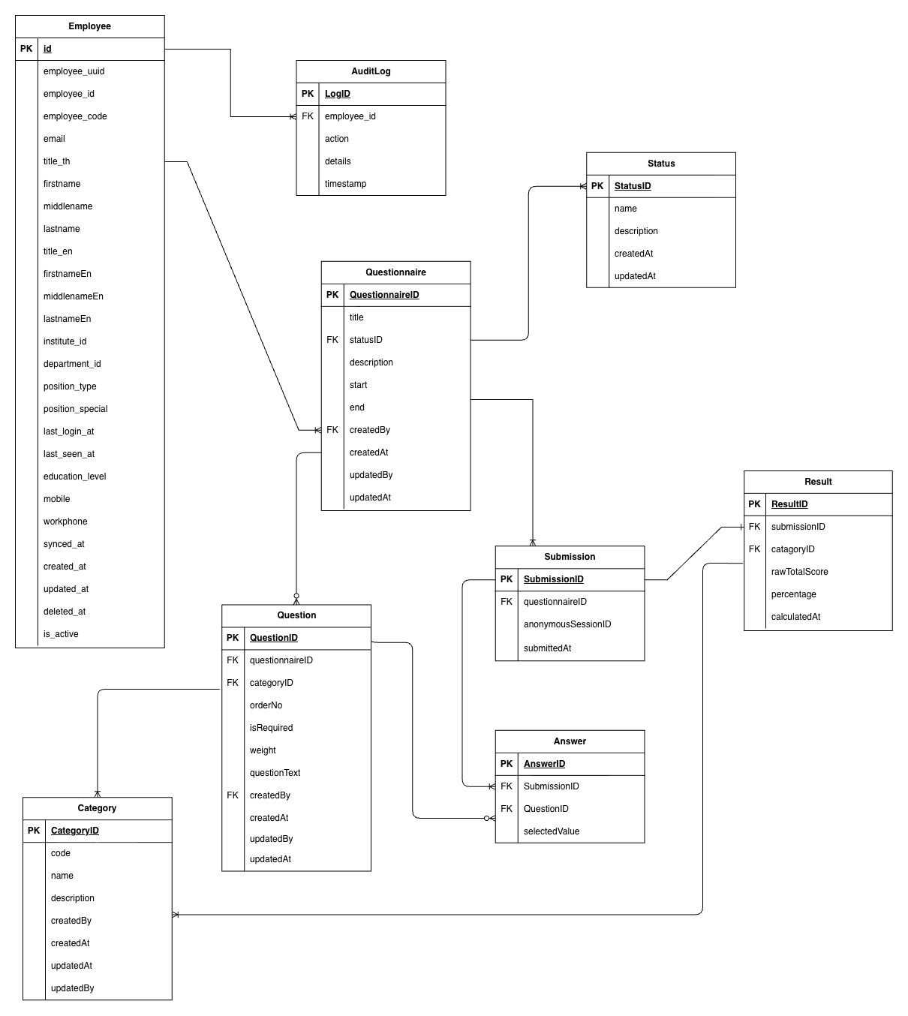

3. Entity Summary

Entity | Primary Key | Foreign Keys | Relationships
Employee | EmployeeID | — | Admin employee can create many Questionnaires, Questions, Categories, Statuses; referenced by AuditLog.
Questionnaire | QuestionnaireID | createdBy → User, status → Status | One Questionnaire has many Questions and many Submissions.
Question | QuestionID | questionnaireID → Questionnaire, categoryID → Category,  createdBy → User | One Question belongs to one Questionnaire and one Category; has many Answers.
Category | CategoryID | createdBy → User | One Category can be assigned to many Questions and many Results.
Status | StatusID | createdBy → User | One Status is assigned to many Questionnaires.
Submissions | SubmissionID | questionnaireID → Questionnaire | One Submission has many Answers and many Results.
Answer | AnswerID | SubmissionID → Submissions, QuestionID → Question | One Answer belongs to one Submission and one Question.
Result | ResultID | submissionID→Submissions,  categoryID → Category | One Result belongs to one Submission and one Category.
AuditLog | LogID | userID → User | One AuditLog entry is associated with one User action.

4. Relationship Cardinality
Relationship | Cardinality | Description
Employee→ Questionnaire | 1 : N | Admin user can create multiple questionnaires.
Questionnaire → Question | 1 : N | One questionnaire contains multiple questions.
Questionnaire → Submissions | 1 : N | One questionnaire can have multiple anonymous submissions.
Category → Question | 1 : N | One category can be associated with multiple questions.
Status → Questionnaire | 1 : N | One status value can be applied to multiple questionnaires.
Submissions → Answer | 1 : N | One submission has one answer per question.
Question → Answer | 1 : N | One question can have many answers across many submissions.
Submissions → Result | 1 : N | One submission produces one result record per category.
Category → Result | 1 : N | One category can appear in results of many submissions.
User → AuditLog | 1 : N | One user can generate multiple audit log entries.

