Replacing lead water pipes and using water filters to solve Flint’s Water Crisis

# Presented to: Rick Synder, Governor of Michigan

# Karen Weaver, City of Flint Mayor

**Presented by: Heliotrope Enterprises, Inc.**

**123 Woodward Avenue**

**Detroit, Michigan 88888**

**Leng Lee, Junior Associate.**

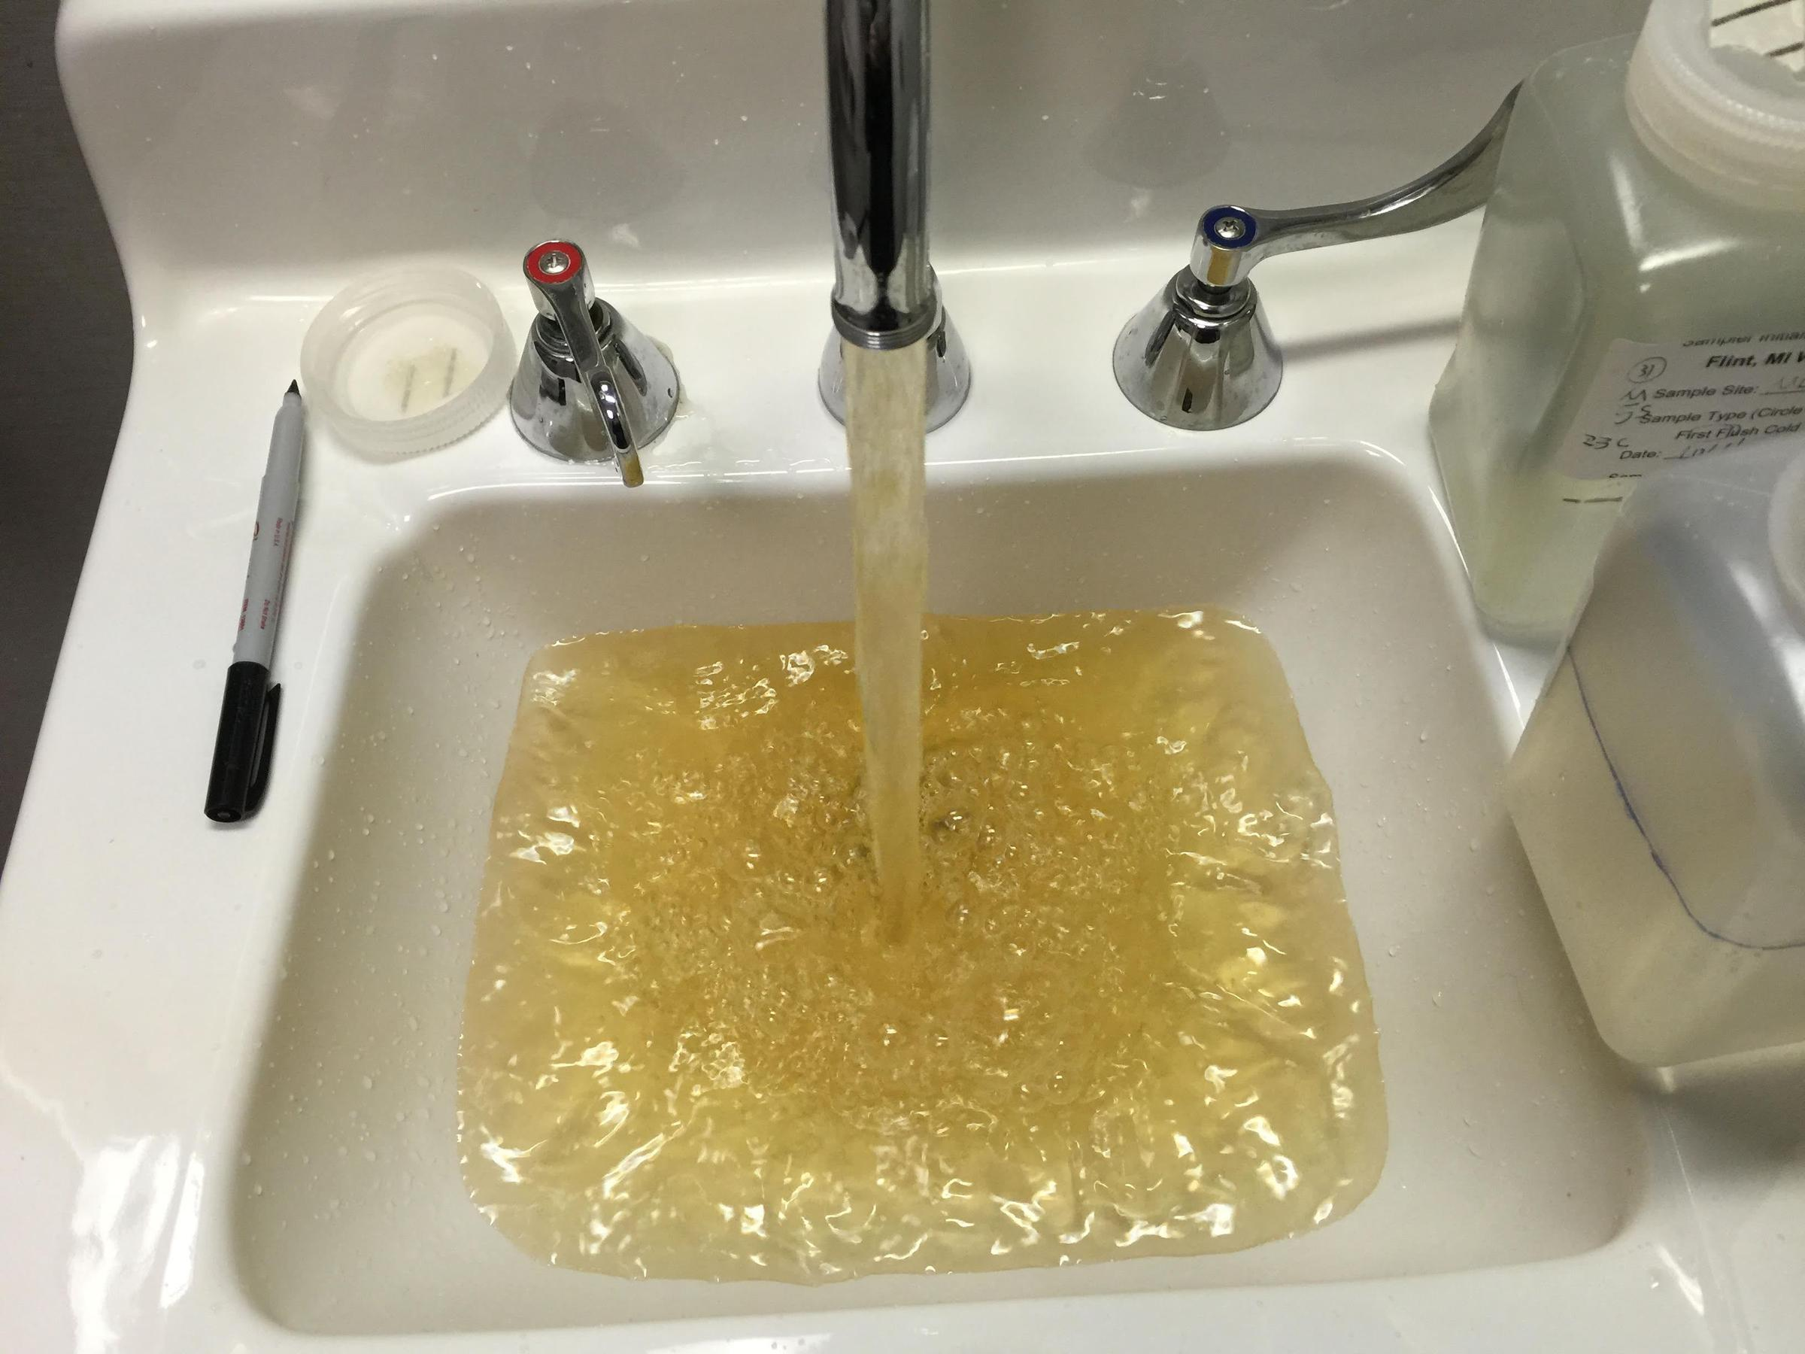

**April 27,2016**

Table of Contents

Executive Summary ii.

1. Introduction 1
2. Replace all lead water pipes in the city 2
3. The need to replacing all lead water pipes in the city 2
4. Pipes that connects main water source to homes are made lead 5
5. Expenses 5
6. Provide National Sanitation Foundation (NSF) certified water filters to every household 6
7. NSF Certified Filters Standards 7
8. What the NSF looks for when testing filters 7
9. Why many are saying fixing the infrastructure and providing water filters won’t work out 7
   * 1. Flint is financially unstable and won’t have the sufficient funds needed 8
   1. There have been cases in Flint where water filters failed to work 8
10. Conclusion 9
11. References 10

Table of Figures

Figure 1- Flint River V.S the Detroit 3

Figure 2- Corroded water pipes 4

Figure 3- Flint’s Water Infrastructure 5

**Executive Summary**

Heliotrope Industries, an organization founded on improving the health and safety of humans, has been investigating some possible solution that can help improve the Flint water crisis. Recently many studies have been done on Flint’s condition and there have been many good results from them. These studies ranges from changing Flint’s whole water infrastructure to providing water filters to every household in Flint. Due to Flint’s condition, the Governor of Michigan is now very confused about his next move for Flint and have asked our company to write a formal report about possible solutions that can be taken for Flint.

Research for this report was conducted by using different academic articles and journals. These articles and journals are directly related to the issue Flint has currently. My primary research was conducted by an email interview with a graduate class at Virginia Tech University who are closely monitoring Flint’s conditions. The following research shows that the Governor will benefit greatly by implementing the solutions that are listed below:

1. Replacing Flint’s whole water infrastructure would be the best thing to do. By doing so, it would make the water safe to drink and bathe in again.
2. Providing NSF certified filters to every household in Flint. By providing filters, it would help the residents of Flint temporary through its water crisis by providing safe and clean water.

The following course of actions is recommended to improve the conditions of Flint’s water Crisis:

* Arrange a meeting with a piping company to get an estimate on how much it would cost to fix the whole water infrastructure and arrange a meeting with a manufacturing company that provides NSF certified water filters.
* Negotiate a contract to best suit the need of the residents of Flint, Michigan. Hire a team of engineers to remove all of the lead pipes from the infrastructure. Also purchase NSF certified water filters to pass out to the residents of Flint.
* Implement the above actions immediately in order to help out with Flint’s crisis.

1. **Introduction**

Rick Synder, Governor of Michigan, has been in the radar lately about the Flint Water Crisis. What happened in Flint was the officials with authority had decided that they wanted to switch water source to the Flint River in an effort to save the city money. This was a huge backfire because the the water was contaminated and was not treated properly before the actual switch. This ended up causing the city even more money than what they were expected to save by switching. The Governor now is very confused about what his next move should be to help solve this water crisis. Therefore, the governor has asked me to write a formal report on some methods that can be taken to help him and the city of Flint.

Another note everyone should keep in mind is that Flint’s only problem is not just lead poisoning. The lead poisoning is a bigger part of the problem, but the other part of the problem is the corroded iron in the water. It was because of the iron corrosion that caused the lead outbreak. Since the pipes are all old, there are remnants of iron particles that has corroded and stuck onto the pipes over time. Iron corrosion tends to consume chlorine (Cl^-) which is added into the water to kill many different microorganisms which tends to lead to diseases. Since the chlorine that are being added to the water to protect it are being consumed, this led to the outbreak because the pipes delivering water to the households were made of lead (Flint Water Study Updates).

The purpose of this report is to provide information regarding methods to help solve Flint’s crisis. This report is based on multiple academic articles discussing what the source of Flint’s water problem is and ways to decontaminate the water. The articles were found through the Wayne library article database system, the Environmental Protection Agency (EPA) website, third parties’ researcher’s websites, and the National Sanitation Foundation (NSF) website. The report also includes an interview with the Virginia Tech Research study group. The Virginia Tech Study group has been monitoring Flint’s water crisis closely. All of the students in the study group are graduate students who have taken courses that relates to Chemistry and Engineering.

The remainder of the report shows:

1) The positive of replacing all of the water pipes

2) The positive of providing National Sanitation Foundation (NSF) certified filters.

3) Why many are saying fixing the infrastructure and providing water filters won’t work out

1. **The need to replacing all lead pipes in the city**

Flint’s water infrastructure problem caused the contamination outbreak. Before switching water sources from the Detroit Water and Sewerage (DWSD), which drew water from Lake Huron, Flint never had to worry about its infrastructure. This was because the water it was receiving from the Detroit Water and Sewerage was up to standard and was very well taken care of. In other words, the water was safe due to the treatments the DSWD was providing at their water plants. The water was treated with anti-corrosive agents which prevented any heavy metal corrosion in the water.

When Flint switched water sources from the DWSD in April 2015, to the Flint River in an effort to save money, certain precaution were not considered. Governor Synder had appointed a financial emergency manager, Darnell Early, to deal with Flint’s financial problems. He felt that it was necessary to switch water sources to save some money.

The water from the Flint River have a very iron corrosive water because the water was not treated with the anti-corrosive agents to prevent heavy metals from corroding. This led to the lead outbreak because the pipes were made of lead. Since the pipes were very corroded with iron (which tends to consume the chlorine that protected the water against dieses), the lead particle leaked from the pipes and traveled with the water into the resident’s homes (Flint Water Study Updates).

* + 1. **Current water pipes are filled with rusting iron and different types of iron corrosion**

Water pipes in Flint have rusting iron and different types of corroded heavy metal in them. These pipes need to be replaced because this is the main cause that contaminated the water. The corroded iron that are stuck onto the pipes are consuming all of the chlorine that’s put into the water to make it safe. Without the chlorine, the lead is leaking into the water simultaneously as the water travels through the pipes. Without getting new and clean pipes, its going to be very difficult to solve this problem (Flint Water Study Update).

The corroded iron is one of the biggest problem Flint has with its water system infrastructure (See Fig 2.). Flint’s water pipes are all aged and shouldn’t be used anymore. The pipes are not safe to use due to the corrosions that took place on the actual pipes (Flint Water Study Update).

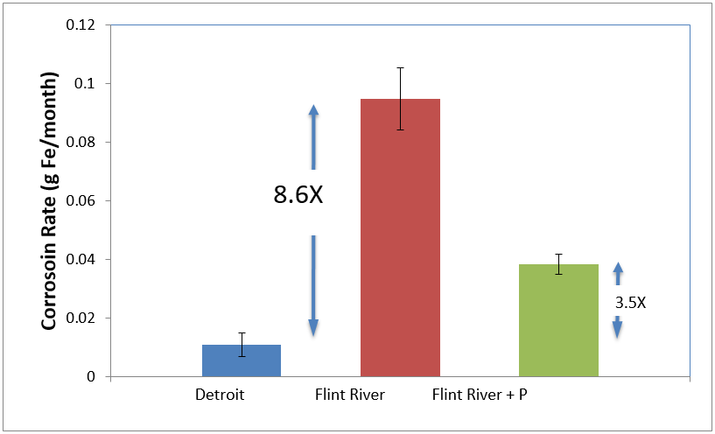

Fig. 1 Flint River V.S Detroit Water

Source: Iron Corrosion Rate [Iron corrosion rate based on weight loss after 1 month in Detroit, Flint River, and Flint River water plus orthophosphate (1mg/L as P).]. (n.d.). Retrieved April 20, 2016, from <http://flintwaterstudy.org/2015/09/research-update-corrosivity-of-flint-water-to-iron-pipes-in-the-city-a-costly-problem/>

The Flint river has an iron corrosion rate much higher than any cities that are around it. This causes the city to have more risk of drinking contaminated water because they don’t have sufficient chlorine to protect the water (See Fig 1.)

Flint’s corrosion rate is a lot more that the rate of neighboring Detroit. Detroit’s rate is so low because it is properly treated with anti-corrosives to prevent heavy metal corrosions inside the water. Because its treated with the anti-corrosives, more chlorine are left in the water to help kill dangerous pathogens that may be inside of the water, thus making the water a lot safer.

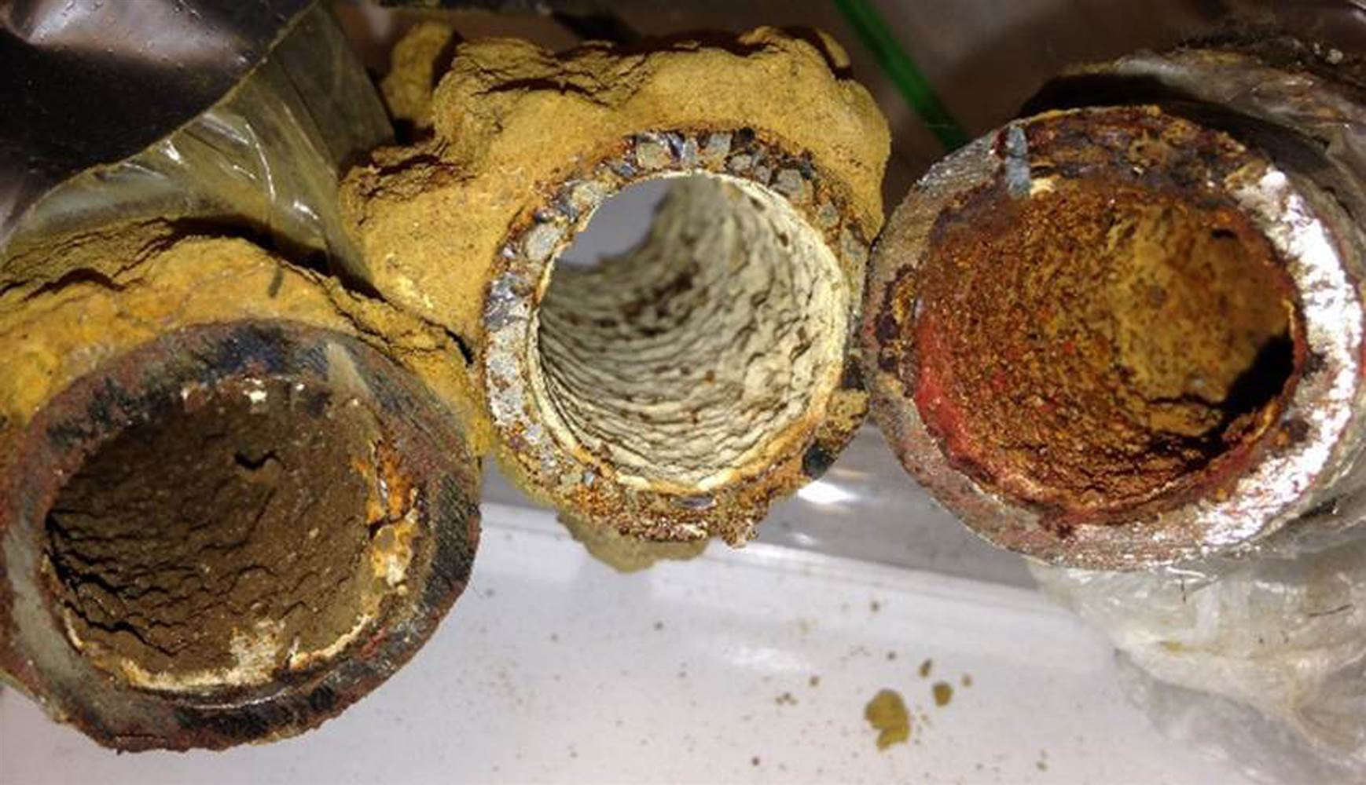

Fig. 2 Corroded water pipes in Flint

Source: Tang, M., & Pieper, K. (n.d.). Corroded Lead Pipes [Flint's water pipes are filled with corroded iron.]. Retrieved April 15, 2016, from http://flintwaterstudy.org/

* + 1. **Pipes that connects main water source to homes are made lead**

Flint’s water infrastructure is made of two pipes to deliver water from the plant to the homes of residents. Flint has a main city pipe, which runs beneath the street. These pipes are not made from lead. The main pipe connects multiple smaller pipes from the street to the homes by another pipe, which is made of lead. This pipe leads directly to the resident’s home. It is also connected by a few more other pipes, some of which are also made of lead (See Fig. 3) (Flint Water Crisis, 2016).

* + 1. **Expenses**

One of the big problem is money. Flint currently is financially unstable, which had originally caused it to switch water sources in an effort to save money. There have been estimates that says fixing the water infrastructure system can cost up to 55 million dollars. With this money, the Mayor of Flint, Karen Weaver, says that she will be able to remove all lead pipes within the infrastructure to make the water safe again (Fantz & Sgueglia, 2016).

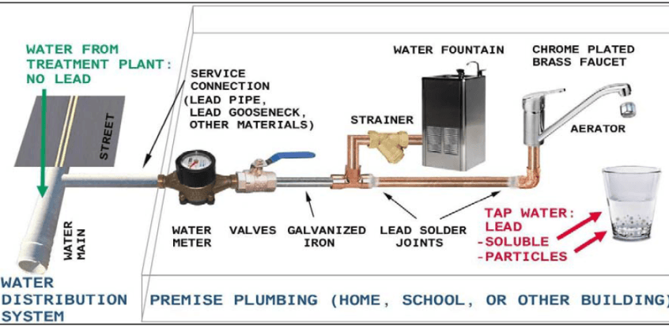

Fig. 3 Flint’s water system infrastructure

Source: Flint's Water Infrasturcture [Flint's Water Infrastructure]. (n.d.). Retrieved April 20, 2016, from http://flintwaterstudy.org/guide-to-flintwaterstudy-org/

1. **Provide National Sanitation Foundation (NSF) certified water filters to every household**

Flint is in desperate need of clean water at the moment. The city’s water has been contaminated by bad decision that was made by appointed officials. The city’s water pipe line is made of lead, which caused all water that was delivered to the city to be contaminated. The residents of Flint are all in panic because of the lack of clean and safe water. They feel that they aren’t being protected and taken care of by their government.

The NSF is an organization dedicated to improving human health. The organization is looked upon to develop public health standards and certifications to protect the health of consumers. The NSF independently test, audit and certifies products and systems that deals with the health of consumers (NSF International).

By providing National Sanitation Foundation (NSF) certified water filter to all of the household of Flint, it would make things a lot safer to the residents. The purpose of a water filter is to remove all particles and pathogens in the water in order to make it safer to consume or bathe in. With the water filter delivered to every household, it would make the residents feel a lot safer and have more faith in their government (NSF International).

1. **NSF Certified Water Filters Standards**

The kind of water filters you need to have are NSF certified water filters. The NSF have very strict standards when is comes to the safety of consumers. In order for a filter to pass the NSF’s standards the filter has to filter 100 percent of pathogens and microorganisms out of the water. “NSF/ANSI Standard 53 for Drinking Water Treatment Units is the nationally recognized standard for evaluating and certifying drinking water treatment systems for the reduction of contaminants from drinking water. NSF/ANSI Standard 58 is the national recognized standard for Water Treatment Systems that use reverse osmosis technology. Water filters are tested and certified to NSF/ANSI 53 and 58 to ensure they reduce contaminants, including lead, per the requirements of the standards” (Certified Product Listing for Lead Reduction). Based on this quote, the NSF has strict standards that deals with water filters. Every water filters that NSF tests has to pass their test, which is named NSF/ANSI 53 to 58.

1. **What NSF looks for when testing filter**

When testing water filters, the NSF are looking to checking for 100 percent filtration success. This means that they would only approve filters that only filter out all pathogens and microorganisms completely. “NSF certified water filters for lead reduction have been evaluated in a study using water that contains 150 parts per billion (ppb) of lead. This lead concentration is ten times higher than the U.S. EPA maximum allowable level in drinking water. The filters are challenged at this level of contaminated water for beyond the filter’s claimed service life-cycle. Certification is only confirmed when the product has met all of the lead reduction and other requirements of the standard” (Certified Product Listing for Lead Reduction). The NSF has set their standards a lot higher than the certified EPA standards for safe water. Thus being said, when they actually test filters, they try to meet the standard that they have set which is 10 times EPA standards. By doing so, they are sure that the filters they certify will be safe enough to use. There are a handful of filters that NSF has approved to efficiently filter out lead completely.

1. **Why many are saying fixing the infrastructure and providing water filters won’t work out**

In Flint’s case, there are many different problems that needs to be accounted for when talking about its issues.

1. **Flint is financially unstable and won’t have sufficient funds that are needed to deal with the issue**

According to Synder’s spokesperson, Dave Murray, many experts have strictly doubt that would be a good approach to solving the water crisis. The main reason they are saying this is because of the amount of money that is needed for this plan to work. “The mayor has estimated that only 55 million is needed but there are other estimates that are in the hundreds million” (Fantz & Sgueglia, 2016). This is a lot of money that the city of Flint and State of Michigan does not have. They think that there are other ways to help Flint’s problem without using so much money. As of now there are many professionals who are trying to find ways that can stop the corrosion in order to make the water safe enough to drink again. (Fantz & Sgueglia, 2016)

The main issue with their stand points are, they are saying that “what’s not completely broken can still be used”. This quote means they are saying that Flint can still use its same water pipes as before if they can find a short term solution. It’s possible that someone may come up with a way to solve the problem with out having to removing the pipes, but sooner or later the problem will resurface again. Now is the best time to deal with the issue and get rid of it once and for all. If the pipes are not completely removed, once the problem resurfaces its going to cost even more money to fix. As the mayor of Flint said, “In order for Flint residents to once again have confidence and trust in the water coming from their faucets, all lead pipes in the city of Flint need to be replaced,” says Mayor Weaver (Fantz & Sgueglia, 2016). The only way to make the residents of Flint to have faith again, is to make sure the problem is dealt with completely.

1. **There have been cases in Flint where filters failed to work**

There have been some cases in Flint, where water filters have failed to completely filter out lead particles. Homes that has high levels of lead seems to be homes where filters are ineffective. Because of this, many families have become more exposed to lead.

The filters which were used did not pass the NSF certification test. Filters that were used were probably not up to the NSF’s standard. The NSF’s standard is that in order for a filter to pass, it has to be able to filter out 150 ppb (particles per billion). Since the crisis was made public, the NSF has been stricter on the products that they are testing in order to provide the safest product for consumers (Flint Water Study Updates).

1. **Conclusion**

As of now, Flint is still struggling with its water crisis. Its fighting for clean water for its residents. By removing all of the old lead pipes from the water infrastructure, it would make the water safer to use. Not only would it make the water safer, but it will make the residents feel more at ease. By providing NSF certified water filters to every house hold, it would give residents a source of clean water temporary. This would allow residents to have safe waters to use again.

Therefore, I recommend Governor Synder takes the following course of actions:

* Arrange a meeting with a piping company to get an estimate on how much it would cost to fix the whole water infrastructure and arrange a meeting with a manufacturing company that provides NSF certified water filters.
* Negotiate a contract to best suit the need of the residents of Flint, Michigan. Hire a team of engineers to remove all of the lead pipes from the infrastructure. Also purchase NSF certified water filters to pass out to the residents of Flint.
* Implement the above actions immediately in order to help out with Flint’s crisis.

**References**

Certified Product Listings for Lead Reduction. (n.d.). Retrieved April 25, 2016, from http://info.nsf.org/Certified/DWTU/listings_leadreduction.asp?ProductFunction=053|Lead Reduction

Fantz, A., & Sgueglia, K. (2016, February 10). Flint mayor says $55 million needed to replace lead pipes. Retrieved April 18, 2016, from http://go.galegroup.com/ps/retrieve.do?sort=DA-SORT&docType=Article&tabID=T004&prodId=AONE&searchId=R2&resultListType=RESULT_LIST&searchType=BasicSearchForm&contentSegment=¤tPosition=2&searchResultsType=SingleTab&inPS=true&userGroupName=lom_waynesu&docId=GALE|A442842373&contentSet=GALE|A442842373

Flint Drinking Water Response. (n.d.). Retrieved April 18, 2016, from https://www.epa.gov/flint

Flint Water Crisis [E-mail interview]. (2016, March 20).

Flint Water Study Updates. (n.d.). Retrieved April 18, 2016, from http://flintwaterstudy.org/

NSF International. (n.d.). Retrieved April 25, 2016, from http://www.nsf.org/