**Outdated Technology Solutions Overview**

**Introduction**

This portion of the solution displays the difference between Wayne State’s technological situation compared to the other neighboring universities and possible solutions to resolving this issue. We will be comparing State Hall to a Wilson’s Building located on Michigan State University’s (MSU) campus. Our proposed solution will meet the following criteria:

* All technologies in State Hall that are found to be outdated be removed immediately.
* Student’s satisfaction with State Hall’s situation improves within the next 2-3 semester.

In order to keep our comparisons consistent, our team has decided to compare a building that is equal to State Hall, meaning that the building will contain lecture halls, classrooms, and study lounges. We will be taking pictures of a Michigan State building called Wilson. This building has lecture halls, lounges, classrooms and many students are required to take classes here. The pictures taken will consist of different classrooms to show what different type of technologies that Michigan State has. By seeing everything first hand, we will get a sense of what its standards are. Through this hands on research, we were able to develop a standard Wayne State University (WSU) should follow.

**Forecast**

**Outdated Technologies**

This section will detail the technology in State Hall that was deemed to be outdated.

In most classrooms inside of State Hall, you will find an unused overhead projector collecting dust. In most cases these projectors have not been used in years. Overhead projectors are used to display something that the professor writes on the transparent onto the board. These things are old, dusty, and takes up a lot of unnecessary space in the classroom. With the classrooms being very crowded already, having a big projector in the corner of the room does not help the students feel that they are in a comfortable learning environment.

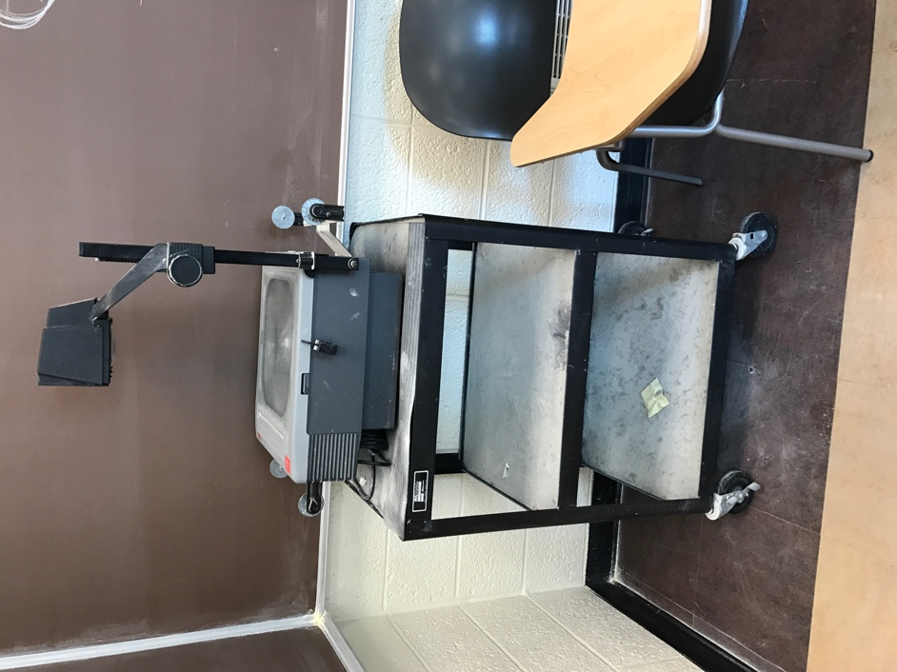

Inside of WSU, overhead projectors can be found in the corner of a classroom. This picture was taken on the second floor of State Hall. It displays the unused outdated technology that is not being used, but also not being removed also.

Additionally, something else that we noticed as a group was the chalk boards. Every room in State Hall has a chalkboard in it. Most of the time these boards are not clean which can make every students’ life just that much harder. There is also not much interaction that the students can have when a professor used a chalkboard.

There is definitely a need for improvement with the technology considering that the students pay a lot of their money to attend WSU. Having better technology can help students learn a lot more and help students retain more information’s.

**University Comparison**

In this section, we will be comparing the standards that WSU has, compared to other neighboring universities. As a team, we decided to use MSU because we believe that MSU is a well known school. Because they are well known nationwide, it would be a good thing if State Hall’s standards can improve by comparing it directly to a good university.

In order to compare the quality of State Hall to other universities, I went to Michigan State to see how it was like to be on campus. I walked around their campus and actually went into some classrooms to observe how they were. The atmosphere of the room felt different from our Wayne State’s atmosphere. The room were very big, clean and did not have any of the outdated technologies like the overhead projector, and chalkboards. Every room had either a white board or a smart board. The Michigan State professors were able to be very interactive with their students. Instead of overheads, they use ELMOS; a new version of a projector that is small and enables the user to be interactive with it. Instead of having to turn off the light to use the transparent on the overhead, now professors can write directly on paper and doesn’t need to turn the lights off. There are multiple television sets inside of classrooms at MSU. The televisions are used by professors to watch educational videos and to connect the ELMO to the screens. Sometimes the students can just hang out inside the classroom while they wait for their class to start.

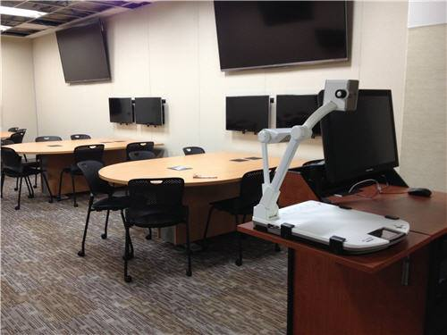

As seen in the picture above, the ELMO is on the professor’s desk. He can directly connect the ELMO to the televisions that are above the student’s work desk. The ELMO is a small machine that serves the same purpose that an overhead projector would, the difference is: its less space consuming, and it is more technological advance allowing it to perform many functions that the overhead can not.

The lecture halls are spacious but are also a very suitable environment. Though the halls are much bigger than those in State Hall, they have very advance technologies within them. They have a surround system in every lecture hall that allows students to hear the professors clearly. Also all the lecture halls have multiple windows in it, allowing light inside of the rooms.

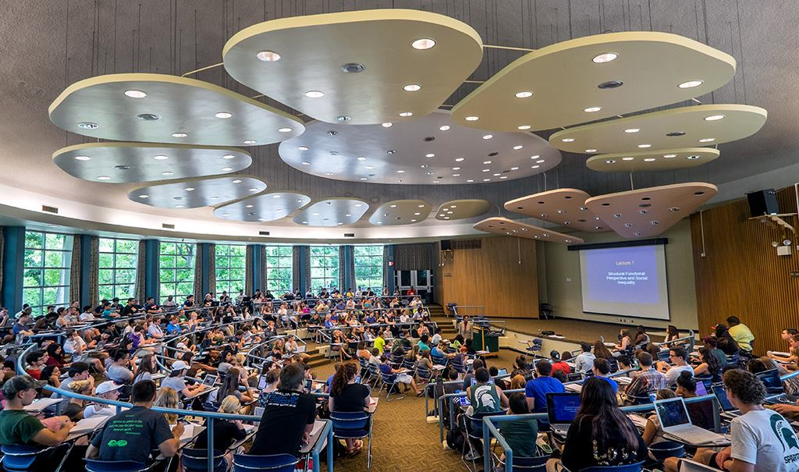

This picture was taken from a lecture hall in MSU’s building Wilson. The room is very big, but seems like a suitable place to learn. It has multiple windows inside the lecture hall, and it has a surround system set up around the classroom, allowing everyone to hear the professor, when he/she lectures.

**Solution’s conclusion**

After comparing State Hall to an equivalent building at Michigan State, there is clearly a big difference in the technology standards. Michigan State has a lot of the new technologies and does not have any outdated technology just laying around in their classrooms. In order to help solve Wayne State’s outdated technology situation, first we need to get rid of all of the outdated unused technology. Overhead projectors and chalkboards needs to be removed. the removal of the overhead projector would only benefit everyone because its barely being used today.