**Technology Solution**

Research led by: Leng Lee

**Introduction**

This section will discuss the importance of having up-to-date technology in classrooms. In this section, I will compare technological issues and new technologies between Wayne State University (WSU) and Michigan State University (MSU). I will also present a possible solution that can help improve WSU’s technological standards.

State Hall is a frequently used building at Wayne State University. The technologies in State Hall are outdated and some of them do not function properly. For example, classrooms often have old overhead projectors collecting dust. Not only are they unused, there is improved technology that has replaced them on the same ceiling. Technology has a very big impact on student learning and by having a low standard it can negatively affect student’s education. Wayne State has to have a higher standard when it comes to technology.

Though there are many types of outdated technologies in State Hall, in this research, we would focus only on the chalkboard and overhead projector. The chalkboard can be found in every classroom in State Hall. It is often over used and very dirty. The overhead can also be found in many classrooms in State and most of the time they aren’t being used. There are better technologies out in the market now that can help improve a student’s education.

An article, published by Vanderbilt University shows that students feel that professors care more about their education when they see the trouble the professor went through to prepare a lecture for class. When a professor takes the time outside of class to prepare a good lecture through updated technologies, it has a positive impact on the students. Technology can improve the dynamics between professors and students, often leading to enhanced learning. Andy Tomarkan, a professor at Vanderbilt University, says, “Students can see you’re doing a lot of work to further their education and I think that there’s an appreciation factor that ultimately contributes to their own motivation,” (Granberg, 2000). Granberg, another professor at Vanderbilt University, performed research on four of her colleagues at the university. Her four colleagues were doing extensive research on how technology can positively enhance students’ learning.

As stated above in the current situation, State Hall has many outdated technologies in it. By having so many outdated technologies, it is affecting the professor’s ability to teach effectively because they have to use old technology and the students’ motivations to learn.  A new and effective tool that enhances interaction between professors and students is the Smart Board. “Smart Boards are a wonderful way to focus students’ attention in the classroom.” (Teacher’s Guide, 2016). According to the Teacher’s Guide, based on the Portland Education website, Smart Boards and other technologies can help a student focus in class. Smart Boards replaces the need for a traditional chalkboard, and has interactive functions that can be used to keep students remain focused in class.

**Technological Issue**

The main technological issue that State Hall has is that it doesn’t supply its students with relevant technology to help improve their education. In the classrooms, there are dirty chalkboards that are very hard to see because of the lack of cleanliness. Most of the time while the professor is writing something on the board, it becomes very hard to read what the professor writes. This also affects the professor’s ability to properly teach a class because their lectures become very unclear.

Old and non-functioning overhead projectors is also a problem in State Hall classrooms. Most of the time, these projectors are very big and unused. When they are being used, it functions at a very slow pace, and it eliminates the interaction between the professors and their students because they are so hard to use. Overheads need to use a transparent sheet in order for them to function properly. After the transparent sheet is filled, they will need to be washed with water to continue working. This process takes too long and can diminish a student’s focus in the meantime.

Some useful technology that can help a student learn better are the Smart Board and the Elmo projector. The Smart Board would eliminate the need for a chalkboard and a whiteboard. The Smart Board has the ability to function as a chalkboard, but the advantage is that a user can erase things much easier. It also enhances interactions between professors and their students. Professors can now have educational games played in class or run a Powerpoint presentation through the board. This new equipment would benefit the students greatly because of how easy it is to use.

The Elmo projector is also a very useful tool in the classroom. The whole unit is much smaller compared to the overhead projector, yet it functions almost the same way. It has the ability to display something that the professor is writing up to the board. The Elmo does not require a transparent sheet in order for it to function. It can use almost anything that can be written on and it can effectively be displayed on the board or wherever the professor chooses to display it.

**University Comparison**

The main research was done by comparing the two universities, WSU and MSU. As a team we choose to compare it to MSU because it is well known nationwide, because of that reason we believe that it has high standards, and we want WSU to have standards comparable to that. Pictures were taken from both universities and compared. The pictures consist of classrooms, and lecture halls from a building on MSU’s campus that is in equal to WSU’s State Hall. From the pictures we identified the differences in the technologies that were present in each building. As a team, we deemed MSU standards are much higher in comparison to WSU because their classrooms does not consist of the outdated technologies that were listed above. Michigan State has all of the up-to-date technologies. In every room that we took pictures of, they had present an Elmo, and multiple television sets at the disposal of the professor. Something that we learned was the television sets were used to display the Elmo projections.

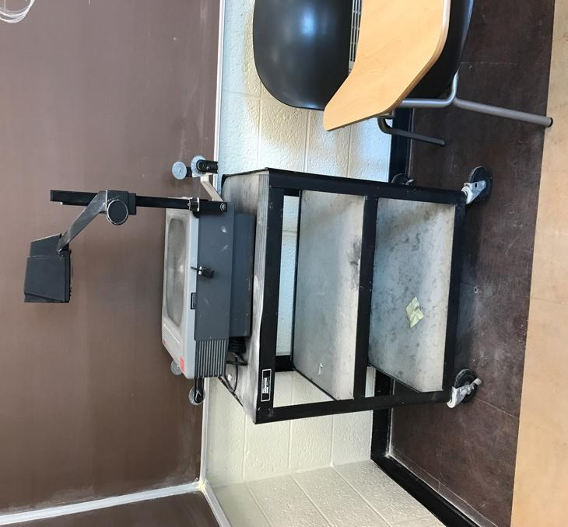

Fig. 1 Overhead Projector in WSU’s classroom

The pictures in Fig. 1 shows a classroom at WSU. In the picture, there is an overhead projector in the corner of the classroom. The picture shows that this is common in WSU’s State Hall classroom. In almost every classroom there is a dusty overhead like the one above.

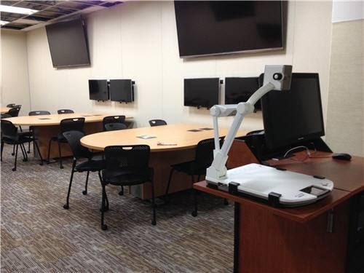

Fig 2. Classroom at MSU

The pictures in Fig. 2 shows a classroom at MSU. While touring the Wilson building on campus, we noticed that in almost every classroom the technology present were similar to the ones in fig. 2.  They had television sets, and an Elmo.

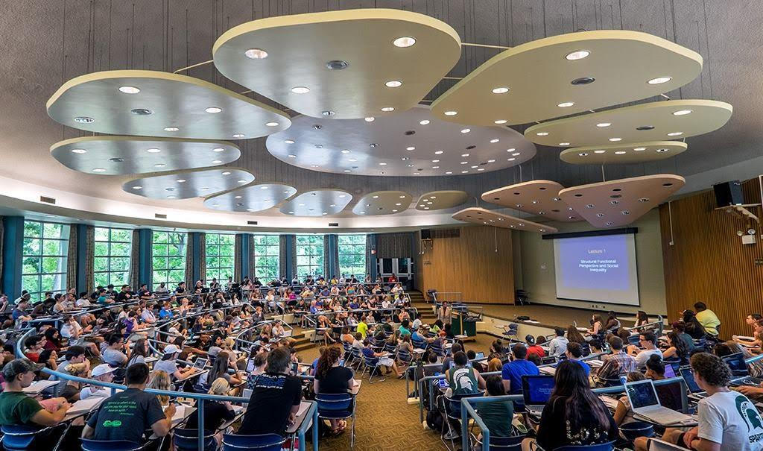.

Fig. 3 MSU lecture hall

Not only were the classroom standards much higher than WSU’s standards, but their lecture halls were also more technological advance than State Hall. Every lecture hall in MSU had a surround sound system, enabling every student in the lecture hall to clearly hear the professor. The lecture halls have multiple screens throughout the hall, allowing the students to be able to see the lecture slides from anywhere in the hall. (See Fig. 3)

In an interview with Rhonda Harris, a current sophomore at WSU, she felt that WSU does not do enough to supply their students with sufficient technologies to succeed. Harris felt that WSU does the bare minimum to provide their students with technologies that is just enough to get the students by. Harris states that “State Hall does not provide their students with up-to-date equipment, and State Hall’s equipment are not comparable to other universities equipment.” (R. Harris, Interview). Harris has stated that she feels WSU could do a better job at bettering their student’s education.

In another interview with a student from MSU, Touger Lee, his answers were different from Harris’s. Lee, a current sophomore at MSU, states that he feels MSU does a great job supplying their students with sufficient up-to-date equipment to help their students succeed. “Michigan State does a good job to help their students succeed and they provide us with great technologies in the classrooms”, stated by Lee (T. Lee, Interview). Lee has always felt that MSU is trying to do its best for their students to succeed. Throughout the two years that Lee has been at MSU, he has always been in classrooms with up-to-date technologies.

**Technology Solution**

In order to solve WSU’s technology issue, WSU needs to first experiment on 4-5 classrooms in State Hall for 2-3 semesters. During this time, student surveys would be taken at the end of each semester to see if the experiment is working. The purpose of this experiment is to see by having up-to-date technologies, would it positively effect the student’s education in a positive matter. If the experiment proves that this model works, then Wayne State would implement this model into more classrooms in State Hall. At this point, WSU would go from experimenting with 4-5 classrooms to implementing it into all of State Hall classrooms.

**Criteria**

The criteria for this research section on the technological issues WSU has are: all outdated and unused technology are removed from State Hall; student satisfaction improves within the next 2-3 semester. The actual implementation of this plan would be implemented over the course of the next few semesters. It would be implemented by first trying out this idea in a couple of classrooms. In the classrooms that will be tested on, they would receive up-to-date technologies at the disposal of the students and professors. Surveys and final grades would be collected from these classrooms to see if the idea is a success or not. If this test is a success, then we would move on and implement it to all of State Hall. This would ensure that student satisfaction improves greatly.

**Technology Solution Conclusion**

In conclusion, after my research was completed, I have found that technologies in State Hall’s classrooms does not measure up to other universities classrooms. It does not provide students with up-to-date equipment to help their students succeed. After comparing State Hall to a similar building on MSU campus, it showed that State Hall’s equipment was not comparable.

The proposed solution of removing all outdated technologies in a few classrooms in State Hall first, would benefit the students. By doing so, it allows these few classrooms to experience the benefits of having new technologies. Surveys and class grades would be recorded every semester to see if this solution is actually working. If the solution is a success, then the implementation to all of State Hall would immediately go into affect.

**Methods**

Lee, L. (Current Technology in State Hall) 2017. Classroom at Wayne State University, State Hall[Photograph]. Detroit, MI: Wayne State University.

Lee, L. (Technology at Michigan State University) 2017. Classroom at Michigan State[Photograph]. Lansing, MI: Michigan State University.

Granberg, E. (n.d.). Retrieved February 28, 2017, from https://cft.vanderbilt.edu/library/articles-and-essays/the-teaching-forum/how-technology-enhances-teaching-and-learning/

Teacher’s Guide: How to Use a Smart Board in the Classroom. (n.d.). Retrieved March 12, 2017, from http://education.cu-portland.edu/blog/educator-tips/teacher-s-guide-how-to-use-a-smartboard-in-the-classroom

Appendix

WSU Student Interview Question

How useful are State Hall’s current technologies in the classrooms?

What technology in the classrooms of State Hall do you feel needs to be updated?

Do you think Wayne State supplies its student with up-to-date equipment?

Are you satisfied with the current technology in the classrooms?

Do you feel that classroom in State Hall have equipment comparable to other universities’ classrooms?

MSU Student Interview Question

How useful are Wilson’s current technologies in the classrooms?

What technology in the classrooms of Wilson do you feel needs to be updated?

Do you think Michigan State supplies its student with up-to-date equipment?

Are you satisfied with the current technology in the classrooms?

Do you feel that classroom in Wilson have equipment comparable to other universities’ classrooms?