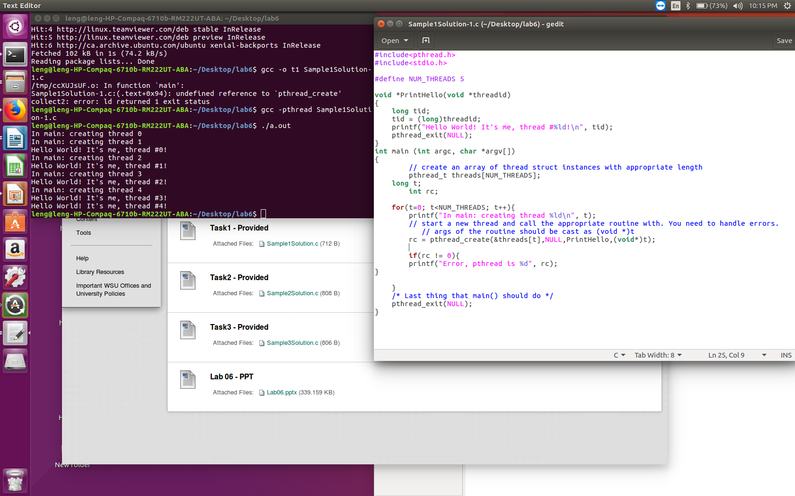
For task one I created a thread using the pthread_create. This thread calls the PrintHello pointer function from above.

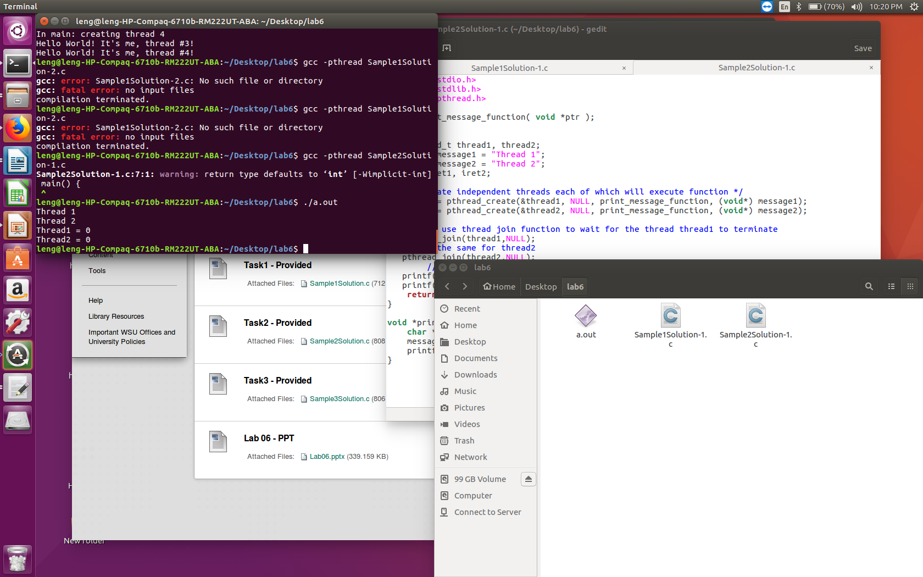
For task 2, I use the pthread_join to join the two threads that were created.

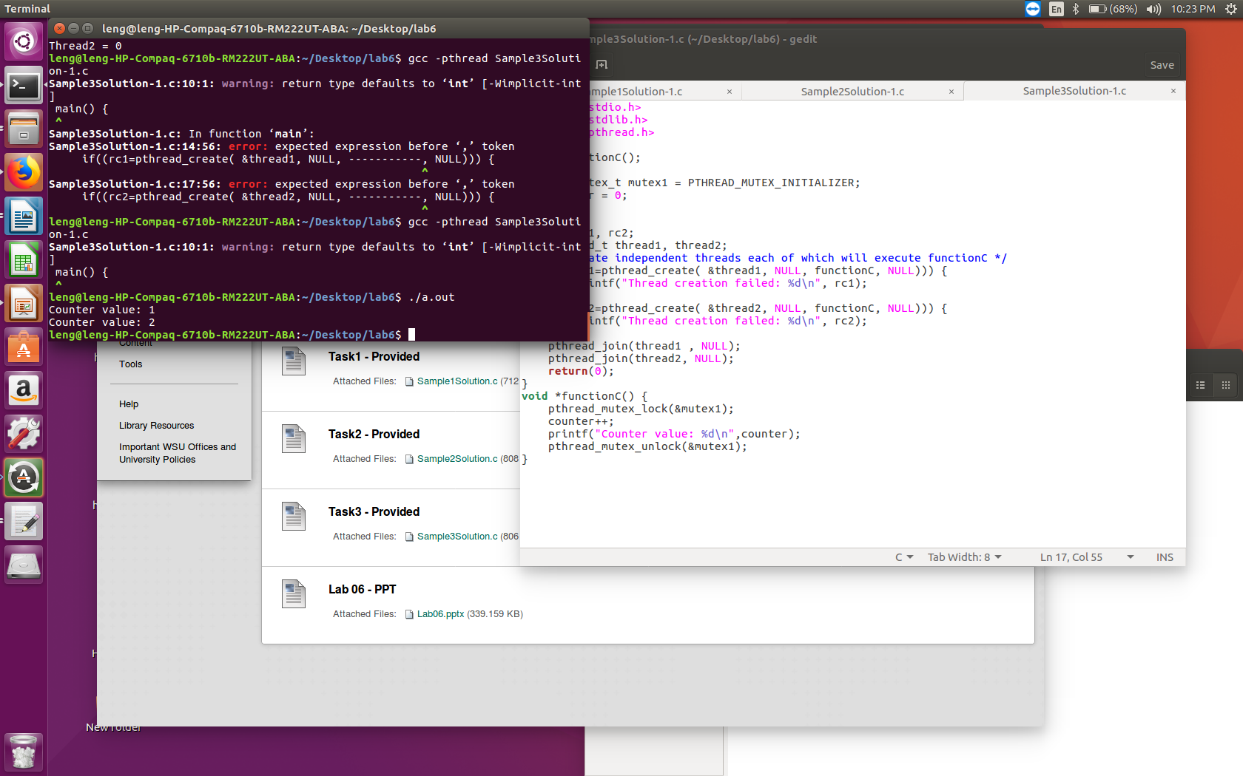
I uses the mutex to keep a count on my newely created threads and joined threads.

