Putting Numbers to the Nattrass Story
ECOH621 Development Economics. GEAR's projections against thirty years of outcomes.

COMPILED BY:
LENGOASA ANELE: 41375060

The question
In 1996 Nicoli Nattrass described South Africa's policy debate as a bet. The SAF/GEAR camp held that private investment would recover once government proved it could control the deficit and inflation. The LABOUR/ILO camp held that investment follows demand, so cutting spending would cut the very thing investment responds to. Nattrass declined to pick a winner, because nobody knew how investors would actually behave.
In 2001 she returned to the question and compared GEAR's projections with what happened between 1996 and 1999. This report rebuilds that comparison, carries it forward to 2024, and then tests the two positions directly with a regression. The short answer is that GEAR delivered the stability it promised and almost none of the growth. Whether that proves the demand camp right is a harder question, and the honest answer depends on two recession years.

Part 1. Rebuilding the table
Nattrass's Table 1 sets GEAR's projections beside actual performance. I rebuilt it for the six indicators the brief lists, using the supplied csv of targets and outturns. Two things needed fixing before the table could be trusted.
The first was the inflation row. The csv gives GEAR inflation targets of 8.4, 10.9 and 9.6 per cent for 1996 to 1998. Those figures do not come from GEAR's Integrated Scenario, which is the plan government actually adopted and the source of every other row. They come from the Base Scenario in the same 1996 document, which was the do-nothing baseline GEAR was designed to beat. I checked this directly against South Africa (1996) and the Integrated Scenario gives 8.0, 9.7 and 8.1 instead. Only the 1999 figure of 7.7 is the same in both scenarios, which is probably why the error went unnoticed. Nattrass's own 2001 table repeats the Base Scenario numbers, so this is an error inherited from the published paper rather than a transcription fault in the course data. I use the verified Integrated Scenario values and supply 7.6 for 2000, which the csv left blank.
The second was the cells flagged as reconstructed from a damaged scan. I checked every one against Nattrass (2001) and against the 1996 GEAR document where the cell is a target. All of them match the values already in the csv, so no changes were needed. One small discrepancy is worth noting: the data dictionary says six cells are affected, but only five carry the flag in the file itself.
Nattrass stops at 1999 because her source, the SARB Quarterly Bulletin of March 2000, predates the full-year figures. I filled 2000 from the SARB Annual Economic Report 2001, which is the first report covering the whole calendar year. Five of the six indicators are there. Employment is not. The report gives private-sector formal employment falling 2.0 per cent and public-sector employment falling 4.1 per cent, but never states a combined total, and building one would need a weighting I could not source. I left that cell blank rather than invent a number.
 | 1996 |  | 1997 |  | 1998 |  | 1999 |  | 2000
Indicator | Target | Actual | Target | Actual | Target | Actual | Target | Actual | Target | Actual
Real GDP growth (%) | 3.5 | 4.2 | 2.9 | 2.5 | 3.8 | 0.6 | 4.9 | 1.2 | 6.1 | 3.0
Real private investment growth (%) | 9.3 | 6.1 | 9.1 | 4.7 | 9.3 | -2.9 | 13.9 | -4.4 | 17.0 | 5.0
Non-agric. formal employment growth (%) | 1.3 | -0.7 | 3.0 | -1.7 | 2.7 | -3.7 | 3.5 | -3.2 | 4.3 | —
CPI inflation (%) | 8.0 | 7.4 | 9.7 | 8.6 | 8.1 | 6.9 | 7.7 | 5.2 | 7.6 | 5.3
Budget deficit (% of GDP) | 5.1 | 4.9 | 4.0 | 4.6 | 3.5 | 3.3 | 3.0 | 2.6 | 3.0 | 2.0
Real bank/repo rate (%) | 7.0 | 8.8 | 5.0 | 7.4 | 4.0 | 8.1 | 3.0 | 7.3 | 3.0 | 6.5
Table 1. GEAR targets and actual performance, 1996 to 2000. Targets from South Africa (1996), Integrated Scenario. Actuals 1996 to 1999 from Nattrass (2001). Actuals for 2000 from SARB (2001).
The brief asks for a source on every row, so Table 2 gives them. Where a figure comes from the supplied csv unchanged, the table says so.
Row | Source
Real GDP growth | Target: South Africa (1996), Integrated Scenario. Actual 1996-99: supplied csv, from Nattrass (2001). Actual 2000: SARB (2001), 3.0 per cent.
Real private investment growth | Target: South Africa (1996). Actual 1996-99: supplied csv, from Nattrass (2001). Actual 2000: SARB (2001), private business enterprise GFCF, 5.0 per cent.
Non-agric. formal employment growth | Target: South Africa (1996). Actual 1996-99: supplied csv, from Nattrass (2001). Actual 2000: not stated as a single figure in SARB (2001) and left blank.
CPI inflation | Target: corrected from South Africa (1996), Integrated Scenario, replacing the Base Scenario values in the supplied csv. Actual 1996-99: supplied csv. Actual 2000: SARB (2001), annual average 5.3 per cent.
Budget deficit, % of GDP | Target: South Africa (1996). Actual 1996-99: supplied csv. Actual 2000: SARB (2001), 2.0 per cent, a fiscal-year figure for 2000/01 and so not strictly comparable with the calendar-year figures above it.
Real bank/repo rate | Target: South Africa (1996). Actual 1996-99: supplied csv. Actual 2000: derived as 11.81 nominal minus 5.3 CPI = 6.51, where the nominal average comes from SARB monthly Bank rate data and matches the rate changes described in SARB (2001).
Table 2. Source for every row of Table 1.

Part 2. Extending the series to 2024
I carried each series forward to 2024 using SARB and StatsSA data. The build chains three sources: Nattrass for 1996 to 1999, the SARB Annual Economic Report 2001 for 2000, and current-vintage SARB and StatsSA series for 2001 onwards. Every cell in the output file carries a source tag, and the plots mark the year where the vintage changes, because presenting one smooth line would hide a real break in the data.
To score a target as met after 2000, when GEAR's own targets stop, I use GEAR's final 2000 target as the implied steady-state goal. Beating it means higher for growth, investment and employment, and lower for inflation, the deficit and the real interest rate.
Indicator | Years met | When
Real GDP growth (%) | 1 of 29 | 1996
Real private investment growth (%) | 0 of 29 | never
Non-agric. formal employment growth (%) | 1 of 12 | 2006
CPI inflation (%) | 27 of 29 | 1996–2024, most years
Budget deficit (% of GDP) | 12 of 29 | 1996–2008, most years
Real bank/repo rate (%) | 18 of 29 | 2006–2023, most years
Table 3. Years in which each GEAR target was met, 1996 to 2024. Denominator is years with data, which is why employment differs.
The pattern is hard to miss. Inflation beat its target in 27 of 29 years, missing only 2002 and 2008, both shock years. The deficit beat its target for a clean run from 1998 to 2008. The real interest rate beat its target for eighteen straight years from 2006. Now look at the other three. Real GDP growth met its target once, in 1996, before the strategy had time to do anything. Employment met it once, in 2006. Private investment growth never met its target in twenty-nine years.
So the three stabilisation indicators were met most of the time and the three growth indicators almost never were. This matters because GEAR was not a stabilisation plan for its own sake. Stability was supposed to buy investment. South Africa delivered the stability and did not get the investment, which is close to a clean failure of the strategy on its own terms.
One period complicates that reading and deserves attention. Between 2004 and 2007 growth reached 5.6 per cent, the budget moved into surplus, inflation fell to 1.4 per cent in 2004, and formal employment grew at around 4 per cent a year. For a few years stability and growth arrived together. Any account that treats GEAR as a simple failure has to explain that episode, and Part 3 offers one.
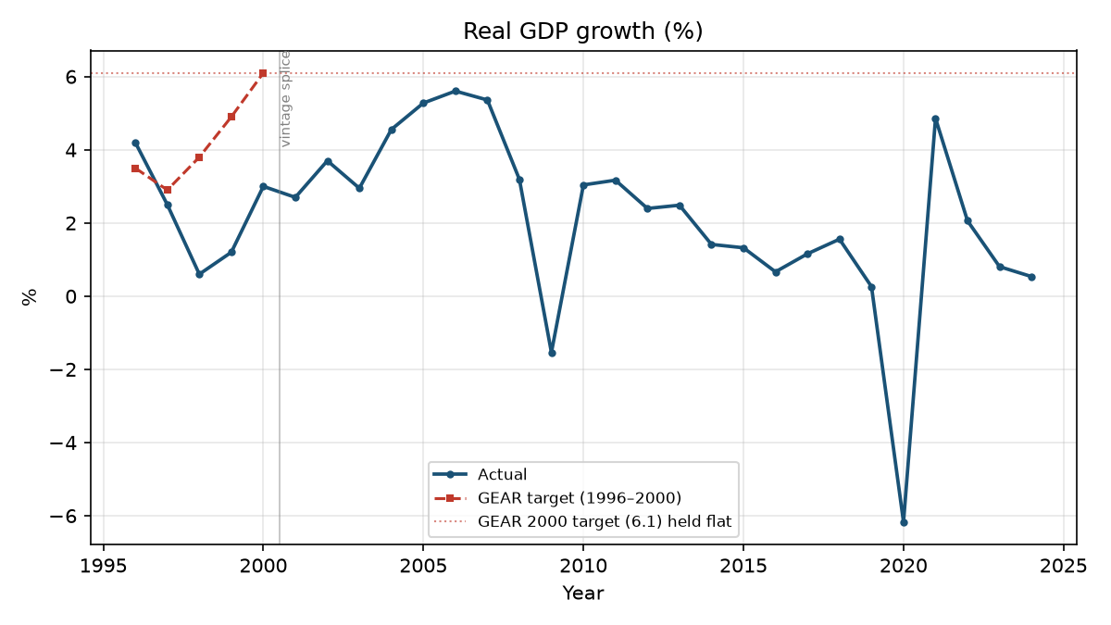
Figure. Real GDP growth (%), actual against GEAR target.
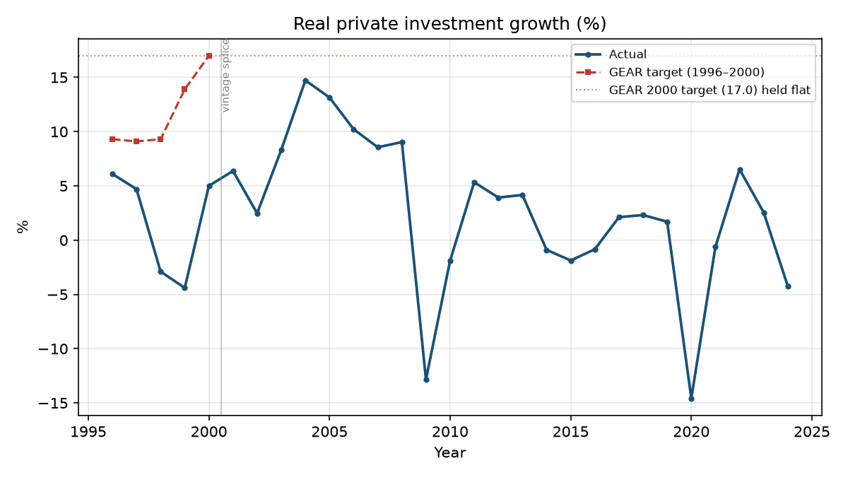
Figure. Real private investment growth (%), actual against GEAR target.

Part 3. Testing the gamble
The two camps make testable claims. If LABOUR/ILO are right, investment should respond to demand, so lagged GDP growth should carry a positive coefficient. If SAF/GEAR are right, investment should respond to the fiscal signal, so the deficit should carry a negative one. I estimate real private investment growth on lagged real GDP growth, the real bank rate and the deficit as a share of GDP, annually from 1994 to 2024, with 31 observations. Throughout, the deficit is positive when the budget is in deficit.
Part 2 chains vintages on purpose so that GEAR can be judged against the data of its own day. That would be wrong here, because a definition that changes mid-sample gets baked into the coefficients. Part 3 therefore uses one current vintage throughout and keeps Boshoff and Fourie's series as a sensitivity check.
The Breusch-Godfrey test rejects the null of no autocorrelation, so I report Newey-West standard errors with one lag. Breusch-Pagan finds no heteroskedasticity, Jarque-Bera does not reject normal residuals, and all variance inflation factors sit below 1.6.
Specification | N | Lagged GDP growth | Real rate | Deficit/GDP
Full sample, 1994–2024 | 31 | 0.52  (0.39) | -0.06  (0.37) | -1.83*  (0.60)
Pre-2008, 1994–2007 | 14 | 0.87  (0.55) | -1.37*  (0.35) | 1.67*  (0.63)
2008 onwards | 17 | 0.30  (0.30) | -0.87  (0.58) | -2.31*  (0.51)
Full, excl. 2009 & 2020 | 29 | 0.94*  (0.32) | -0.03  (0.33) | -0.70  (0.48)
2008 on, excl. 2009 & 2020 | 15 | 0.75*  (0.14) | -0.98*  (0.32) | -0.14  (0.66)
Table 4. Real private investment growth. Newey-West standard errors in parentheses. * = p < 0.05.
Read the first row alone and GEAR wins. The deficit coefficient is -1.83 and significant at the 1 per cent level, exactly the sign the confidence argument predicts, while lagged GDP growth is insignificant. That reading does not survive two checks.
The first is the 2008 split the brief asks for. A Chow test rejects parameter stability (F = 4.01, p = 0.013). Estimating either side, the deficit coefficient is +1.67 before 2008 and -2.31 after, and it is significant in both directions. A coefficient that reverses sign like that is not measuring a stable behavioural parameter. The full-sample estimate is averaging two opposite regimes.
The second check matters more. In 2009 and 2020 the deficit exploded and private investment collapsed, but the recession caused both. Automatic stabilisers widen the deficit in a downturn by construction, so the correlation runs from recession to deficit rather than from deficit to lost confidence. Dropping those two years from thirty-one reverses the conclusion. The deficit coefficient falls to -0.70 and loses significance, then to -0.14 in the post-2008 window. Lagged GDP growth rises to 0.94 and becomes significant at the 1 per cent level.
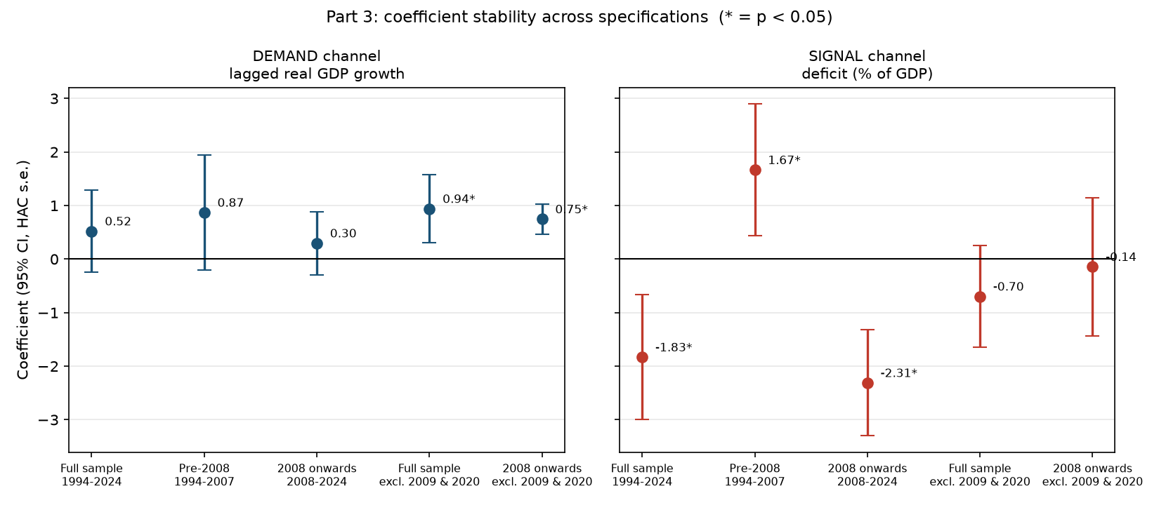
Figure. Coefficient stability across specifications, with 95 per cent confidence intervals.
So which camp does the evidence favour? On balance the demand camp, with qualifications. The demand coefficient is positive in all five specifications and becomes significant precisely when the observations most contaminated by reverse causation come out. That is what a real relationship obscured by noise looks like. A coefficient of 0.94 also means something economically: a one-point rise in last year's growth goes with roughly a one-point rise in investment growth.
Against that, the demand result is not significant on the full sample, and it depends on which GDP series I use. Re-estimating with Boshoff and Fourie's factor-cost series gives 0.26 with a p-value of 0.77, so nothing survives. Part of that is the shorter sample ending in 2018 and part is the change in definition, and I cannot separate the two.
The firmer finding is the negative one. There is no reliable evidence for the confidence channel GEAR was built on. The only specification where the fiscal signal is significant with GEAR's predicted sign is also the one most obviously contaminated by recession-driven simultaneity, and it does not survive dropping two outlier years. That fits Part 2, where the consolidation arrived and the investment never did. It also explains the 2004 to 2007 episode: growth and investment rose together in those years because demand was strong, which is what the demand channel predicts, and the budget surplus was along for the ride.
The 1994 split the brief also asks for cannot be run. The supplied deficit and policy-rate series both start in 1994, so there are no pre-1994 observations for two of the three regressors. That is a limit of the data rather than a choice about method, and I report it as such instead of substituting a different test.
None of these coefficients is causal. Investment, growth and the deficit are determined together and I use no instrument. What the crisis-year exercise shows is which results are most contaminated by that simultaneity, which is a weaker claim than causation but a defensible one.

Part 4. The counterfactual
What would have had to be true for LABOUR/ILO to work? The strategy was a conditional bet, and four conditions had to hold together.
First, investment had to respond strongly to demand. Nattrass cites Chirinko's finding that lagged demand is the most significant empirical determinant of investment, so this was the better-supported prior even in 1996. My own estimates agree: outside the two recession years, a point of lagged growth buys 0.75 to 0.94 points of investment growth. On this condition the later evidence supports LABOUR/ILO.
Second, growth had to translate into jobs. Here the record is better than the usual jobless-growth story suggests. Formal non-agricultural employment grew between 1.9 and 4.5 per cent a year from 2001 to 2006 and beat GEAR's 4.3 per cent target in 2006. Demand-led growth did create formal jobs when it came. But Nattrass's warning still bites. Raising average labour productivity, which the high-productivity industrial and wage policies aimed at, mechanically lowers the employment elasticity of output. Real wage growth in 1996 to 1999 ran at 1.7, 2.3, 8.6 and 3.0 per cent against GEAR's assumed path of -0.5, 1.0, 1.0 and 1.0, and formal employment fell in every one of those years. The strategy wanted labour-demanding growth while its own allies bargained for wage floors that discourage it.
Third, the capital account had to stay calm. This is where Nattrass criticises LABOUR/ILO hardest and where the counterfactual is weakest. A deficit-financed expansion only works if the risk premium and the capital outflow response to fiscal divergence are small. South Africa's history says otherwise: the 2001 currency collapse, the 2008 reversal, and the debt path since 2020. Nattrass's East Asian comparison is the telling one. Malaysia and Thailand could run large deficits because deep domestic savings made them less prone to destabilising capital flight. South Africa's savings rate was low then and is low now, so the same deficit is a different instrument here.
Fourth, the expansion had to avoid destabilising the economy. Nattrass is explicit that the demand relationship has a ceiling. If expansion produces inflation and depreciation, profitability suffers and investment falls rather than rises. Latin American macroeconomic populism is her example. LABOUR/ILO needed demand strong enough to pull investment along but not so strong that it broke the conditions investment depends on, which is a narrow path to walk.
The conclusion is not that LABOUR/ILO would have worked. It is that each camp was right about what the other missed. LABOUR/ILO identified the mechanism GEAR got wrong, since investment does follow demand and the confidence channel does not show up in my results. GEAR took seriously the constraint LABOUR/ILO waved away, since an open capital account and a low savings rate really do limit what fiscal policy can do. Nattrass criticised both camps in 1996 and my own evidence leaves that criticism standing.

Conclusion
Three findings come out of this exercise. The first is descriptive. Across twenty-nine years South Africa met the targets GEAR set for inflation, the deficit and the real interest rate in most years, and missed the targets for growth, investment and employment in nearly all of them. Private investment growth never once reached its target. GEAR was not sold as a stabilisation plan for its own sake, so meeting only the stabilisation half is a failure on the strategy's own terms.
The second finding is that the regression evidence points the same way, but only after the crisis years are handled properly. Taken whole, the sample says the deficit predicts investment with GEAR's expected sign. That result rests entirely on 2009 and 2020, when recession drove the deficit and investment at the same time and in opposite directions. Remove those two years and the fiscal signal disappears while the demand channel strengthens.
The third finding concerns what the data can and cannot settle. My demand result does not hold on the alternative GDP vintage, the dependent variable's definition is not fully verified, the employment series has a nine-year hole, and nothing here is identified causally. The evidence is mixed. What makes it useful is that the mixing has a traceable source, which is two recessions doing the work of a behavioural parameter. Nattrass refused to call the bet in 1996 on the grounds that the profession knew very little about how investors respond. Thirty years of data narrow the question without closing it.

How I handled the traps
Trap | How it was handled
1. Employment series is not continuous | Kept OHS, LFS, QLFS and QES separate by survey label and never spliced across them. The supplied extract has no coverage for 2016 to 2024, so employment appears for only 12 of 29 years. I left the gap visible rather than interpolating.
2. Private investment is not one thing | Not fully resolved, and reported as such. The series carries no source or series code. Its 2009 and 2020 contractions (-12.8 and -14.6 per cent) are far too steep for a blended total that includes public and parastatal capital spending, which is consistent with a private-only series. That is corroboration, not confirmation.
3. Nominal versus real, and which deflator | Investment and GDP are constant-price. The deficit is a ratio of two nominal series, so it needs no deflating. The real bank rate is the nominal annual average minus annual-average CPI, which is how Nattrass built hers. That is an ex-post rate, not an ex-ante one, and the two can differ sharply in fast-disinflation years.
4. Boshoff and Fourie's splice | Used as the Part 3 sensitivity check. The demand result holds on SARB market-price GDP and disappears on the factor-cost series, so the finding is sensitive to this choice and I say so rather than reporting only the specification I prefer.
5. Cells reconstructed from a damaged scan | All checked against Nattrass (2001) and the 1996 GEAR document. All correct as supplied. The dictionary says six cells, the file has five.
6. Data vintage | Made explicitly and differently in each part. Part 2 chains vintages so GEAR is judged against the data of its day, with the splice year marked on every plot. Part 3 holds one vintage fixed so the break is not estimated into the coefficients.
7. Endogeneity | Diagnosed, not solved. No instrument is used and no coefficient is causal. The crisis-year exercise exists to show which results simultaneity contaminates most.
Table 5. The seven traps and how each was treated.

References
Boshoff, W.H. and Fourie, J. (2020) 'The South African economy in the twentieth century', in Boshoff, W.H. (ed.) Business Cycles and Structural Change in South Africa. Cham: Springer.
Chirinko, R. (1993) 'Business fixed investment spending: modeling strategies, empirical results and policy implications', Journal of Economic Literature, 31, pp. 1875-1911. Cited in Nattrass (2001).
Nattrass, N. (1996) 'Gambling on investment: competing economic strategies in South Africa', Transformation, 31, pp. 25-42.
Nattrass, N. (2001) 'High productivity now: a critical review of South Africa's growth strategy', Transformation, 45, pp. 1-24.
South Africa (1996) Growth, Employment and Redistribution: A Macroeconomic Strategy. Pretoria: Department of Finance.
South African Reserve Bank (2001) Annual Economic Report 2001. Pretoria: SARB.
Statistics South Africa (various years) Consumer Price Index (P0141); Quarterly Employment Statistics; Labour Force Survey. Pretoria: StatsSA.
Weeks, J. (1999) 'Stuck in low GEAR? Macroeconomic policy in South Africa, 1996-98', Cambridge Journal of Economics, 23(4), pp. 795-811.

